**Product Marketing Analytics Report**

**Reporting Period: 2023-2025**

This report provides a comprehensive analysis of product marketing performance, covering **conversion rates, social media engagement**, and **customer reviews** across a diverse product range. Key insights have been derived from trends observed by **month** and by **product**.

# Conversion Analysis

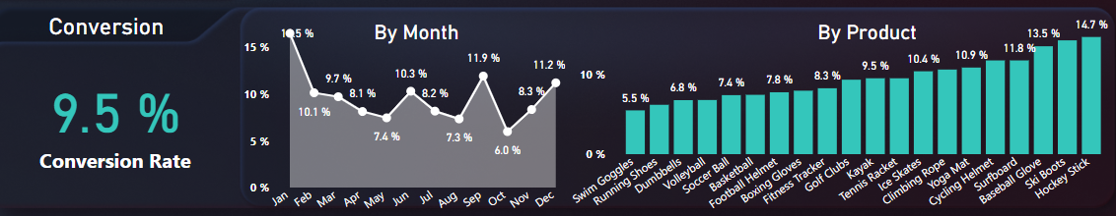

**Overall Conversion Rate:** 9.5%

**a. By Month:**

* **High Performance:** January (15.5%), September (11.9%), December (11.2%)
* **Low Performance:** August (6.0%), July (7.3%), May (7.4%)

**Insight:** Conversion rates are highest at the beginning and end of the year, suggesting effective seasonal campaigns. The mid-year dip indicates a need for strategic revision during Q2 and Q3.

**b. By Product:**

* **Top Converting Products:** Hockey Stick (14.7%), Ski Boots (13.5%), Baseball Glove (11.8%)
* **Low Converting Products:** Swim Goggles (5.5%), Running Shoes (6.8%), Dumbbells (6.6%)

**Insight:** There is a clear performance gap across product lines. High-performing products should be prioritized in marketing efforts, while underperforming products require evaluation.

# Social Media & Engagement Analysis

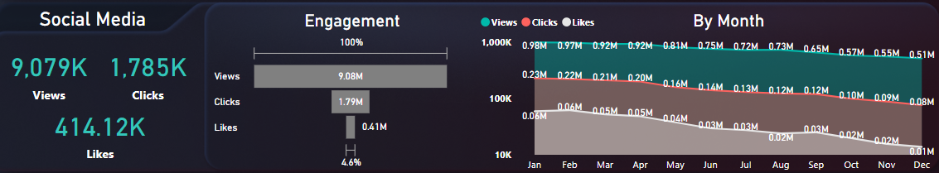

**Total Metrics:** - Views: 9,079K - Clicks: 1,785K - Likes: 414.12K

1. **Monthly Engagement Trend:**
   * Views start at 0.98M in January and decline to 0.51M by December.
   * Likes remain consistently low, peaking at just 0.06M in April.

**Insight:** Despite consistent visibility, the low interaction rate, particularly in likes (4.6% of total engagement), suggests the need to improve content relevance and platform strategy.

1. **Engagement Distribution:**
   * Views: 9.08M
   * Clicks: 1.79M
   * Likes: 0.41M

**Insight:** A high number of views with relatively fewer clicks and very low likes indicates weak user engagement. Improving CTAs and content appeal could enhance interaction.

# Customer Reviews Analysis

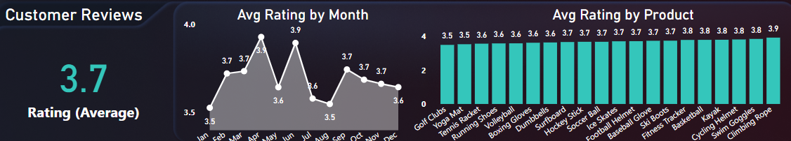

**Average Rating:** 3.7 stars

1. **Monthly Trend:**
   * **Highest:** May (4.0)
   * **Lowest:** January (3.5)
2. **Product Ratings:**
   * **Top Rated:** Climbing Rope (3.9), Yoga Mat & Cycling Helmet (3.8)
   * **Low Rated:** Swim Goggles, Running Shoes, Volleyball (3.5)

**Insight:** Ratings are inconsistent across months and products. Products with poor reviews may need quality checks or service improvements. High-rated products are potential flagships for brand promotion.

1. **Recommendations**

**1. Campaign Optimization:** Strengthen mid-year marketing with fresh content and targeted campaigns.

**2. Product Focus:**

* Promote high performers like Hockey Stick and Climbing Rope.
* Audit and possibly revamp low-performing items (e.g., Swim Goggles, Dumbbells).

**3. Enhance Social Media Engagement:** Utilize interactive formats such as contests and influencer collaborations to increase likes and clicks.

**4. Customer Satisfaction:** Collect feedback on poorly rated items and address customer pain points.

**5. Content Strategy Refresh:** Revise social content to be more engaging and relevant to reduce the gap between views and meaningful interaction.

# Conclusion

This product marketing analysis for 2023-2025 reveals a mixed but discernible performance across key metrics. While certain periods (e.g., Q1 and Q4 for conversions) and products (e.g., Hockey Stick, Ski Boots) demonstrate strong performance, significant opportunities for improvement exist, particularly in mid-year conversion rates, overall social media engagement, and consistency in customer satisfaction.

The data indicates that current marketing strategies effectively capture initial attention (high views), but struggle to convert that interest into meaningful interaction (clicks, likes) and sales during specific periods. Furthermore, a clear disparity in product performance highlights the need for targeted interventions—leveraging top performers while critically assessing and improving underperforming product lines. By addressing these identified gaps through strategic campaign adjustments, enhanced content relevance, and focused product development or marketing efforts, the overall effectiveness of product marketing can be substantially elevated to drive sustained growth and customer loyalty.

# Revised and Enhanced Recommendations/Solutions

Building upon the insights, here are more specific solutions, focusing on addressing low-performing parameters:

1. **Conversion Optimization:**
   * **Challenge:** Mid-year dip in conversion rates (Q2 & Q3: August 6.0%, July 7.3%, May 7.4%).
   * **Solution:** Implement **targeted mid-year campaigns** featuring exclusive discounts, bundled offers, or limited-time promotions specifically designed for Q2 and Q3. Consider seasonal relevancy for products that might not typically perform well in warmer months (e.g., "Summer Sports Kick-off" for relevant products or "Back-to-School/Work" promotions).
   * **Challenge:** Low-converting products (Swim Goggles 5.5%, Running Shoes 6.8%, Dumbbells 6.6%).
   * **Solution:** Conduct **A/B testing on product pages** for these items (e.g., different product images, clearer benefit-oriented descriptions, enhanced customer testimonials). Explore **re-targeting campaigns** specifically for users who viewed these products but did not convert. Consider **price adjustments or special bundles** to increase perceived value for these items.
2. **Social Media Engagement Enhancement:**
   * **Challenge:** High views (9.08M) but low clicks (1.79M) and very low likes (0.41M), indicating weak user engagement and content relevance issues.
   * **Solution:**
     + **Implement diverse content formats:** Move beyond static posts to include more **interactive content** such as polls, quizzes, live Q&A sessions, behind-the-scenes videos, and user-generated content features.
     + **Strengthen Calls-to-Action (CTAs):** Make CTAs more prominent, action-oriented, and varied (e.g., "Shop Now for 20% Off," "Discover Your Perfect Gear," "Vote for Your Favorite").
     + **Leverage Influencer Marketing:** Collaborate with micro-influencers in relevant sports niches to showcase products authentically and drive engagement.
     + **Run Contests & Giveaways:** Directly incentivize likes, shares, and comments through contests that require engagement.
     + **Optimize Posting Times:** Analyze platform-specific analytics to determine peak engagement times and schedule posts accordingly.
3. **Customer Satisfaction & Product Quality Improvement:**
   * **Challenge:** Inconsistent average rating (3.7 stars) with specific low-rated products (Swim Goggles 3.5, Running Shoes 3.5, Volleyball 3.5).
   * **Solution:**
     + **Direct Feedback Collection:** Implement a proactive system to collect feedback from customers who purchased low-rated items (e.g., follow-up emails post-purchase asking for specific feedback on product quality or fit).
     + **Product Quality Audit:** For Swim Goggles, Running Shoes, and Volleyball, initiate a thorough internal review of their design, manufacturing, and material quality. Address any identified flaws or common customer complaints.
     + **Customer Service Interventions:** Ensure customer service teams are equipped to handle complaints about these products effectively, potentially offering replacements or detailed troubleshooting guides.
     + **Update Product Information:** Based on feedback, refine product descriptions and FAQs to better manage customer expectations and highlight key features that address previous concerns.
4. **Product Prioritization & Strategic Marketing:**
   * **Challenge:** Clear performance gap across product lines (Hockey Stick 14.7%, Ski Boots 13.5% vs. Swim Goggles 5.5%, Dumbbells 6.6%).
   * **Solution:**
     + **Amplify High Performers:** Allocate additional marketing budget to promote top-converting products (Hockey Stick, Ski Boots, Baseball Glove) and top-rated products (Climbing Rope, Yoga Mat, Cycling Helmet). Create compelling campaigns that leverage their success and positive customer sentiment.
     + **Re-evaluate Underperformers:** For consistently low-performing products, conduct a deeper market analysis. Decisions might range from a complete product redesign, re-positioning, or even discontinuation if they consistently drain resources without adequate returns.

**Thank You!**

Submitted By:

Mohammad osama 23SCSE1420190

Abdul Irfan shah 23SCSE1012806

Utkarsh sharma 23SCSE1410187

Tannu kumari 23SCE1410110