**Link to Video:**

https://youtu.be/bp-FKXfxvAk

**Introduction**

The designed database system has been developed to take care of all operations of a health club covering the members, trainers, as well as the administrative staff as well. It adopts a relational way to store and manage data that depicts these entities and their interactions. The relational schema was utilized for schematizing the model to a database using the PostgreSQL.

**Entities and Relationships:**

The database consists of the following entities and their relationships:

* **Members:** Represents individuals who have registered with the club

|  |  |  |  |
| --- | --- | --- | --- |
| Column Name | Data Type | Constraints | Description |
| member_id | INT | PRIMARY KEY | Unique identifier for each member. |
| email | VARCHAR | UNIQUE | Member's email address for login. |
| password | VARCHAR |  | Hashed password for secure authentication. |
| first_name | VARCHAR |  | Member's first name. |
| last_name | VARCHAR |  | Member's last name. |
| gender | CHAR |  | Member's gender (e.g., M, F). |
| birthdate | DATE |  | Member's date of birth. |
| phone_number | VARCHAR |  | Member's phone number. |
| address | VARCHAR |  | Member's address. |
| membership_type | VARCHAR |  | Type of membership (e.g., standard, premium). |
| profile_picture | VARCHAR |  | Path to member's profile picture (optional). |

* **Trainers:** Represents certified professionals who provide training services

|  |  |  |  |
| --- | --- | --- | --- |
| Column Name | Data Type | Constraints | Description |
| trainer_id | INT | PRIMARY KEY | Unique identifier for each trainer. |
| email | VARCHAR | UNIQUE | Trainer's email address for login (optional). |
| first_name | VARCHAR |  | Trainer's first name. |
| last_name | VARCHAR |  | Trainer's last name. |
| gender | CHAR |  | Trainer's gender (e.g., M, F). |
| specialization | VARCHAR |  | Trainer's area of expertise (e.g., strength training, yoga). |
| bio | TEXT |  | Trainer's biography. |
| profile_picture | VARCHAR |  | Path to trainer's profile picture (optional). |

* **Administrative Staff:** Represents personnel managing the club's operations

|  |  |  |  |
| --- | --- | --- | --- |
| Column Name | Data Type | Constraints | Description |
| staff_id | INT | PRIMARY KEY | Unique identifier for each staff member. |
| email | VARCHAR | UNIQUE | Staff member's email address for login. |
| password | VARCHAR |  | Hashed password for secure authentication. |
| first_name | VARCHAR |  | Staff member's first name. |
| last_name | VARCHAR |  | Staff member's last name. |

* **Equipment:** Represents exercise equipment available for member use ().

|  |  |  |  |
| --- | --- | --- | --- |
| Column Name | Data Type | Constraints | Description |
| equipment_id | INT | PRIMARY KEY | Unique identifier for each equipment piece. |
| name | VARCHAR |  | Name of the equipment (e.g., treadmill, elliptical trainer). |

* **Exercise Routines:** Represents personalized exercise plans for members

|  |  |  |  |
| --- | --- | --- | --- |
| Column Name | Data Type | Constraints | Description |
| routine_id | INT | PRIMARY KEY | Unique identifier for each exercise routine. |
| member_id | INT | FOREIGN KEY REFERENCES members(member_id) | Member associated with the routine. |
| exercise_name | VARCHAR |  | Name of the exercise. |
| sets | INT |  | Number of sets for the exercise. |
| reps | INT |  | Number of repetitions for the exercise. |
| weight | DECIMAL |  | Weight used for the exercise |
| day_of_week | VARCHAR |  | Day of the week the exercise is performed. |

* **Goals:** Represents personal fitness goals set by members (one-to-many with Members and optional one-to-many with Fitness Achievements).

|  |  |  |  |
| --- | --- | --- | --- |
| Column Name | Data Type | Constraints | Description |
| goal_id | INT | PRIMARY KEY | Unique identifier for each goal. |
| member_id | INT | FOREIGN KEY REFERENCES members(member_id) | Member associated with the goal. |
| goal_type | VARCHAR |  | Type of fitness goal (e.g., weight loss, muscle gain). |
| target_value | DECIMAL |  | Target value for the goal. |
| start_date | DATE |  | Start date for achieving the goal. |
| end_date | DATE |  | Target end date for achieving the goal. |

* **Fitness Achievements:** Represents accomplishments towards member goals (optional one-to-many with Goals and one-to-many with Members).

|  |  |  |  |
| --- | --- | --- | --- |
| Column Name | Data Type | Constraints | Description |
| achievement_id | INT | PRIMARY KEY | Unique identifier for each achievement. |
| member_id | INT | FOREIGN KEY REFERENCES members(member_id) | Member associated with the achievement. |
| achievement_date | DATE |  | Date the achievement was accomplished. |
| achievement_description | TEXT |  | Description of the achievement. |
| goal_id | INT | FOREIGN KEY REFERENCES goals(goal_id) | Goal associated with the achievement. |

* **Health Statistics:** Represents health data tracked for members

|  |  |  |  |
| --- | --- | --- | --- |
| Column Name | Data Type | Constraints | Description |
| statistic_id | INT | PRIMARY KEY | Unique identifier for each health statistic entry. |
| member_id | INT | FOREIGN KEY REFERENCES members(member_id) | Member associated with the statistic. |
| date | DATE |  | Date the statistic was recorded. |
| weight | DECIMAL |  | Member's weight. |
| height | DECIMAL |  | Member's height. |
| body_fat_percentage | DECIMAL |  | Member's body fat percentage (optional). |
| blood_pressure_systolic | INT |  | Systolic blood pressure reading (optional). |
| blood_pressure_diastolic | INT |  | Diastolic blood pressure reading (optional). |
| resting_heart_rate | INT |  | Member's resting heart rate (optional). |

|  |  |  |  |
| --- | --- | --- | --- |
| Column Name | Data Type | Constraints | Description |
| class_id | SERIAL | PRIMARY KEY | Unique identifier for each class. |
| class_name | VARCHAR |  | Name of the class. |
| description | TEXT |  | Description of the class. |
| trainer_id | INTEGER |  | ID of the trainer leading the class. |
| class_day | VARCHAR |  | Day of the week the class takes place. |
| class_time | TIME |  | Time the class starts. |
| duration_min | INTEGER |  | Duration of the class in minutes. |
| max_capacity | INTEGER |  | Maximum capacity of the class. |

* **Classes:** Represents group fitness classes offered by the club
* **Room Bookings:** Represents reservations for group fitness classes

|  |  |  |  |
| --- | --- | --- | --- |
| Column Name | Data Type | Constraints | Description |
| booking_id | INT | PRIMARY KEY | Unique identifier for each room booking. |
| class_id | INT | FOREIGN KEY REFERENCES classes(class_id) | Class associated with the booking. |
| room | VARCHAR |  | Room where the class takes place (e.g., Studio 1, Studio 2). |
| status | VARCHAR |  | Status of the booking (e.g., confirmed, cancelled, pending). |
| booking_date | DATE |  | Date of the booking. |
| from_time | TIME |  | Starting time of the booking. |
| to_time | TIME |  | Ending time of the booking. |

* **Payments:** Represents financial transactions made by members

|  |  |  |  |
| --- | --- | --- | --- |
| Column Name | Data Type | Constraints | Description |
| payment_id | INT | PRIMARY KEY | Unique identifier for each payment. |
| member_id | INT | FOREIGN KEY REFERENCES members(member_id) | Member who made the payment. |
| payment_date | DATE |  | Date the payment was made. |
| amount | DECIMAL |  | Amount paid. |
| payment_method | VARCHAR |  | Method of payment (e.g., credit card, cash). |
| description | TEXT |  | Description of the payment (e.g., membership fee, personal training session). |

**Cardinalities and Participation Types:**

The cardinalities (number of occurrences) and participation types (mandatory or optional) for the relationships are based on the problem statement and typical fitness club operations:

* **Members:**
  + Can have many Exercise Routines. (One member can have multiple routines)
  + Can have many Goals. (One member can set multiple goals)
  + Can have many Fitness Achievements. (One member can achieve multiple goals)
  + Can have many Health Statistics entries. (Health data is tracked over time)
  + Can make many Payments. (Members pay fees and for services)
* **Trainers:**
  + Can provide training to many Members (many-to-many relationship modeled through a separate table for Personal Training Sessions)
* **Administrative Staff:**
  + Can create many Room Bookings. (Staff manages reservations for classes)
* **Equipment:** (Independent entity, not directly related to other entities)
* **Exercise Routines:**
  + Belong to one Member. (A routine is specific to a member's plan)
* **Goals:**
  + Set by one Member. (A goal belongs to a specific member)
  + May be linked to zero or one Fitness Achievement. (A goal may or may not have a corresponding achievement)
* **Fitness Achievements:**
  + Achieved by one Member. (An achievement belongs to a specific member)
  + May be linked to zero or one Goal. (An achievement may or may not be related to a specific goal)
* **Health Statistics:**
  + Recorded for one Member. (Health data belongs to a specific member)
* **Payments:**
  + Made by one Member. (A payment is made by a specific member)
* **Classes:** (Not explicitly modeled, but assumed to be offered by the club)
  + Can have many Room Bookings. (A class can have multiple bookings)
* **Room Bookings:**
  + Made for one Class. (A booking is for a specific class)
  + Created by one Administrative Staff member. (Staff manages bookings)

**ER Diagram**

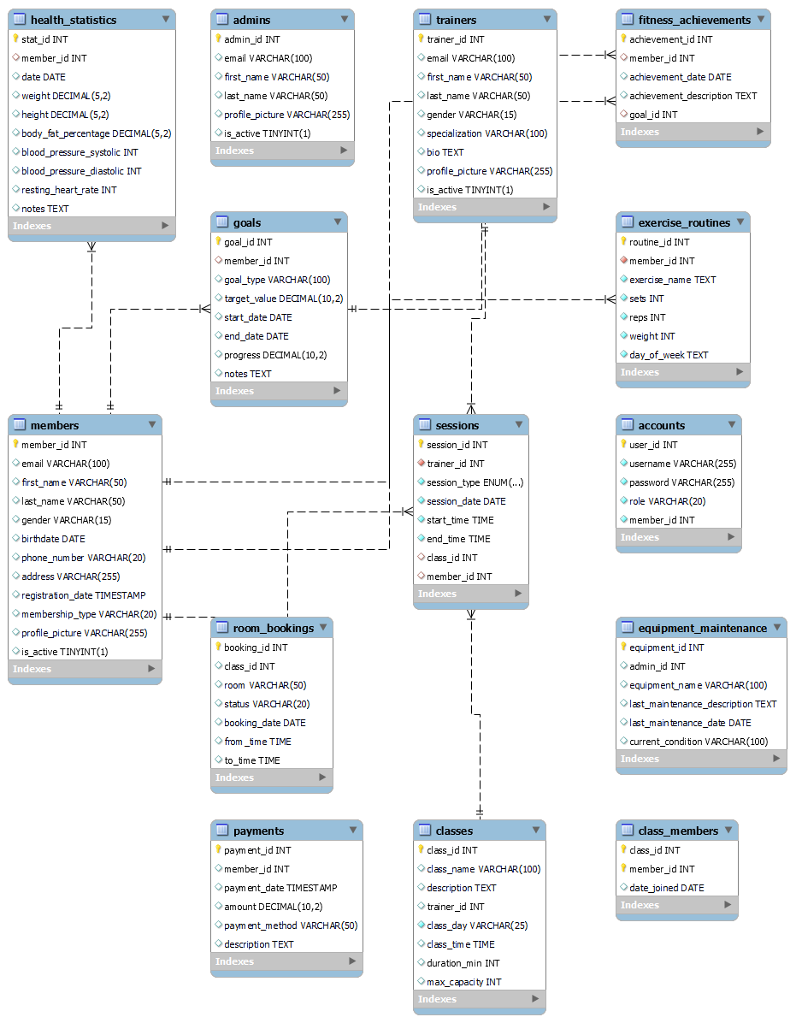

**Relational Schema**  
