Inputs:

· N: Number of food stations in the pantry.

· ProcessRate: maximum number of people can enter to stations line in each second

· MaxLength: max number of people can be in line for each station

· ParkingCapacity: max number of cars can park in the parking lot

· NumberOfCarsInParkingLine: initial number of cars waiting in the parking lot line

· CarArrivalRatePerUnitTime:number of arrivals per iteration

Simulations:

In this Code, we model each person as an $2×(N+1)$ array, where $N$ stands for number of stations in food pantry. In cell $\left(0,i\right),∀ i∈\{ 0, …,N-1\}$ of this matrix we store the total time that the person is simulated to be scheduled to spend in the $i^{th}$ station and the element $\left(0,N\right)$ indicates the time this person spends to get in the car after being served in all her desired stations. Also, each cell in the second row measures the total units of time this person has spend in each station. Apparently, if the person has not been served in one of these stations, then the corresponding cell would be zero, if the person is currently being served this cell records the total unit of times the person is in the server. Finally, when the person finishes her job in each server this cell will get value equal to the corresponding cell in the first row.

| *Stations* | *Produce* | *Meat* | *Baked* | *Clothing* | *Parking* |
| --- | --- | --- | --- | --- | --- |
| *Time Scheduled* | 360 | 400 | 320 | 200 | 140 |
| *Time Spent* | 360 | 400 | 320 | 100 | 0 |

In which follows, we elaborate on the fellow of the simulation process:

1. Entering Parking Lot

a. Manage the process of cars arriving at a parking lot,

b. Simulate and process the people in those cars,

c. Update the state of the parking lot capacity and lines accordingly.

2. Waiting in Stations

a. Calculate stations that have available spots and feasible,

b. Assign people to a station by random transition probability,

c. Manage the line in the corresponding station based on available servers and capacity,

d. Update Station states and customer states, and lines accordingly.

3. Exiting Parking Lot

a. Process served people to exit the pantry

b. Update system history

Outputs:

· FullyProcessedPeople:

Number of people finished all assigned stations before pantry closes.

· df_StationLineLength_History:

a data frame that records the line length in each station and parking lot for each second.

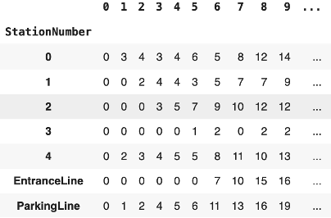

· df_StationWaitingTime:

a data frame that records the waiting time for each person in each station and parking lot.

