Data article (Data in Brief template)
Authors/affiliations/funding marked [TBD] should be completed before submission. Figures are embedded from final_figures/manuscript_final/. Paste into Elsevier's official Data in Brief .docx template if required by Editorial Manager.

Article information

Article title
A Sentinel-2 active-fire segmentation dataset for 25 California wildfires with a leak-free fire holdout and analyst-validated labels

Authors
Shreyan Mitra a, Mohammadreza Narimani b,*, Parastoo Farajpoor b
* Corresponding author.

Affiliations
a California High School, San Ramon, CA 94583, USA
b Department of Biological and Agricultural Engineering, University of California, Davis, Davis, CA 95616, USA

Corresponding author email and Twitter handle
[corresponding author institutional email]
Twitter: [optional]

Keywords
active fire detection; Sentinel-2; SWIR; semantic segmentation; weak supervision; U-Net; California wildfire; remote sensing

Abstract
Flaming combustion emits strongly near 2.2 um, driving Sentinel-2 SWIR2 (B12) past reflectance levels reachable by passive surfaces while narrow NIR (B8A) remains comparatively dark. This data article describes 2,148 co-registered image-mask pairs covering 25 California wildfires (July 2020-August 2026). Chips are 512 x 512 pixels at 20 m, rendered as a fixed-stretch false-colour composite (R = B12, G = B11, B = B8A). Masks encode background, active fire, and an explicit no-data class, and were produced automatically with a modified HOTMAP SWIR hotspot rule. Partitions hold out whole fires (18 train / 3 validation / 4 test) rather than random chips, so evaluation targets transfer to unseen incidents. A ResNet-34 U-Net baseline, with the decision threshold selected on validation, reaches 0.837 fire-class IoU on the held-out fires. Independently, a human analyst reviewed 233 test chips (54% of the test split) from the composites alone: chip-level agreement is 89.7% and 88.5% of labelled fire clusters were confirmed. False alarms of the rule concentrate in tiny clusters (30% of flagged chips but only 1.0% of labelled fire pixels). The deposit, build/train code, baseline artefacts, and review protocol are shared for reuse in active-fire segmentation, weak-supervision benchmarking, and operational threshold studies.

Specifications table
Subject | Earth and Planetary Sciences; Computer Vision and Pattern Recognition
Specific subject area | Active wildfire detection and semantic segmentation from multispectral satellite imagery
Type of data | Image (PNG); Mask (PNG); Table (CSV); Chart/Figure; Analysed; Filtered
How the data were acquired | Sentinel-2 Level-2A surface reflectance via the Earth Search STAC API over AWS Open Data; fire perimeters and burn windows from the NIFC WFIGS Interagency Fire Perimeters service. No credentialed or restricted source was used. Dataset construction, tiling, labelling, baseline training and analyst-review tooling are provided as Python scripts (build_fire_dataset.py, kaggle_fire_train.py, make_label_batch.py, import_labels.py).
Data format | Raw (transient reflectance reads); Analysed (8-bit RGB composites and integer masks); Filtered (footprint-screened tiles)
Description of data collection | The 25 largest California fires above 20,000 acres since 2019 were retained. For each fire, up to 14 Sentinel-2 passes were sampled evenly across a burn window capped at 60 days from discovery, read over a 1,536 px window centred on the perimeter centroid, tiled into 512 px chips, and labelled with a SWIR2 hotspot rule. Fire-free tiles were retained at a 1:1 ratio with fire-bearing tiles.
Data source location | Institution: University of California, Davis [TBD]  City/Region/Country: California, USA  Latitude and longitude: approximately 32.7-41.9 N, 124.4-114.1 W  Acquisitions: 2020-07-23 to 2026-08-21  Primary sources: Copernicus Sentinel-2 L2A (AWS Open Data); NIFC WFIGS perimeters
Data accessibility | Repository name: Kaggle Datasets  Data identification number / slug: shreyanmitra5/active-fire-dataset  Direct URL to data: https://www.kaggle.com/datasets/shreyanmitra5/active-fire-dataset  Code and analyst hand masks: accompanying GitHub repository for this data article  Figures: final_figures/manuscript_final/ (Figs. 1-9)
Related research article | None.

Value of the data
- These data provide per-pixel active-flame labels (not burn scar or smoke) on Sentinel-2 20 m SWIR/NIR composites for 25 large California wildfires, enabling supervised and weakly supervised segmentation research on a rare positive class (~0.077% of pixels).
- Remote-sensing, wildfire science, and computer-vision communities can reuse the chips for detector development, threshold sensitivity studies, data-augmentation research, and transfer tests across held-out fire incidents.
- The fire-holdout split, fixed dataset-wide render stretch, explicit no-data class, and published SWIR rule thresholds allow others to reproduce the corpus, retrain baselines, and compare methods under a shared protocol.
- An independent analyst review of 54% of the test split quantifies label noise at chip and cluster levels, so users can price supervision error when training models or designing alert systems.
- A documented ResNet-34 U-Net baseline (validation-swept threshold, reported fire IoU/precision/recall) provides a reference operating point for benchmarking.

Data description
The public deposit contains images/ (2,148 RGB PNG composites), masks/ (2,148 single-channel PNG masks with matching filenames), and summary.csv (one row per chip). Filenames follow {fire}_{YYYY-MM-DD}_r{row}c{col}.png so fire name, acquisition date and tile indices are recoverable from the path. Mask values are 0 = background, 1 = active fire, and 255 = no-data (outside the acquisition footprint). Of 2,148 chips, 841 (39.2%) contain at least one fire pixel; 431,427 pixels are labelled active fire (0.0766% of all pixels).
Chips are 512 x 512 pixels at 20 m (~10.24 km across) using B12, B11 and B8A at native resolution (no inter-band resampling). Channels are R = B12 (2.19 um), G = B11 (1.61 um), B = B8A (0.865 um), mapped to 8 bits by a fixed, dataset-wide linear stretch (upper bounds 0.60, 0.50 and 0.45 reflectance). The stretch is not per-image: auto-levelling would equalise quiet and burning scenes and erase the emission signal used for labelling. In this rendering, vegetation tends to appear blue/cyan, burn scar brown, cloud/smoke white, and active flame saturates orange-white.
Partition summary (leak-free by fire):
Partition | Fires | Chips | With fire | Fire px | Fire % | Held-out fires
Train | 18 | 1,470 | 548 | 284,948 | 0.0739 | -
Validation | 3 | 246 | 137 | 75,028 | 0.1163 | Bobcat, Castle, McCash
Test | 4 | 432 | 156 | 71,451 | 0.0631 | CALDWELL, Hopkins, Slater, Windy
All | 25 | 2,148 | 841 | 431,427 | 0.0766
Table 1. Partition summary. Fire prevalence differs across partitions because it depends on which fires were observed mid-burn.
Figures 1-9 summarise the deposit geometry, spectral labelling rationale, rare-class structure, baseline training and evaluation, and per-incident fire-pixel inventory. Source files reside in final_figures/manuscript_final/.
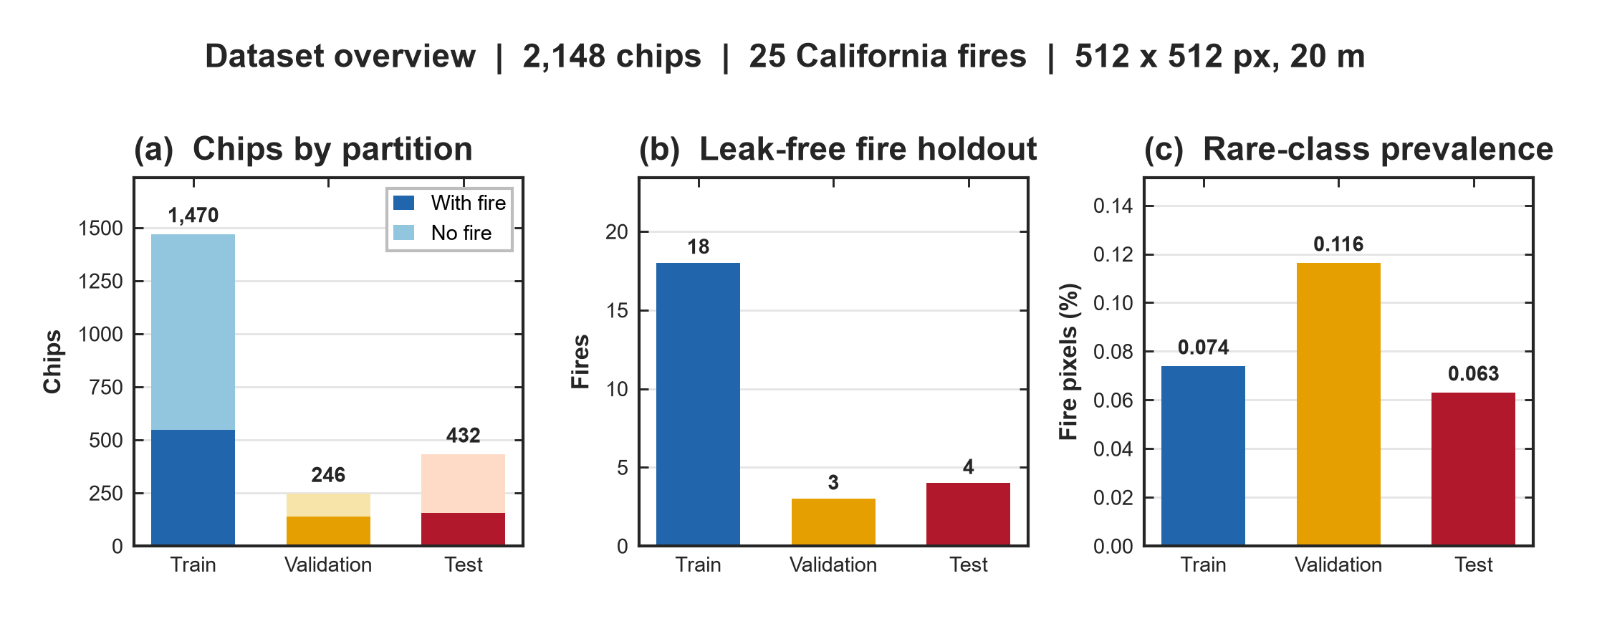
Fig. 1. Dataset overview. (a) Chips by partition with/without fire. (b) Leak-free fire holdout counts. (c) Fire-pixel prevalence (%) by partition.
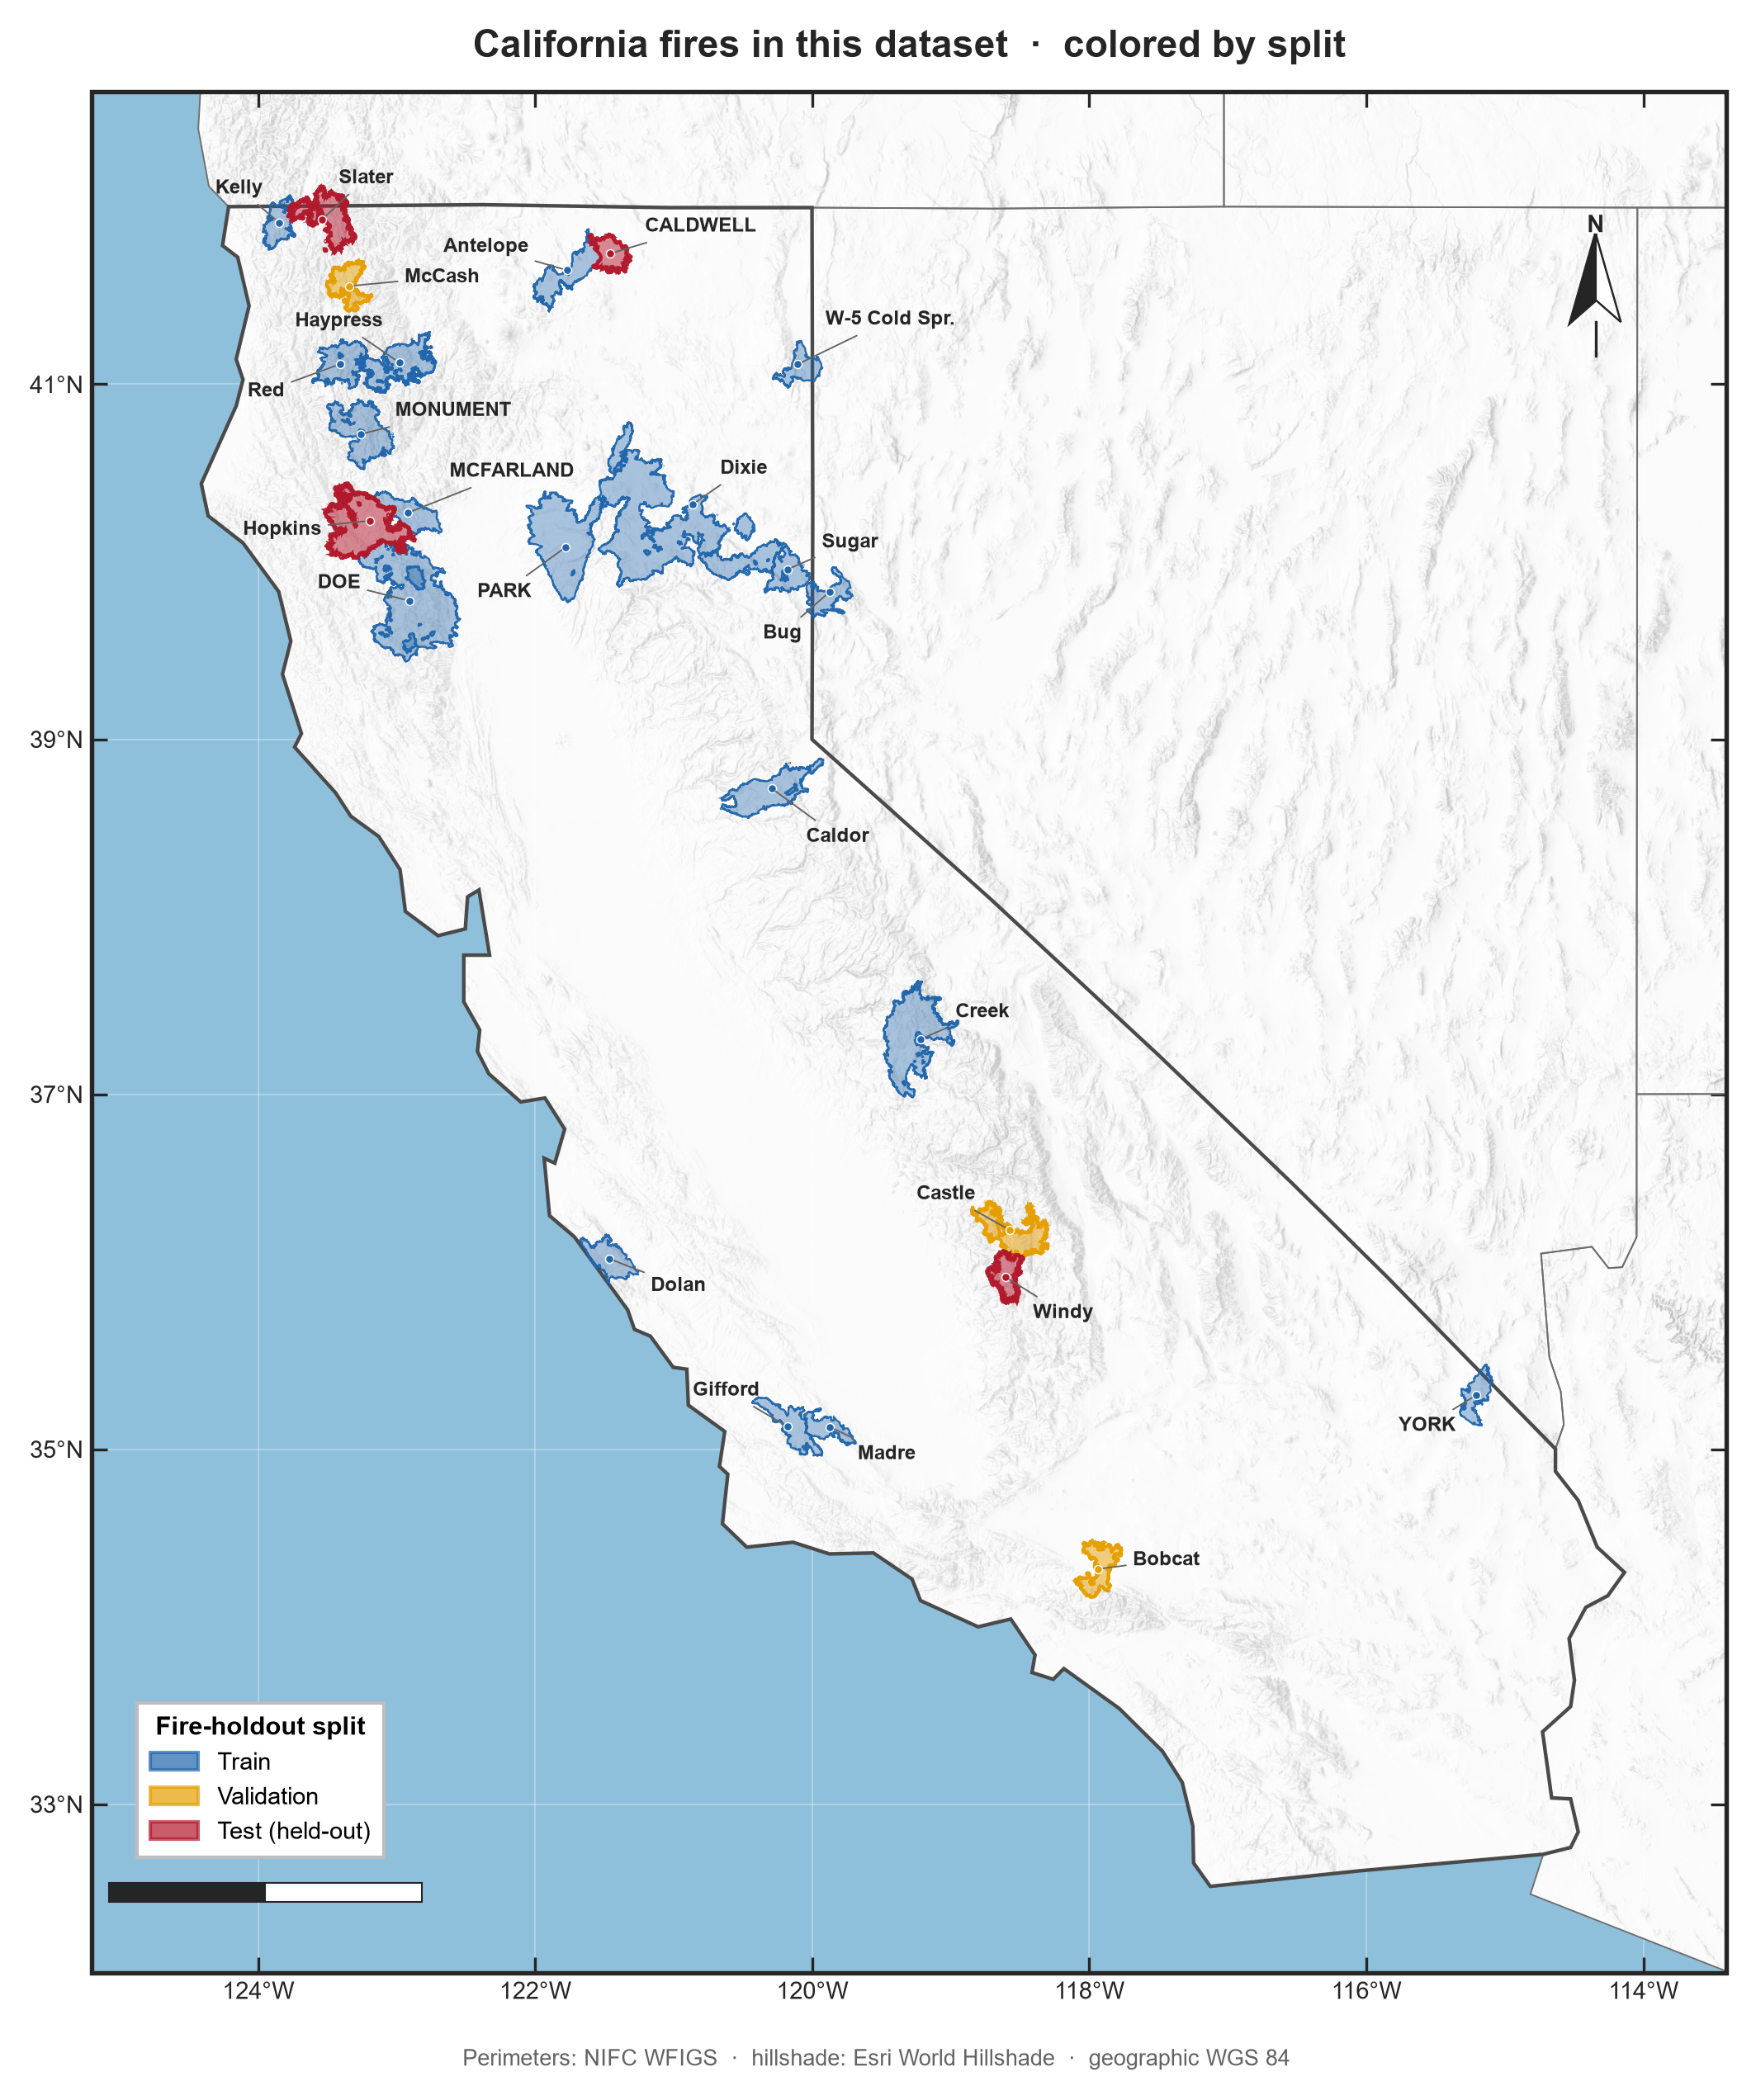
Fig. 2. California fire perimeters in this dataset, coloured by fire-holdout split (train / validation / test). Perimeters: NIFC WFIGS; hillshade: Esri World Hillshade.
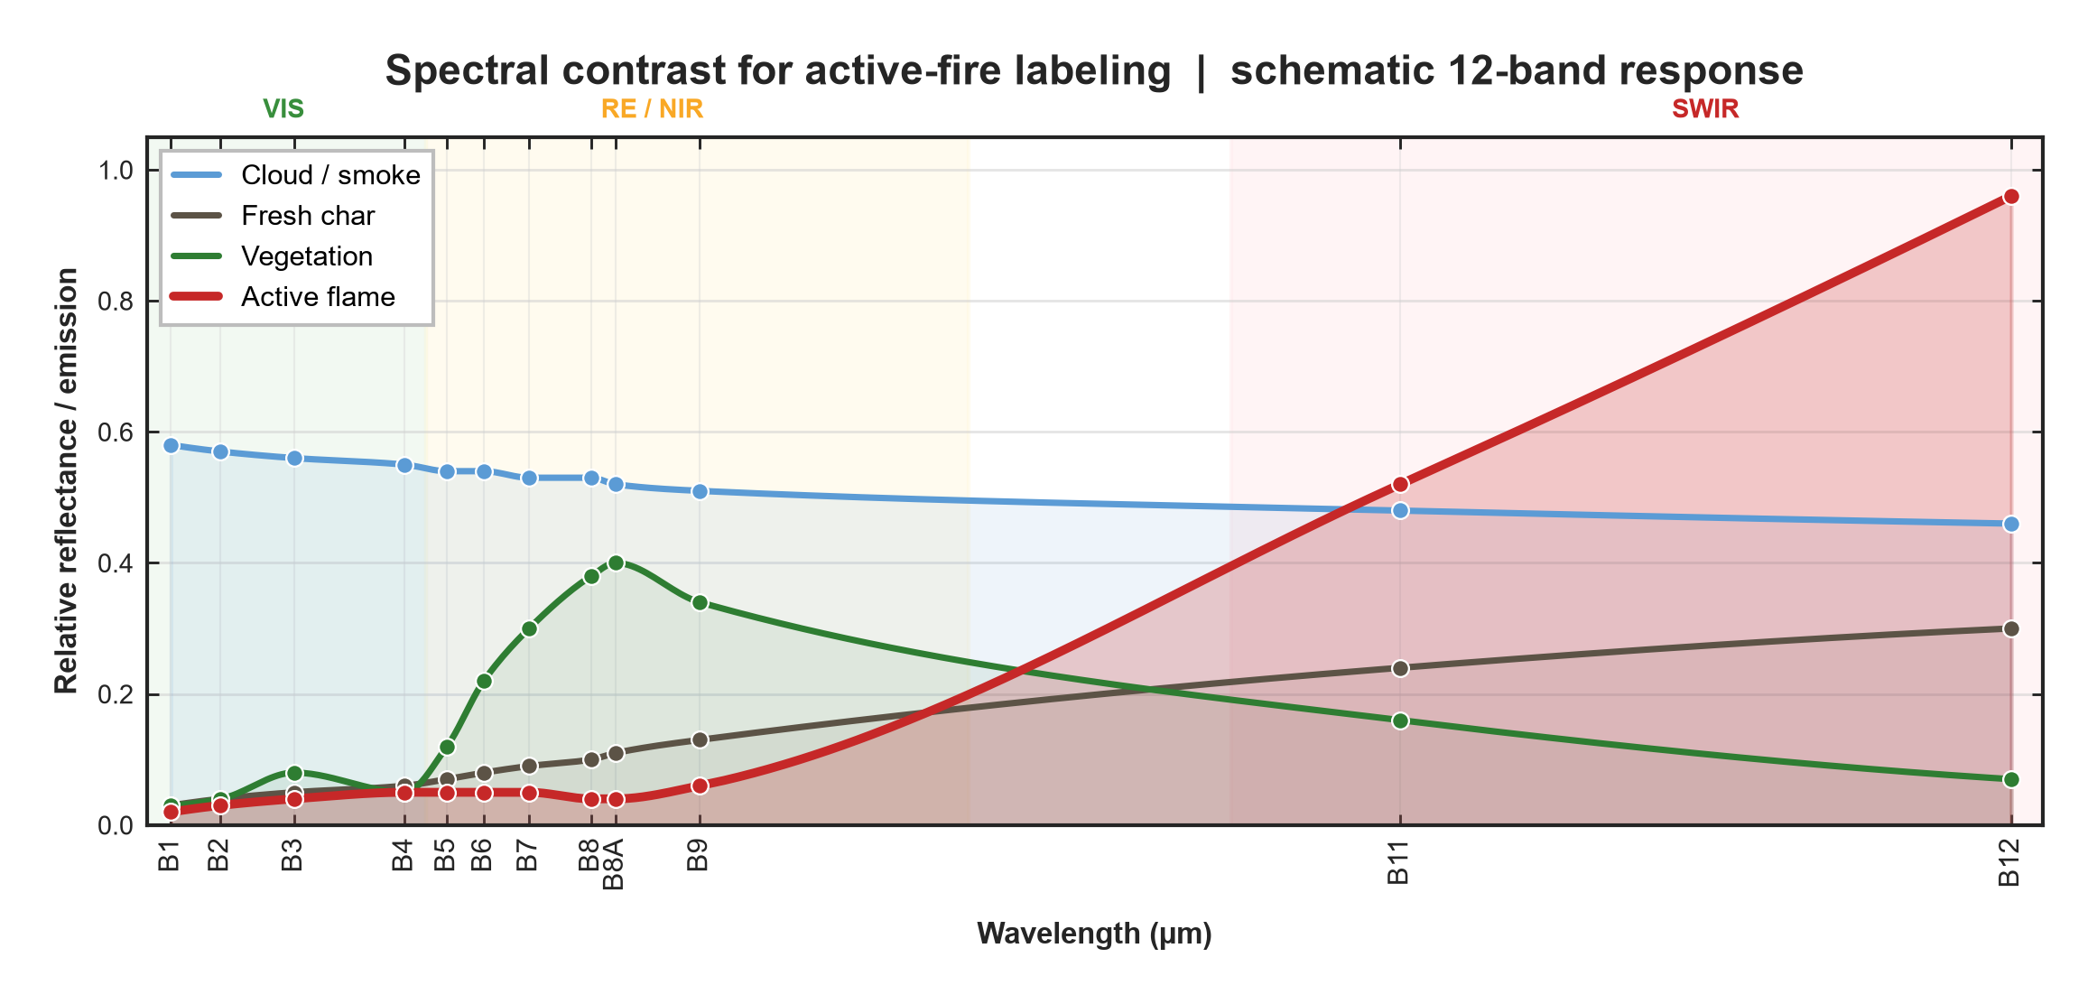
Fig. 3. Schematic 12-band spectral contrast motivating active-fire labelling. Active flame rises sharply in SWIR (B11-B12) relative to vegetation, fresh char and cloud/smoke.
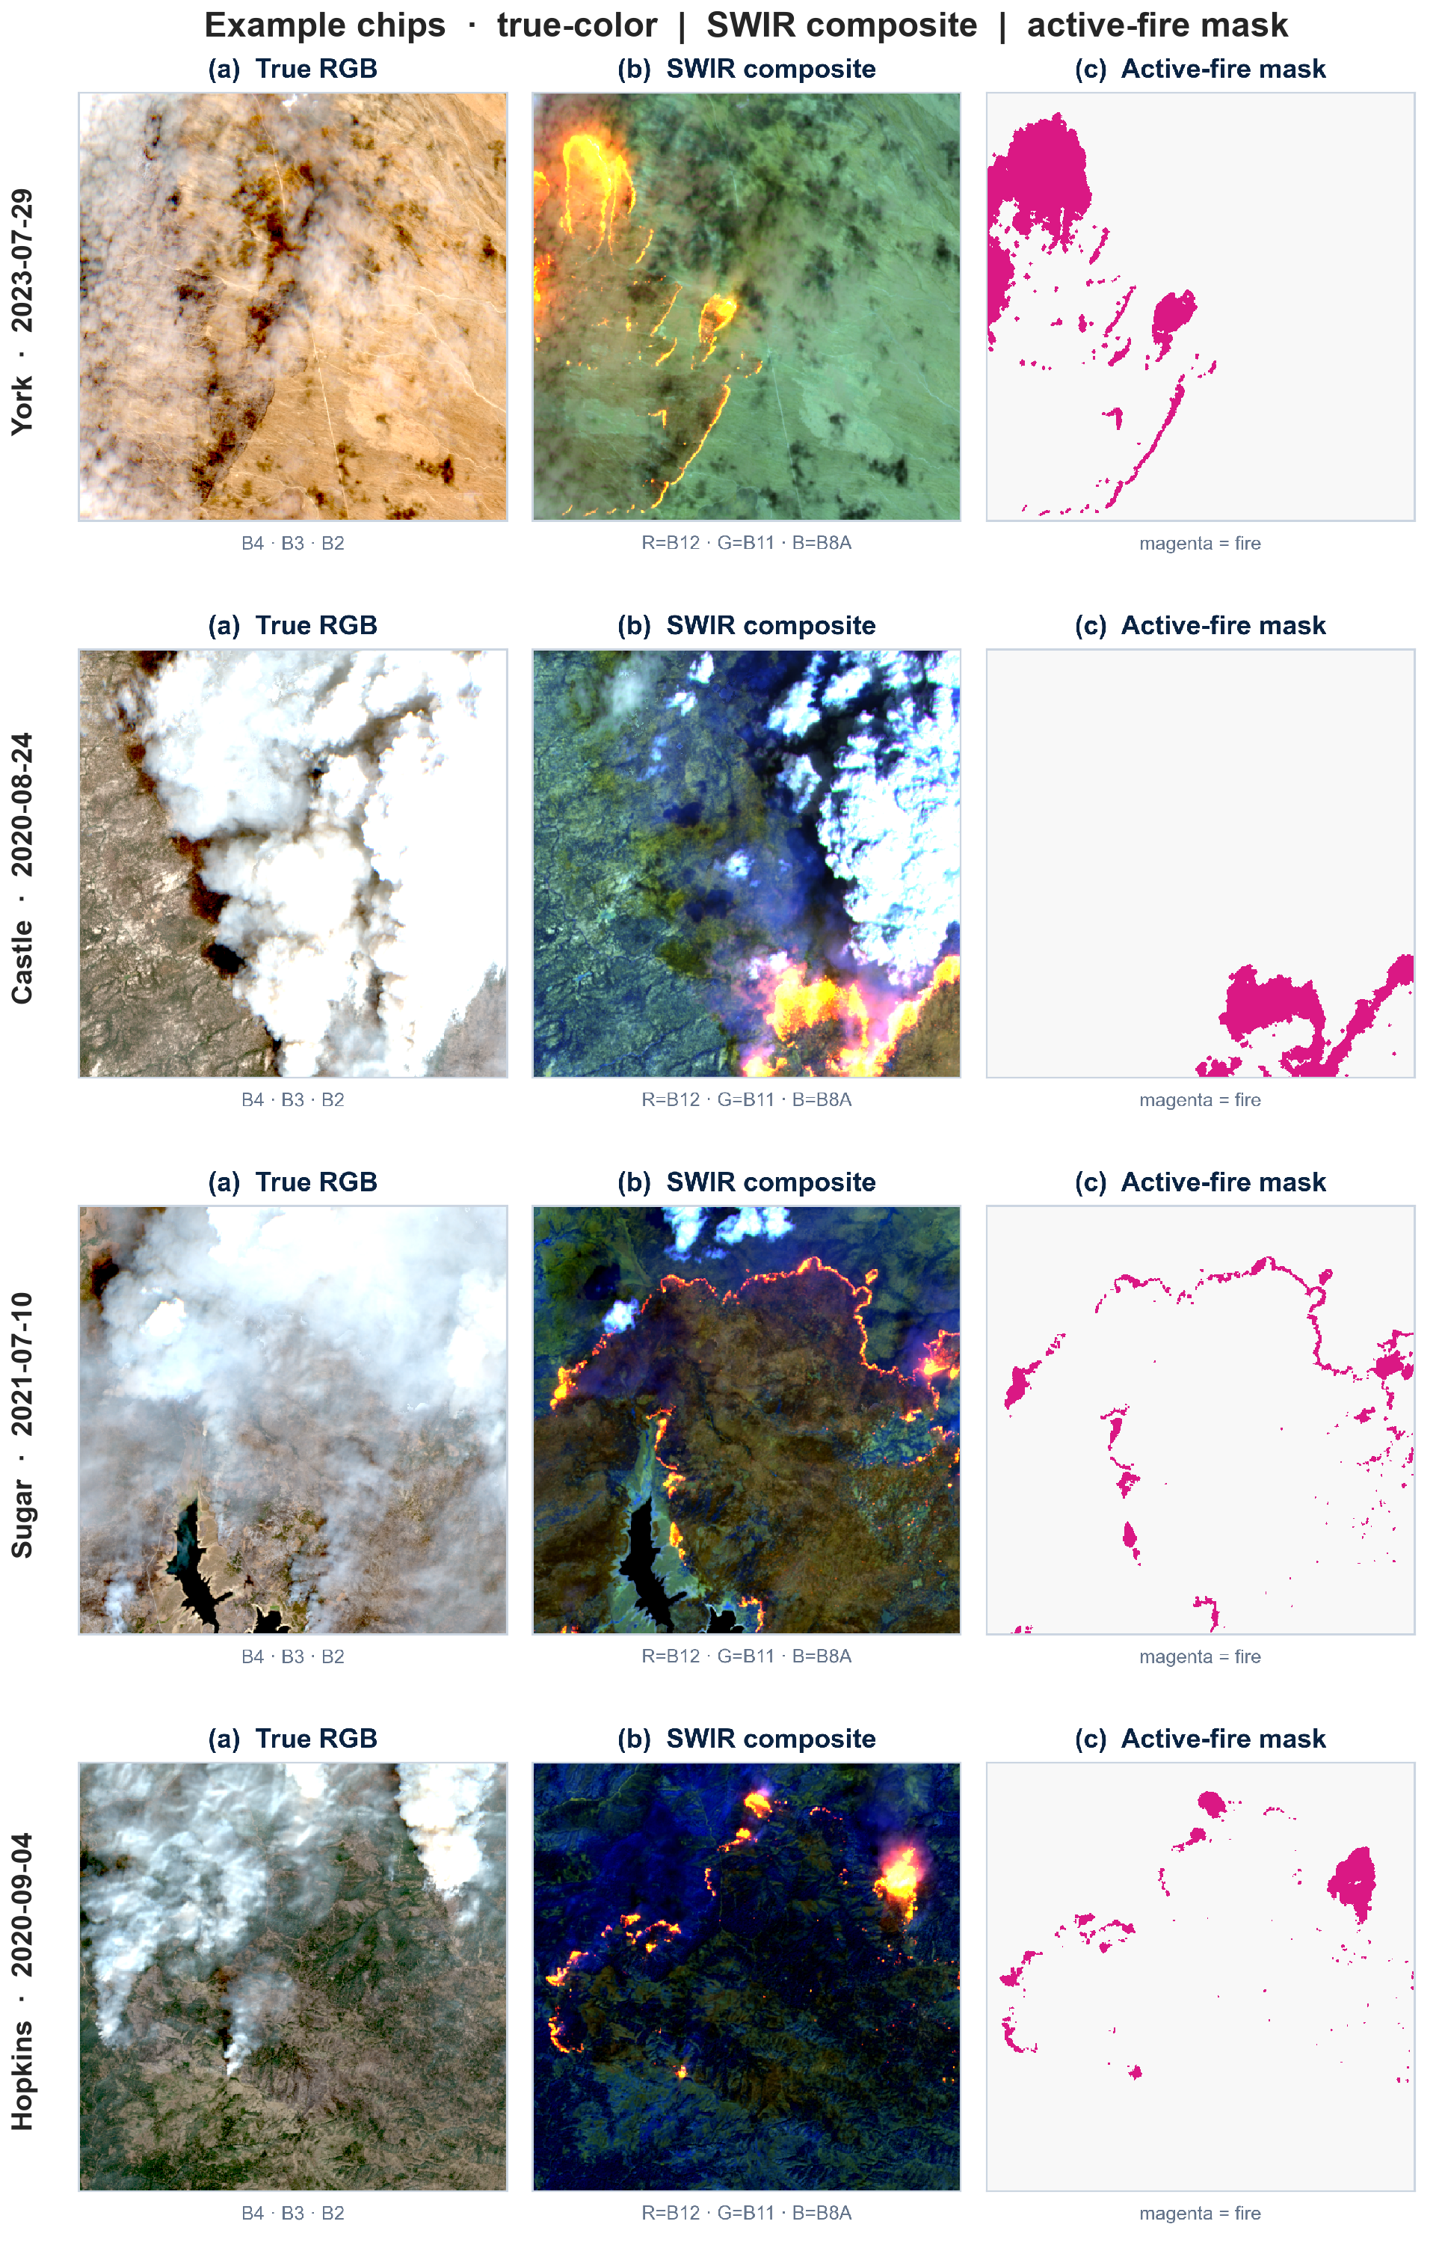
Fig. 4. Example chips (York, Castle, Sugar, Hopkins): true-colour (B4-B3-B2), SWIR composite (B12-B11-B8A), and active-fire mask (magenta).
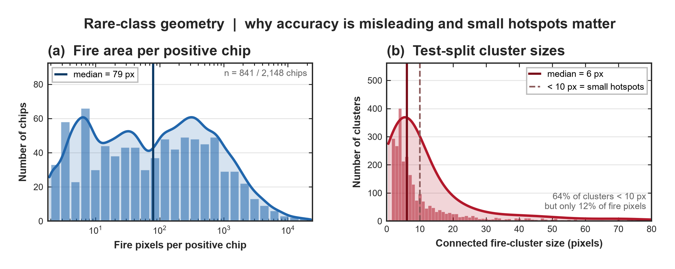
Fig. 5. Rare-class geometry. (a) Fire area per positive chip (median 79 px). (b) Test-split connected fire-cluster sizes (median 6 px); 64% of clusters are <10 px but only 12% of fire pixels.
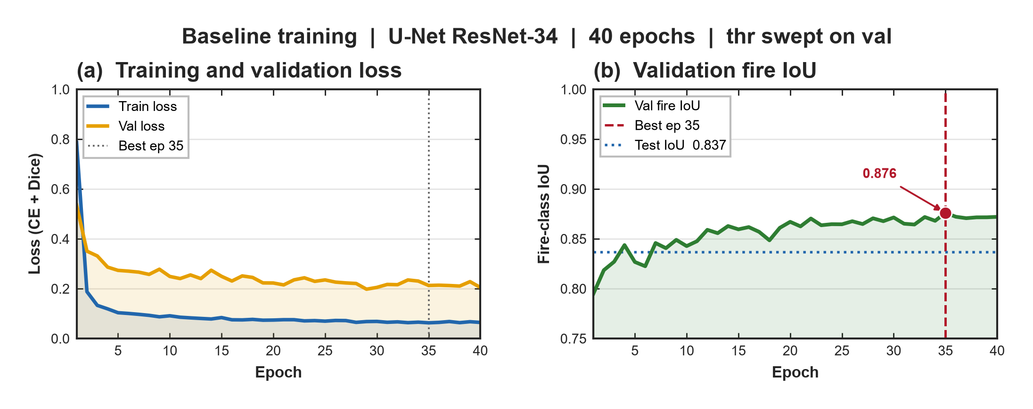
Fig. 6. Baseline training (U-Net ResNet-34, 40 epochs). (a) Train/validation loss (CE + Dice). (b) Validation fire IoU; best epoch 35 (val IoU 0.876); horizontal guide shows test IoU 0.837 at the validation-chosen threshold.
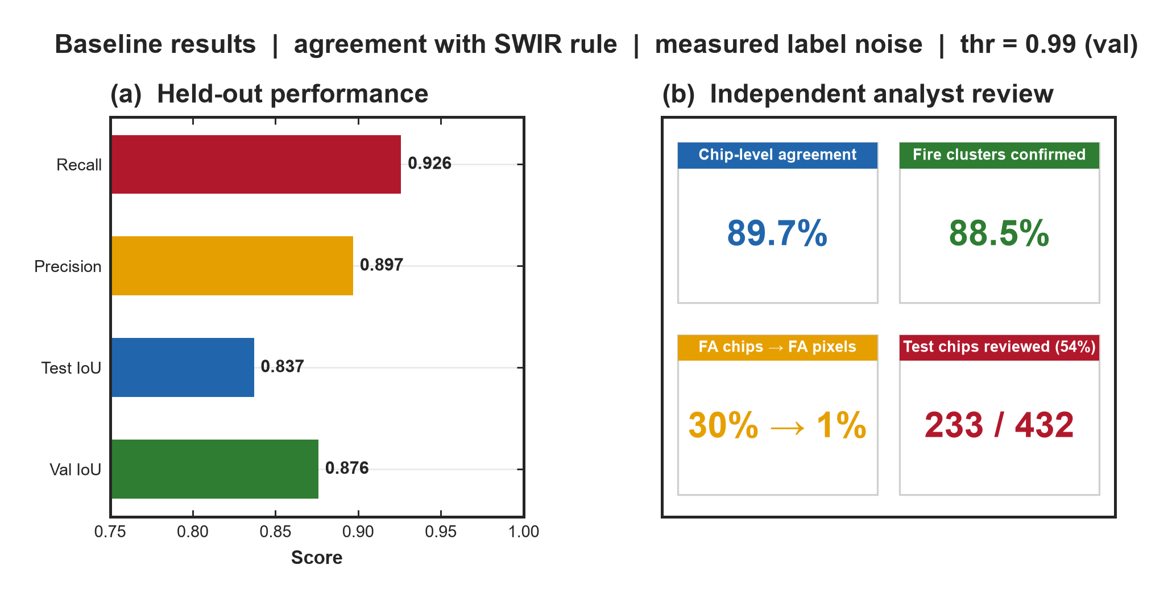
Fig. 7. Baseline results at thr = 0.99 (validation-swept). (a) Held-out scores (val/test IoU, precision, recall). (b) Independent analyst review summary on 233/432 test chips.
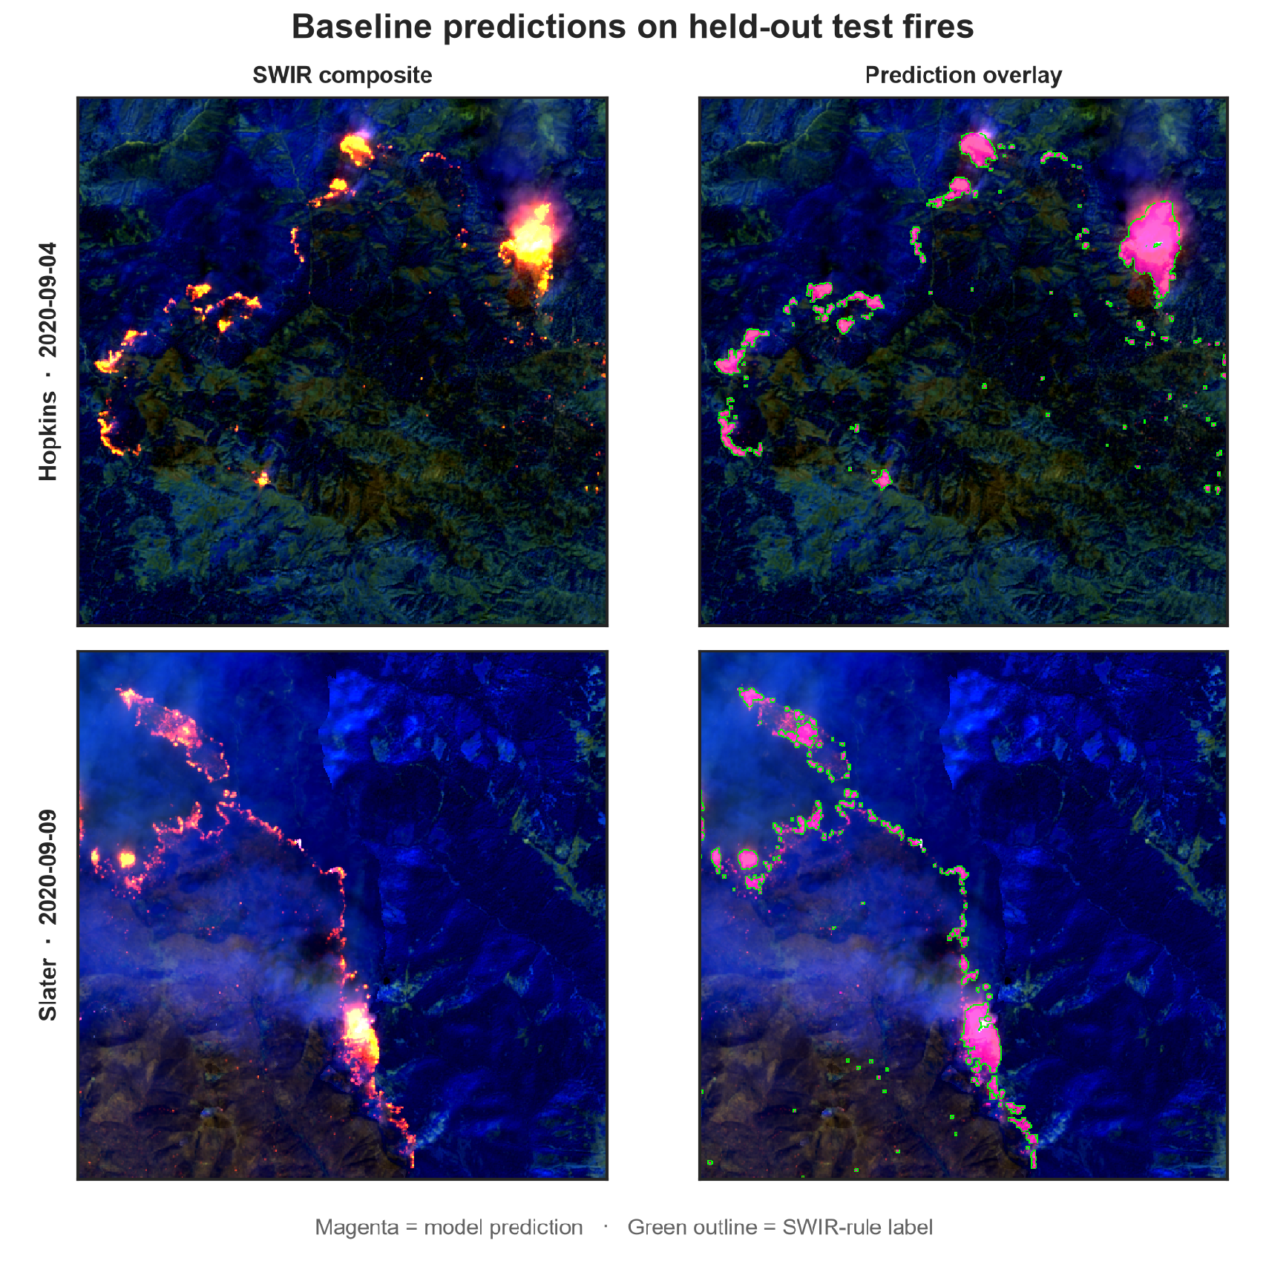
Fig. 8. Baseline predictions on held-out test fires (Hopkins 2020-09-04; Slater 2020-09-09). Left: SWIR composite. Right: magenta = model prediction; green outline = SWIR-rule label.
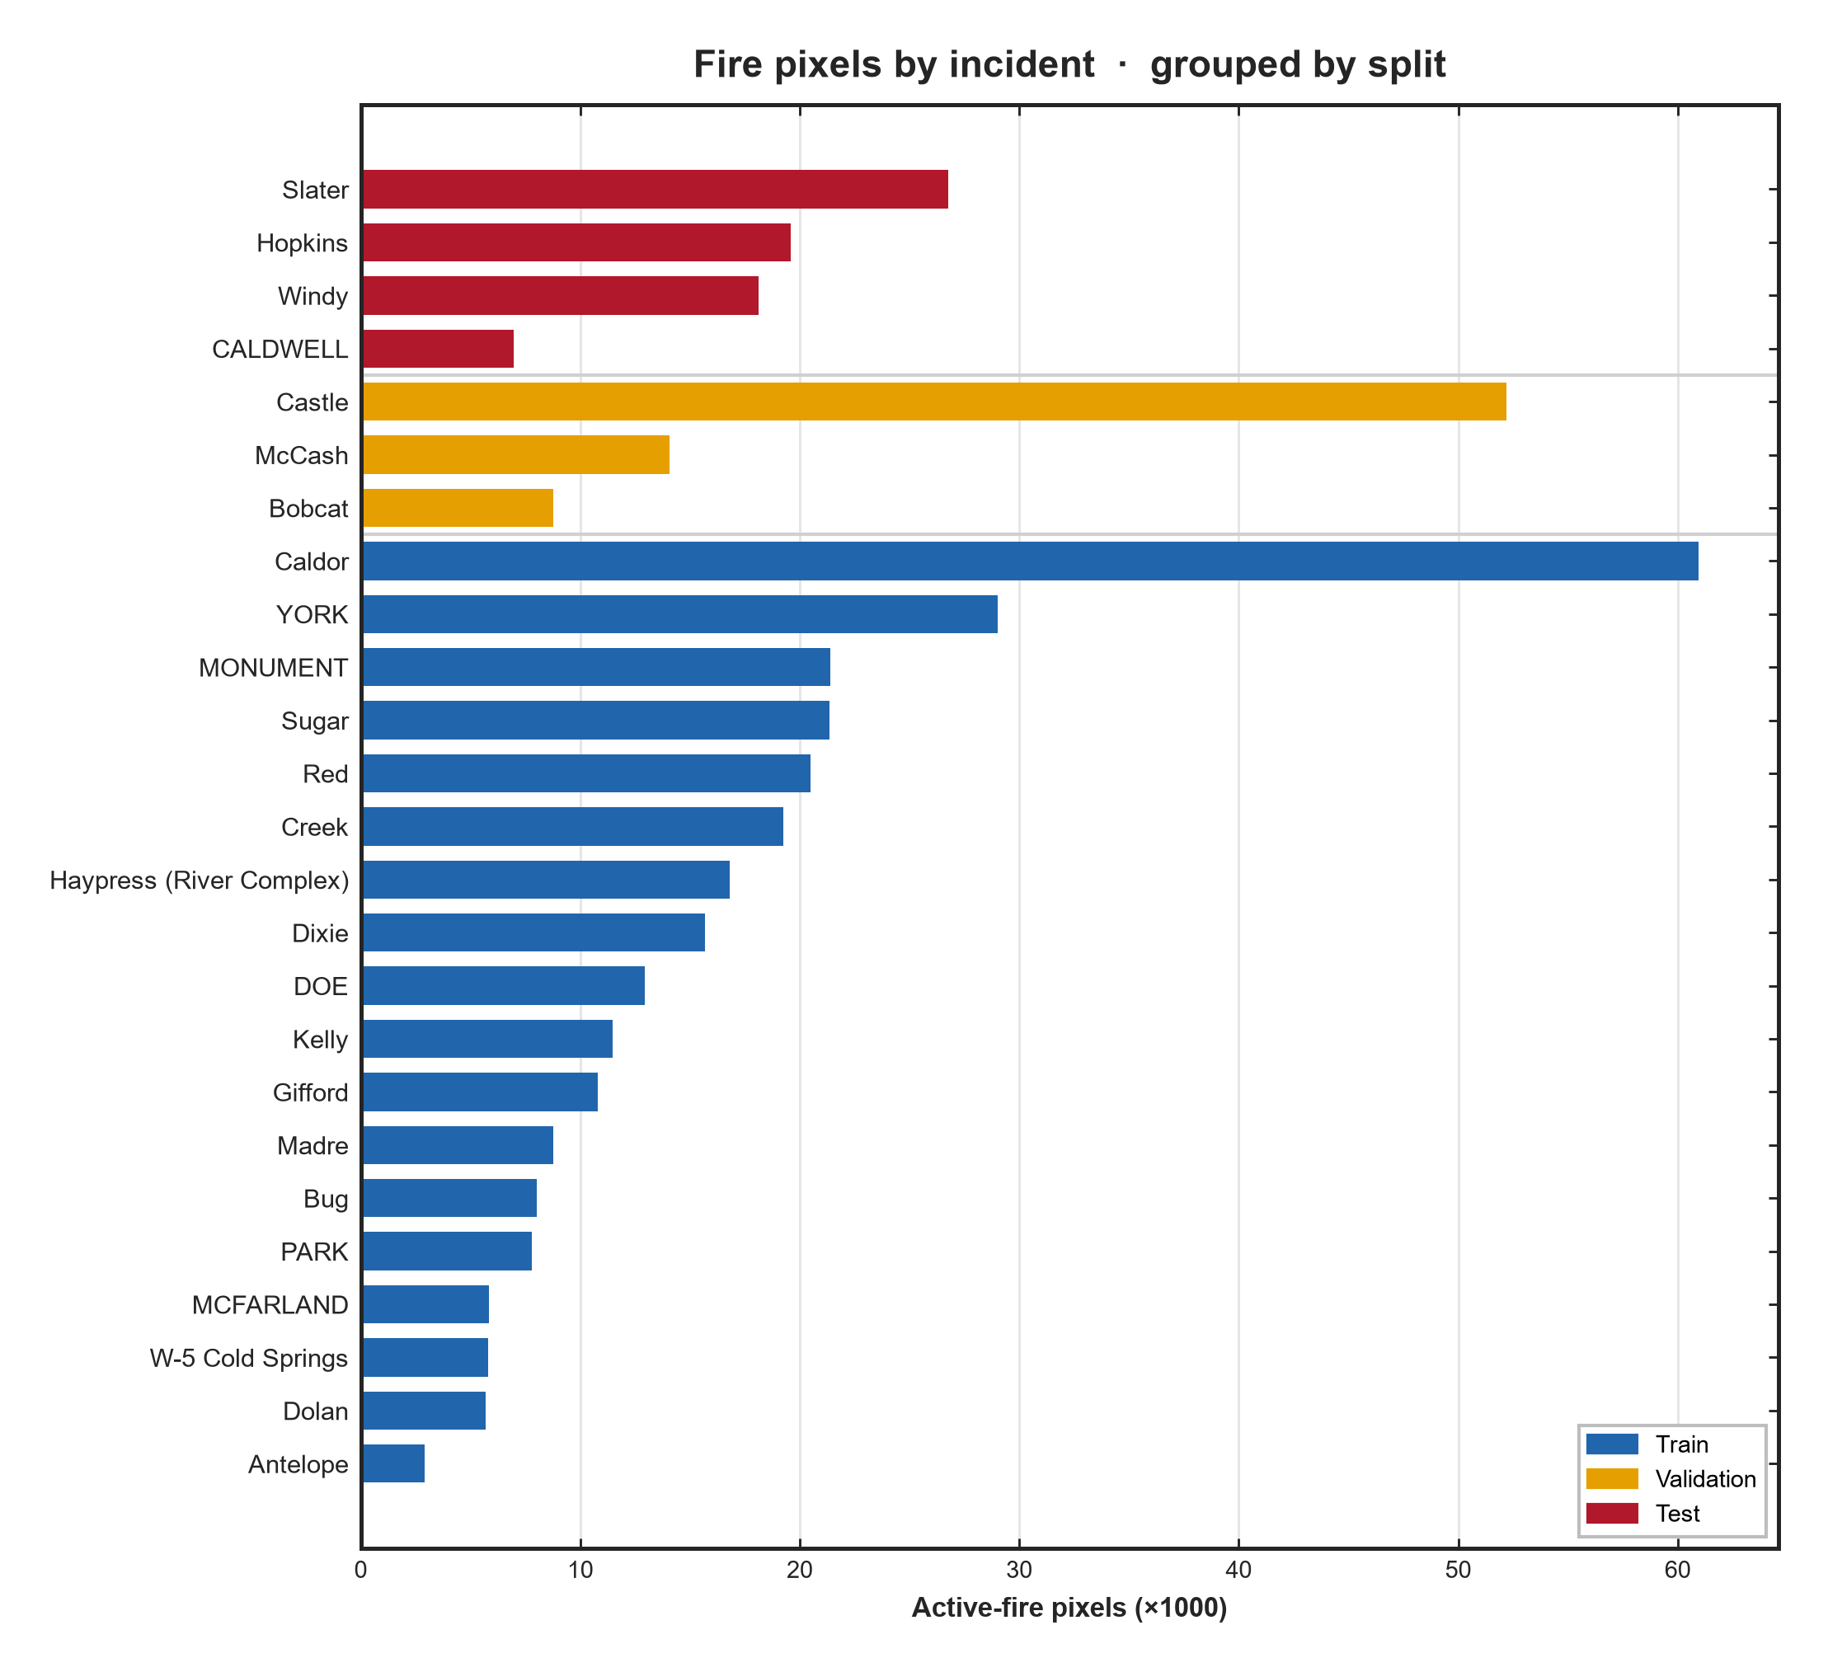
Fig. 9. Active-fire pixels by incident, grouped by split (test, validation, train) and ordered within each group.
Supplementary materials in the code repository include the analyst labelling protocol (label_batch/README.md), Label Studio configuration, and 233 hand-reviewed mask exports under label_batch/hand_masks/.

Experimental design, materials and methods

Acquisition
Incidents were drawn from NIFC WFIGS, filtered to California and to final perimeters above 20,000 acres; the 25 largest were retained (approximately 80,779 to 963,309 acres). Each fire's burn window runs from discovery to containment, capped at 60 days (reported containment can extend far longer while flaming activity ends earlier). Scenes were queried from the Earth Search STAC sentinel-2-l2a collection with a permissive 95% cloud ceiling, because Sentinel-2 scene classification often labels dense smoke as cloud and conventional cloud filters preferentially remove the acquisitions where a fire is burning hardest. Up to 14 passes per fire were sampled evenly across the burn window rather than from its start: large fires ignite at one edge of the final perimeter, so early scenes near the eventual centroid are frequently empty. The read window is 1,536 pixels (30.72 km) cut in each scene's own projection; several fires straddle the UTM 10N/11N boundary, and a grid pinned to a single zone would silently drop scenes.

Label generation
Masks derive from a HOTMAP-style hot-target rule [1] applied to native 20 m B8A/B11/B12 reflectance. A pixel is confirmed fire where B12 >= 0.35 and B12/B8A >= 4.0; a looser growth tier (B12 >= 0.25 and B12/B8A >= 2.0) is accepted only where 4-connected to a confirmed pixel, recovering the cooler skirt of a front, followed by two dilations and an 8-connected sieve at 2 pixels. Relative to published HOTMAP defaults, the NIR ratio floor is raised (1.4 -> 4.0) to reject specular glint that is bright in every band (measured B12/B8A ~ 0.76-1.33) while flame ratios typically run ~8-10; the brightness floor is raised (0.15 -> 0.35) to avoid labelling fresh char weeks after containment. A B12/B11 test is not used: on the hottest fronts B11 saturates and would discard the most certain fire pixels. Implementation is in src/indices.py.

Tiling and packaging
Each 1,536 px window is cut into a 3 x 3 grid of 512 px tiles. Tiles with more than 50% no-data are dropped; all fire-bearing tiles are kept; fire-free tiles are subsampled 1:1. Composites and masks are written as PNGs with the naming scheme above; summary.csv records fire, date, split, fire pixel count and related metadata.

Baseline model
The reference model is a U-Net [2] with an ImageNet-initialised ResNet-34 encoder [3,4]. The encoder is frozen for two epochs, then unfrozen at one-tenth the base learning rate. Training uses AdamW [5] at 3e-4 with cosine annealing [6], batch size 8, mixed precision [7], and 40 epochs. The objective sums class-weighted cross-entropy and a soft Dice term on the fire class [8]. Augmentation combines dihedral transforms, scale jitter with fire-aimed crops, and copy-paste of flame fronts between chips [9], which increases sampled fire prevalence during training. Because the optimal operating point for this rare class is far from 0.5, the decision threshold is swept on the validation partition and applied once to test. The reported metric is fire-class IoU accumulated over the partition (not mean per chip). Accuracy is not used as a headline metric: predicting 'no fire' everywhere exceeds 99.9% accuracy.
On the reference run, validation fire IoU peaked at 0.876 (epoch 35) with a validation-chosen threshold of 0.99. Applied to the four held-out test fires, the same threshold yields test fire IoU 0.837, precision 0.897 and recall 0.926 (Figs. 6-8).

Independent analyst review of labels
The distributed masks are weak supervision: baseline scores measure agreement with the SWIR rule, not with an independent human reference. To bound the difference, 233 chips (54% of the test split; all four held-out fires) were reviewed by a human analyst from the SWIR composites alone, without access to the generated masks. Chips were shown in a fire-stratified random order and included fire-free chips so rule omissions could surface. The labelling protocol is documented in label_batch/README.md.
Analyst and rule use different delineation conventions (envelope vs threshold-crossing pixels), so pixel IoU between them is not reported. Detection-level statistics are: chip-level agreement 89.7%; 88.5% of labelled fire clusters confirmed; 155 chips confirmed empty; 1 chip with fire the rule missed. Of chips the rule flagged, 30% contained no fire the analyst could see, yet those chips carried only 1.0% of labelled fire pixels-false alarms are numerous as detections but small in area, consistent with the cluster-size distribution in Fig. 5. Summary cards appear in Fig. 7b.

Limitations for users of the data
Labels remain weak supervision; 46% of the test split is unreviewed; pixel-level outline agreement is not validated. In the test split, median connected fire clusters are 6 pixels; clusters <10 px are ~64% of clusters but ~12% of fire pixels, so pixel IoU can under-penalise missed small hotspots. The 8-bit composite discards float reflectance detail used by the rule. Geographic scope is California large fires only; the 30.72 km window samples fronts rather than entire mega-fire footprints; Sentinel-2 revisit and mid-morning overpass leave diurnal behaviour unsampled and there is no thermal band.

Ethics statements
This work did not involve human subjects, animal experimentation, or personally identifiable information. Sentinel-2 imagery is distributed under the Copernicus open data policy via AWS Open Data; fire perimeters are published by the National Interagency Fire Center. No credentialed or restricted source was accessed. The 20 m resolution precludes identification of individuals or vehicles.

CRediT author statement
Shreyan Mitra: Conceptualization, Methodology, Software, Validation, Formal analysis, Investigation, Data curation, Writing - original draft, Visualization. Mohammadreza Narimani: Writing - review & editing, Visualization, Project administration. Parastoo Farajpoor: Writing - review & editing, Supervision.

Acknowledgments
Funding: [TBD]. If no specific grant supported this work, use: "This research did not receive any specific grant from funding agencies in the public, commercial, or not-for-profit sectors."

Declaration of interests
The authors declare that they have no known competing financial interests or personal relationships that could have appeared to influence the work reported in this paper.
If competing interests exist, replace the sentence above with the journal's disclosure statement.

References
Maximum 20 references for Data in Brief. Verify DOIs against publisher records before submission.
[1] S.W. Murphy, R. Wright, C. Oppenheimer, C.R. Souza Filho, HOTMAP: Global hot target detection at moderate spatial resolution, Remote Sensing of Environment 177 (2016) 78-88.
[2] O. Ronneberger, P. Fischer, T. Brox, U-Net: Convolutional networks for biomedical image segmentation, in: MICCAI 2015, LNCS 9351, Springer, 2015, pp. 234-241.
[3] K. He, X. Zhang, S. Ren, J. Sun, Deep residual learning for image recognition, in: Proc. IEEE CVPR, 2016, pp. 770-778.
[4] J. Deng, W. Dong, R. Socher, L.-J. Li, K. Li, L. Fei-Fei, ImageNet: A large-scale hierarchical image database, in: Proc. IEEE CVPR, 2009, pp. 248-255.
[5] I. Loshchilov, F. Hutter, Decoupled weight decay regularization, in: Proc. ICLR, 2019.
[6] I. Loshchilov, F. Hutter, SGDR: Stochastic gradient descent with warm restarts, in: Proc. ICLR, 2017.
[7] P. Micikevicius, S. Narang, J. Alben, et al., Mixed precision training, in: Proc. ICLR, 2018.
[8] F. Milletari, N. Navab, S.-A. Ahmadi, V-Net: Fully convolutional neural networks for volumetric medical image segmentation, in: Proc. 3DV, 2016, pp. 565-571.
[9] G. Ghiasi, Y. Cui, A. Srinivas, et al., Simple copy-paste is a strong data augmentation method for instance segmentation, in: Proc. IEEE/CVF CVPR, 2021, pp. 2918-2928.
[10] M. Drusch, U. Del Bello, S. Carlier, et al., Sentinel-2: ESA's optical high-resolution mission for GMES operational services, Remote Sensing of Environment 120 (2012) 25-36.
[11] National Interagency Fire Center, WFIGS Interagency Fire Perimeters, NIFC Open Data Site.

Manuscript draft aligned to the Data in Brief data-article template and manuscript_final Figs. 1-9.
Dataset: https://www.kaggle.com/datasets/shreyanmitra5/active-fire-dataset

