About Contact us Find Help Login

**Nidhi Foods**



***“We believe food taste better when made ethically and with care.”***

**Login to Shop with us…….**

**Username:**

**Password:**

**Login**

Sign-up

**Connect with us by creating your own account…..**

**NAME: NAME:**

Last Name

First Name

**Email;**

**Contact no:**

**Alternate Contact no:**

**Purpose:**

**Locality:**

**PinCode:**

**City:**

**State:**

**Done**

**Nidhi Foods** Home Notification Cart Help

Masala Powder



Atta

**Let’s chat??**

**Masala Powder**

**Puthani chatni**

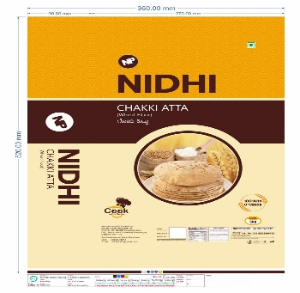

**Sambar pudi**

 **Next>>**

**Ballolli chatni**

**Chakki Atta**

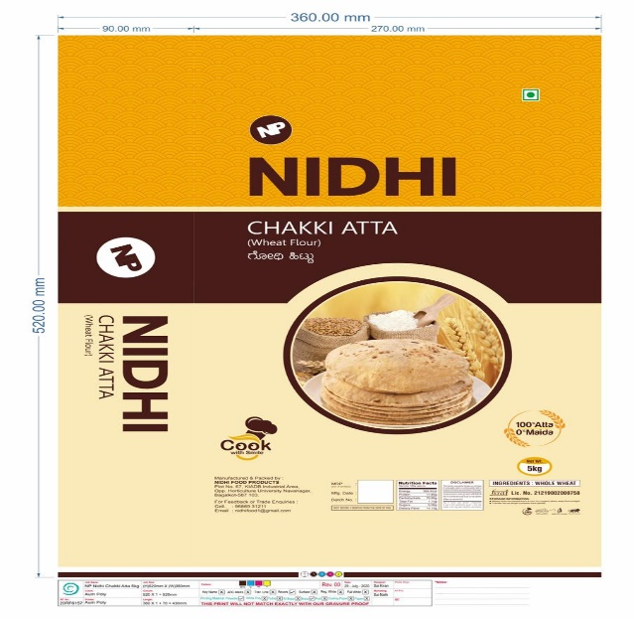

**RS.___** per kg

**BUY**

Speicification:

Recipes :

Details:

**IN CART**

Quantity:



>50kg

20kg

10kg

5kg

**CART**

**Details** **Remove**

**Details**

**Details**