About Contact us Find Help Login

**Nidhi Foods**



***“We believe food taste better when made ethically and with care.”***

**Login to Shop with us…….**

**Username:**

**Password:**

**Login**

Sign-up

**Connect with us by creating your own account…..**

**NAME: NAME:**

Last Name

First Name

**Email:**

**Password: (minimum 8 characters)**

**Contact no:**

**Alternate Contact no:**

**Purpose:**

**Locality:**

**PinCode:**

**City:**

**State:**

**Done**

**Gallery**

(Video)

rrrr

**Contact Us**

* **(Call)**

 **(mail us)**

**(visit us)**

Blah blah……….

(Bagalkot)

**Request a call back**

**Ph.no**

**Email-id**

**Alternate No.**

**Stay connected till we give a call (*~*)**

Home Notification Cart Help

Masala Powder



Atta

**Let’s chat??**

**Masala Powder**

**Puthani chatni**

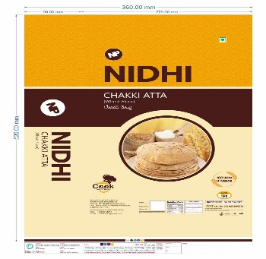

**Sambar pudi**

 **Next>>**

**Ballolli chatni**

**Chakki Atta**

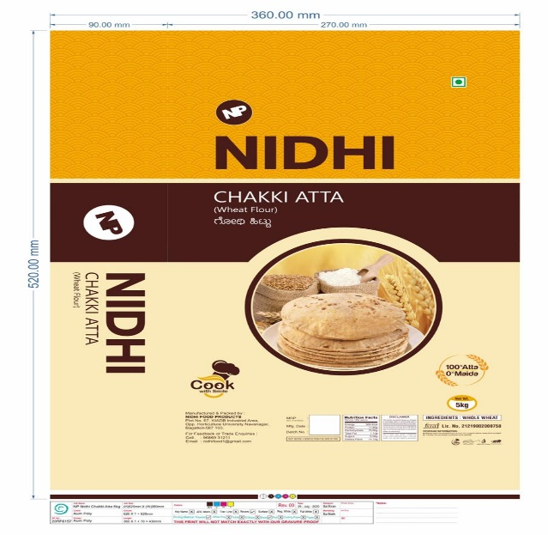

**RS.___** per kg

**BUY**

Speicification:

Recipes :

Details:

**IN CART**

Quantity:



>50kg

20kg

10kg

5kg

**CART**

**Details** **Remove**

**Details**

**Details**

**Summary**

**Sl.no Name Quantity Price**

1. **Atta**

**PROCEED**

**TOTAL:**

Pay

UPI:

Debit/Credit Card:

Amazon Pay:

**Submit**

Thank you for purchasing…

**Delivery in ( )Days**

**Back**