HOME->

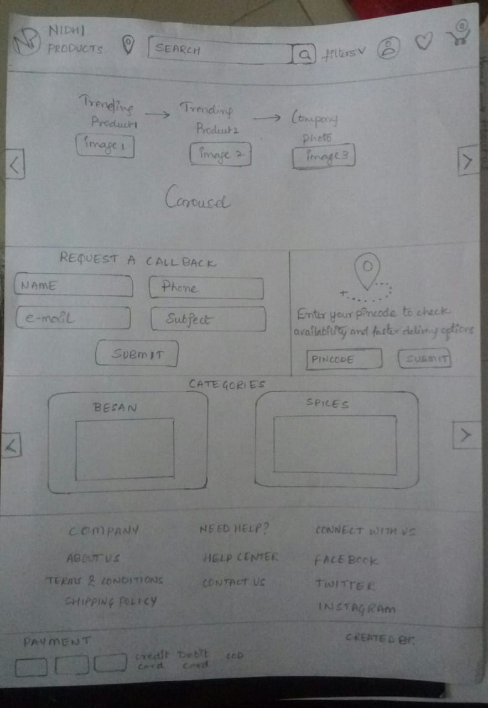

HOME ->(LOCATION , CONTACT US) ->

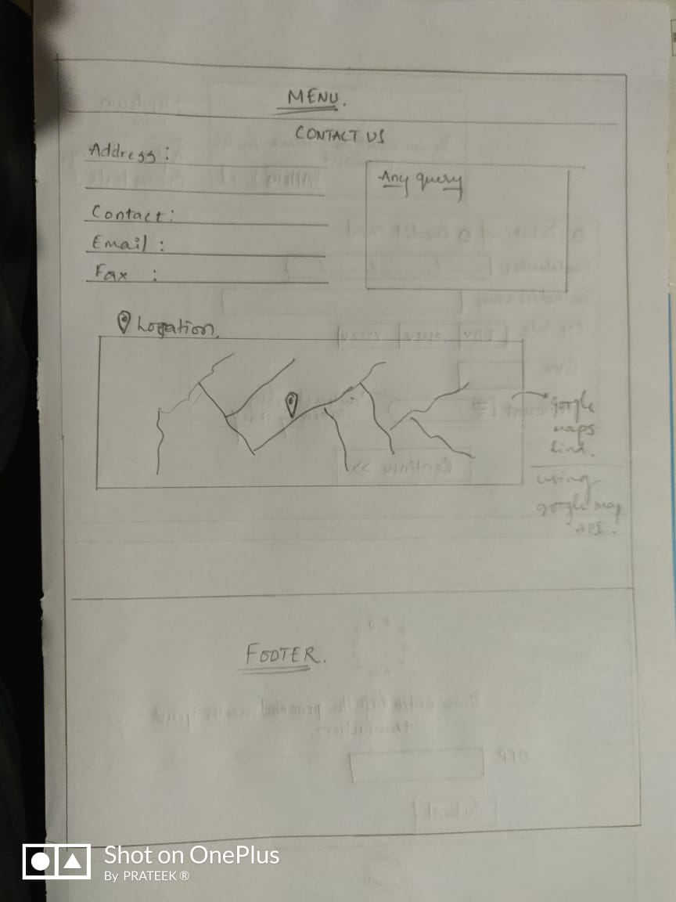

HOME->ACCOUNT ICON ->LOGIN

-> SIGN UP

SIGN UP

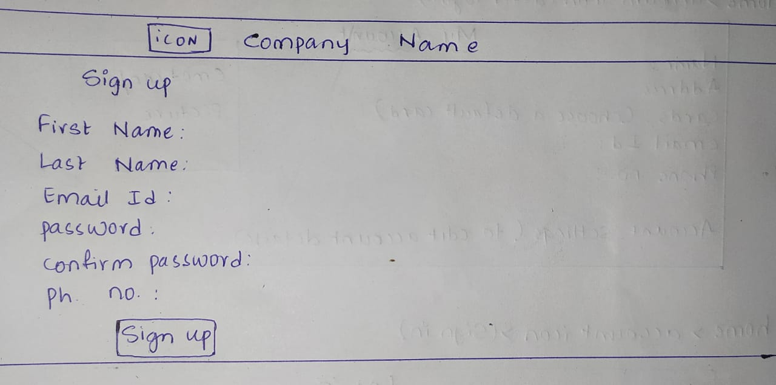

LOGIN

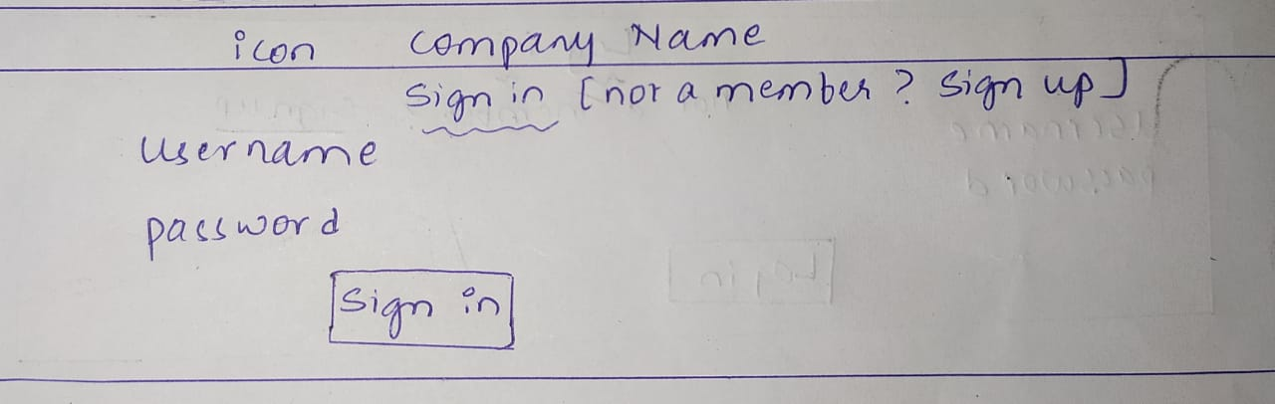

HOME->ACCOUNT-(AFTER LOGGIN IN)

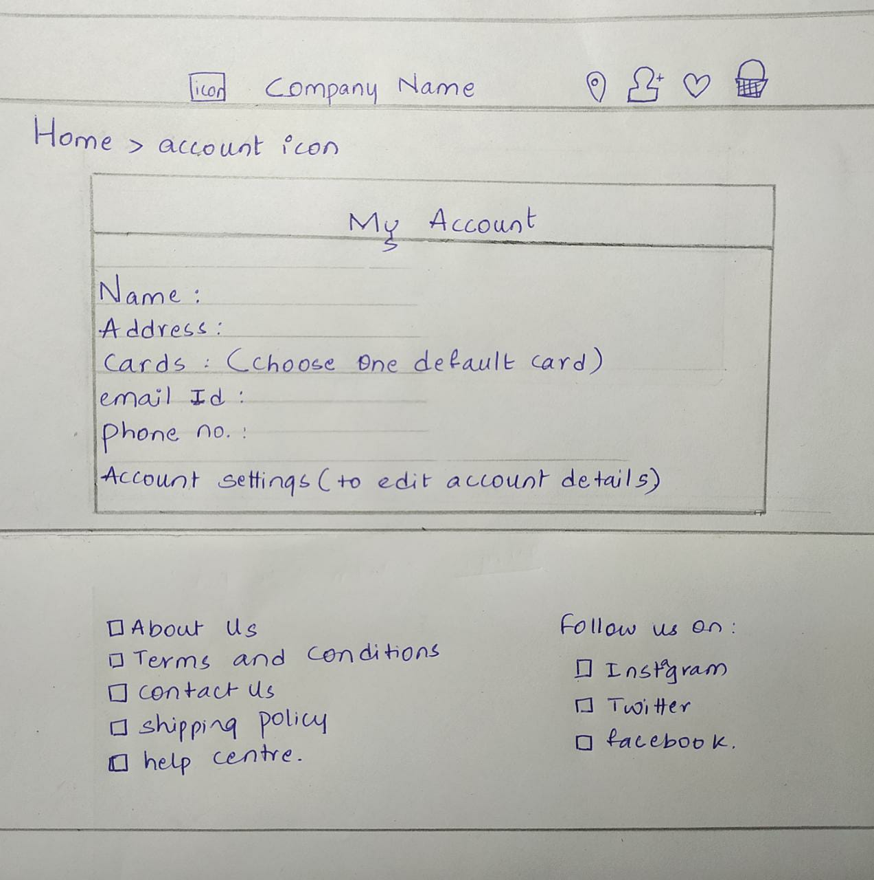

HOME -> CART

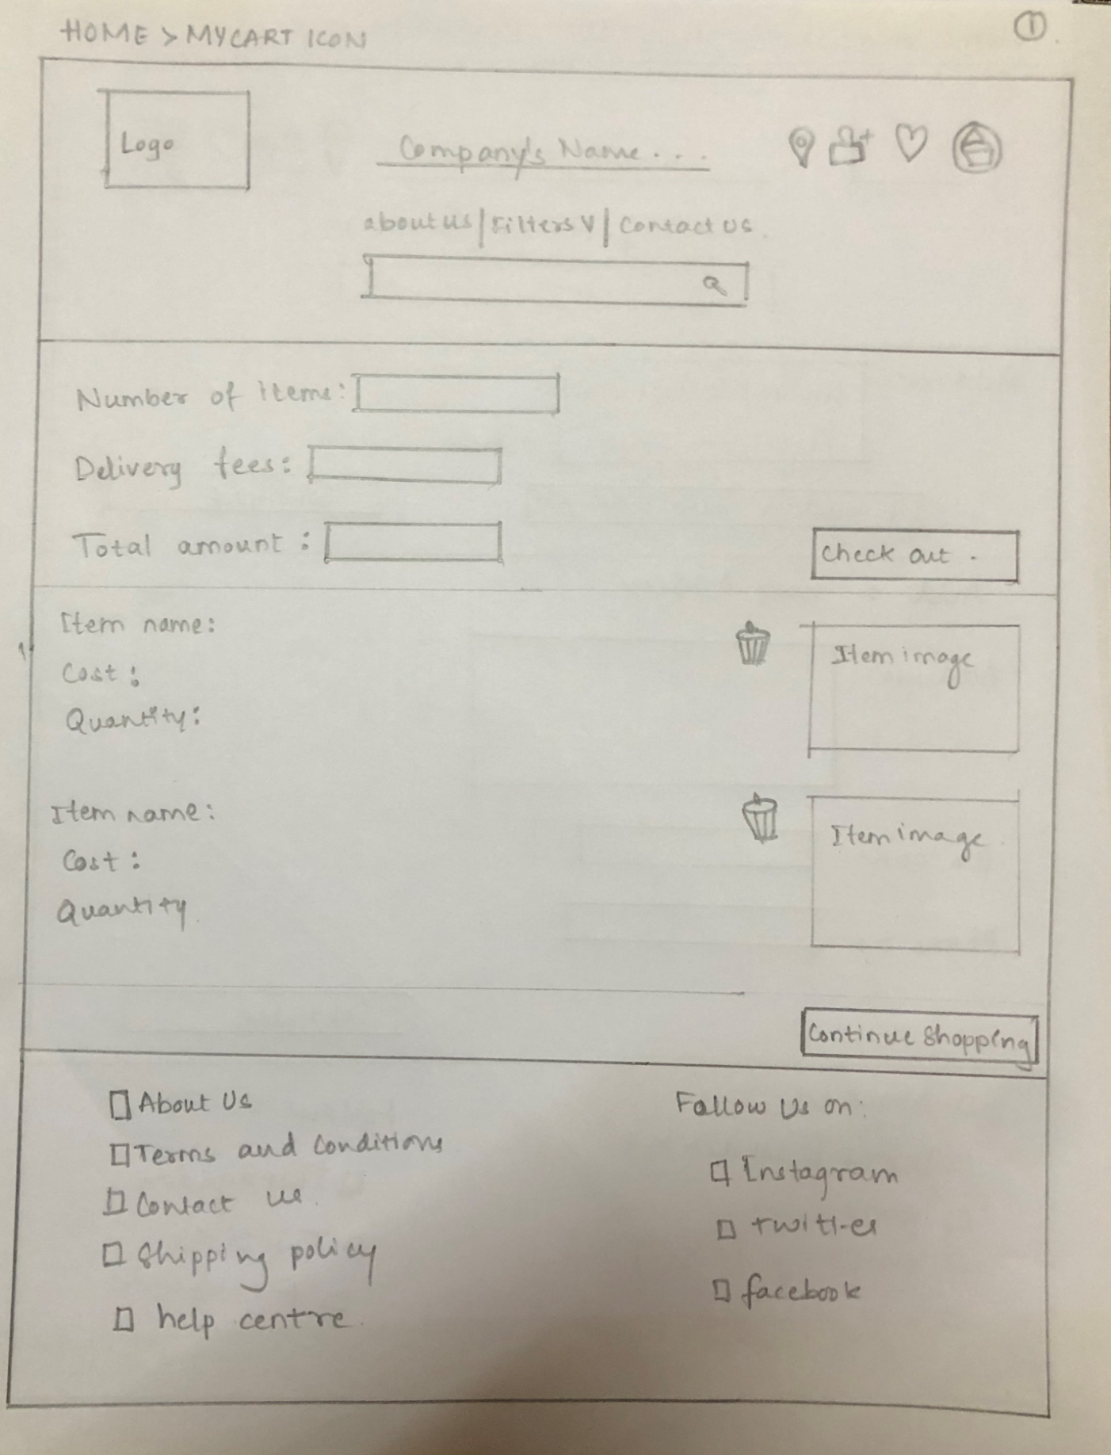

HOME -> CART -> CHECKOUT

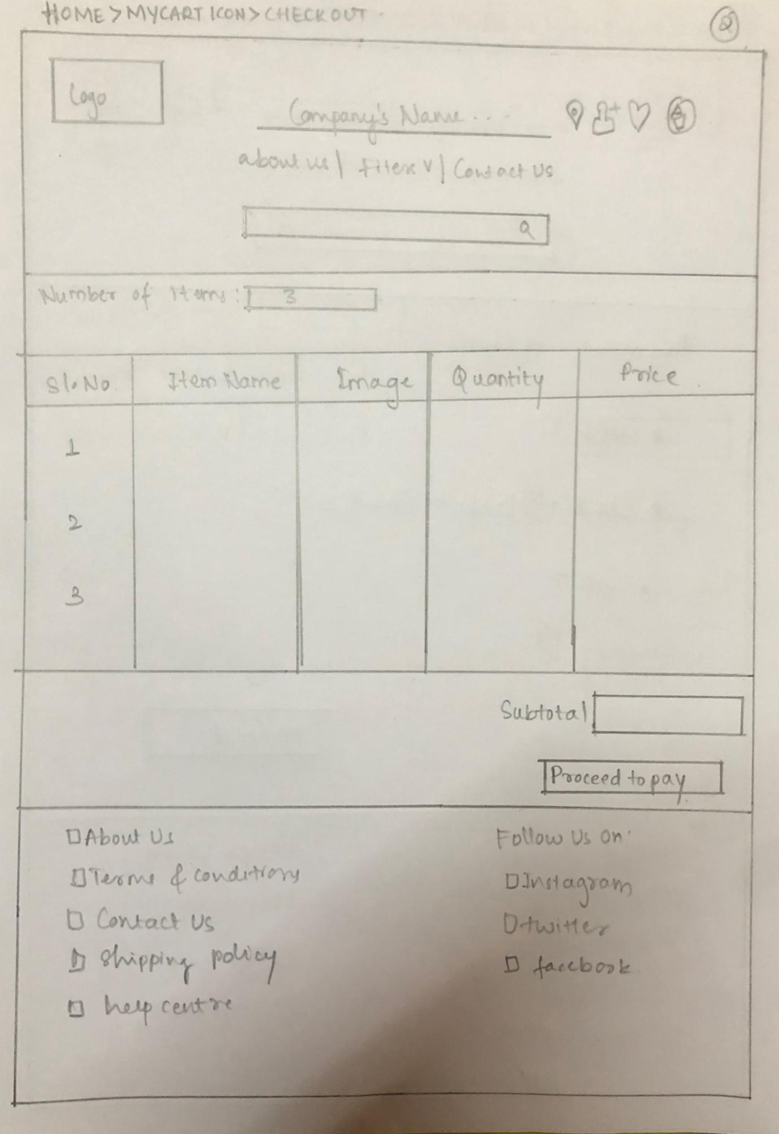

HOME -> CART -> CHECKOUT -> PROCEED TO PAY ->

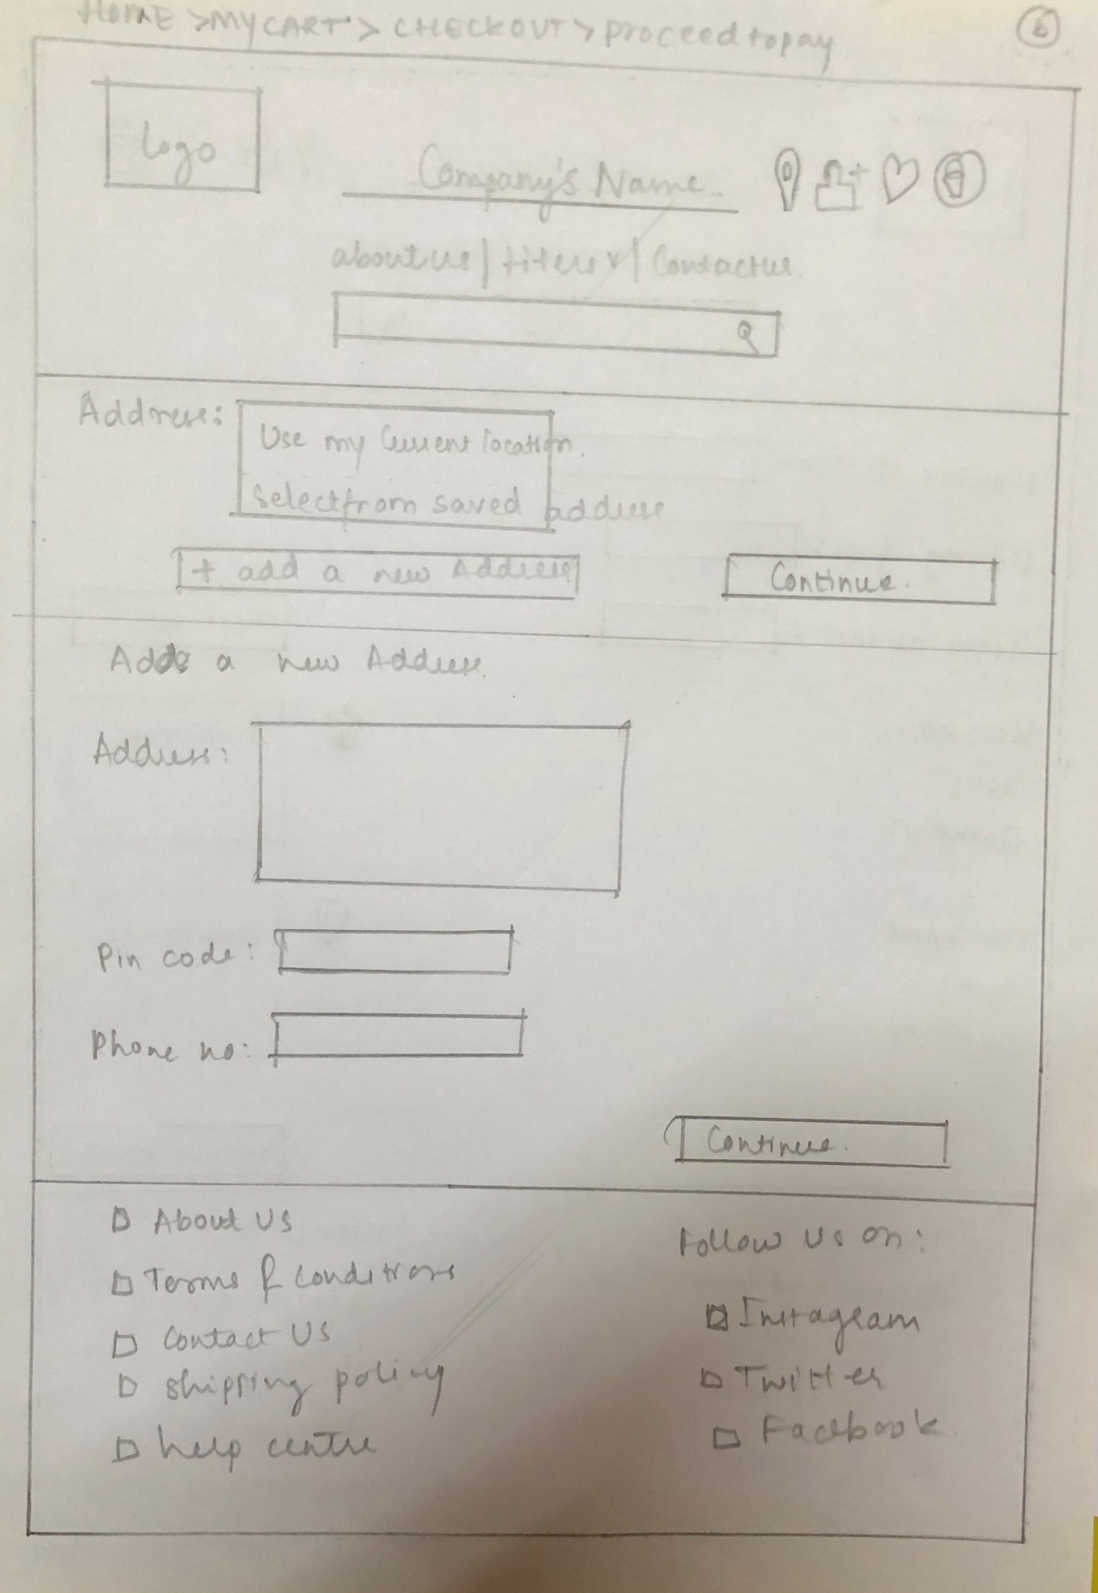

HOME -> CART -> CHECKOUT -> PROCEED TO PAY -> CONTINUE

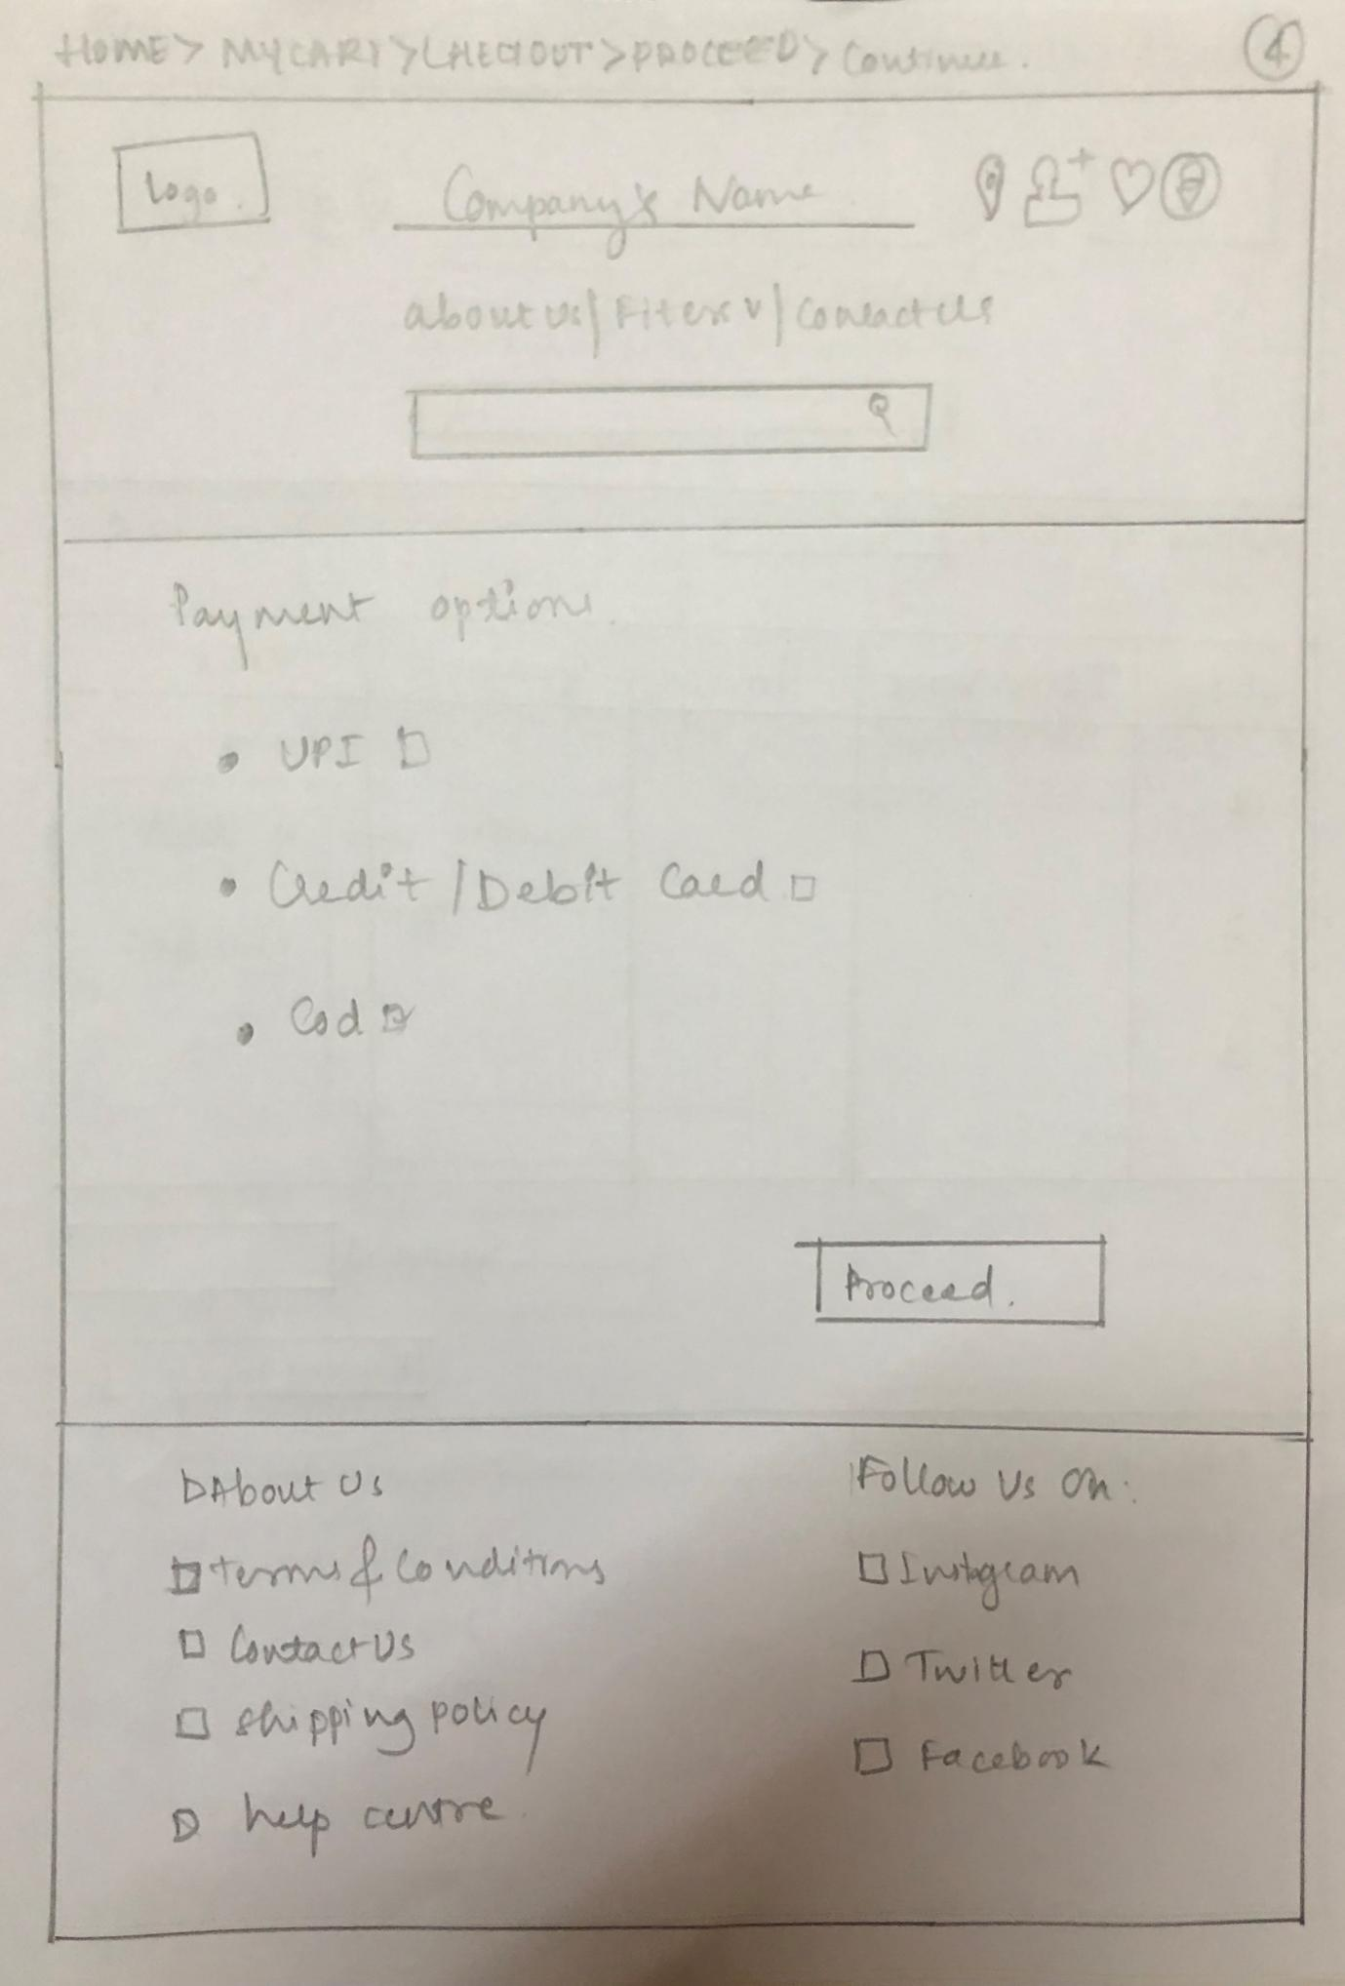

HOME -> CART -> CHECKOUT -> PROCEED TO PAY -> CONTINUE -(CREDIT OR DEBIT CARD)

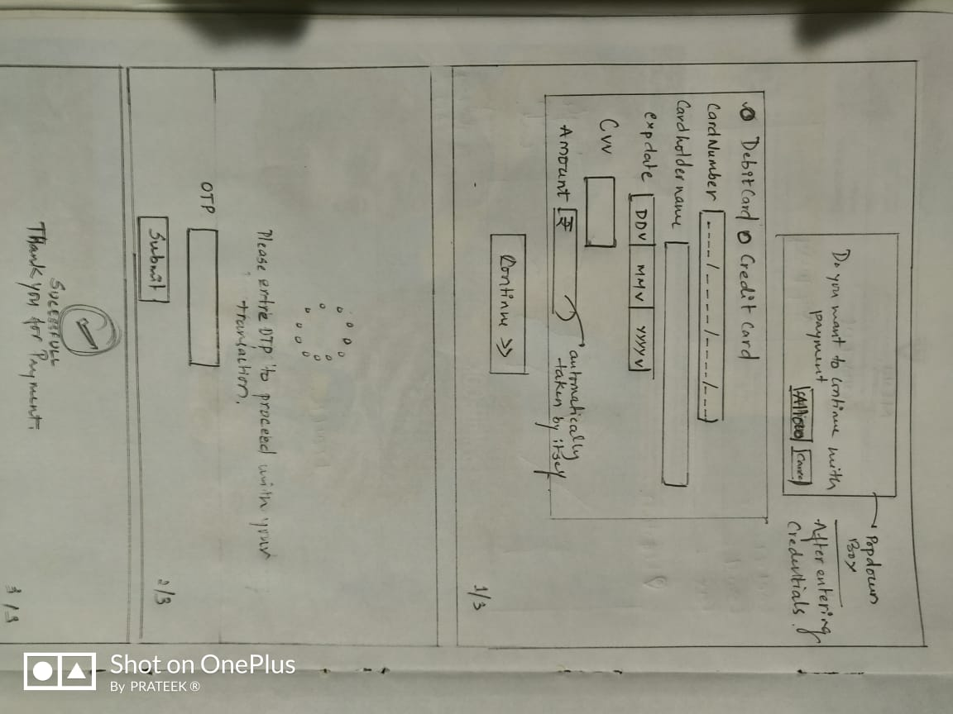

HOME -> CATEGORY 1->

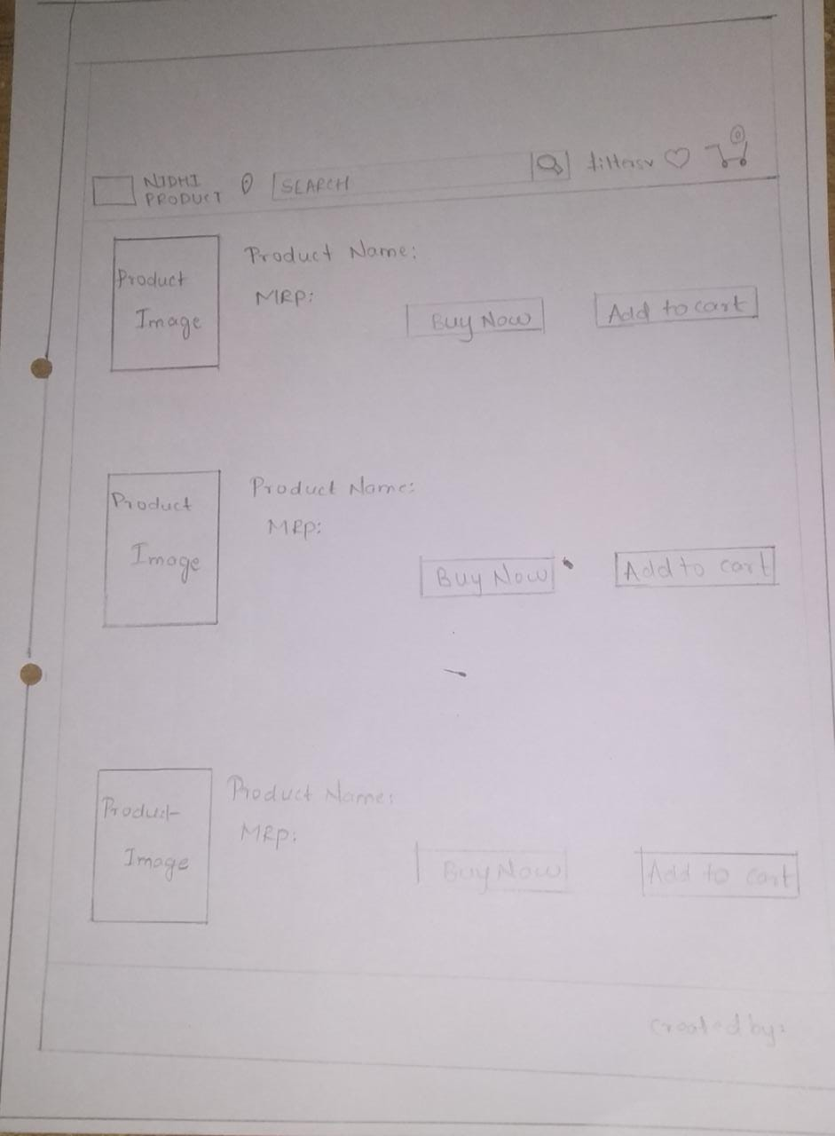

HOME -> CATEGPRY1 -> ONCLICK INDIVIDUAL ITEM ->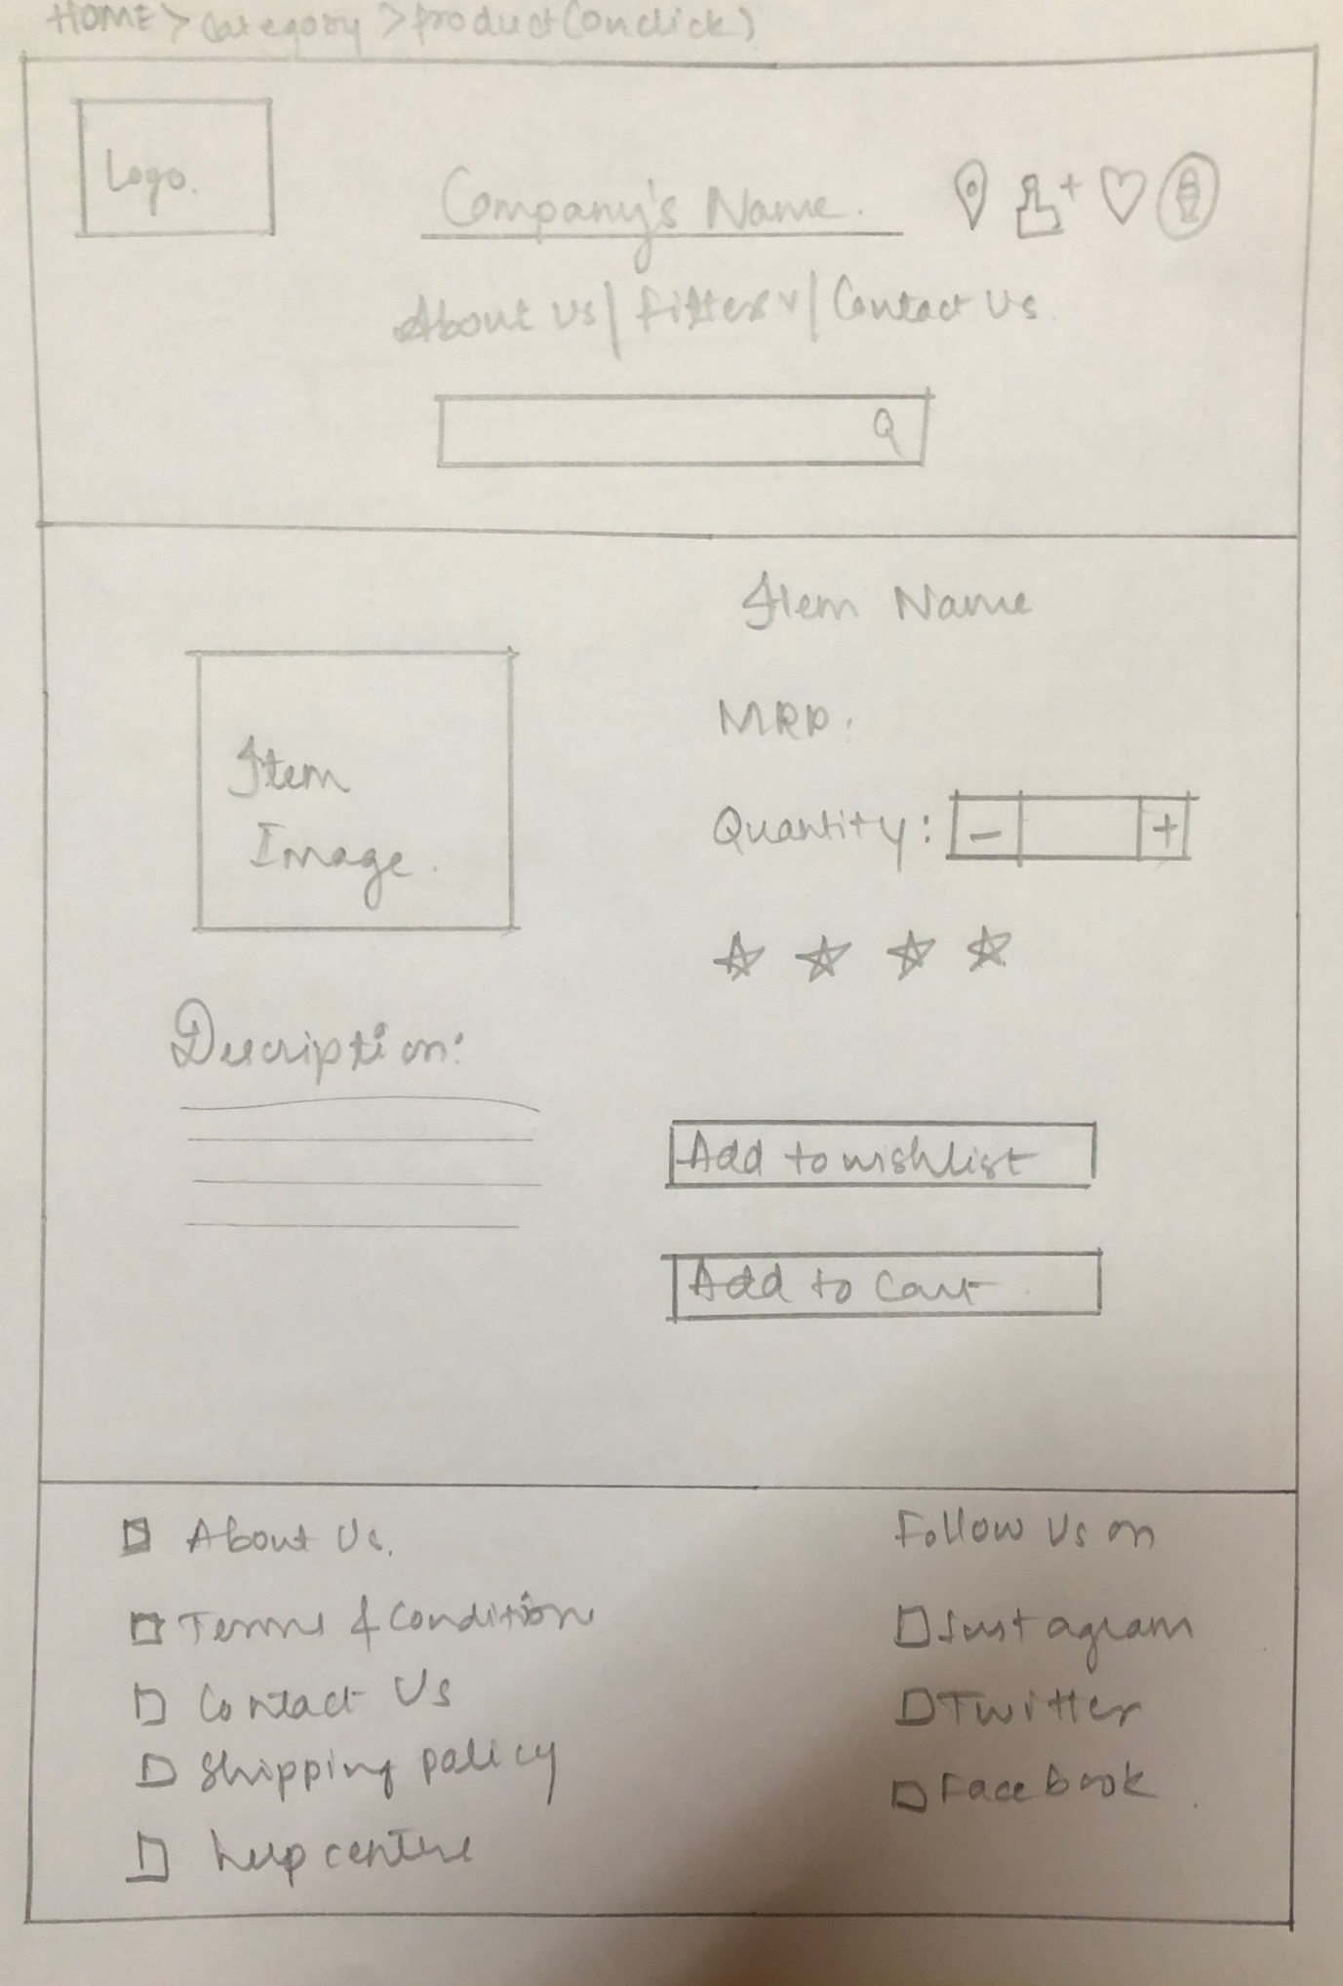

Home -> wish list ->

