  



**Home shop by categories offers**

**Company Name**



|  |  |
| --- | --- |
| **fresh dairy and baked products**  **(corousel-slide-1)** | milk.jpg |

|  |  |
| --- | --- |
| 888.jfif | **daily staples**  **(corousel-slide-2)** |

|  |  |
| --- | --- |
| **fresh veges**  **(corousel-slide-3)** | **veges.PNG** |

|  |  |
| --- | --- |
| dddd.jpg | **chocolates and festival**  **delicacies**  **(corousel-slide-4)** |
|  |  |
|  |  |

**Fruits and vegetables**

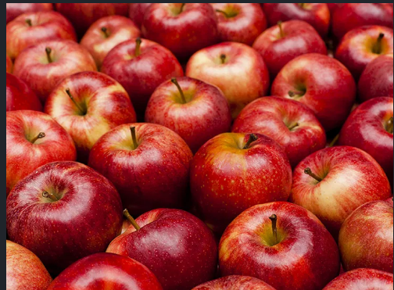

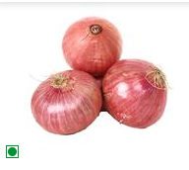

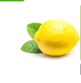

**add to cart**

**add to cart**

**add to cart**

**daily staples**

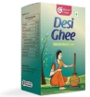

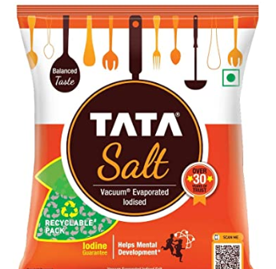

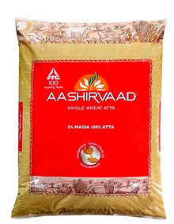

**add to cart**

**add to cart**

**add to cart**

#### popular products:

#### 



**About us:**

#### 

**sHOP LOC:**

**(map location of store)**

**CONTACT US:**

**phone number:**

**email id:**

|  |  |
| --- | --- |
| * [**About Us**](https://www.bigbasket.com/about-us/?nc=bt) * [**Privacy Policy**](https://www.bigbasket.com/privacy-policy/?nc=bt) * **Cancellation policies** * [**Terms and Conditions**](https://www.bigbasket.com/terms-and-conditions/?nc=bt) * [**FAQs**](http://www.bigbasket.com/faq/?nc=bt) * [**Contact Us**](http://www.bigbasket.com/contact/?nc=bt) * [**Wallet**](https://www.bigbasket.com/bb-Wallet-faq/) * **shipping policy**   **CITIES WE SERVE:**  **PAYMENT OPTIONS:** | **Download our app:**   * **on android store**   **Follow us on:**   * **instagram** * **twitter** * **facebook** |

#### Details:

#### in shop by categories:

#### dairy and baked products:

#### festival delights

#### fresh vegetables

#### fresh fruits

#### daily staple

#### Log in

#### need an account ? sign up

#### username

#### password:

#### log in

#### 

#### 

**My wish list**

**My wish list**

#### 

**Number of items:**

**Delivery fees:**

**Total amount:**

**check out**

Image

**Item name:**

**Cost:**

**Quantity:**

**My cart**

**Add to cart**

Image

**Item name:**

**cost:**

#### 

#### 

**Sign up**

**First name:**

**last name:**

**email:**

**password:**

**confirm password**

* **I agree to terms and conditions**

**Sign up**