Students:

Ahmad Othman – 11924964

Mohammad Zaid – 11924574

Github repo: [Mohammadzaied/Dos_hm_2 (github.com)](https://github.com/Mohammadzaied/Dos_hm_2)

In the first scenario, the servers were not distributed across multiple containers, which slowed down the process. This includes, for example, sending data from the browser to the client server, then to the ordering server, then communicating with the catalog server, and finally waiting for the results to be returned.

The job was run via Docker and placed two copies of the catalog server, two copies of the order server, and a copy of the client server.

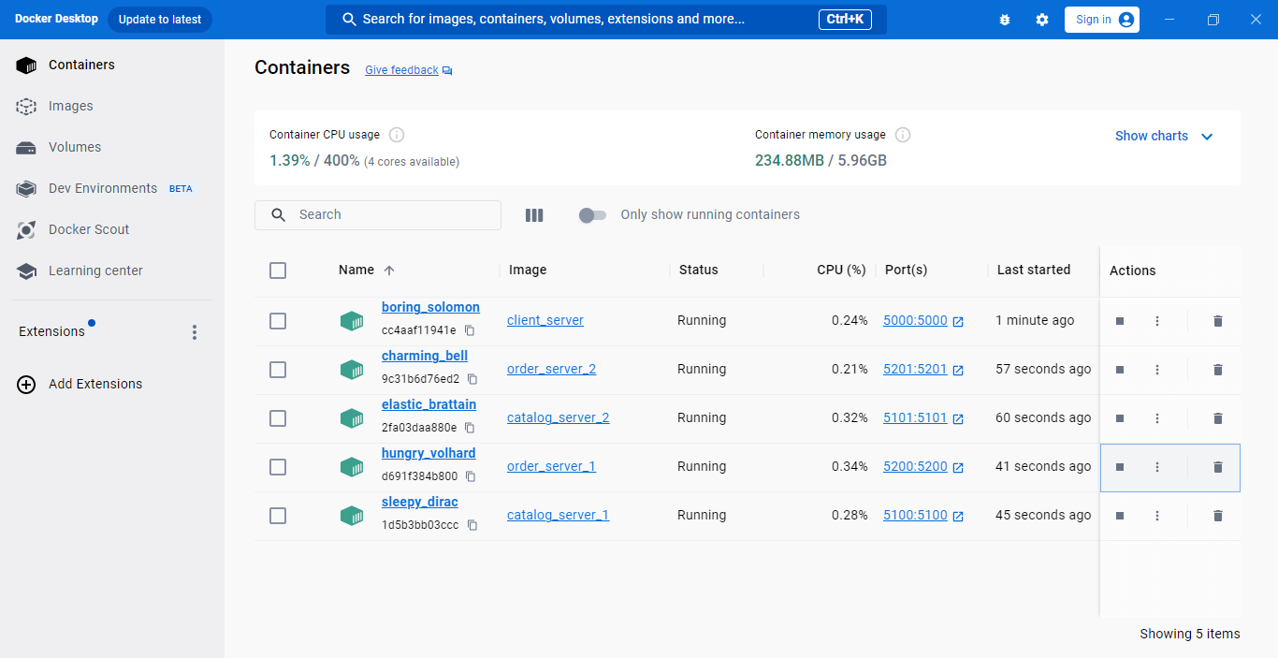

Code:

1. Client server:

The IP and port were created for each copy of the servers, and the round robin method was used to choose between the copies of the servers, and the flask_caching library was used to store data in it for a period of 5 minutes, based on a private key. Before the request is sent to the server, the information is checked inside the cache memory. If it exists, it is returned from memory, and if it does not exist, it is requested from the server and stored in the cache, but if the operation is a data update (purchase), the information is deleted from the cache.

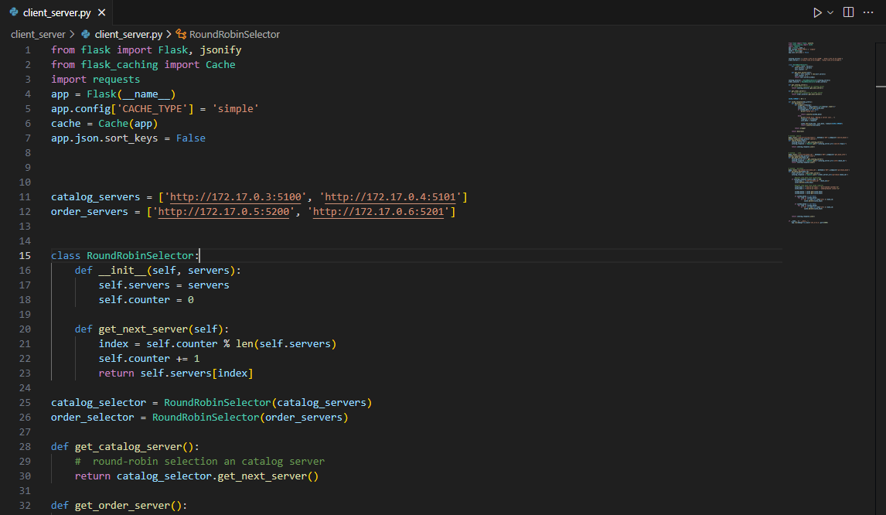

1. Catalog servers:

A part of the code for lab 1 has been updated, which is to synchronize data between servers. When the process is a purchase and the process is completed successfully, a copy is sent to the other copy of the catalog server to modify the database it has.

response=requests.put(f"{catalog_server2}/synchronize/{book_id}")

response=requests.put(f"{catalog_server1}/synchronize/{book_id}")

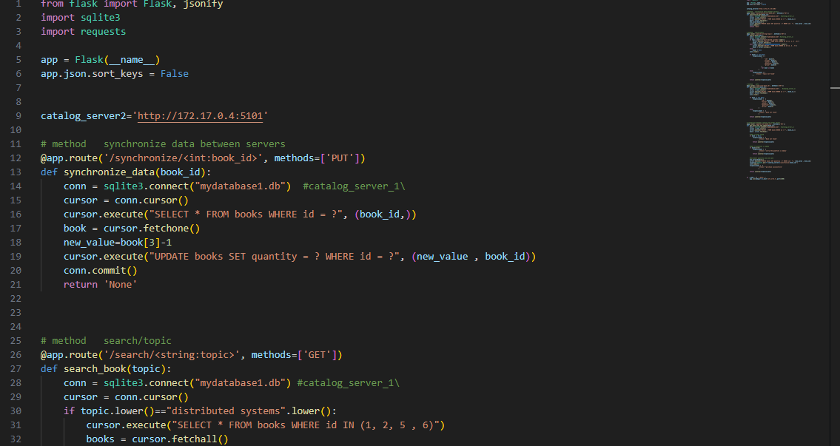

1. order servers:

A section of the code for Lab 1 has been updated, which is distributing purchase orders to catalog servers via round robin.

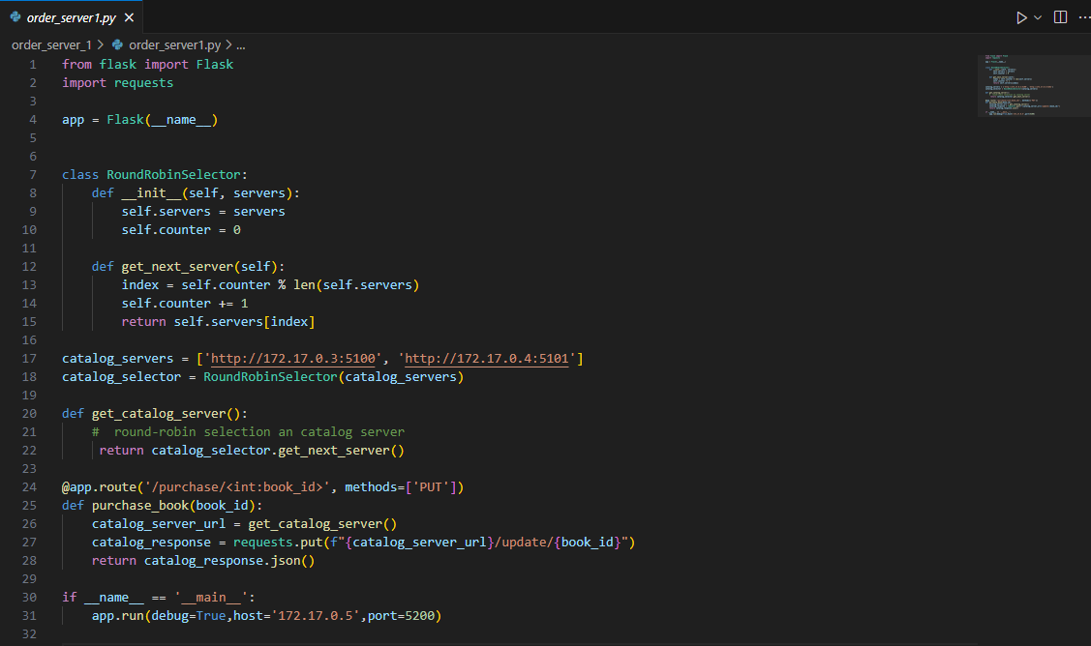

1. Front user:

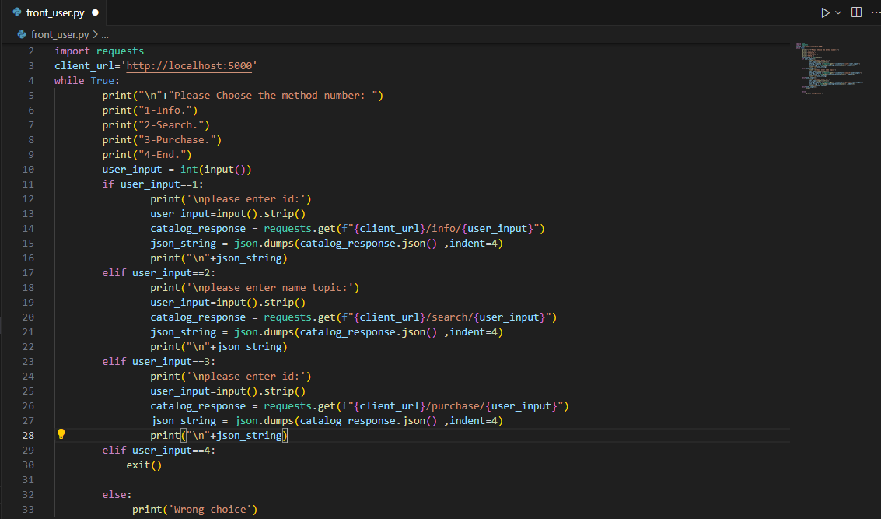

Possible Improvements:

1. User Authentication: use user authentication to allow the user to do specific actions such as order a book.
2. Payment Integration: Add payment integration for handling payment process.