***Output Lab***

1. Info: Search by id.

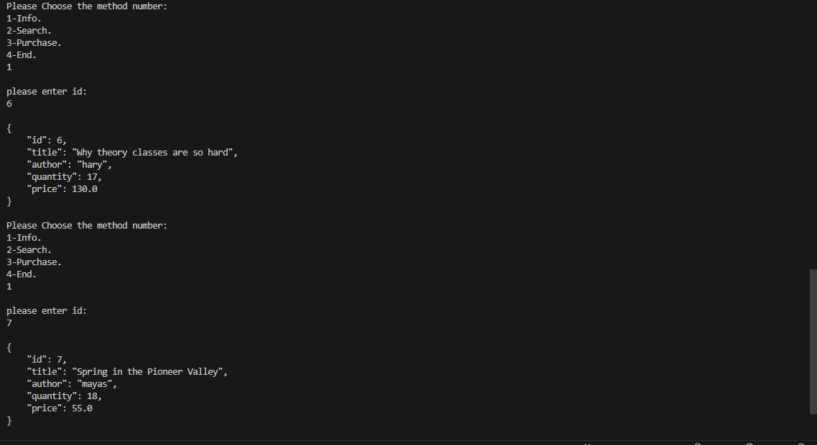

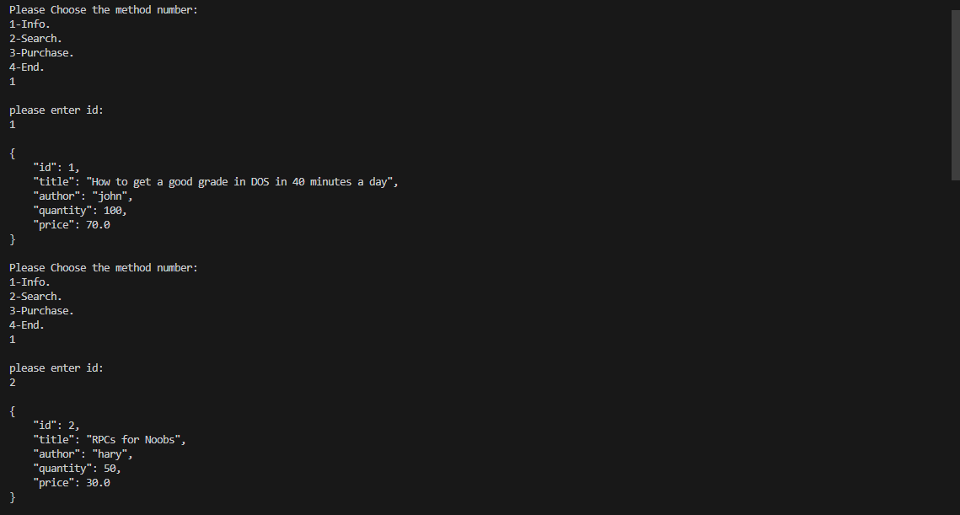

1. search by topic: returns the books with the same topic.

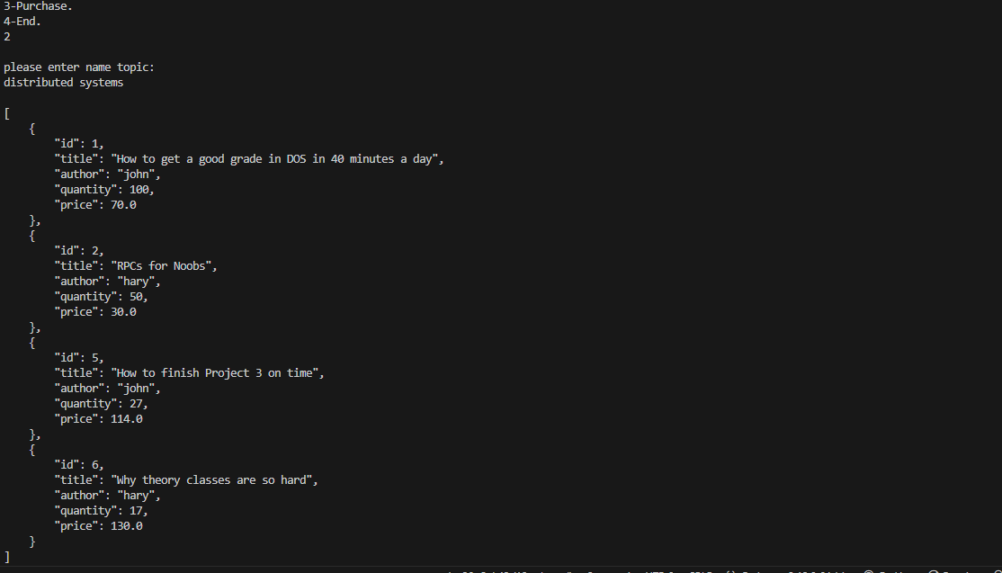

1. Purchase: Purchase a book and decrease the quantity .

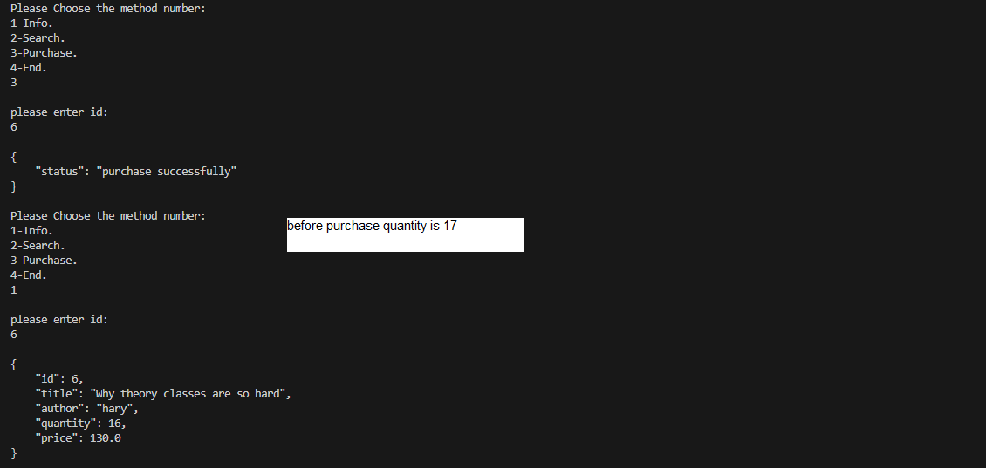

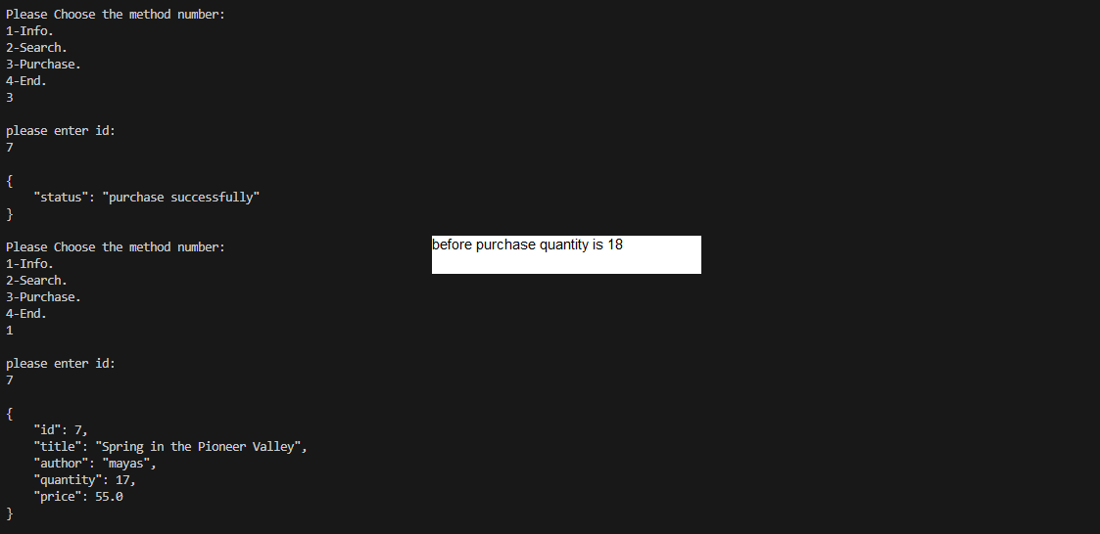

Cache:

1. Search:

When I searched for the book id 7 for the first time, it was not stored in the cache (cache miss), but the second time it became stored, and the information was taken from the cache (cache hit).



1. Search:

When I searched for the book id 7 for the first time, it was not stored in the cache (cache miss), but the second time it became stored, and the information was taken from the cache (cache hit(,After updating the data for item 7, it is deleted from the cache.

