***Result***

Info:

We notice that in the query process, when using the cache, the response time decreases because the information is returned from the cache and not through the server.

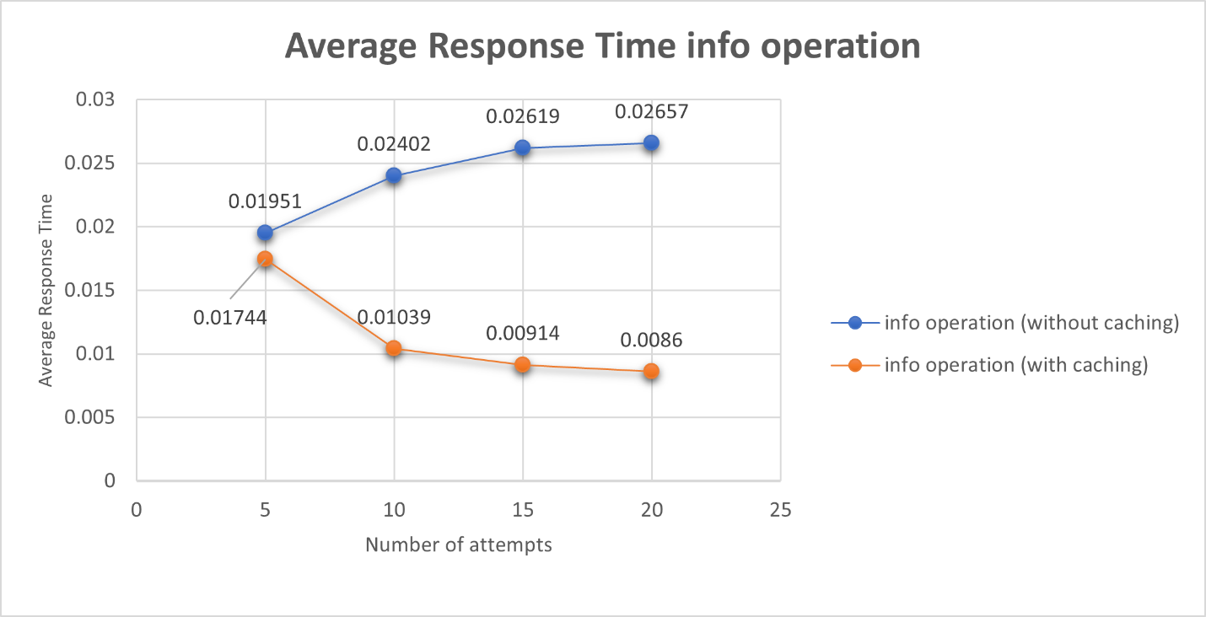

Purchase:

We notice that in the purchase process, when using cache, the time period increases because the presence of the item in the cache is checked every time to delete the information from the cache.

Q1: What are the overhead of cache consistency operations?

The time required for memory consistency is deleting the item from within the cache because the data will be modified, and a request will be sent between the catalog servers to coordinate the information within the database.

Q2: What is the latency of a subsequent request that sees a cache miss?

When cache miss happens, first it will ask for the request and store its response in the cache, then return the response to the user.