Online Drinking Store Documentation

# Team Members

|  |  |
| --- | --- |
| Name | ID |
| Mohammed Mahmood Hamed | 221001026 |
| Mohamed Mahmoud Ahmed | 221001856 |
| Mostafa Mohamed | 221001602 |
| Aliaa Nagdy | 222000114 |
| Menna Ahmed Reda | 221001720 |

# 1. Introduction

This documentation describes a web-based e-commerce platform named Online Drinking Store.   
The system enables users to register securely, browse various beverages, place and manage orders, and receive notifications.   
Technologies used include:

# 2. System Overview

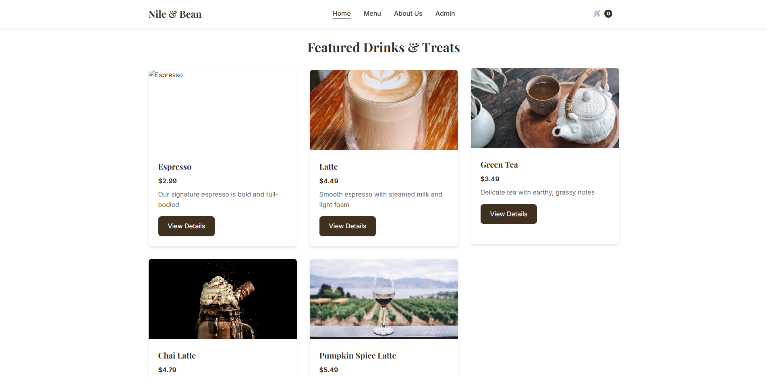

# 2.1 Technology Stack

- Frontend: HTML5, Tailwind CSS, JavaScript , TypeScript  
- Backend: Python Flask  
- Database: MySQL  
- Authentication: JWT (JSON Web Tokens)

# 2.2 Key Features

- User registration and authentication  
- Order creation and management  
- Responsive UI  
- Secure session handling  
- RESTful APIs

# 3. Use Case Diagram & Descriptions

Actors:  
- Guest: Unauthenticated users (can register or log in)  
- Customer: Authenticated users (can manage their own orders)  
- Admin: Users with advanced permissions (can manage users, orders, and categories)  
  
Use Cases:  
- Register/Login: Allows account creation or login  
- View Dashboard: Displays user's orders  
- Submit Orders: Create new orders  
- Delete Orders: Remove an order  
- Set Order Status: Update order state  
- Assign Orders: Admin assigns tasks  
- Create Categories: Admin creates new categories  
- Customer Support: Exchange messages/files  
  
Relationships:  
<<include>>:  
- Register/Login includes authentication verification  
- Manage Orders includes status updates and assignments  
  
<<extend>>:  
- Delete Orders extends Order Management  
- System Management extends User Management

See detailed class attributes and relationships in the full documentation.

Includes user registration and login workflows.

# 6. Frontend ComponentsC:\Users\moham\AppData\Local\Microsoft\Windows\INetCache\Content.Word\Screenshot 2025-05-26 113707.png

1. Login Page  
- Email/password fields  
- "Forgot Password" option

# 7. Testing

Test Cases include valid/invalid login, order creation, deletion, and validation errors.  
All test cases passed as expected.

This Online Drinking Store provides a secure, responsive web interface for personal order organization. The system follows modern web development practices with a clear separation between frontend and backend components, implemented with Flask and Tailwind CSS. The documentation covers all aspects of the system from use cases to technical implementation details.

**Chapter 6: Testing**

**6.1 Test Cases**

| **Test Case ID** | **Description** | **Expected Result** | **Actual Result** | **Status** |
| --- | --- | --- | --- | --- |
| TC01 | User registers with valid credentials | Redirect to dashboard with success message | As expected | ✅ Pass |
| TC02 | Login with incorrect password | Show error message, no login | As expected | ✅ Pass |
| TC03 | Create a new task with valid data | Task appears in dashboard | As expected | ✅ Pass |
| TC04 | Delete a task as a member | Task is removed from the system | As expected | ✅ Pass |
| TC05 (Negative) | Try submitting a task with blank title | Show form validation error | As expected | ✅ Pass |

8. Risk & Security

| **Risk ID** | **Category** | **Description** |
| --- | --- | --- |
| R1 | Security | Unauthorized access via token leakage |
| R2 | Performance | System slows down with 1000+ tasks |
| R3 | Usability | Users may forget to logout on shared devices |
| R4 | Data Integrity | Accidental deletion of tasks without undo |
| R5 | Hosting/Infra | Downtime due to server outage or database corruption |

**7.2 Risk Assessment**

| **Risk ID** | **Likelihood** | **Impact** | **Risk Level** |
| --- | --- | --- | --- |
| R1 | High | High | Critical |
| R2 | Medium | Medium | Moderate |
| R3 | Medium | Low | Low |
| R4 | Medium | High | High |
| R5 | Low | High | Moderate |

Risk Types:  
- Security: Token leakage  
- Performance: Lag with 1000+ tasks  
- Usability: Forgotten logout  
- Data Integrity: No undo on deletion  
- Infrastructure: Server/database failures  
  
Mitigations:  
- HTTPS-only tokens with expiry  
- Lazy loading and pagination  
- Auto-logout after inactivity  
- Soft-delete for orders  
- Cloud backups and HA hosting

# 9. Requirement Refinement (SRS Updates)

Functional:  
- FR9: Implement soft-delete for orders  
- FR10: Auto-logout after 15 mins of inactivity  
  
Non-Functional:  
- NFR5: Handle up to 2000 orders with <500ms latency  
- NFR6: JWT tokens encrypted and stored securely

# 10. Repository

GitHub Link: https://github.com/Mohammed-004del/deliverable_03