Online Drinking Store

1. Introduction

This documentation covers a web-based beverage e-commerce platform called 'Online Drinking Store'. The system enables users to securely register, browse a wide range of beverages, place orders, and manage their profiles. It integrates Stripe for payments, React.js for the frontend, Node.js with Express for the backend, and MySQL for the database.

2. System Overview

2.1 Technology Stack

- Frontend**: HTML5, Tailwind CSS, JavaScript

- Backend**: Python Flask

- Database**: SQLite

- Authentication**: JWT (JSON Web Tokens)

2.2 Key Features

- User registration and authentication

- Task creation and management

- Responsive design

- Secure session management

- RESTful API endpoints

3. Use Case Diagram

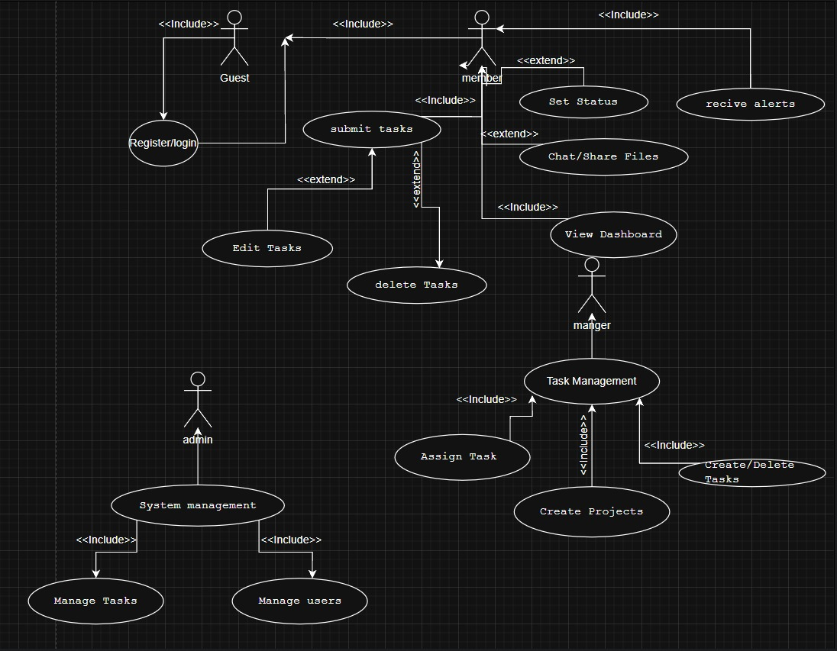

Use Case Descriptions

Actor Definitions

1. **Guest**
   * Unauthenticated user
   * Can register or log in to the system
2. **Member**
   * Regular authenticated user
   * Can perform basic task operations
   * Can collaborate with team members
3. **Manager**
   * Privileged user with additional permissions
   * Can manage team assignments and projects
   * Has administrative capabilities
4. **Admin** (implied from class diagram)
   * System administrator
   * Manages user accounts and system settings
   * Has full access to all features

Use Case Descriptions

Authentication Use Cases

1. **Register/Login** (Guest)
   * **Description**: Allows users to create accounts or authenticate
   * **Related Class**: User
   * **Preconditions**: None
   * **Postconditions**: User gains appropriate access level
2. **View Dashboard** (Member/Manager)
   * **Description**: Displays personalized task overview
   * **Related Classes**: User, Task, Project
   * **Preconditions**: Successful authentication
   * **Postconditions**: Dashboard rendered with user-specific data

Task Management Use Cases

1. **Submit Tasks** (Member)
   * **Description**: Create new task items
   * **Related Classes**: Task, User
   * **Preconditions**: Member logged in
   * **Postconditions**: New task appears in system
2. **Delete Tasks** (Member/Manager)
   * **Description**: Remove tasks from system
   * **Related Classes**: Task, Notification
   * **Preconditions**: User has appropriate permissions
   * **Postconditions**: Task removed and notifications sent if assigned
3. **Set Task Status** (Member/Manager)
   * **Description**: Update task progress state
   * **Related Classes**: Task, Notification
   * **Preconditions**: Task exists and is assigned to user
   * **Postconditions**: Task status updated, notifications triggered

Manager-Specific Use Cases

1. **Assign Tasks** (Manager)
   * **Description**: Delegate tasks to team members
   * **Related Classes**: Task, User, Notification
   * **Preconditions**: Manager logged in, task exists
   * **Postconditions**: Task assigned and notification sent
2. **Create Projects** (Manager)
   * **Description**: Establish new project containers
   * **Related Classes**: Project, User
   * **Preconditions**: Manager logged in
   * **Postconditions**: New project available for task organization

Collaboration Use Cases

1. **Chat/Share Files** (Member/Manager)
   * **Description**: Team communication and file exchange
   * **Related Classes**: Message, File, User
   * **Preconditions**: User authenticated
   * **Postconditions**: Messages/files stored in system

Admin Use Cases (implied)

1. **System Management** (Admin)
   * **Description**: Configure system settings and users
   * **Related Classes**: User
   * **Preconditions**: Admin privileges
   * **Postconditions**: System configuration updated

Relationships

1. **Inclusion Relationships** (<<include>>):
   * "Register/login" includes authentication verification
   * "Manage Tasks" includes status updates and assignments
   * "Task Management" includes all task-related operations
2. **Extension Relationships** (<<extend>>):
   * "Delete Tasks" extends from basic task management
   * "Set Status" extends from task operations
   * "System management" extends from user management

4. Class Diagram

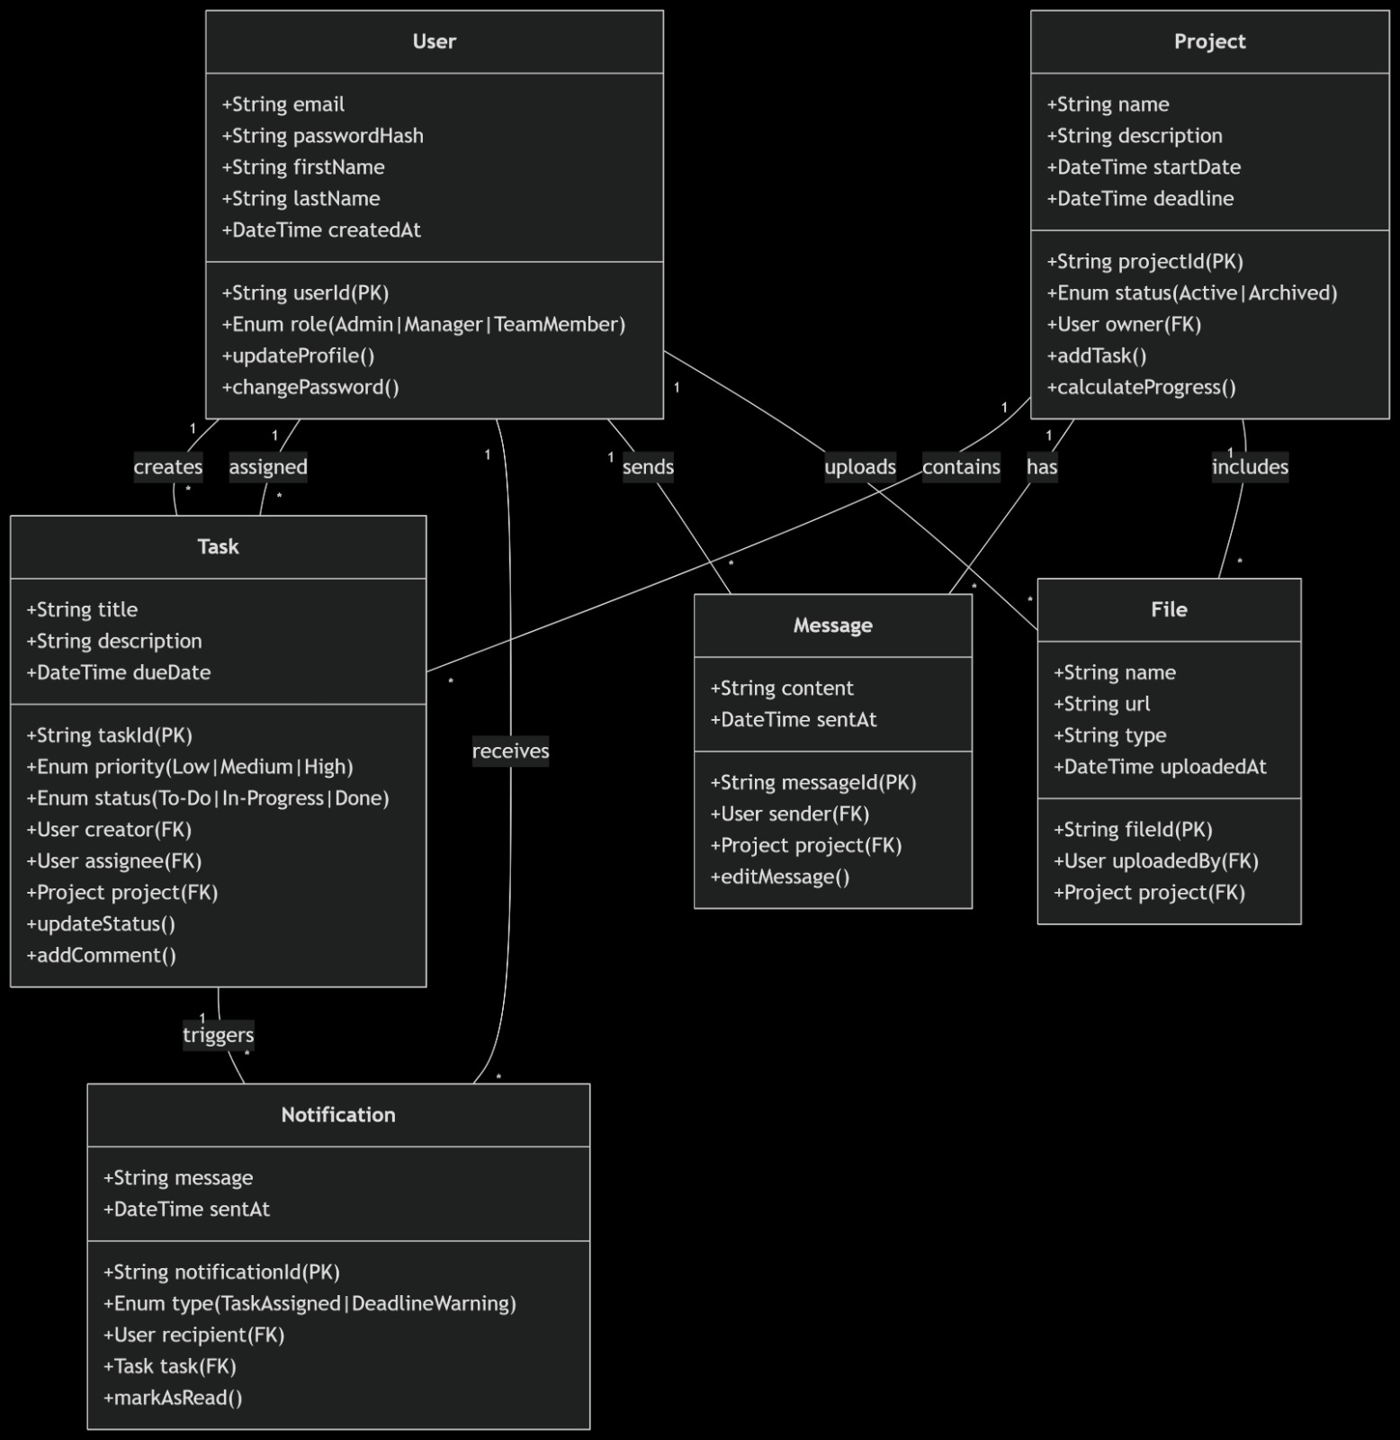

1. User Class

**Attributes:**

* userId: Primary key (String)
* email: Unique user identifier (String)
* passwordHash: Securely stored password (String)
* firstName: User's first name (String)
* lastName: User's last name (String)
* createdAt: Account creation timestamp (DateTime)
* role: User role (Enum: Admin|Manager|TeamMember)

**Methods:**

* updateProfile(): Updates user information
* changePassword(): Changes user password

**Relationships:**

* Creates Tasks (1-to-many)
* Receives Notifications (1-to-many)
* Owns Projects (1-to-many)
* Uploads Files (1-to-many)
* Sends Messages (1-to-many)

2. Task Class

**Attributes:**

* taskId: Primary key (String)
* title: Task name (String)
* description: Task details (String)
* dueDate: Completion deadline (DateTime)
* priority: Importance level (Enum: Low|Medium|High)
* status: Completion state (Enum: To-Do|In-Progress|Done)

**Methods:**

* updateStatus(): Changes task status
* addComment(): Adds comments to task

**Relationships:**

* Belongs to Project (many-to-1)
* Created by User (many-to-1)
* Assigned to User (many-to-1)
* Triggers Notifications (1-to-many)

3. Notification Class

**Attributes:**

* notificationId: Primary key (String)
* message: Notification content (String)
* sentAt: Creation timestamp (DateTime)
* type: Notification category (Enum: TaskAssigned|DeadlineWarning)

**Methods:**

* markAsRead(): Updates read status

**Relationships:**

* Sent to User (many-to-1)
* Related to Task (many-to-1)

4. Project Class

**Attributes:**

* projectId: Primary key (String)
* name: Project title (String)
* description: Project details (String)
* startDate: Initiation date (DateTime)
* deadline: Completion date (DateTime)
* status: Current state (Enum: Active|Archived)

**Methods:**

* addTask(): Creates new tasks
* calculateProgress(): Computes completion percentage

**Relationships:**

* Owned by User (many-to-1)
* Contains Tasks (1-to-many)
* Contains Files (1-to-many)
* Contains Messages (1-to-many)

5. File Class

**Attributes:**

* fileId: Primary key (String)
* name: File name (String)
* url: Storage location (String)
* type: File format (String)
* uploadedAt: Creation timestamp (DateTime)

**Relationships:**

* Uploaded by User (many-to-1)
* Belongs to Project (many-to-1)

6. Message Class

**Attributes:**

* messageId: Primary key (String)
* content: Message text (String)
* sentAt: Creation timestamp (DateTime)

**Methods:**

* editMessage(): Modifies message content

**Relationships:**

* Sent by User (many-to-1)
* Belongs to Project (many-to-1)

5. Sequence Diagrams

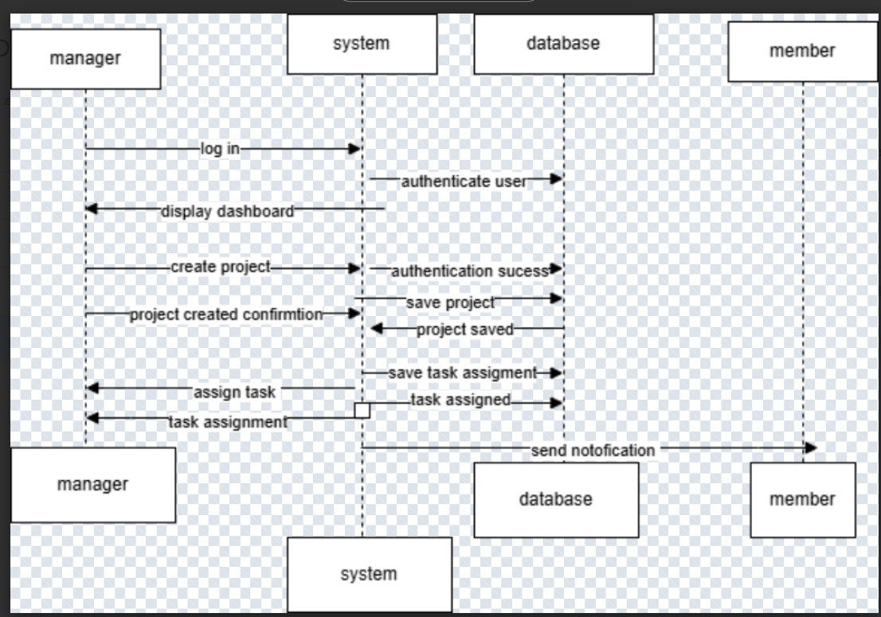

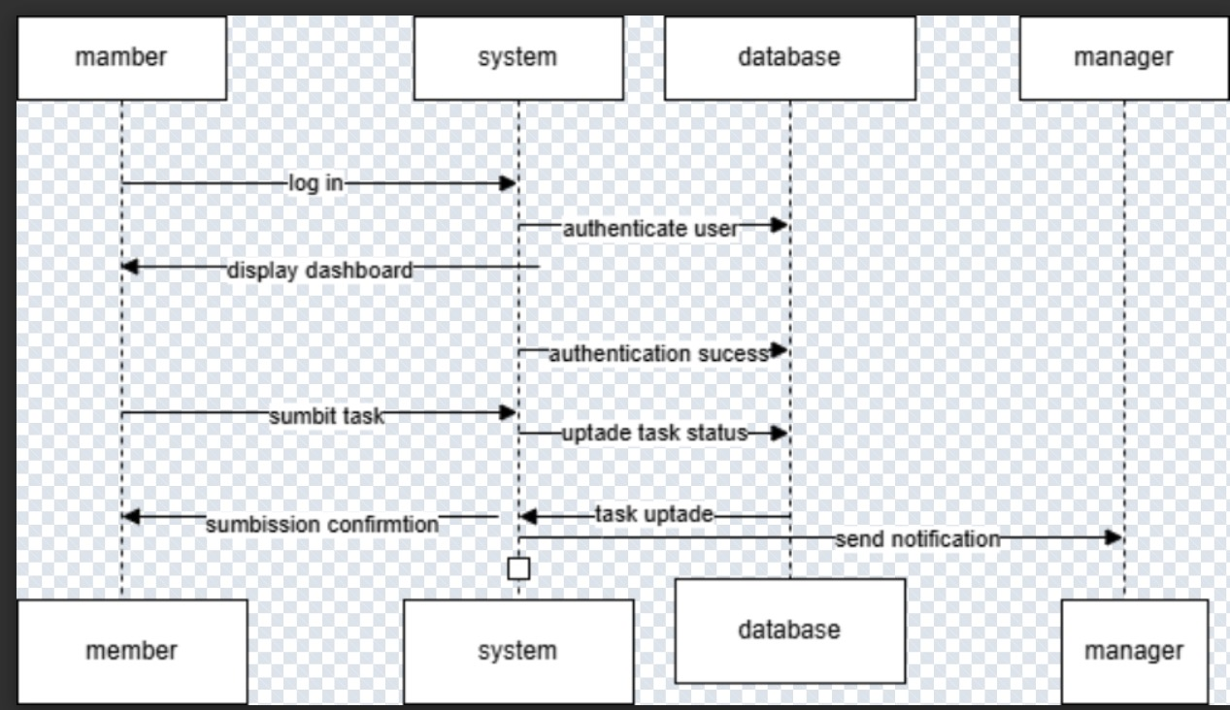

5.1 User Registration

```plaintext

User -> Browser: Fills registration form

Browser -> Flask: POST /api/register (form data)

Flask -> Database: Create new user

Database -> Flask: User record

Flask -> Browser: 201 Created + JWT

Browser -> LocalStorage: Store token

Browser -> User: Redirect to dashboard

```

5.2 User Login

```plaintext

User -> Browser: Fills login form

Browser -> Flask: POST /api/login (credentials)

Flask -> Database: Validate credentials

Database -> Flask: User record

Flask -> Browser: 200 OK + JWT

Browser -> Storage: Store token (local/session)

Browser -> User: Redirect to dashboard

```

5.3 Task Management

6. Frontend Components

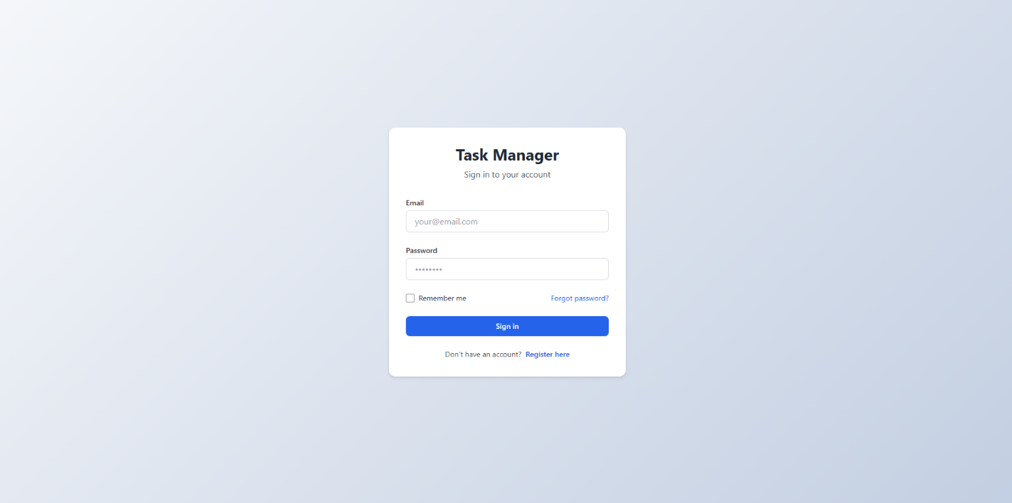

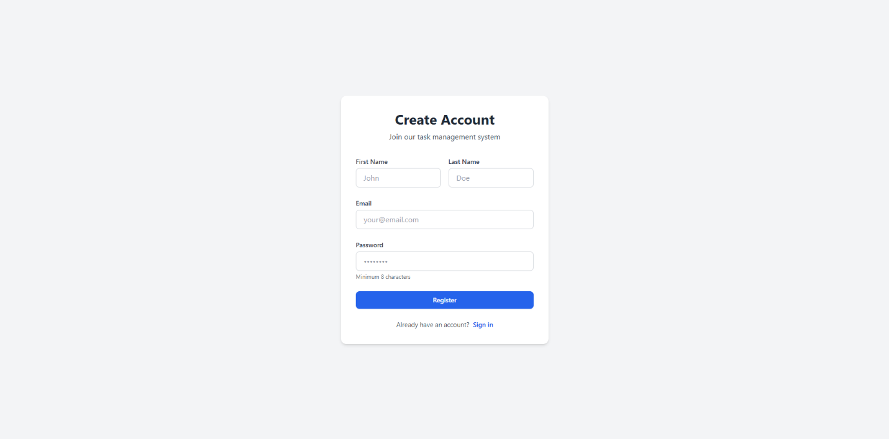

1. Login Page

- Email/password input

- Remember me option

- Registration link

2. Registration Page

- Name, email, password fields

- Form validation

- Password requirements

3. Dashboard

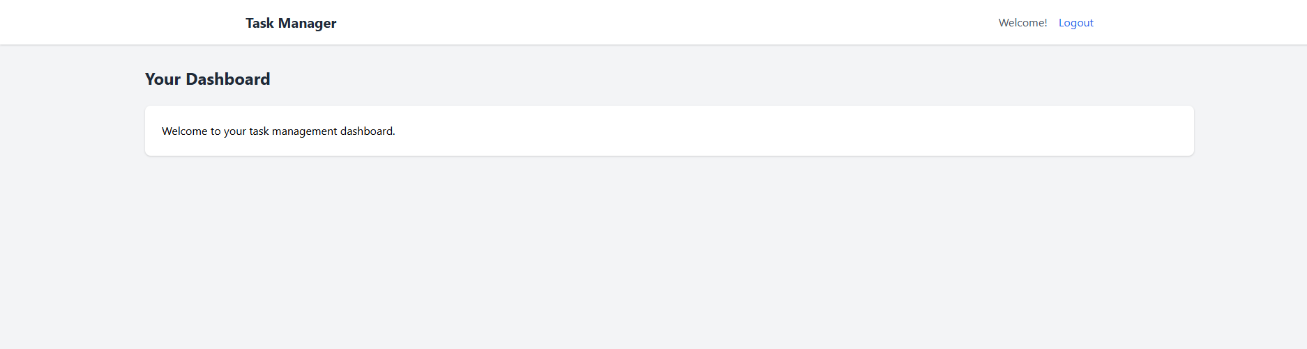

- Task overview statistics

- Task list with completion toggle

- Logout functionality

7. Conclusion

This Task Management Tool provides a secure, responsive web interface for personal task organization. The system follows modern web development practices with a clear separation between frontend and backend components, implemented with Flask and Tailwind CSS. The documentation covers all aspects of the system from use cases to technical implementation details.

**Chapter 6: Testing**

**6.1 Test Cases**

| **Test Case ID** | **Description** | **Expected Result** | **Actual Result** | **Status** |
| --- | --- | --- | --- | --- |
| TC01 | User registers with valid credentials | Redirect to dashboard with success message | As expected | ✅ Pass |
| TC02 | Login with incorrect password | Show error message, no login | As expected | ✅ Pass |
| TC03 | Create a new task with valid data | Task appears in dashboard | As expected | ✅ Pass |
| TC04 | Delete a task as a member | Task is removed from the system | As expected | ✅ Pass |
| TC05 (Negative) | Try submitting a task with blank title | Show form validation error | As expected | ✅ Pass |

**Chapter 7: Risk and Security Requirements**

**7.1 Risk Identification**

| **Risk ID** | **Category** | **Description** |
| --- | --- | --- |
| R1 | Security | Unauthorized access via token leakage |
| R2 | Performance | System slows down with 1000+ tasks |
| R3 | Usability | Users may forget to logout on shared devices |
| R4 | Data Integrity | Accidental deletion of tasks without undo |
| R5 | Hosting/Infra | Downtime due to server outage or database corruption |

**7.2 Risk Assessment**

| **Risk ID** | **Likelihood** | **Impact** | **Risk Level** |
| --- | --- | --- | --- |
| R1 | High | High | Critical |
| R2 | Medium | Medium | Moderate |
| R3 | Medium | Low | Low |
| R4 | Medium | High | High |
| R5 | Low | High | Moderate |

**7.3 Mitigation Techniques**

* **R1:** Implement token expiry and refresh mechanisms, secure HTTPS-only cookies.
* **R2:** Use task pagination or lazy loading.
* **R3:** Add auto-logout after inactivity.
* **R4:** Include a “Recycle Bin” or undo feature for deleted tasks.
* **R5:** Use cloud-based hosting with automated daily backups.

**7.4 Requirement Refinement (SRS Updates)**

**Functional Requirements**

* FR9: System shall implement a "soft delete" mechanism for tasks.
* FR10: System shall auto-logout users after 15 minutes of inactivity.

**Non-Functional Requirements**

* NFR5: System shall support up to 2000 concurrent tasks with <500ms response time.
* NFR6: All JWT tokens must be encrypted and stored securely in session cookies.