HR Employee Attrition & Workforce Analytics
NTI Graduation Project - Exploratory Data Analysis Report

Project Overview:
Employee attrition is a common problem in many companies. When employees leave, the company spends more money and time hiring and training new employees. It can also reduce productivity and affect the company's performance. Understanding why employees leave helps the HR department create better plans to keep employees.

Business Problem
In this project, we analyze the IBM HR Analytics Employee Attrition dataset to find the main reasons employees leave the company and provide recommendations to help improve employee retention.
The company has a high employee attrition rate, which causes several problems. When employees leave, the company spends more money on hiring and training new employees. It also loses experienced workers, which can reduce productivity and affect business performance. The HR department wants to understand why employees leave and identify the main factors that lead to employee attrition so they can improve employee retention.

How We Solve the Problem:

1. Dataset Understanding (Dataset Information)
IBM HR Analytics Employee Attrition & Performance
- Source: https://www.kaggle.com/datasets/pavansubhasht/ibm-hr-analytics-attrition-dataset
- Rows: 1,470
- Columns: 35 (raw) → 31 after removing zero-variance / ID columns
Description
Column | Description
Age | Employee's age in years.
Attrition | Indicates whether the employee left the company (Yes/No).
BusinessTravel | Frequency of business travel (Travel_Rarely, Travel_Frequently, Non-Travel).
DailyRate | Employee's daily salary rate.
Department | Department where the employee works.
DistanceFromHome | Distance between the employee's home and workplace (in miles).
Education | Employee's education level (1 = Below College, 5 = Doctor).
EducationField | Field of study or educational specialization.
EmployeeCount | Number of employees (constant value, usually 1).
EmployeeNumber | Unique identifier assigned to each employee.
EnvironmentSatisfaction | Employee's satisfaction with the work environment (1 = Low, 4 = Very High).
Gender | Employee's gender.
HourlyRate | Employee's hourly pay rate.
JobInvolvement | Level of involvement in the job (1 = Low, 4 = Very High).
JobLevel | Employee's job level within the organization.
JobRole | Employee's job position or role.
JobSatisfaction | Employee's satisfaction with their job (1 = Low, 4 = Very High).
MaritalStatus | Employee's marital status (Single, Married, Divorced).
MonthlyIncome | Employee's monthly income.
MonthlyRate | Monthly salary rate.
NumCompaniesWorked | Number of companies the employee worked for before joining the current company.
Over18 | Indicates whether the employee is over 18 years old (constant value).
OverTime | Indicates whether the employee works overtime (Yes/No).
PercentSalaryHike | Percentage increase in salary from the previous year.
PerformanceRating | Employee's performance rating (3 = Good, 4 = Excellent).
RelationshipSatisfaction | Employee's satisfaction with workplace relationships (1 = Low, 4 = Very High).
StandardHours | Standard working hours (constant value).
StockOptionLevel | Employee's stock option level.
TotalWorkingYears | Total years of professional work experience.
TrainingTimesLastYear | Number of training sessions attended during the last year.
WorkLifeBalance | Employee's work-life balance rating (1 = Bad, 4 = Best).
YearsAtCompany | Number of years the employee has worked at the company.
YearsInCurrentRole | Number of years in the current job role.
YearsSinceLastPromotion | Number of years since the last promotion.
YearsWithCurrManager | Number of years working with the current manager.
Understand the Dataset Structure - Findings:
- The raw dataset contains 1,470 rows and 35 columns.
- The dataset includes both numerical and categorical features; no incorrect data types were detected (26 numeric, 9 object/string columns).

2. Data Exploration
2.1 Statistical Summary - Findings:
- Employee ages range from 18 to 60 years (mean ≈ 36.9).
- Monthly income ranges from $1,009 to $19,999 (mean ≈ $6,503).
- Total working years range from 0 to 40, and years at the current company range from 0 to 40.
2.2 Missing Values - Findings:
- No missing values were found across any of the 35 columns.
- No imputation for missing data was required.
2.3 Duplicate Records - Findings:
- No duplicate records were found (0 duplicated rows).
2.4 Class Imbalance - Findings:
Using
df["Attrition"].value_counts(normalize=True) * 100:
- Retention (No): 83.88% (1,233 employees)
- Attrition (Yes): 16.12% (237 employees)
The target class is imbalanced roughly 5-to-1 in favor of retained employees, which is expected for attrition datasets and was kept in mind when interpreting group-level rates below.

3. Data Cleaning
3.1 Remove Unnecessary Columns
Columns with a single constant value across all rows add no analytical value and were dropped, along with the row-identifier column:
- Dropped: EmployeeCount, Over18, StandardHours (zero-variance) and EmployeeNumber (ID column).
- Resulting shape: 1,470 rows × 31 columns.
3.2 Outlier Management (IQR Method)
Continuous numeric columns (columns with more than 10 unique values) were checked for outliers using the 1.5×IQR rule.
- Total rows containing at least one outlier value: 240 (about 16.3% of employees).
- Decision: outlier values in the affected continuous columns were replaced with the column median rather than removed, to preserve sample size while limiting the influence of extreme values (e.g., very high salaries or very long tenures).
3.3 Categorical Data Type Optimization
- All object/string columns (Attrition, BusinessTravel, Department, EducationField, Gender, JobRole, MaritalStatus, OverTime, etc.) were cast to the pandas 'category' dtype to reduce memory usage and speed up group-by operations.
3.4 Export
- The cleaned dataset was exported to data/cleaned_data.csv for use in the analysis notebook.

4. Business Findings
The sections below summarize each analytical question explored in the notebook, matching the corresponding SQL business-question queries.

Overall Attrition Rate
Across the full workforce of 1,470 employees, 237 left the company and 1,233 stayed, for an overall attrition rate of 16.12%.
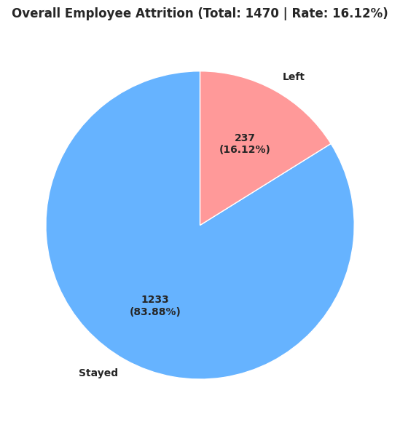

Question: What is the attrition rate by department, job role, and overtime status?
Objective
Analyze employee attrition across departments, job roles, and overtime status to identify the organizational units and employee groups with the highest turnover risk.
Methodology
Employees were grouped by Department, then by JobRole, and the attrition rate (employees left ÷ total employees × 100) was computed for each group.
Results
- Sales recorded the highest attrition rate (20.63%), followed by Human Resources (19.05%) and Research & Development (13.84%).
- Sales Representative had the highest attrition rate of any job role (39.76%).
- Laboratory Technician (23.94%) and Human Resources (23.08%) were the next highest-risk roles.
- Research Director (2.50%) and Manager (4.90%) had the lowest attrition rates.
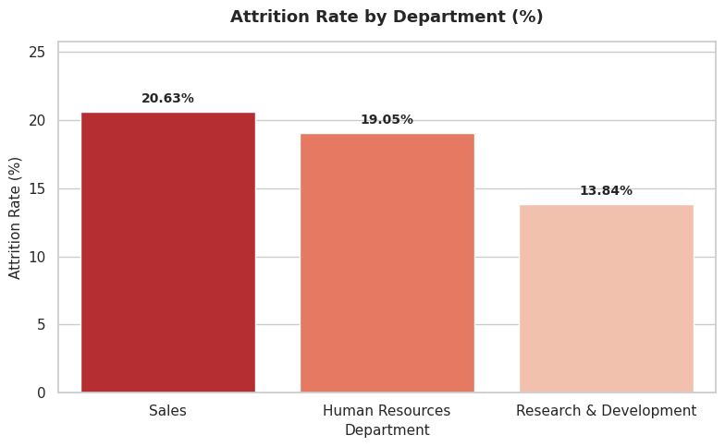
Business Insight
Sales, and the Sales Representative role in particular, is the highest-risk area for employee turnover. Employees who work overtime also show a markedly higher attrition rate than those who do not (see the OverTime analysis below).
Recommendation
- Prioritize retention programs in the Sales department, especially for Sales Representatives.
- Review overtime policies and reduce excessive overtime where possible to improve employee well-being.
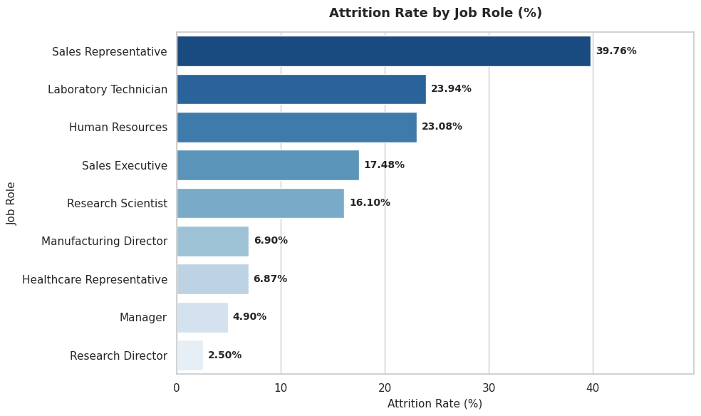

Question: Is employee attrition associated with overtime status?
Objective
Determine whether employees who work overtime are more likely to leave the company than those who do not.
Methodology
A cross-tabulation was performed between OverTime and Attrition, and the attrition rate was calculated within each overtime group.
Results
- Employees who work overtime have an attrition rate of 30.53%.
- Employees who do not work overtime have an attrition rate of 10.44%.
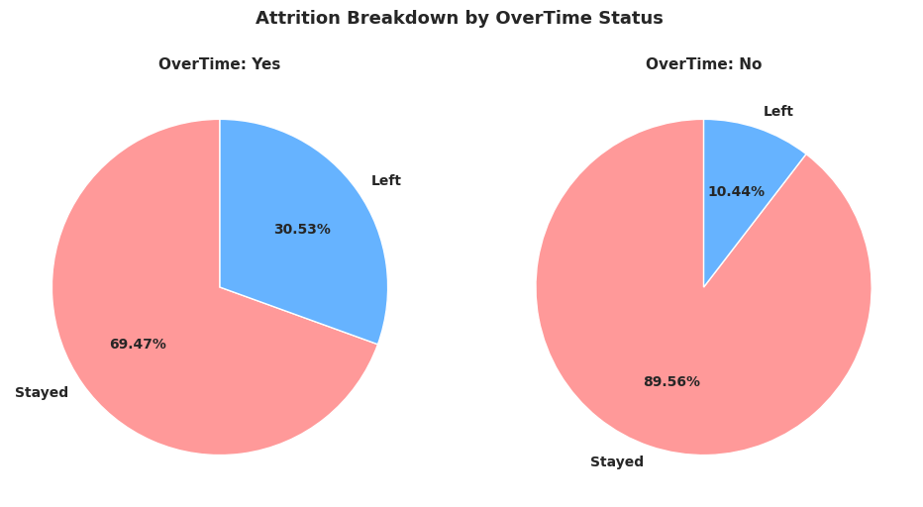
Business Insight
Employees who regularly work overtime are roughly three times more likely to leave than employees who do not, indicating that workload and overtime are strongly associated with turnover.
Recommendation
- Review overtime policies and reduce excessive overtime where possible.
- Monitor employee workload to prevent burnout.
- Strengthen work-life balance initiatives, especially for employees who frequently work overtime.

Question: What is the average monthly income by job level and attrition status?
Objective
Determine whether salary differs between employees who stayed and those who left, and whether income is associated with attrition, at each job level.
Methodology
The average monthly income was calculated by grouping employees by Job Level and Attrition Status (Left/Stayed).
Results
- Average monthly income rises consistently with Job Level, from about $2,700 at Level 1 to roughly $11,600 at Level 4-5.
- At Job Levels 1 and 2, employees who stayed earned somewhat more on average than those who left ($2,854 vs. $2,598 at Level 1; $5,474 vs. $5,760 at Level 2).
- At Job Levels 3 and 4, employees who left had a higher average income than those who stayed ($9,388 vs. $9,891 at Level 3; $13,150 vs. $10,155 at Level 4).
- At Job Level 5, average income was essentially identical for both groups (about $4,919).
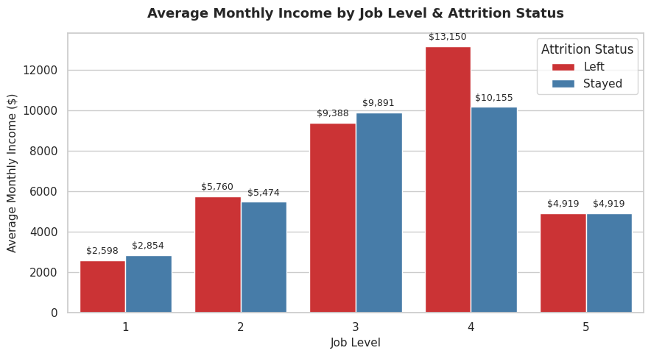
Business Insight
Monthly income is strongly associated with job level, but the relationship between income and attrition is not consistent across levels — at some levels leavers earned less, at others they earned more. This suggests salary alone is unlikely to be the primary driver of attrition, and other factors (overtime, satisfaction, workload) should be considered alongside it.
Recommendation
- Continue reviewing the compensation structure to ensure salaries remain competitive at every job level.
- Focus on non-financial retention levers — career development, workload management, and work-life balance.
- Investigate income equity further at Job Levels 3 and 4, where leavers earned more than stayers.

Question: Which employees combine low job satisfaction with frequent overtime?
Objective
Identify the concentration of attrition risk among employees who report low job satisfaction (levels 1-2) and also work overtime, since this combination may represent the highest-risk group.
Methodology
Employees were filtered to JobSatisfaction ≤ 2 and OverTime = Yes, then grouped by JobSatisfaction level to compute the attrition rate within each group.
Results
- Employees with the lowest job satisfaction (level 1) who also work overtime have an attrition rate of 35.71%.
- Employees with medium-low job satisfaction (level 2) who also work overtime have an even higher attrition rate of 37.68%.
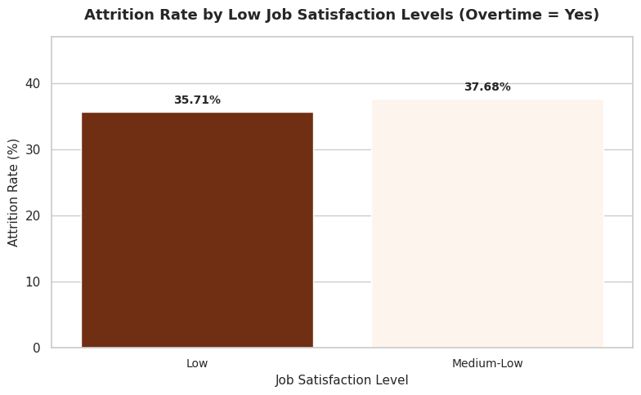
Business Insight
Overtime combined with low-to-medium job satisfaction produces attrition rates more than double the company-wide average (16.12%), confirming that this employee segment is a priority for intervention.
Recommendation
- Proactively monitor employees who report low job satisfaction and are also working overtime.
- Reduce excessive overtime and rebalance workload for this segment.
- Use engagement surveys and one-on-one check-ins to catch dissatisfaction before it leads to resignation.

Question: Which department has the highest attrition, and how does it break down by job role within that department?
Objective
Drill into the department with the highest attrition rate to identify which specific job roles are driving the turnover.
Methodology
The Sales department (highest department-level attrition at 20.63%) was selected, and its employees were grouped by Job Role to compute the attrition rate for each role.
Results
- Sales Representative recorded the highest attrition rate within Sales, at 39.76%.
- Sales Executive recorded an attrition rate of 17.48%.
- Manager recorded the lowest attrition rate in the department, at 5.41%.
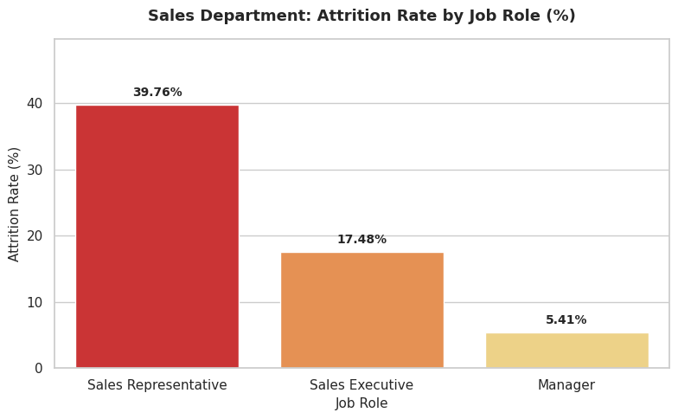
Business Insight
The high attrition rate in Sales is concentrated almost entirely in the Sales Representative role, which turns over at more than 7x the rate of Sales Managers. Attrition in this department is a frontline, not a leadership, problem.
Recommendation
- Prioritize retention strategies specifically for Sales Representatives.
- Review sales targets, workload, and performance expectations for frontline roles.
- Strengthen onboarding, coaching, and career-progression paths for sales employees.

Question: How does employee attrition vary across tenure groups (YearsAtCompany)?
Objective
Determine whether employees at certain stages of their tenure are more likely to leave the company.
Methodology
Employees were grouped into five tenure bands based on YearsAtCompany: 0-2, 3-5, 6-10, 11-15, and 16+ years, and the attrition rate was computed for each band.
Results
- 0-2 Years: 29.82% attrition (highest-risk band).
- 3-5 Years: 13.01% attrition.
- 6-10 Years: 12.28% attrition.
- 11-15 Years: 6.48% attrition (lowest-risk band).
- 16+ Years: 8.82% attrition.
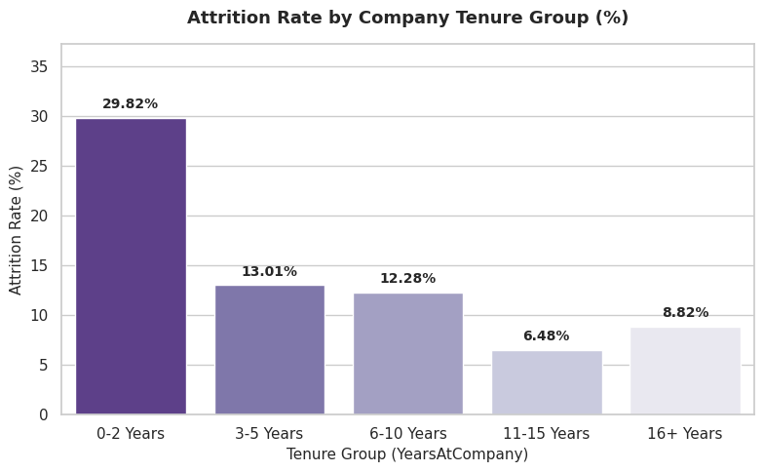
Business Insight
Attrition risk is highest in an employee's first two years and drops sharply through the 11-15 year mark, before ticking up slightly again for the longest-tenured employees. The early tenure period is clearly the point of greatest flight risk.
Recommendation
- Strengthen onboarding and orientation programs for new employees.
- Introduce mentoring or buddy programs during the first two years of employment.
- Conduct regular check-ins with new hires to surface concerns early.
- Investigate the modest uptick in attrition among 16+ year employees separately (e.g., retirement or plateaued career growth).

Question: How do average income, job satisfaction, and work-life balance compare between employees who left and those who stayed?
Objective
Compare average monthly income, job satisfaction, and work-life balance between leavers and stayers to identify which factors are most associated with attrition.
Methodology
Employees were grouped by Attrition Status (Left/Stayed), and the mean of MonthlyIncome, JobSatisfaction, and WorkLifeBalance was computed for each group.
Results
- Average Monthly Income — Left: $4,480 vs. Stayed: $5,645 (a gap of roughly 20%).
- Average Job Satisfaction (1-4) — Left: 2.47 vs. Stayed: 2.78.
- Average Work-Life Balance (1-4) — Left: 2.66 vs. Stayed: 2.78.
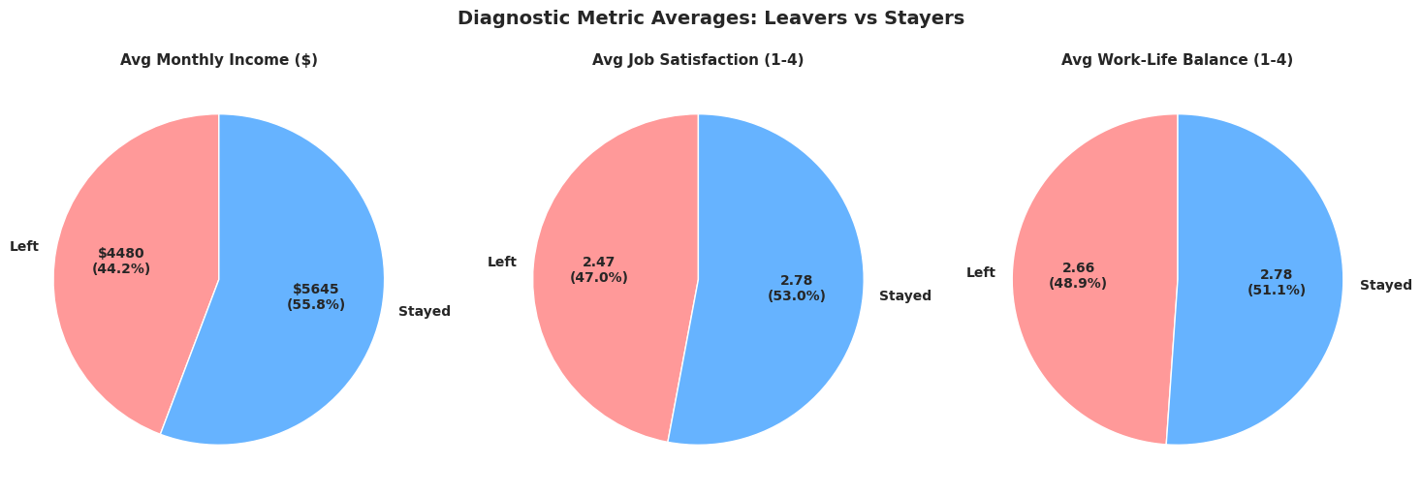
Business Insight
Employees who left earned less, reported lower job satisfaction, and reported slightly lower work-life balance than employees who stayed. The largest relative gap is in monthly income, followed by job satisfaction, while the work-life balance gap is comparatively small — attrition appears to be driven by a combination of factors rather than any single one.
Recommendation
- Review compensation to ensure it remains competitive, particularly for lower-income employees.
- Improve job satisfaction through recognition, career development, and engagement programs.
- Continue promoting work-life balance initiatives, while prioritizing compensation and satisfaction improvements.

Executive Summary & Key Findings
As computed directly in the analysis notebook:
- Overall organizational attrition rate: 16.12%
- Highest-turnover department: Sales (20.63%)
- Overtime risk multiplier: 30.53% (overtime) vs. 10.44% (no overtime)
- Early-career turnover hazard: 29.82% attrition in the 0-2 year tenure band

Final Business Recommendations
- Reduce excessive overtime, especially in the Sales department.
- Prioritize retention strategies for Sales Representatives, the single highest-risk role.
- Increase employee engagement and job satisfaction, particularly for employees combining low satisfaction with overtime.
- Review compensation for lower-income employee groups, since leavers earn noticeably less on average.
- Strengthen onboarding, mentoring, and early check-ins to support employees through their first two years.

