EJ Viewer
User’s Guide



Table of Contents
1. Overview
2. Features
2.1 Sign in to Pricing UI Tool……………………………………………………………………………………………….3
2.2 EJ Viewer…………………………………………………………………………………………………………………...4
2.3 Search with Transaction Key………………………………………………………………………………………….4
2.4 Search with Optional Search criteria……………………………………………………………………………...5
2.5 Logout……………………………………………………………………………………………………………………….7

1. Overview
This document provides a step-by-step guide for using the EJ Viewer in the Pricing Tool application. Follow these instructions to search and view Electronic Journal (EJ) data.
2. Features

2.1 Sign in to Pricing UI Tool

1. Users open the Pricing UI tool and log in using their User ID and password.

Note: The Pricing UI can be accessed from any Windows device on the store network at the following URL:
http://daisocsxenia.eastus2.cloudapp.azure.com:232. 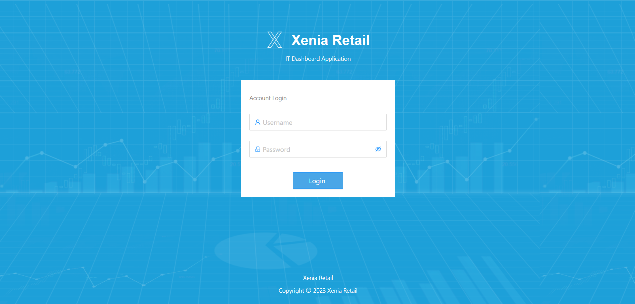

2. Sign in: After users log in using their credentials, they are directed to the Config Setup screen.
The sidebar on the left provides access to other functionalities like Item Maintenance,
Promotions and EJ Viewer.

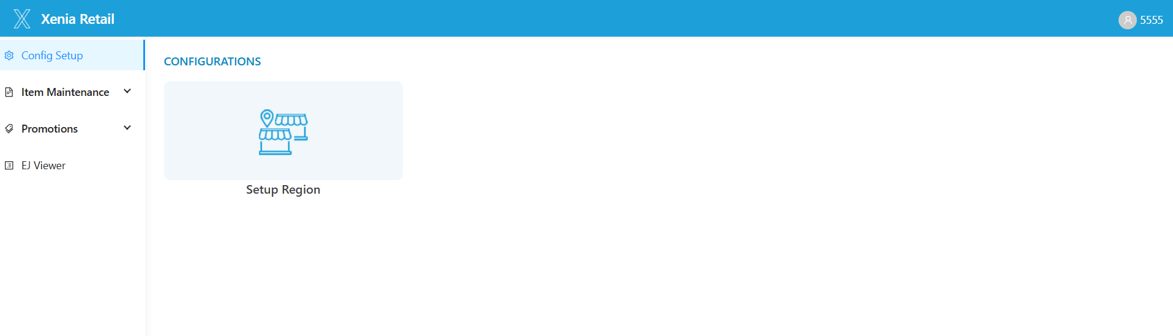

2.2 EJ Viewer
Click on EJ Viewer from the left sidebar. The EJ Viewer page will be displayed.
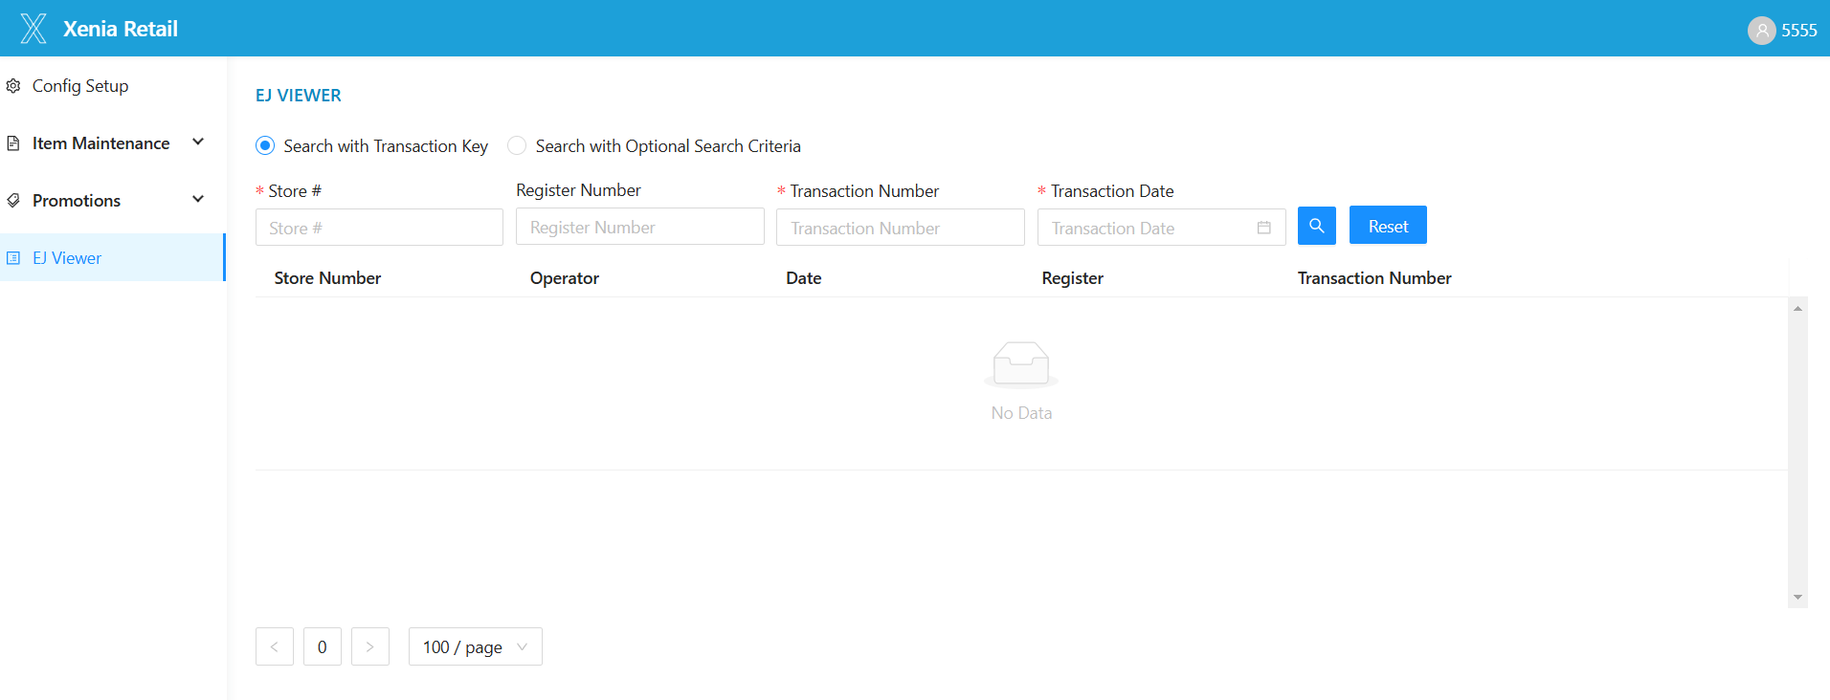

2.3 Search with Transaction Key (Default Option)
1. The page will display the Search with Transaction Key option selected by default.
2. The following fields will be available: Store (Mandatory), Register Number, Transaction Number (Mandatory), Transaction Date (Mandatory), Search Button and Reset Button.
3. Enter the required details (Store, Transaction Number, and Transaction Date).
Note: Transaction number should be 6 digits (e.g. 008633) format.
4. Click the Search button.
5. The data will be displayed with the following columns: Store Number, Operator, Date, Register, Transaction Number.
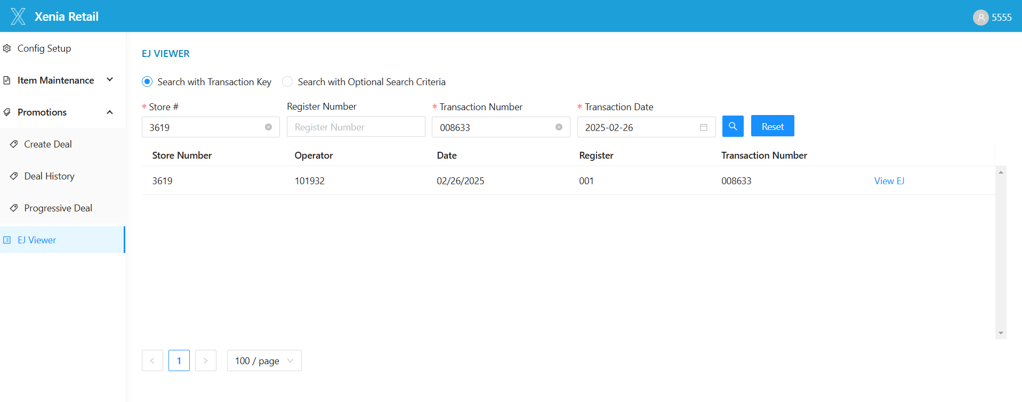
6. Click on View EJ to view the EJ transaction data.
7. The document will have a Scroll bar to navigate the EJ transaction data, along with View in full screen, Close, OK and Cancel buttons.
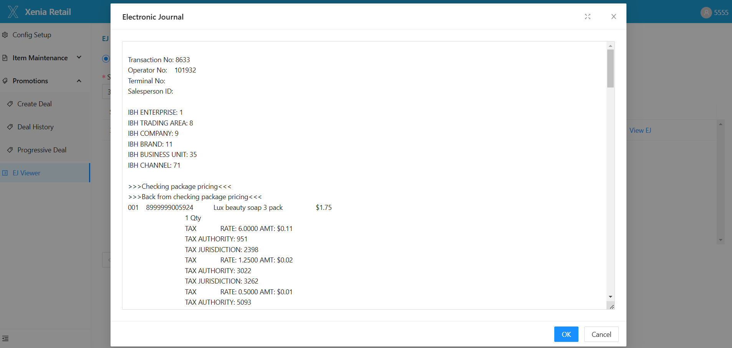
8. Click Reset to clear the search and start a new search.

2.4 Search with Optional Search Criteria
1. Select Search with Optional Search Criteria radio button.
2. The following fields will be available: Store (Mandatory), Register Number, Start Date & Time, End Date & Time, Operator Number, Search Button and Reset Button.
3. Enter Store and other fields as needed.
4. Click the Search button.
5. The previous 24 hours EJ data will be displayed.
6. The data will be displayed with the following columns: Store Number, Operator, Date, Register, Transaction Number.
7. Pagination Options will be available for navigation: First Page, Last Page, Fast Forward, Fast Backward, 10/20/50/100 per page options.
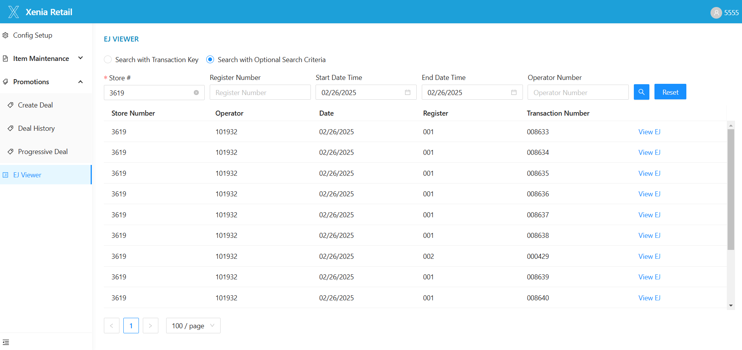

8. Click on View EJ to view the EJ transaction data.
9. The document will have a Scroll bar to navigate the EJ transaction data, along with View in full screen, Close, OK and Cancel buttons.
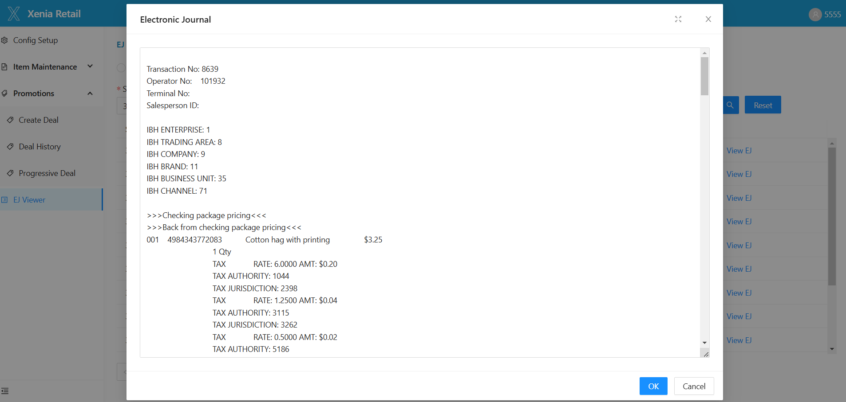

10. Click Reset to clear the search and start a new search.

2.5 Logout
1. To log out, click the Log Out icon at the top right of the screen.
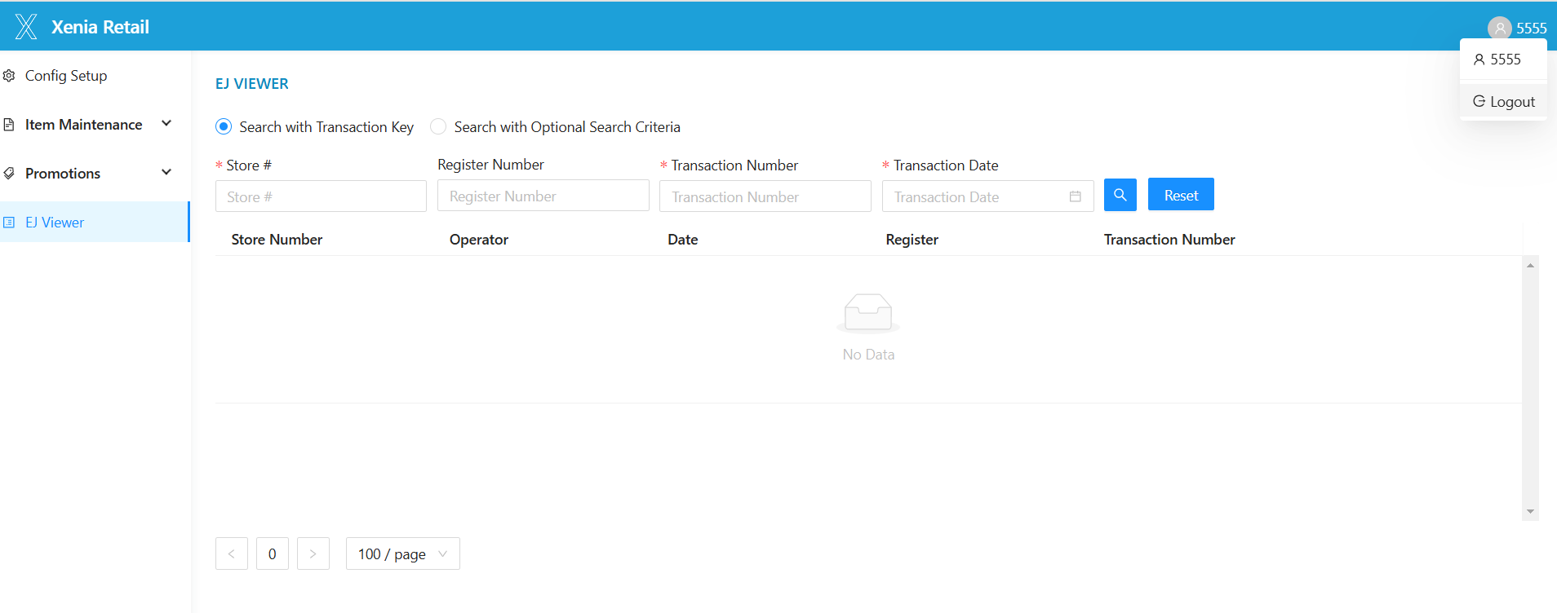

2. The system will log you out and return you to the pricing UI sign-in screen.

