`

Faculty of Engineering and Technology

Computer Science Department

**Database Management Systems**

**COMP 333**

E-Menu

Group Members:

**Mohammed Abed Alkareem ID: 1210708**

**Mosa Sbeih ID: 1211250**

**Osama Quttenh ID: 1222825**

Group**: 1**

Instructor: **Dr.** **Bassem Sayrafi**

Date: **Monday, April 15, 2024**

# Project idea

E-Menu is a website designed for restaurants, offering two interfaces. The first is for the customer, who uses their phone camera to scan a QR code, which redirects them to the website (provided they are connected to the restaurant's Wi-Fi). Upon accessing the site, the customer must enter the code for their table and then sign in using their phone. This leads to a page displaying the menu, from which the customer can order food. Payment can be made either through VISA or by requesting a receipt to pay in cash. The second interface is for restaurant management; the restaurant manager must enter a username and password to access a page that offers panels for menu modification (with options to delete, insert, or update items) and provides statistical analysis of the orders.

# Project Goal

* Payment Flexibility
* Data Analytics
* Menu Management
* Cost Savings
* Automation

# Customer Specifications

**Menu Items** have a Name, Price, Description, In stock, and a Category.

**Customers** have a Name and a Phone Number.

**Payment Methods** have a Name and Description.

**Tables** have a Table Code, Number of Seats, Location, and Type.

An **Order** is created when a **Customer** Orders **Menu Items**.

Each **Order** is linked to a single **Customer**.

A single **Order** can include multiple **Menu Items**.

**Customers** can provide a **rating** for the **Orders** they place.

Each **Order** is assigned to a specific **Table**, but a **Table** can have many **Orders**.

A single **Payment Method** is used for each **Order**.

# ER Diagram

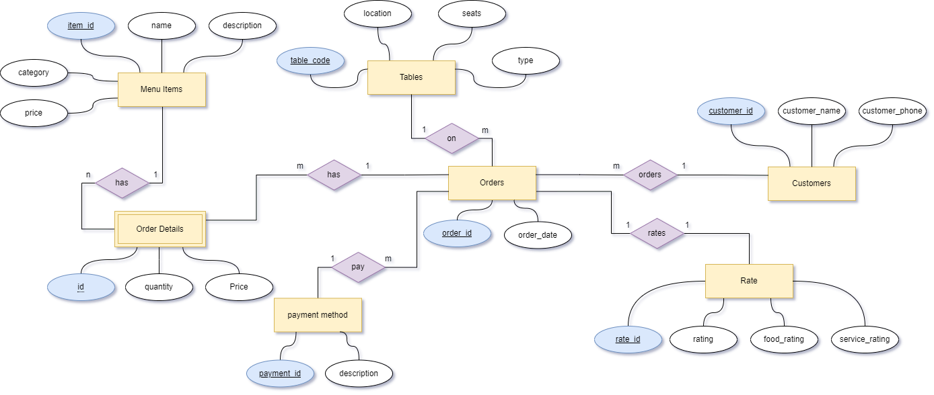

# Technology

Hardware: Average Student Laptop

Operating System:Windows.

Database System: Relational Database.

Programming Languages: Python, Javascript, Html and Css