Setting

This view contains most controller for website to controller site name, email, logo, icon, Description, Keywords, Language, Status and message maintenance. the admin can change site name Arabic or English from settings view , can change email address website if there update in email in future , can change logo website also icon , can make description for website (SEO) search Engine Optimizations to make at more active in all browser also can add Keywords for website , can change language like Arabic or English to make it main language to display website because website Supports two language and can controller Status website to make it Open or close if there process maintenance in future can make it close with make message maintenance to display in frontend for users.

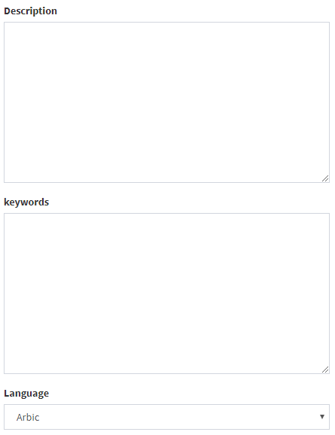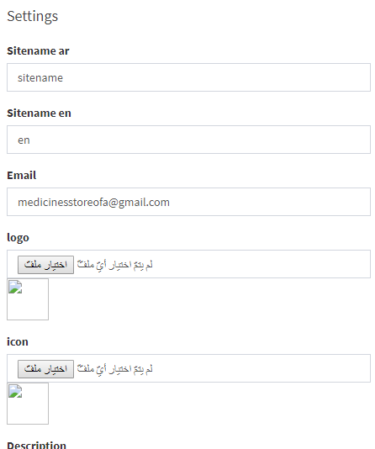

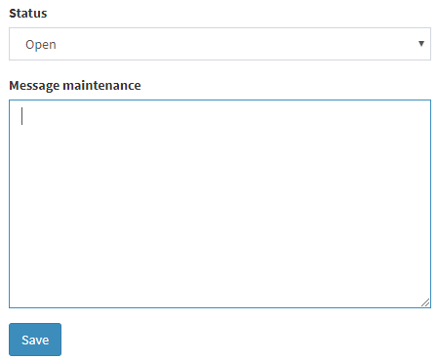

Account

This view contain accounts admins also can added, edit or delete account if the admin wants added account admin click on added admin button and enter name, email address and password.

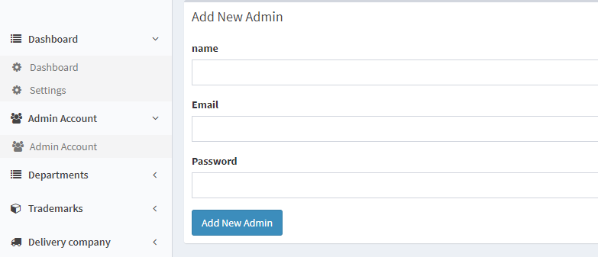

Departments or Categories

This view contains all categories for all products also the admin can added, edit or delete categories from this view if there process add category can add category more easy just click on button add and enter the information for category if there mistake in information after add process can edit it just choose category and click on button edit will display the information that want to edit also can delete it.

Delivery company view

This view contains all delivery companies in yajer datatable that show all details …

Products view

This view contains all product's companies details that show in yajra datatable that is used to display data from database also include search, print, delete, edit and add processes for search process is used for search about product in any column, print process is used for print the products information, the add process is used to add new product to add new product there are several steps must follow first must enter name, serial number and description second enter price, quantity, start show in website, end show in website,price offer if there and enter start show offer and end show offer. And the start date product and end date product. Third step enter the media product by using dropzone to enter more one image. Forth step must choose the stocks, company and trademark. If the one of them is empty this product will not add also will display message for deter where the errors.

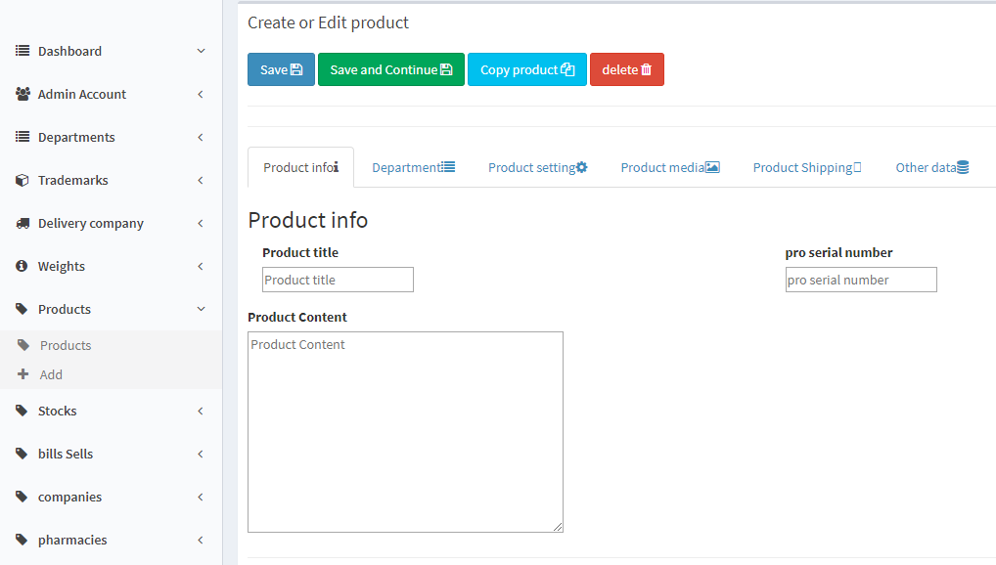

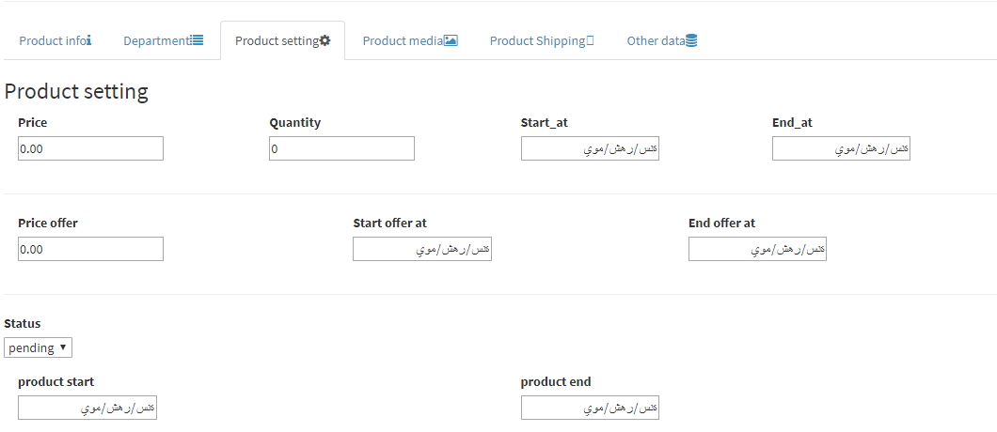

Stocks

This view include header buttons displayed as exporting buttons , adding button , print button ,refresh button and delete all button also includes datatable that display completely stock's information and search input whereas the first cell is stock name, the second cell is stock address, third cell is company's stock and the cell to edit also cell to delete. At last it has navigations button as next and previous

When you want to add a new stock click on add button to display a new view that contains allot of input field now . the must common of them are name stock , address browse it from google map , company's stock , icon and button adding after you fill all necessary information click to adding button to addition .

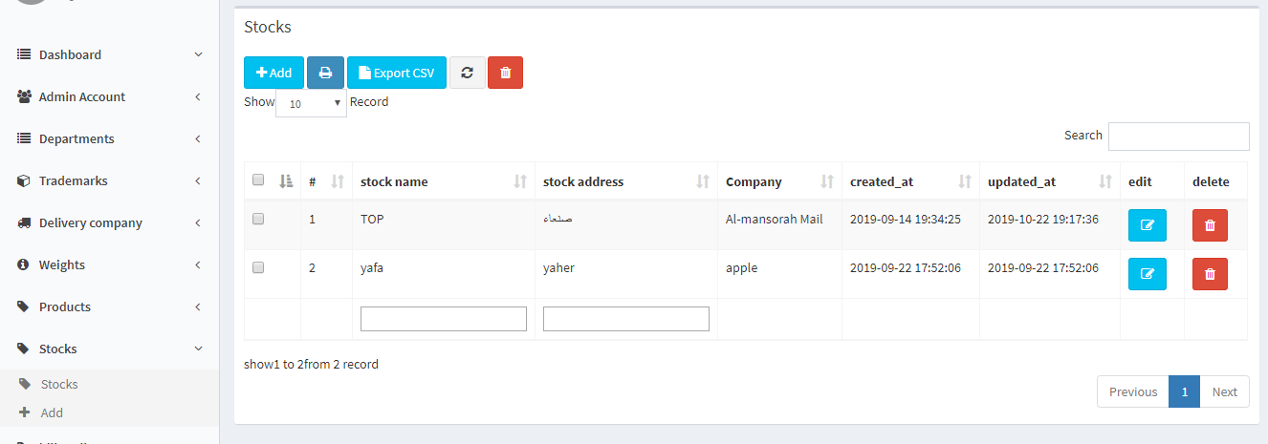

Bills view

There are tow type of bills the first one is bill sell and the second one is bill purchase that main is tow view have similar information

Bill sell

This view include header buttons displayed as exporting buttons , print button ,refresh button and delete all button also includes datatable that display completely bill's sell information and search input whereas the first cell is id bill sell , the second cell is id product, third cell is product name , quantity ,price and original price whenever cell to delete. At last it has navigations button as next and previous

Bill purchase

This view include header buttons displayed as exporting buttons , print button ,refresh button and delete all button also includes datatable that display completely bill's purchase information and search input whereas the first cell is id bill pru , the second cell is id product, third cell is product name , quantity ,price and date of purchasing whenever cell to delete. At last it has navigations button as next and previous

Companies view

This view include header buttons displayed as exporting buttons , print button ,refresh button and delete all button also includes datatable that display completely company's information and search input whereas the first cell is id company , the second cell is company name , third cell is address , phone number ,telephone and email whenever cell to delete. At last it has navigations button as next and previous

Pharmacies view

This view include header buttons displayed as exporting buttons , print button ,refresh button and delete all button also includes datatable that display completely pharmacy's information and search input whereas the first cell is id pharmacy , the second cell is pharmacy name , third cell is address , phone number ,telephone and email whenever cell to delete. At last it has navigations button as next and previous