

**University of Aden**

**Faculty of engineering**

**IT Department**

**B5ITE**

**Final project 2**

**Medicines Store**

**(Website)**

**Produced by :**

**Fahad Hussein Ahmed Hudnah 147525**

**Omar Saleh Ibraheem Bin Modied 147549**

**Abdullah Abdulmajeed Ahmed Al-Qodsi 147608**

**Supervised by :**

**Signature :**

**Dr.Wadah Ahmed**

**April/2019**

**ACKNOWLEDGMENT**

Firstly, all thanks to Allah who helped us to produce this final project. Then we would like to take the chance to acknowledge the effort of all whose helped us so directly or indirectly to choosing idea, creating and documentation this course project.

Thanks all the supervisor Dr. Wadah Ahmed , Eng. Mohson whose have supported us all the way through. Them never hesitated to provide us with any kind of assistance we needed in the this project.

Finally, we would like to express our most sincere gratitude to our families because without their continuous support and encouragement, we could not have undertaken this work and completed it on time .Thanks to the head of IT department Dr.Jamal on the given efforts for advising us to work this project

**ABSTRACT**

In this project will be the work of a website for medicines, the site of the sale and purchase between companies and displays the products of pharmaceutical companies and the process of shipping and delivery as a mediator between the sale and the buyer.

One of the most important features of the project:-

* It makes a sale platform for various pharmaceutical companies.
* Makes the sale easier.
* Facilitates the delivery and charging process.
* Facilitates the operation and management of companies.
* It facilitates the search for medicines.

|  |  |
| --- | --- |
| **Index** | **Page** |
| **ACKNOWLEDGMENT …………………………………………………** | **i** |
| **ABSTRACT ……………………………………………………………….** | **ii** |
| **Chapter 1** |  |
| 1.1 Overview …………………………………………...…….……………. | 1 |
| 1.2 Problem Statement ………………………………………..…………... | 1 |
| 1.3 motivation of project………………………………………………….. | 2 |
| 1.4 Scope of project …………………………………………………………………………………. | 2 |
| **Chapter 2** |  |
| 2.1 Introduction ………………..………………..……………...…………. | 3 |
| 2.1 SAP ………….……………..………………………..………..……….. | 3 |
| 2.2.1 SAP ARIBA NETWORK…...……………..………..………………. | 3 |
| 2.3 Saydl ………..………………………..………..………..…………….. | 5 |
| 2.4 PharmEasy ……….…………………………………..………..……… | 6 |
| 2.5 One image …………………………………………………………….. | 6 |
| 2.6 Amazon Health Care ………………………………………………….. | 7 |
| 2.7 Mchemist………………………………………………………………. | 7 |
| 2.8 Netmeds…………………………………………………………………. | 7 |
| Chapter 3 |  |
| 3.1 Introduction ………………..…………...……………………………….. | 9 |
| 3.2 PHP …………………………………………………………………….. | 9 |
| 3.3 Laravel .……….……..………………………………………………….. | 9 |
| 3.4 Vue Js or Angular.……….………………..…………..…………………. | 11 |
| 3.5 Conclusion – Angular JS vs Vue JS….…………………..………………. | 12 |
| 3.6 HTML ……….……………………………………..………..…………… | 13 |
| 3.7 CSS ………………………………………………………………………. | 14 |
| 3.8 JavaScript ……….……….……………………………..…………..……. | 14 |
| 3.9 Bootstrap.……….…………………………………..…………..………... | 14 |
| Chapter 4 |  |
| 4.1 Introduction ……………………………………………………………… | 15 |
| 4.2 UML Use case Diagram …………………………………………………. | 15 |
| 4.3 UML Sequence Diagram ………………………………………………… | 22 |
| 4.4 UML Class Diagram …………………………………………………….. | 25(A3) |
| 4.5 ERD ………………………………………………………………………. | A3 |
| 4.5 Database ………………………………………………………………….. | A3 |
| **CONCLUSION ……………………………………………………………...** | v |
| **REFERENCES ………………………………………………………………** | vi |

**Content**

**Table of Figures**

|  |  |
| --- | --- |
| **Name of figure** | **Page** |
| Figure 4.1: Use Case for login processor | 16 |
| Figure 4.2 : Explain view Items by use case | 17 |
| Figure 4.3 : Explain checkout by use case | 18 |
| Figure 4.4 : Web application admin website | 19 |
| Figure 4.5 : Website administrator | 19 |
| Figure 4.6 : Explain by use case the website administrator | 20 |
| Figure 4.7 : Explain operation of session | 21 |
| Figure 4.8 : Manage logs | 22 |
| Figure 4.9 : Sequence of operation for admin | 23 |
| Figure 4.10 : Sequence to customer | 23 |
| Figure 4.11 :Explain how to order from website | 24 |
| Figure 4.12 : Order by sequences | 24 |

**CHAPTER ONE:** **INTRODUCTION**

**1.1 Overview**

In our project, we will implement four parts of the SAP system, the procurement and sales system, the shipping and transport system, warehouse Management and the accounting system, our project is a web site for pharmacy medicines store.

In addition, some of the previous work will be mentioned in the second section and they will mention how they work and what tools they use in working Web sites There are many examples in this area.

In the third digit we will mention the languages and tools that will be used in our work and we will learn about the advantages of the languages and why they were selected from the rest.

**1.2 Problem Statement**

There are many problems and difficulties that have made us think about solving these problems in the field of buying and selling drugs.

1- Difficulty in finding the required medication in a short time.

2- Take a lot of time to get down to distributing medicines by companies across their distributors.

3- Monopoly of some traders for some types of medicines because there is not enough quantity in the market.

4- Difficulty connecting drugs to remote areas.

5- Difficulty managing company accounts.

**1.3 Project Objectives**

There are many goals for the project :  
*1- Solve all the above mentioned problems  
2- Make the sale of drugs more easy for pharmaceutical companies  
3- Offers to all regions through our website  
4- Saving on companies in money, business and time*

**1.4 Scope of Project**

The project scope consists of four parts from SAP application. Not all SAP applications are implemented, but only four are chosen for the reason we do not need these applications to run our project as human resource management. In addition to the lack of time for all applications.

Due to the lack of a payment feature online for not providing the payment card in our country, Yemen has been replaced with cash payment or money transfer through banks and cashiers.

The process of developing the e-commerce website will go through several phases to complete the main objective:

* First, we should analyze the website effectively and define all the tasks that the system will be able to accomplish.
* Second, the website will be developed, so the relational database and tables should be analyzed and designed. After that, the design of the website should be completed and flexible in order to let all the people use it without any problem.
* Third step, we should write the codes needed to accomplish the tasks perfectly. After completing the website and Database of website.
* Fourth Each hand account especially where to spread jobs on the website.
* Finally, upload files of website onto the server, it will be collected all the data.

**CHAPTER TWO: PREVIOUS WORK**

**2.1 Introduction**

In this chapter we will discuss some things that about similarity previous work as our final project So we will get good advantages from the previous work and put them in our final project the similarity are the following:

* 1. **SAP**

SAP is system use Enterprise Resources Planning model used to Provides end to end solutions for financial, logistics, distribution, inventories. The ERP meaning Enterprise Resource Planning is completely planning for company management by other way is solutions for financial, logistics, distribution, inventories in any company

SAP system is a business software package designed to integrate all areas of a business.

* + 1. **SAP ARIBA NETWORK**

Ariba Network is a hosted service that connects suppliers to buying organizations, allowing them to conduct transactions over the internet.

The SAP Ariba's Network solutions make it easier to collaborate , complet , and raising your business in short time . SAP Ariba is how companies connect to get business done, using our market-leading solutions for digital commerce and Ariba Network.

The Benefits of using Ariba Network when you Registering on Ariba Network provides suppliers with access to a network of high-volume buying organizations that can download the supplier’s product and service catalogs and decide which products to purchase.

Suppliers and buyers can use Ariba Network no matter what they sell or buy.

**The purchase order life cycle**

* Their customer uses their procurement application to browse catalogs for products and services and initiate purchase requisitions, which are routed through their organizations for approval.
* Up on approval, the customer’s procurement application automatically converts the requisitions to purchase orders and sends them in cXML format to Ariba Network.
* Ariba Network sends the purchase orders to the supplier’s account where they can view them in their online inbox.
* If the customer’s business rules allow suppliers to send order confirmations, ship notices, and invoices through Ariba Network, suppliers can then send order fulfillment information and invoices electronically to their customer.

We get from SAP, SAP Ariba and ERP planning how to make your system completely for manage any company with any service it needs

Way Provides end to end solutions for financial, logistics, distribution, inventories way of analyzing ,designing , documenting and implementing the way of helping buyer and supplier to support their business

* 1. **Saydl** [www.saydl.com](http://www.saydl.com)

Saydl is a mobile application that gives you the convenience of purchasing all your pharmaceutical needs and delivering them to you within an hour Aslas is an innovative e-commerce company founded in 2016, and located in Riyadh, Saudi Arabia. Saydl is one of the best services we provide. Our mission is to provide on-demand pharmacy delivery services in form of mobile apps to the Saudi Arabian market. We use technology to improve the lives of our users, and to automate their day-to-day activities with top quality solutions.

**Saydl's Features**

* **Delivery within one hour** We’re fast on our feet and care about the well-being of our customers. All supplies from your order will be delivered within 1 hour.
* **Pay on delivery** You pay when the items are delivered to your home.
* **Stock availability check** No more jumping from one to another pharmacy to get what you need. Saydl allows you to check the stock in different stores before you make the order.
* **Save your time** Stop losing a few hours from your busy schedule in traffic just to get some medical supplies.
* **User-friendly interface** Everything you need is just a few screens taps away.
* Vast inventory of pharmaceutical supplies What you would buy in your favorite pharmacy, you can get it using our app.
* **Scheduled delivery** You choose the delivery time and we make sure you get on time.

What do we get from Saydl ?

We get from Saydl the speed delivery the order from the nearest pharmacy its give the buyer his order and the structure of payment pay on deliver You pay when the items are delivered to your home

* 1. **PharmEasy**  [www.pharmeasy.in](http://www.pharmeasy.in)

PharmEasy is pharmacy made easy. In a short span of three years, we have established ourselves as India’s leading online healthcare and medicine delivery platform, catering to two million customers pan India. Through our mobile app and website, we help customers (patients and their caregiver) connect with local pharmacy stores and diagnostic centers to fulfill their extensive medical needs. We firmly believe that everyone should have access to good health and that health care should be affordable to all We now deliver medicines in 1000+ cities in India, covering 22000+ pin codes.

What do we get from PharmEasy ?

We get from PharmEasy firstly the design of their website they made it for mobile and computer , the way of helping buyers as connect with local pharmacy stores and diagnostic centers to fulfill their extensive medical needs if that medicine in their website .

* 1. **One image** [www.1mg.com](http://www.1mg.com)

Order medicines and health products online and get it delivered at home from licensed pharmacies 1mg.com brings to you an online platform, which can be accessed for all your health needs. We are trying to make healthcare a hassle-free experience for you

What do we get from One Image ?

We get from One Image how to make your website desirable or lovely to the buyers the way of acquisition the buyer

* 1. **Amazon Health Care** [www.amazon.com](http://www.amazon.com)

All of us know amazon what is it and what amazon for.

What do we get from amazon health care ?

We get from amazon the structure of secure buyer's business as visa card or others and grantee for delivery his order what steps you flowing in it when you buy any things

* 1. **Mchemist**  [www.mchemist.com](http://www.mchemist.com)

Modernizing the conventional means of buying medicines, mCHEMIST provides fully functional online prescription medicine buying service to the users. It facilitates the purchase and delivery of prescribed medicines and healthcare products. Our online pharmacy provides customers access to affordable medicines backed by outstanding customer service and support

What do we get from Mchemist ?

We get from mchemist the way of provides buyers access to affordable medicines or to get information about it

* 1. **Netmeds** [www.netmeds.com](http://www.netmeds.com)

With a long legacy of over 100 years in the pharma business, Netmeds.com is the first choice of Online Pharmacy India for over 3 million+ satisfied customers, delivering health essentials to every state in the nation – PAN India.

At Netmeds.com get everything you need to take care of your health from high-quality, affordable prescription medicines, over-the-counter pharmaceuticals to general health care products, Ayurveda and Homeopathy medicines.

Right at the comfort of your home, buy medicines online at Netmeds.com to get them delivered straight to your door anywhere across India.

Why Choose Netmeds.com?

* Over 100 Years of Service in the Pharma Industry
* No Limits! Delivery All Across India
* Family Pharmacy of choice for 3 Million Indians
* High-Quality, Genuine Medicines
* A Team of Highly Experienced Pharmacists
* State-of-the Art Warehouses
* A Large Inventory of Medicines/35000+ SKUs

What do we get from Netmeds?

We get from Netmeds the ways of spreading and controlling on large space of India do for long time to be common and delivery in any cities in India and it provides all kinds of medicines

**CHAPTER THREE: METHODOLOGY**

* 1. **Introduction**

In this book we will talk about the methodologies used in our project and the definition of each methodology and its advantages and how to use and what role in the project in addition to why we chose this methodology at the expense of other methodologies.

**3.2 PHP**

PHP is a server side scripting language for building dynamic, interactive Web sites. As a general rule, PHP programs run on a Web server, and serve Web pages to visitors on request.

One of the key features of PHP is that you can embed PHP code within HTML Web pages, making it very easy for you to create dynamic content quickly.

*What exactly does the phrase “ dynamic, interactive Web sites ” mean?*

A *dynamic* Web page is a page whose contents can change automatically each time the page is viewed. Contrast this with a *static* Web page, such as a simple HTML file, which looks the same each time it ’ s displayed (at least until the page is next edited). Meanwhile, an *interactive* Web site is a site that responds to input

from its visitors. A Web forum is a good example — users can post new messato the forum, which are then displayed on the site for all to see. Another simple example is a “ contact us ” form where visitors interact with the page by filling out and sending a form, which is then emailed to the Webmaster.

**3.3 Laravel.**

Why Choose Laravel over other PHP Frameworks?

[Laravel](https://www.techcompose.com/technologies/laravel-application-development/) has been launched just 7 years ago but has taken over the whole development field. Laravel is the only one such framework which has made [PHP](https://www.techcompose.com/technologies/php-development/) even more useful than it was earlier by introducing various latest advancements in the PHP platform.

PHP has always been a very dynamic language but since the arrival of Laravel, it has even become more powerful, faster, simpler and secure. With every new release, it seems to make a certain advancement in the PHP framework. The major and foremost aim behind the [Laravel development](https://www.techcompose.com/it-services/web-application-development/) was to prevent faults that happens in the coding and security of the development. This Laravel framework was built with a purpose to strengthen security, database migration with lower data loss in order to make the entire development process quite easy.

Let’s look into more benefits of Laravel over other PHP Languages:

**Benefits:**

* *Composer based dependency manager*
* *Eloquent ORM*
* *Artisan command with sample codes lines interface.*
* *Faster Caching*
* *Database Migration*
* *Easy Unit-Testing*
* *Blade template engine*
* *Offers incredible development features such as security, user-friendly interface, and maintenance.*
* *Rich Add-ons*
* *More secure than other frameworks*
* *Artisan command with sample codes lines interface.*
* *IoC Container*

***3.4 Vue Js or Angular.***

*Differences Between Angular JS vs Vue JS*

Angular JS is an open source framework for building web application front-end and based on JavaScript. It is maintained by Google developers to address the challenges faced during the development of single page applications.

Vue is a JavaScript front-end framework created by Evan You, after utilizing[Angular JS](https://www.educba.com/angularjs-interview-questions/) in multiple projects in Google. The purpose of Vue is to organize and [simplify web development](https://www.educba.com/python-and-django-for-web-development/). Vue was originally released in February 2014.

Angular JS provides a set of features to greatly reduce the amount of code and hence effort involved to make an application fully functional. It is also described as Model-View-Controller (MVC) framework because its approach is modular toward building an application.

With the help of Vue, web UI developments can be more approachable. It is easier for developers to pick up since it is less opinionated. The architecture of Vue is incrementally adoptable, this is one of the key strength of Vue.

There are more than one [JavaScript files](https://www.educba.com/javascript-vs-ruby/) in Angular JS. The core file is included by every application wishes to use Angular JS since it contains major framework features. Additional files and modules can be added to functionality built on the top of a core feature.

The core library of Vue focuses primarily on declarative rendering and component composition and can be embedded into existing pages. When it comes to design reactive systems, Vue can become a lifesaver within a short span of time. Vue cares about features which a framework must provide to developer i.e.  Performance, flexibility and ease of use. Vue is a major leap when it comes to flexibility and ease of use. It also provides seamless configuration and customization to fit the specific needs of already existing web pages.

Angular JS is very useful in creating dynamic [web applications](https://www.educba.com/how-to-build-web-applications-using-mongodb/). Developers working with Angular JS uses HTML as template language and its syntax is used to express the application’s component briefly. Its architecture allows automatic and smooth data synchronization between model, view, and components. For a single-page based web application, Angular JS is quicker and easier to code. Its templates are same as the traditional plain HTML and include extended [HTML terminology](https://www.educba.com/course/online-html-training/), which means that even a beginner can straight away get his hands dirty with Angular JS.

Vue can be easily integrated with other projects and libraries. Its installation is fairly simple, even beginners can start building user interfaces from the word ‘go’. Vue makes the use of DOM (Document Object Model), which is also used by other [JavaScript frameworks like React](https://www.educba.com/best-javascript-frameworks/), Ember etc. Instead of directly changing the DOM, it will change the replica of DOM, final changes are updated then to the real DOM, which the users will see changes.

Angular JS provides a potential to build GUI (Graphical User Interface) for dynamic websites and web programs. Single page applications are created smoothly using Angular JS framework which allows writing custom HTML codes and integrating with other UI tools.

**3.5 Conclusion – Angular JS vs Vue JS**

If developers are looking for easier product creation, they should choose Vue JS. It would be a more helpful option when your JavaScript fundamentals are not too strong. If your front end is Laravel community, then you should definitely go with Vue JS since [Laravel](https://www.educba.com/laravel-vs-codeigniter/) community considers Vue JS as their most preferred framework. It will reduce the total process time by 50% and also frees up space on the server.

Angular JS is a better option for those developers who need to deal with both client side and server side modes. If one wishes to create heavy web applications with several components and complex requirements, Angular JS would be an ideal choice. One can also go with Angular JS if there is a requirement to choose the existing components in a new project.

Vue JS is lightweight and acts as a fitter little brother of Angular JS. If you want a less opinionated framework, Vue JS is a better choice than Angular JS whereas Angular JS is a preferred way of building complex applications, yet good quality. So basically which one is perfect boils down to the nature of the project and learning capability of a developer. But Angular JS and Vue JS both JavaScript frameworks can give the best results for your application development.

* 1. **HTML.**

HTML is the standard markup language for creating Web pages.

* HTML stands for Hyper Text Markup Language
* HTML describes the structure of Web pages using markup
* HTML elements are the building blocks of HTML pages
* HTML elements are represented by tags
* HTML tags label pieces of content such as "heading", "paragraph", "table", and so on
* Browsers do not display the HTML tags, but use them to render the content of the page.
  1. **CSS**
* CSS stands for Cascading Style Sheets
* CSS describes how HTML elements are to be displayed on screen, paper, or in other media
* CSS saves a lot of work. It can control the layout of multiple web pages all at once
* External stylesheets are stored in CSS files
  1. **JavaScript**
* JavaScript is the Programming Language for the Web
* JavaScript can update and change both HTML and CSS
* JavaScript can calculate, manipulate and validate data
  1. **Bootstrap.**

Bootstrap is a [free and open source](https://whatis.techtarget.com/definition/Free-and-open-source-software-FOSS-or-free-libre-open-source-software-FLOSS) [front end](https://whatis.techtarget.com/definition/front-end) development framework for the creation of websites and [web apps](https://searchsoftwarequality.techtarget.com/definition/Web-application-Web-app). The Bootstrap framework is built on [HTML](https://www.theserverside.com/definition/HTML-Hypertext-Markup-Language), [CSS](https://www.theserverside.com/definition/cascading-style-sheet-CSS), and JavaScript ([JS](https://www.theserverside.com/definition/JavaScript)) to facilitate the development of [responsive](https://whatis.techtarget.com/definition/responsive-design), [mobile-first](https://searchmobilecomputing.techtarget.com/definition/mobile-first) sites and apps.

Responsive design makes it possible for a web page or app to detect the visitor’s screen size and orientation and automatically adapt the display accordingly; the mobile first approach assumes that smartphones, tablets and task-specific mobile apps are employees' primary tools for getting work done and addresses the requirements of those technologies in design

Bootstrap includes user interface components, layouts and JS tools along with the framework for implementation. The software is available precompiled or as [source code](https://searchmicroservices.techtarget.com/definition/source-code).

**CHAPTER FOUR :ANALYSIS**

**4.1 Introduction**

In this chapter we will talk about the analysis and how to analyse and then we will analyse through the diagrams and three types from UML Diagrams Use case , Sequence and class diagram were developed and then we show you the database and how the relationships between the tables.

**4.2 UML Use Case Diagram**

Web Customer actor uses some web site to make purchases online. Top level use cases are View Items, Make Purchase and Client Register. View Items use case could be used by customer as top level use case if customer only wants to find and see some products. This use case could also be used as a part of Make Purchase use case. Client Register use case allows customer to register on the web site, for example to get some coupons or be invited to private sales. Note, that Checkout use case is included use case not available by itself - checkout is part of making purchase.

Except for the Web Customer actor there are several other actors which will be described below with detailed use cases.

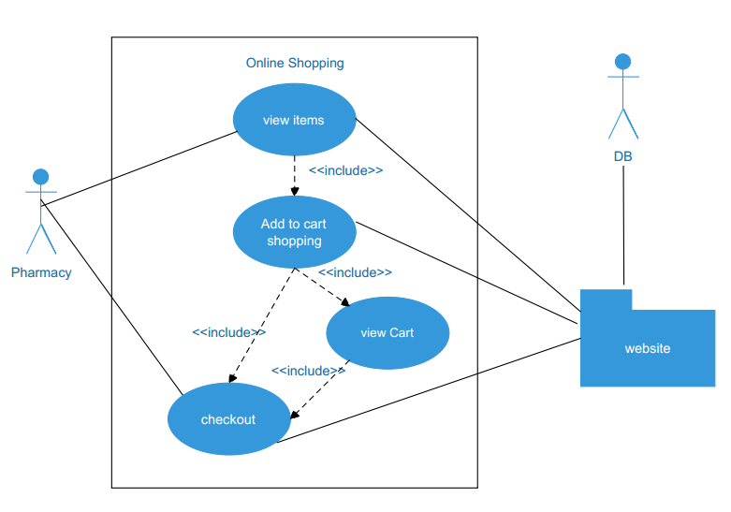Figure 4.3 : Explain Online Shopping by use case.

Web Customer actor uses some web site to make purchases online. Top level use cases are View Items, Make Purchase and Client Register. View Items use case could be used by customer as top level use case if customer only wants to find and see some products. This use case could also be used as a part of Make Purchase use case. Client Register use case allows customer to register on the web site, for example to get some coupons or be invited to private sales. Note, that Checkout use case is included use case not available by itself – checkout is part of making purchase. 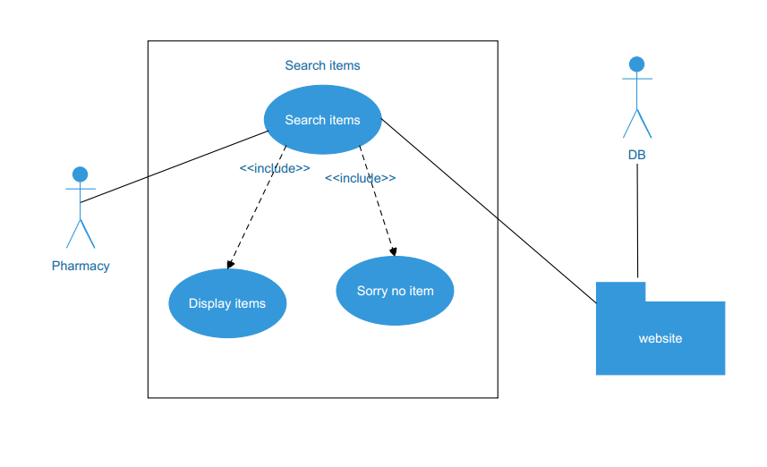  Figure 4.3 : Explain Search items by use case.

View Items use case is extended by several optional use cases - customer may search for items, browse catalog, view items recommended for him/her, add items to shopping cart. All these use cases are extending use cases because they provide some optional functions allowing customer to find item.

Customer Authentication use case is included in View Recommended Items and Add to Wish List because both require the customer to be authenticated. At the same time, item could be added to the shopping cart without user authentication.

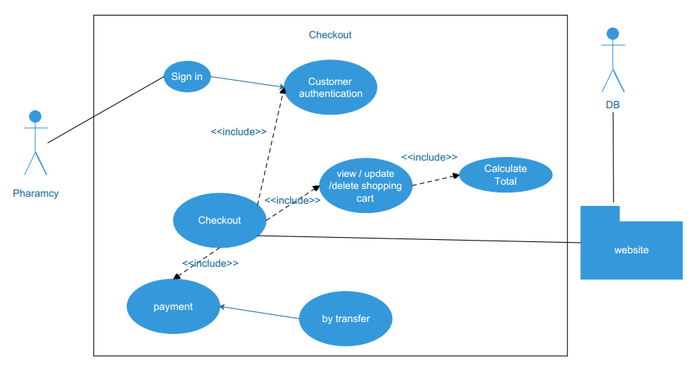

Figure 4.3 : Explain checkout by use case

Checkout use case includes several required uses cases. Web customer should be authenticated. It could be done through user login page.

Checkout use case also includes Payment use case which could be done either by using receive order.

Many actors using administrative interfaces are Website Administrator and Help Desk. Help Desk uses a subset of functions available to the Website Administrator. All top level use cases shown are abstract as each represents some group or "package" of administrative functionality.

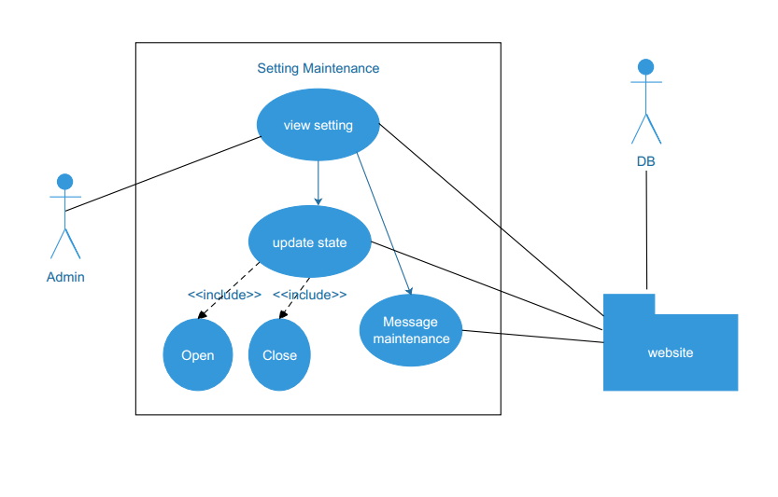

Figure 4.3 : Explain Setting Maintenance by use case

Manage Setting Maintenance abstract use case is specialized by Update State to Open or Close With include message maintenance to shows the reason. The idea is that website administrator could create different maintenance , for example, having different development in future.

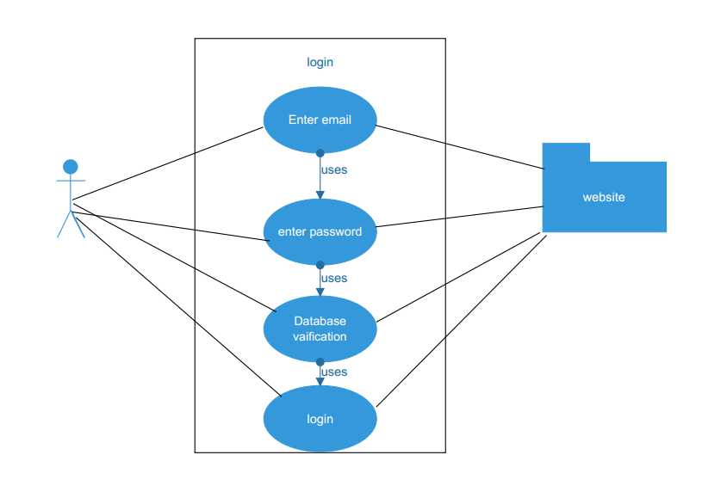

Figure 4.5 :website administrator

This use case describes how a user logs into the website. If in the Basic Flow the actor enters an invalid name and/or password, the system displays an error message. The actor can choose to either return to the beginning of the Basic Flow or cancel the login, at which point the use case ends.

List of administrative functions included in the log management depend on the security requirements supported and implemented by the website.

Website administrator should be able to see status of logs. The status could include verification that logging is still functional (there is enough space on disk and/or connection to database is not stale), and that older log files are on schedule being moved to a permanent storage for archiving

User session is created either for each new incoming request that is not yet part of a session, or/and after user was authenticated. Website administrator should have ability to see how many sessions were created, including some statistics about sessions, to find some specific session and see status of that session, and to cancel (delete) some session, if required.

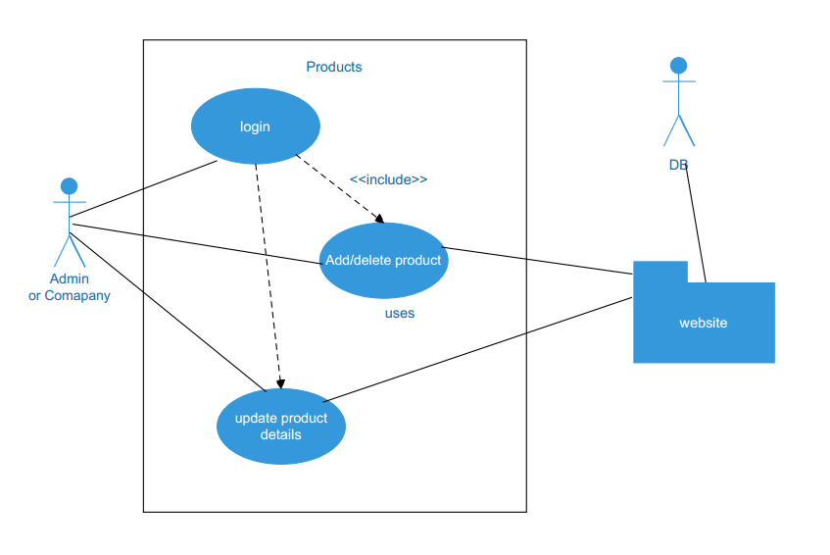

Figure 4.6 : Explain by use case the Products management.

Products management use cases are available both to the Website Administrator and to the Help Desk. There is standard user CRUD (Create, Retrieve/Find, Update, Delete) functionality set.

Two other use cases, Add/delete product and update product are specific to website security.

Figure 4.7 : Explain operation of session

**4.3 UML Sequence Diagram**

Sequence diagram is the most common kind of interaction diagram, which focuses on the message interchange between a number of lifelines.

Sequence diagram describes an interaction by focusing on the sequence of messages that are exchanged, along with their corresponding occurrence specifications on the lifelines.

In finger how the processor login action in sequence diagram .

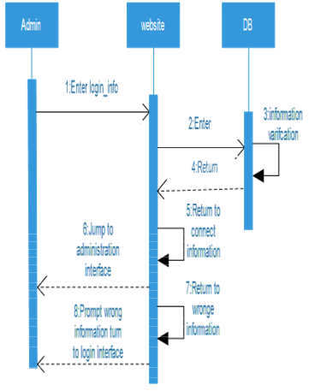

Figure 4.9 : sequence of operation for admin

sequence diagram for online bookshop. Online customer can search about category, view description of a selected category , add category to shopping cart, do checkout.

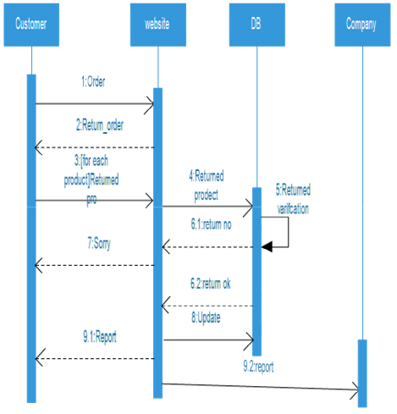

Figure 4.10 : Sequence the customer



Figure 4.11 :Explain how to order from website

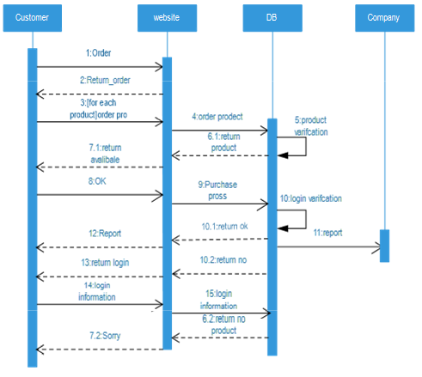

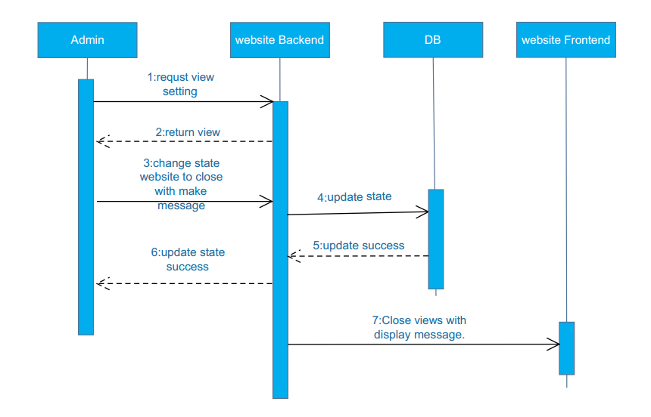 **Figure 4.3 : Explain checkout by use case**

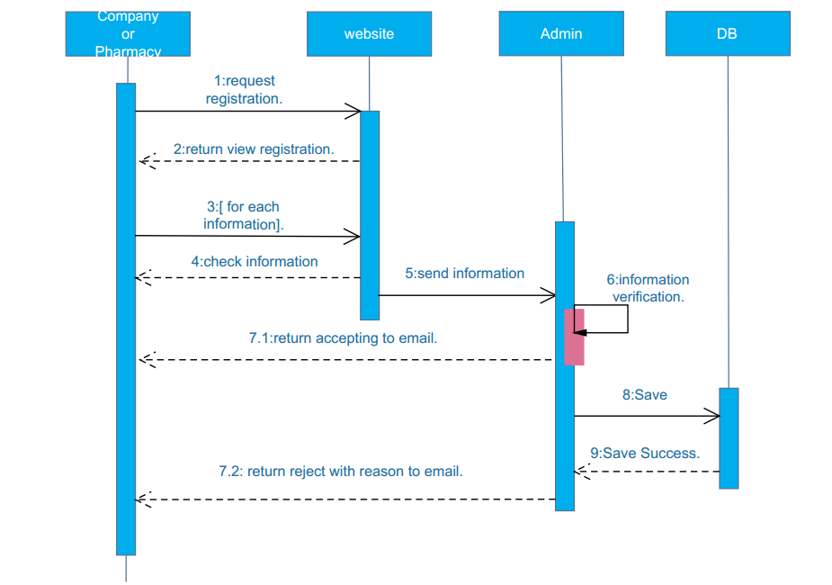

**Figure 4.3 : Explain checkout by use case**

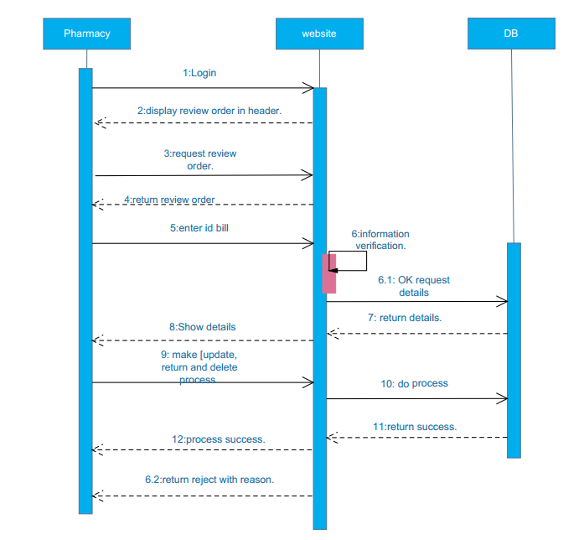 **Figure 4.3 : Explain checkout by use case**

**4.4 UML Class Diagram**

Class diagram is UML structure diagram which shows structure of the designed system at the level of classes and interfaces, shows their features, constraints and relationships - associations, generalizations, dependencies, etc.

Some common types of class diagrams are:

* domain model diagram,
* diagram of implementation classes.

Object diagram could be considered as instance level class diagram which shows instance specifications of classes and interfaces (objects), slots with value specifications, and links (instances of association).

**CONCLUSION**

In our project to build on Medicine store web application for companies and pharmacies.

The web application is benefit for both companies enable companies to buy has product and show easy to the pharmacies while the benefit of pharmacies the web application will let potential pharmacies check product by category and pass orders security and provides process delivery to the places of pharmacies ,while admin perform their business and get interest rate , so this project will easy process of purchase and sell and delivery and benefit the pharmacy to see everything new about company such product and views etc.

**REFERENCES**

* 1. <https://www.uml-diagrams.org>
  2. <https://www.sap.com/index.html>
  3. [www.saydl.com](http://www.saydl.com)
  4. <https://www.php.net/>
  5. <https://laravel.com/>