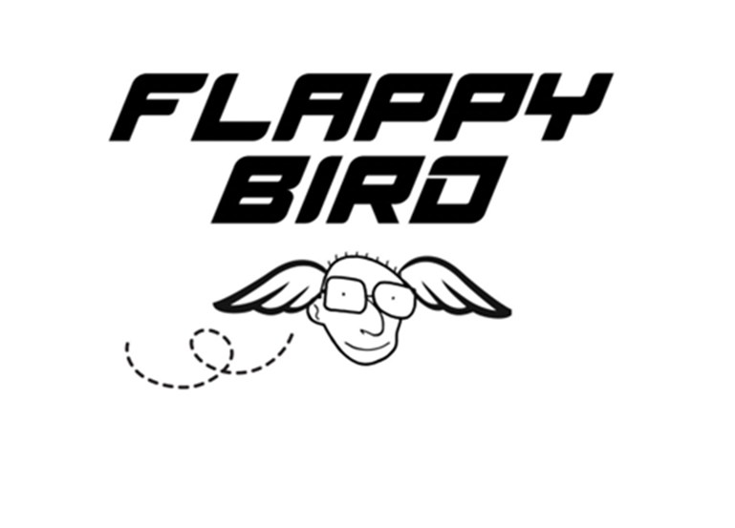

**Course:** COMP 2659, Winter 2023

**Instructor:**  Paul Pospisil

**Author(s):**  Mohammed Arab, Khanh Le

**Last Modified:**  April 5th, 2023

**1** **GENERAL GAME OVERVIEW:**

*Flappy Bird* is a 2D jumping game.

The game typically consists of a scrolling background that moves from right to left, with the player controlling a bird that can flap its wings to fly upward. The bird starts at the middle of the screen, and the player must press the spacebar to make the bird flap its wings and fly upward. Each time the player(s) hit(s) the space bar, the bird only jumps once and falls in a calculated velocity due to gravity.

In the game, a top pipe and a bottom pipe that are aligned vertically make one pair of pipes. A pair has a gap between the top and bottom pipes. There are two (will discuss how many pairs in one screen later) pairs of pipes in one screen along the screen’s horizontal edges. The pairs of pipes are obstacles to challenge the bird to fly through the gap. Pipes appear on the screen from the right side, and the player must navigate the bird through the space between the pipes in order to earn points. The pipes are placed at different heights, and the player must time their flaps correctly in order to fly through the gap without hitting the pipes. The game ends when the bird crashes into a pipe or the ground. Therefore, this game is designed to aim for the highest points determined by how many times the bird can pass through the pipes.

With the 2-player game, the players take turns to play each round. Player 1 plays first, then player 2. At the end of 2 rounds, the game compares the score of each round to determine who is the winner.

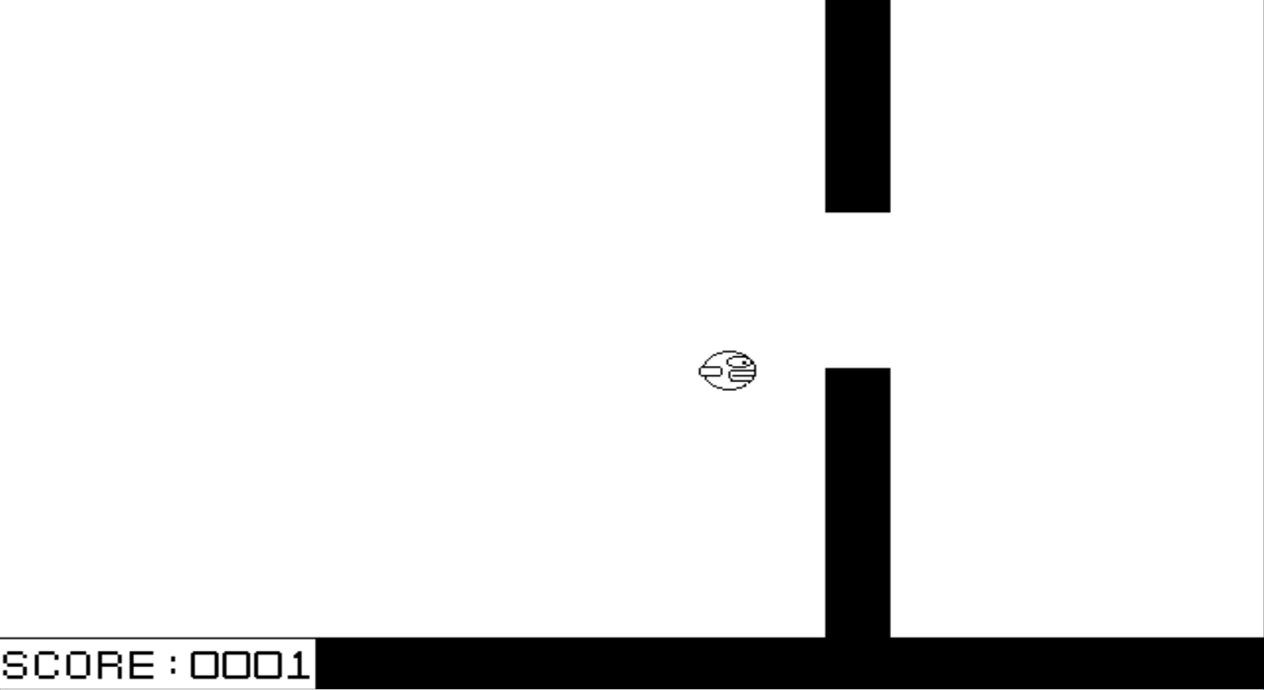

**2 GAME PLAY DETAILS FOR CORE 1-PLAYER VERSION 2.1 OBJECTIVES AND RULES**

**2.1.1 Start Screen**

The game starts with a screen of the bird logo and three options: a button for 1-player mode, 2-player mode or quit the game.

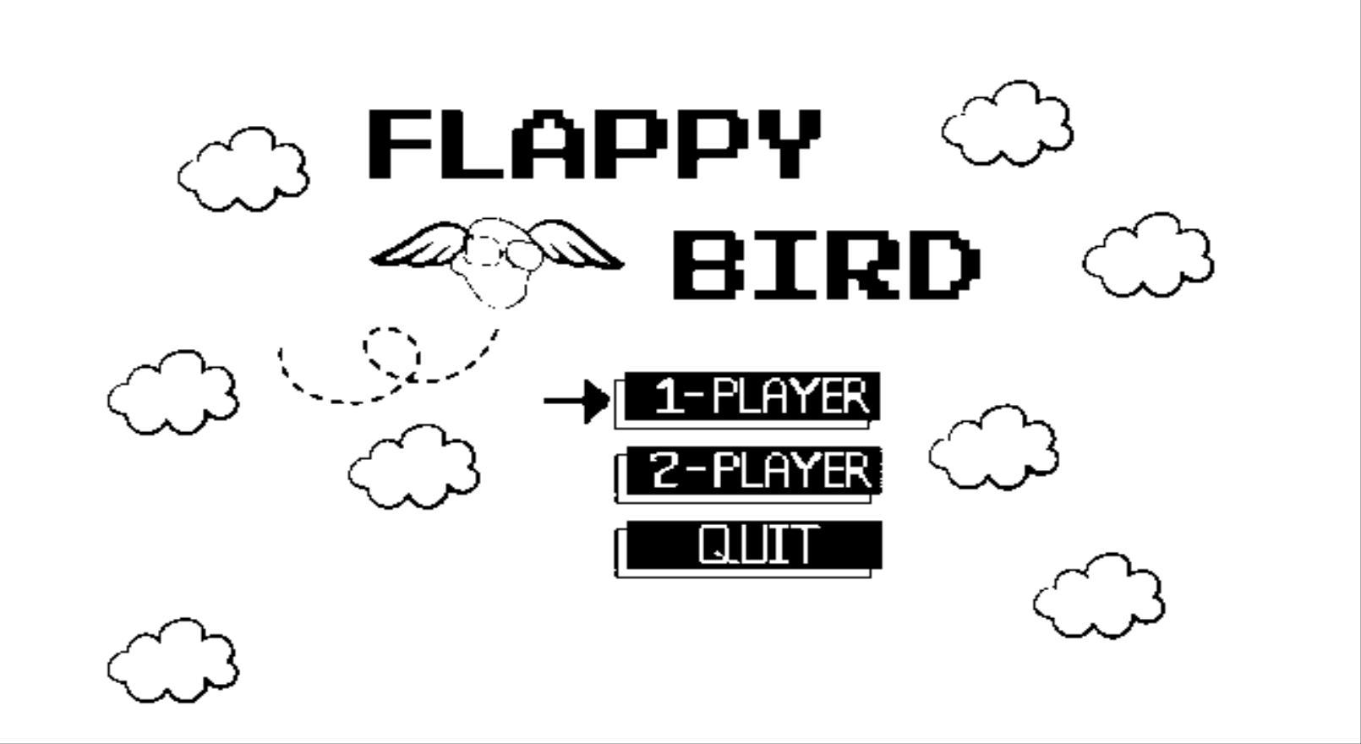

**2.1.2 Game Level Start State (1-Player):**

In the game Flappy Bird, the level start state would typically consist of the following elements:

* The bird: The bird is typically positioned at the middle of the screen, ready for the player to take control and begin flapping its wings to fly upward.
* The pipes: The pipes are not visible on the screen at the beginning of the level. They will appear from the right side of the screen as the level progresses.
* The background: The background is usually a scrolling image that moves from right to left, creating the illusion that the bird is moving forward.
* The score counter: The score counter is usually located on the bottomleft of the screen, displaying the current score. At the start of the level, the score is set to zero.

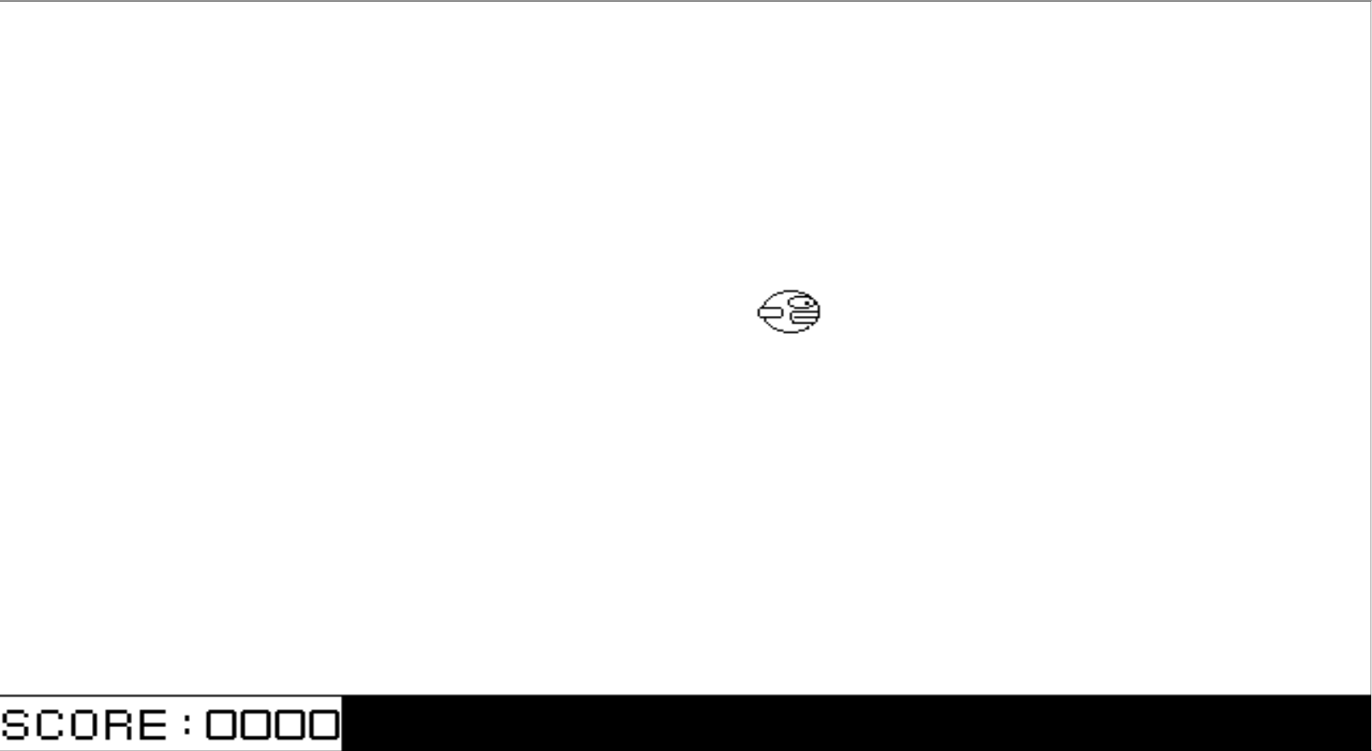

**2.1.3 Game Rules:**

**Scoring:**

* Each time the bird successfully passes between a pair of pipes, the player scores a point (ie: earned point).
* Every Time the bird passes 10 pairs of pipes, it is a strike, in which the earned points will now be doubled and added to the total points.

**Ex:** Passing the first 10 pairs of pipes (1st strike): earned point_01 = 1 * 2 = 2

Passing another 10 pairs of pipes (2nd strike): earned point_02 = earned point_01 * 2 = 4

Passing another 10 pairs of pipes (2nd strike): earned point_03 = earned point_02 * 2 = 8

* There will be no winning, the aim is only to get the highest score possible.

**Motion:**

**Bird’s motion:**

* Fixed x location starts at 352
* The bird flaps up with the velocity 13 pixels up.
* The bird falls with the gravity 2 pixels down every second.

**Background’s motion:**

* Except for the bird, whose motion only is either up or down exclusively and except for the score box, which is in a fixed location, the background including all of the pairs of pipes keep changing the heights and allocations.
* The pipes move right to left every 1 second. Specifically, when the pipe x position reaches to 250 it gets cleared, a new pipe then generated at position 639.
* The gap between the top pipes and bottom pipe is 90 pixels vertically.
* There is always 1 pipe in one screen.

**2.1.4 End Screen :**

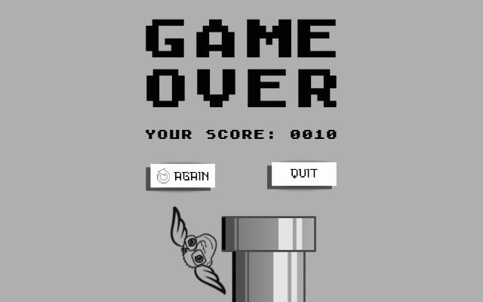

**2.2 OBJECTS**

| **Object** | **Properties** | **Behaviors** | **Graphical ImageS** |
| --- | --- | --- | --- |
| Screen | * Score box * Pipe * Bird * Dimensions: 640 x 400 pixels | * Display (all objects) |  |
| Score Box  —  Title  —  Score | * Dimension: 160 x 30 pixels * String * Integer Score * Max Score: 9999 * Position Integer * X coordinate * Y coordinate | * Display score * Update Score |  |
| Bird | * Direction * Up * Down * Position integer * X coordinate * Y coordinate * Size   32x32 pixels   * Speed * alive | * Move up in 2 directions: up or down exclusively. (ie: At the beginning of the game, while waiting for the player to press the key, the default image is the “Flying bird” image. When the key is pressed, the image orientation also is the “Flying bird” image. Otherwise, the orientation image turns to the “Falling Bird” image. | Flying Bird/ Default    Falling Bird |
| Pipes | * Position * Gap   32 x 90 pixels | * Move right to left |  |

**2.3 PHYSICS**

**None**

**2.4 ASYNCHRONOUS (INPUT) EVENTS**

| **Event Name** | **Triggering Input Event** | **Description** |
| --- | --- | --- |
| Bird Jumping | In both 1-player and 2-player mode, whenever the space bar is pressed | The bird flaps up when the users hit the space bar |

**2.5 SYNCHRONOUS (TIMED) EVENTS**

| **Event Name** | **Triggering Input Event** | **Description** |
| --- | --- | --- |
| Move pipe | Every second | Pipe will move from right to left and everytime the pipe reach to x = 250 it will get removed from the screen |
| Bird falls | Every second | The bird falls due to gravity and the player’s failure to keep it aloft by pressing the spacebar to make the bird flap. |

**2.6 CONDITION-BASED (CASCADED) EVENTS**

| **Event Name** | **Triggering Input Event** | **Description** |
| --- | --- | --- |
| Score Updates | Pipe passed condition is true | The corresponding player’s score is updated by 1 and every 10 pairs of pipes passed score is x2 |
| Bird stops flapping | Player not hitting space bar | The bird falls to the ground if the space key is not pressed every second |
| Bird Collides | Bird hit the pipe or the ground (ie: bottom edge of the screen) or the top edge of the screen | Game ends when the bird hits of the pipe and can’t make it through the gap |
| Game Over | When the bird collides | The game ends and displays a screen showing Game Over and Score message when the bird collides with an obstacle such as pipe or the ground |
| Pipes collides | When the pipe x position reaches 250 | Generate a new pair of pipe at 639 |

**2.7 HYPOTHETICAL GAMING SESSION**

In a hypothetical gaming session of Flappy Bird, the player starts the game by pressing the spacebar. The bird starts at the middle of the screen and begins to fall.

The player quickly presses the spacebar to make the bird flap its wings and fly upward. The first set of pipes appear on the screen from the right, and the player must time their flaps correctly to navigate the bird through the gap in the pipes. The bird successfully flies through the gap, and the player earns one point.

The bird continues to fly to the left, and the next set of pipes appear. The player must make quick decisions to flap the bird's wings at the right time, to avoid crashing into the pipes. The bird crashes into the pipe on the third set of pipes, and the game ends. The final score is two.

The player can restart the game and try again to beat their previous score.

**3** **GAME PLAY DETAILS FOR CORE 2-PLAYER VERSION (NOT IMPLEMENTED) :**

**3.1 OBJECTIVES AND RULES MODIFICATIONS**

**3.1.1 Start Screen**

*See section 2.1.1 for more details.*

**3.1.2 Game Level Start State (2-player):**

For 2-player mode game sessions, since player 1 and player 2 take turn play, the game level start state stays the same for each round of each player *(see section 2.1.2)*.

**3.1.3 Game Rule Modification(s):**

* There is a winner in 2-player mode, the game takes the total score of each player and compares. Whoever has a higher score will be the winner of the game.

**3.1.4 Gameplay Modification(s):**

* None (ie: the space key is the only input for both game modes)

**3.1.4 Ending Screen:**

* The game over message: At the start of the level, the game over message is not visible. It will only appear if the bird crashes into a pipe or the ground and the game ends.
* After player 1’s round ends, a splash screen will display the total score of player 1 and “next player” button

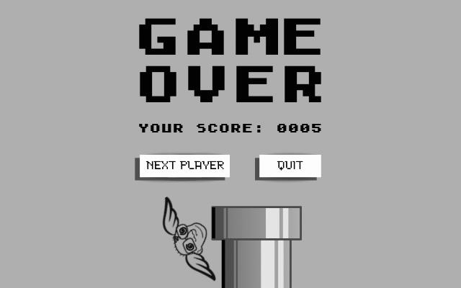

* After player 2’s round ends, a splash screen will display the total scores of both player 1 and player 2 with the “again ?” and the “quit” button.

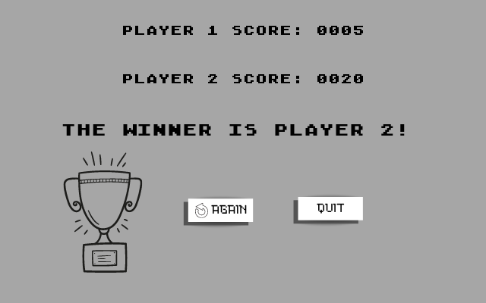

**4**  **SOUND EFFECTS:**

**Sound Effect Name Brief Description Event which Triggers Playback**

*Wing* A short, low-pitched Players press the spacebar to make

sound effect the bird flapping its wing

*Hit* A short, distinctive The bird hits the pipes or screen’s

sound effect top and bottom edges