**Scenario 1: The bank wants to apply a discount to loan interest rates for customers above 60 years old.**

PL/SQL block that loops through all customers, checks their age, and if they are above 60, apply a 1% discount to their current loan interest rates.

**Code:**

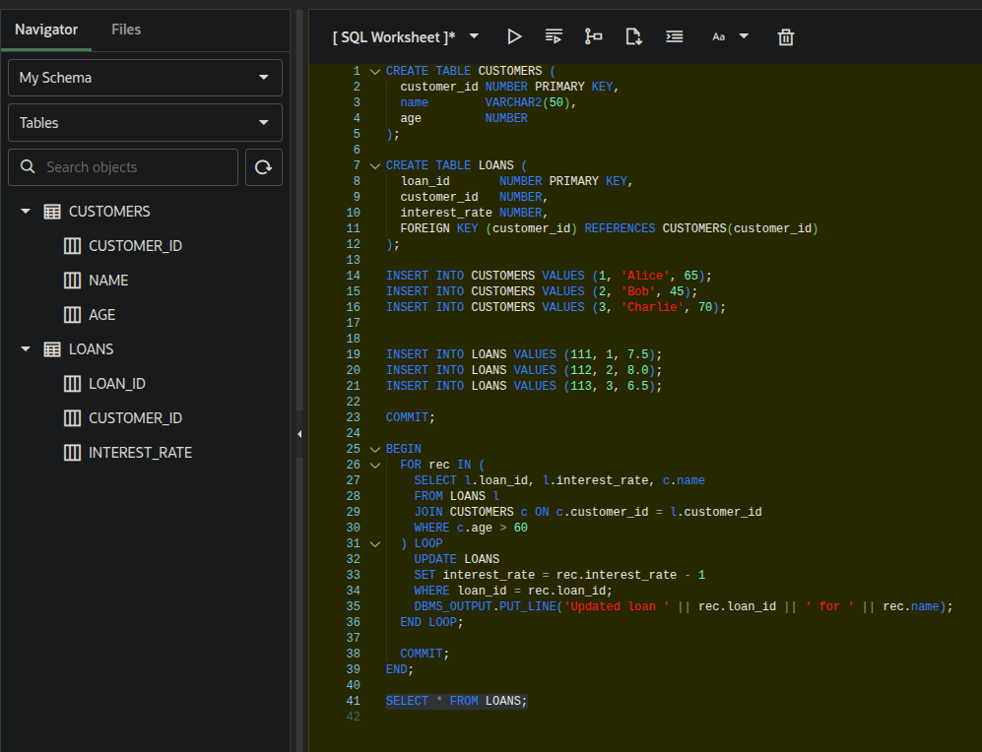

**Loans Table:**

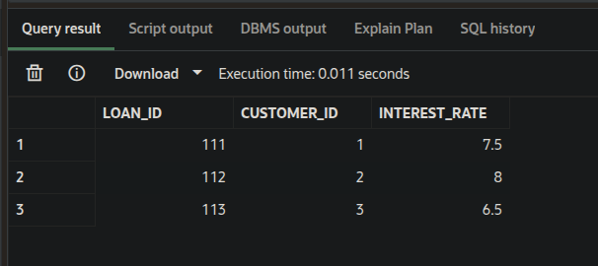

**Output:**

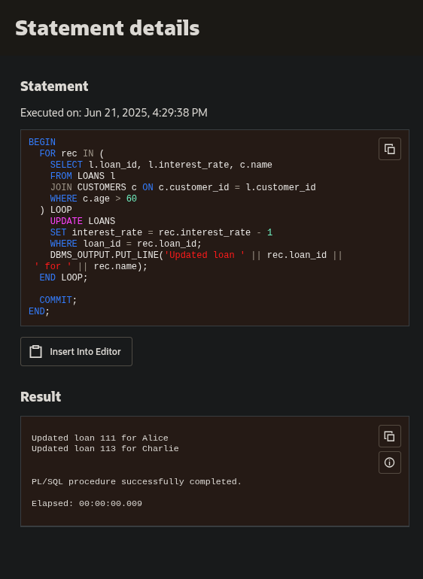

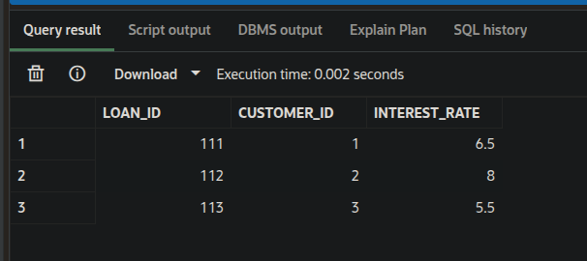**Loans Table after changes :**