**Scenario 1: The bank needs to process monthly interest for all savings accounts.**

Stored procedure **ProcessMonthlyInterest** that calculates and updates the balance of all savings accounts by applying an interest rate of 1% to the current balance.

**Code :**

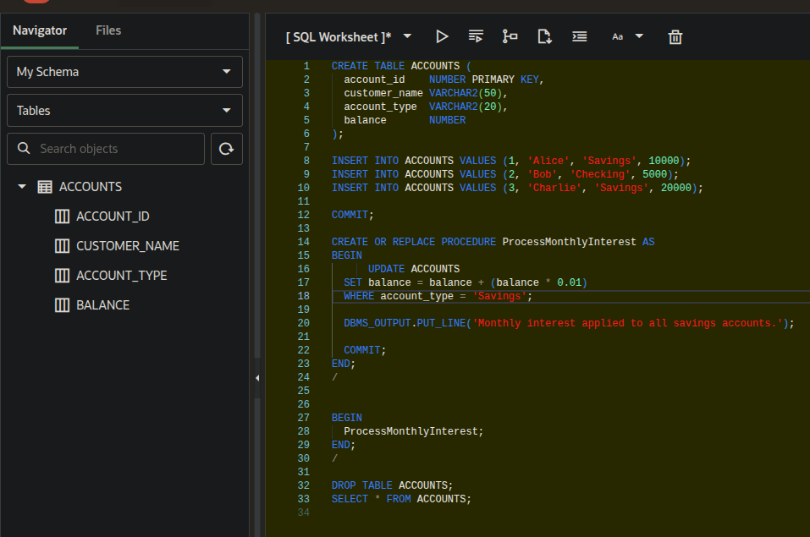

**Output :**

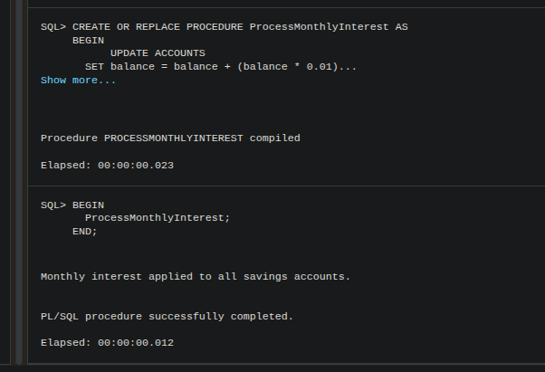

**Table Outputs :**

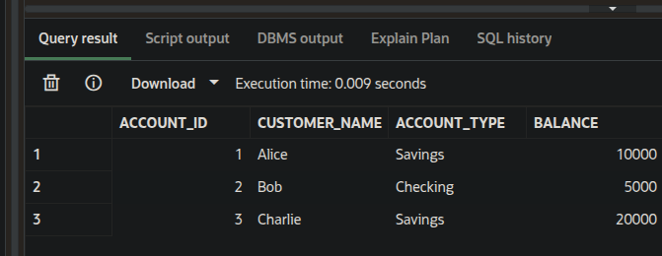

**After Procedure :**

