**Scenario 2: The bank wants to implement a bonus scheme for employees based on their performance.**

Stored procedure UpdateEmployeeBonus that updates the salary of employees in a given department by adding a bonus percentage passed as a parameter.

**Code :**

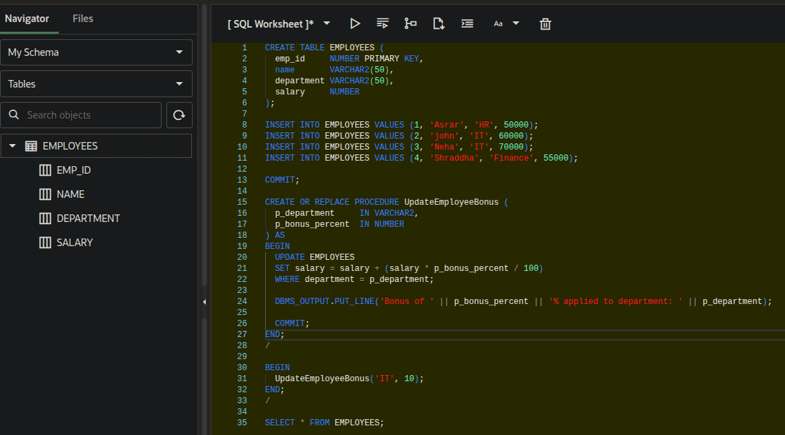

**Output :**

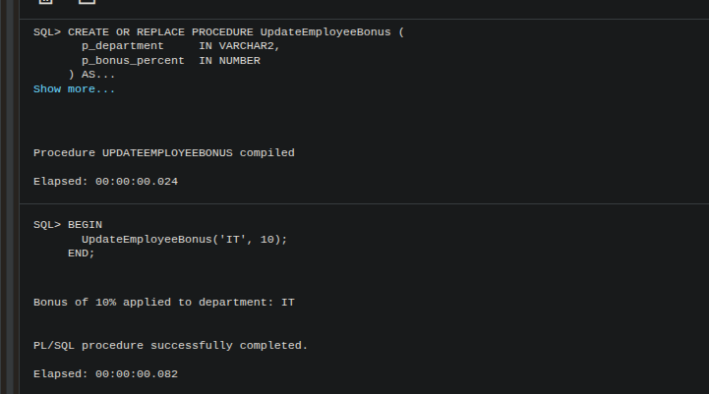

**Table Result :**

