**Exercise 7: Financial Forecasting**

### **Recursive Algorithm:**

**Recursion** is a programming technique where a method calls itself to solve a problem.  
It breaks a large problem into smaller subproblems of the same type, making the solution more readable and logical.

In the context of financial forecasting, recursion is useful because:

* Each future value depends on the previous year’s value.
* Instead of using loops, recursion allows you to **express growth step-by-step**.

**CODE :**

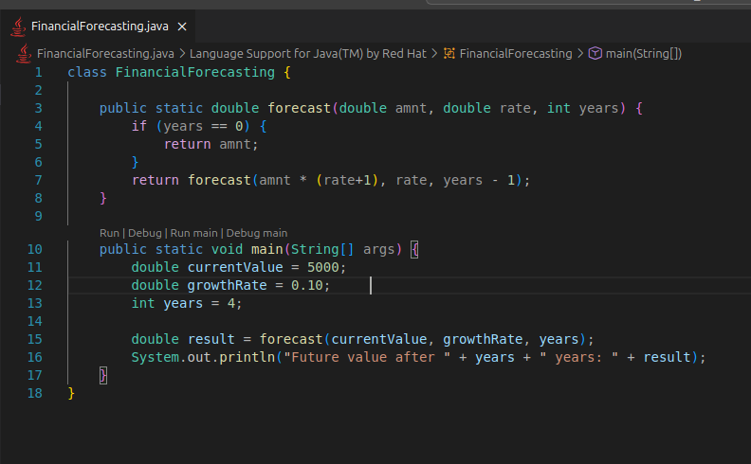

**Output** :



**Time Complexity:**

* The function calls itself once per year.
* So, for n years, it performs **O(n)** recursive calls.
* Each call does constant work so the overall complexity is **linear**.