**Scenario 3: Customers should be able to transfer funds between their accounts.**

Stored procedure TransferFunds that transfers a specified amount from one account to another, checking that the source account has sufficient balance before making the transfer.

**Code :**

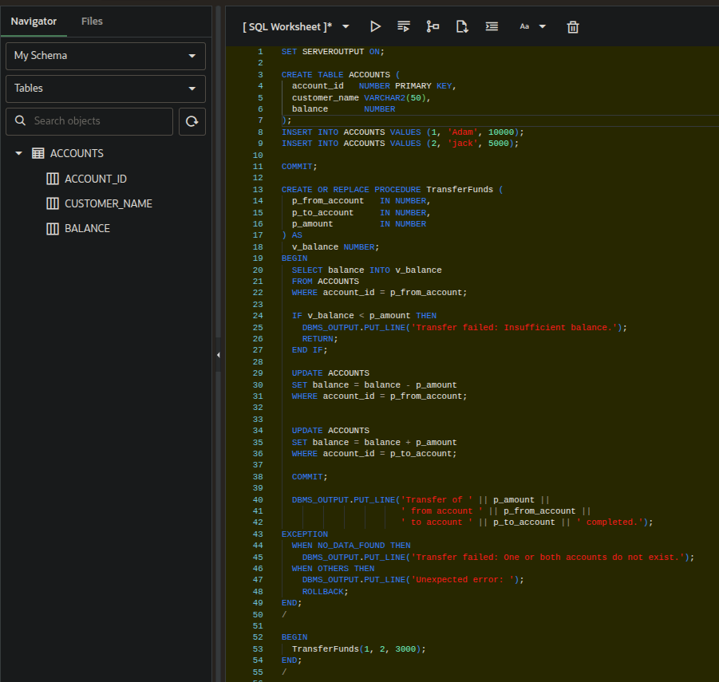

**Output :**

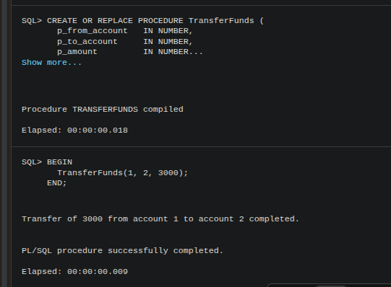

**Table Output :**

