Q2
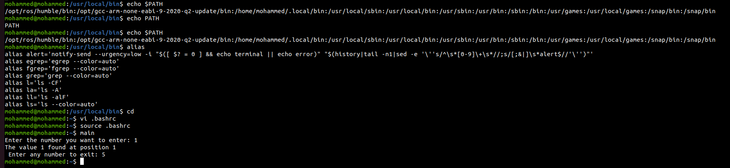
Nan2na2a

1.
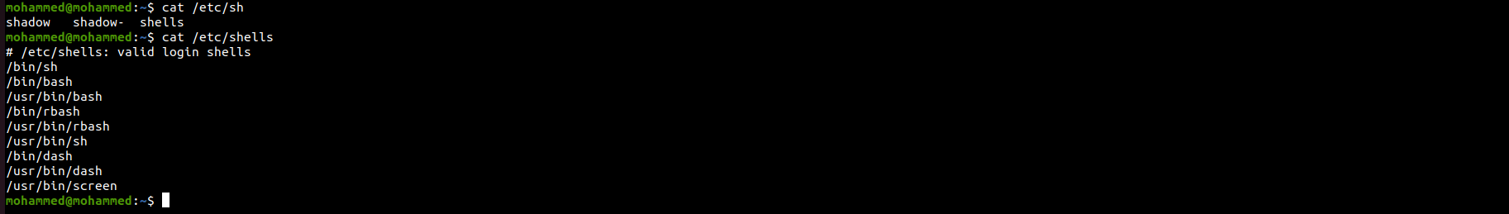
2.
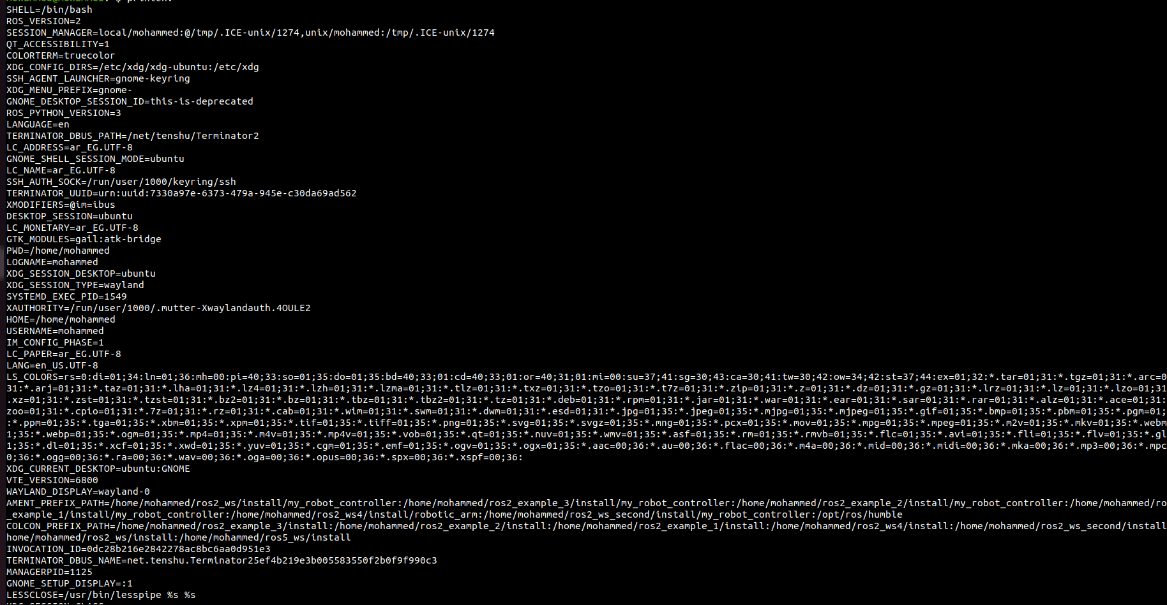
3.
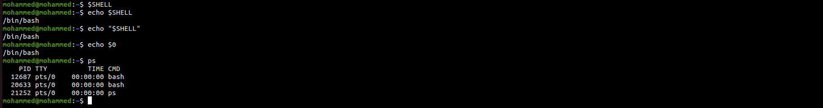
4.
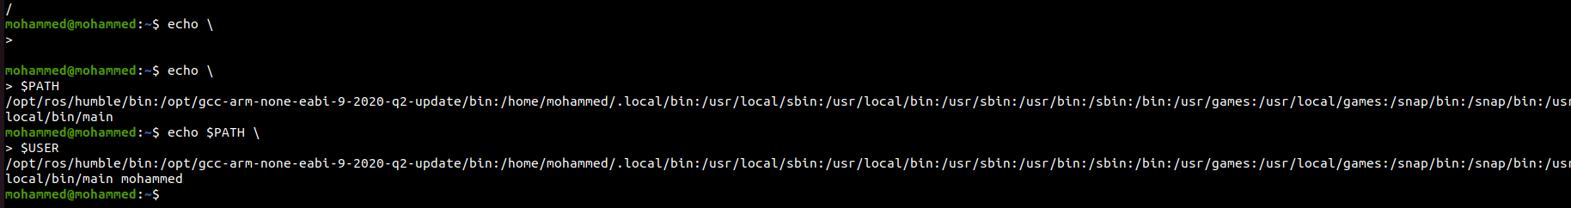
it can be used as escaping special characters or continuation lines or quotation characters

5.

