

**Prince Mohammad bin Fahd University**

**College of Computer Engineering and Science**

**GEIT_3351: Software Engineering I**

**Section 101**

Fall 2023/2024

Dr. Ilyes Jenhani

**Project: PMURide**

Group members:

Computer Scientist: Mohammed Alqadda, 202002837

Computer Engineer: Ibrahim Aldossary, 201800259

**Coding and implementation:**

Our public GitHub repository: <https://github.com/MFQ7/PMURide.git>

MFQ7: Mohammed Alqadda

barhoom-22: Ibrahim Aldossary

**User account creation:-**

Since the app is for PMU students the account creation is included with the object Student.

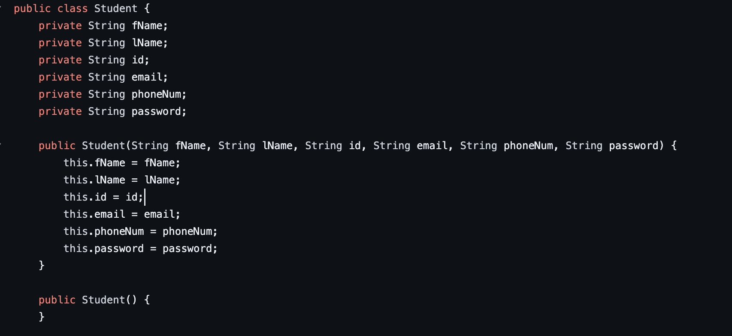

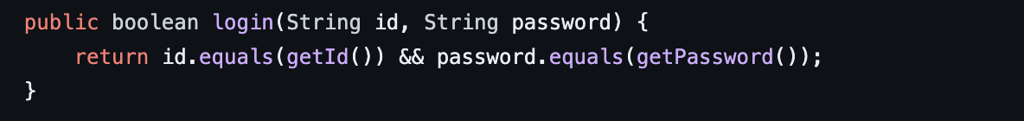

**Screenshots of code changes:**

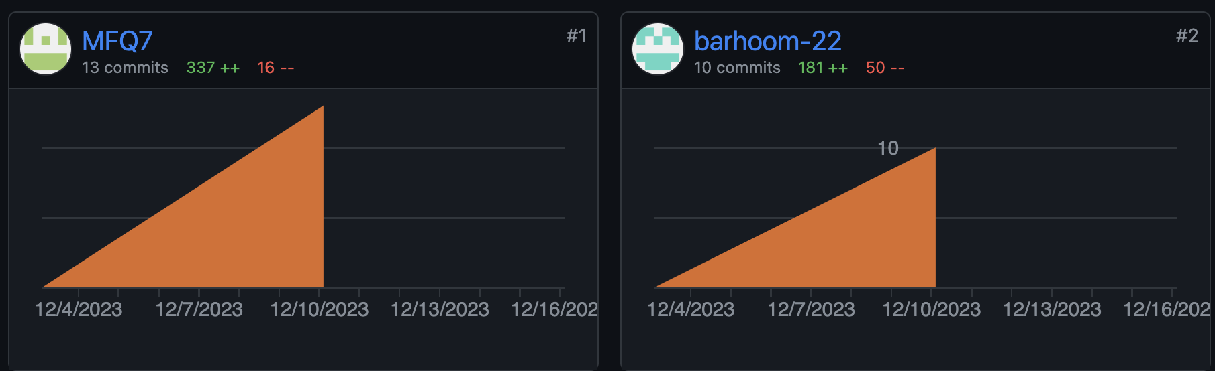

**Example of changes by Mohammed:**

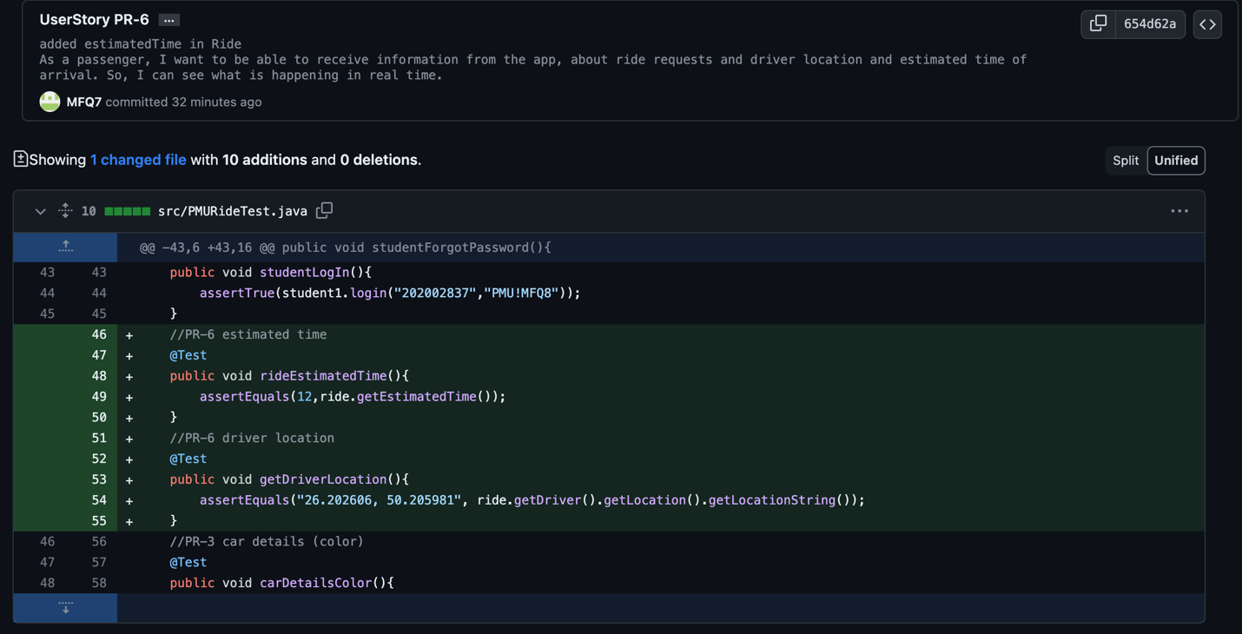

**Example of changes by Ibrahim:**

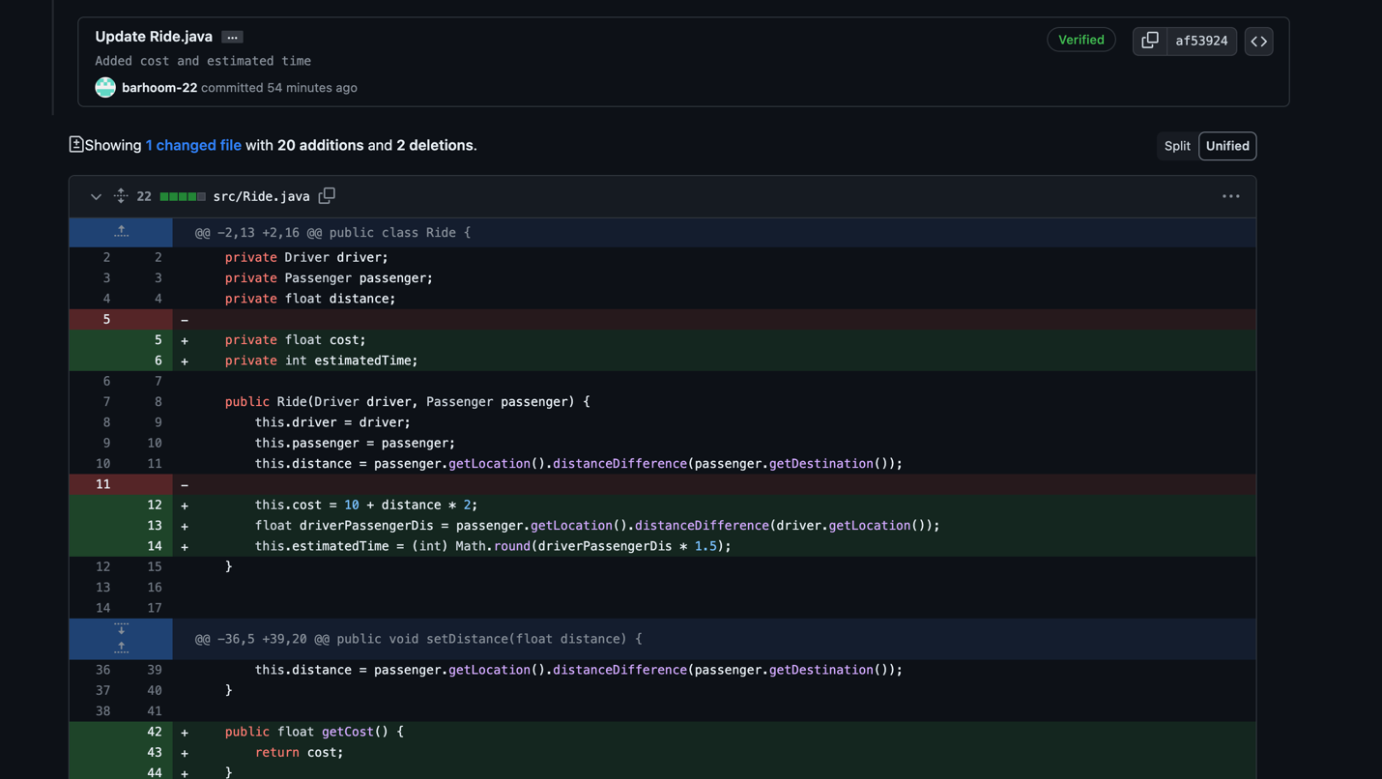

**using Git as a version control tool:**

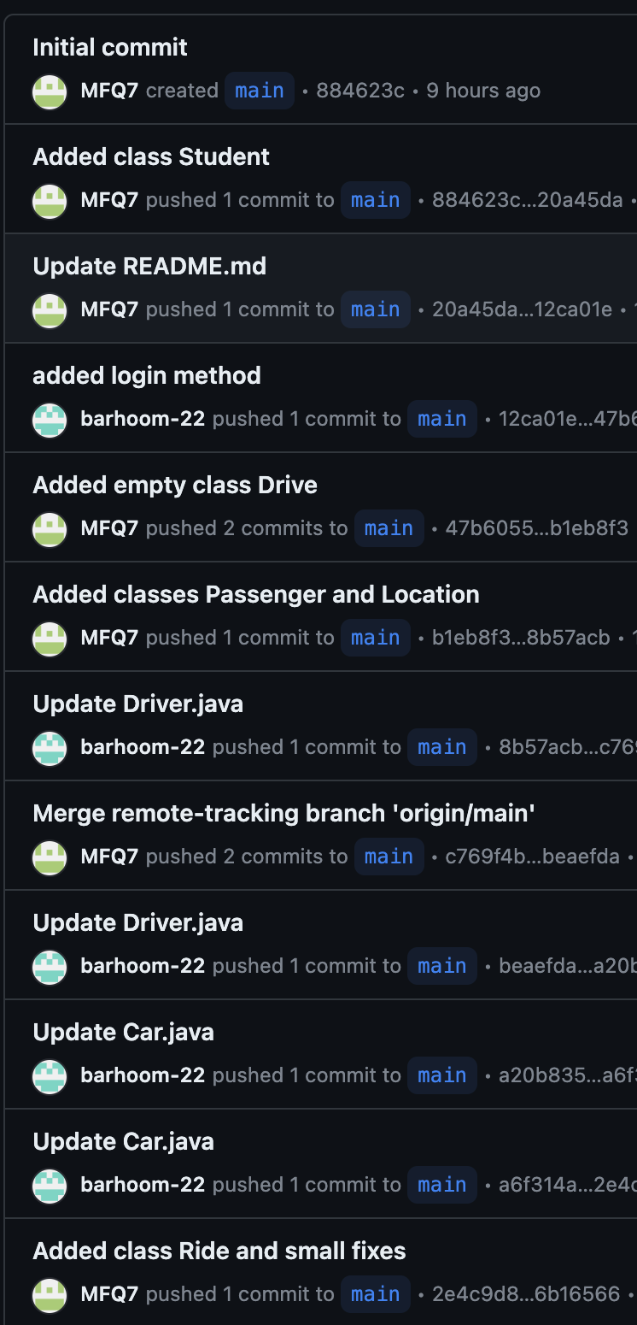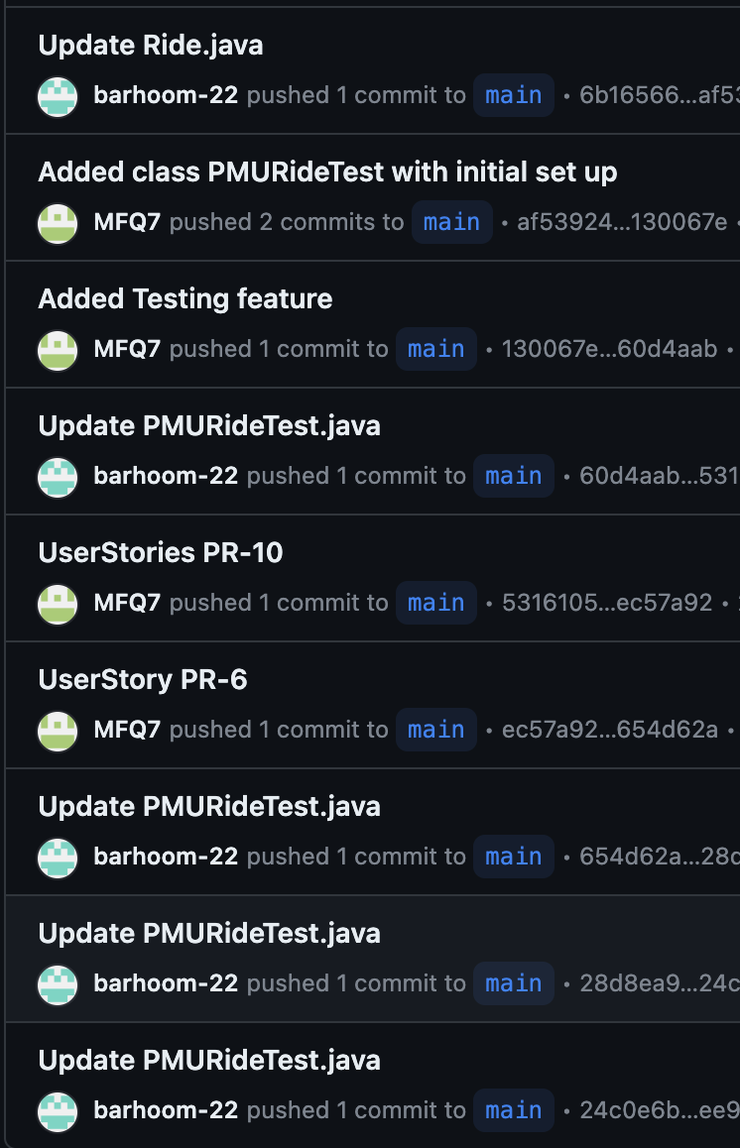

**Testing:**

Our public GitHub repository: <https://github.com/MFQ7/PMURide.git>

**Using Junit Testing:**

**Initial set up**

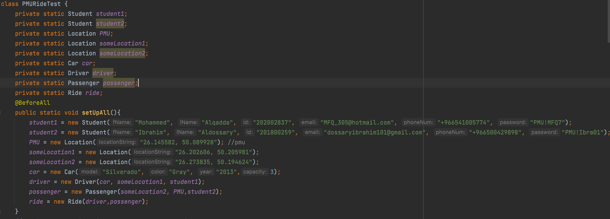

**We have one BDD (Behavior-Driven Development)**

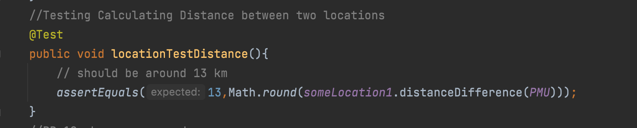

The locationTestDistance() method is a test case designed to verify the accuracy of distance calculation between two geographical locations. In this specific test, it calculates the distance between two locations: one representing Prince Mohammad Bin Fahd University (PMU) coordinates and another location specified by coordinates. The expected behavior is based on a predetermined distance between the two locations, which is approximately 13 kilometers. The method utilizes the distanceDifference() function provided by the Location class to calculate the distance between these locations.

**The rest are ATDD (Acceptance Test Driven Development)**

These test cases were taken from User Stories. ATDD was the guiding principle in formulating our test strategy. This approach involves creating acceptance tests based on the specified requirements and user stories before the actual implementation. Our test cases were driven by these acceptance criteria, ensuring that they reflect the expected behavior of the system from an end-user perspective.



