Alexandria University
Faculty of Engineering
Computers & Systems Engineering Department

Designing Data Intensive Applications
CSE-4E3

Weather Stations Monitoring System
Course Project Report

Spring 2026

Table of Contents

1. Introduction and System Overview
2. System Architecture
3. Weather Station Mock (Section A)
4. Kafka Integration (Section B)
5. Rain Detector — Kafka Streams (Section C)
6. Central Station (Section D)
6.1 BitCask Riak Implementation
6.2 BitCask Client
6.3 Parquet Archiver
7. Elasticsearch & Kibana Analytics (Section E)
8. Docker & Kubernetes Deployment (Section F)
9. JFR Profiling (Section G)
10. Bonus: Open-Meteo Integration & EIP Patterns
11. Conclusion

1. Introduction and System Overview
This report documents the design, implementation, and deployment of a distributed Weather Stations Monitoring System, developed as the course project for Designing Data Intensive Applications (CSE-4E3) at Alexandria University, Faculty of Engineering. The system demonstrates practical application of stream processing, key-value storage, columnar archiving, full-text indexing, containerized deployment, and JVM profiling.
The project simulates an IoT environment in which 10 weather stations continuously emit weather readings at a rate of one message per second. These readings flow through Apache Kafka into a Central Station that persists data using a custom BitCask Riak key-value store for the latest state and Apache Parquet files for historical archival. A Kafka Streams processor independently monitors humidity levels for rain detection. Archived Parquet data is shipped to Elasticsearch for indexing and visualized through Kibana dashboards. The entire system is containerized with Docker and deployable on Kubernetes.
The technology stack comprises Java (Kafka clients, Kafka Streams, Spring Boot), Python (Parquet shipper), Apache Kafka with Zookeeper, Elasticsearch 8.10.2, Kibana 8.10.2, Docker Compose, Kubernetes, and Java Flight Recorder (JFR) for profiling. The project also implements a bonus Open-Meteo integration using Spring Integration with several Enterprise Integration Patterns.

2. System Architecture
The system follows a three-stage pipeline architecture that separates data acquisition, processing and archiving, and indexing into distinct layers connected through Kafka as the central message broker.

Data Acquisition Layer
Ten weather station services produce JSON-formatted weather status messages to the weather_status Kafka topic. Each station is identified by a unique STATION_ID (1 through 10) and uses the station ID as the Kafka message key, ensuring all messages from a given station land on the same partition. An additional Open-Meteo integration service (station ID 999) polls the Open-Meteo API and feeds real weather data into the same topic.

Data Processing & Archiving Layer
The Central Station consumes from the weather_status topic and performs two operations on each message: it updates the BitCask key-value store with the latest reading per station (keyed as station_N), and it buffers every message (including drop markers) for batch writing into Parquet files partitioned by date and station ID. Separately, the Rain Detector service (a Kafka Streams application) filters the same topic for messages where humidity exceeds 70% and publishes alerts to the raining_alerts topic.

Indexing Layer
The Parquet Shipper is a Python service that periodically scans the shared Parquet directory for new files, reads them with pandas, and bulk-indexes the records into Elasticsearch under the weather-status index. Kibana connects to Elasticsearch and provides dashboards for battery status distribution and message drop rate analysis.

Services and Ports
Service | Port | Description
Central Station | 8080 | BitCask REST API + Kafka Consumer
Kafka | 9092 | Message broker
Zookeeper | 2181 | Kafka coordination
Elasticsearch | 9200 | Full-text search and indexing
Kibana | 5601 | Visualization dashboards

3. Weather Station Mock (Section A)
Each weather station mock (WeatherStationApp.java) is a standalone Java application that produces one weather status message per second to the weather_status Kafka topic. The station ID is configured via the STATION_ID environment variable, and the Kafka broker address via KAFKA_BOOTSTRAP_SERVERS.

Weather Status Message Schema
Each message follows the required JSON schema containing station_id (Long), s_no (Long, auto-incremented), battery_status (String: "low", "medium", or "high"), status_timestamp (Unix epoch in seconds), and a nested weather object with humidity (0–100%), temperature (50–110°F), and wind_speed (0–99 km/h). A message_dropped boolean flag is also included.

Battery Status Distribution
The battery status is randomly assigned according to the specified probability distribution: 30% low, 40% medium, and 30% high. This is achieved using a uniform random number and threshold comparison in the randomBatteryStatus() method.

Message Drop Simulation
A 10% message drop rate is simulated by checking random.nextDouble() < 0.1 before each send. When a drop occurs, a drop marker message (with message_dropped: true and null weather/battery fields) is still published to Kafka so that downstream analytics can track the drop rate. The station logs both sent and dropped messages to the console.
Screenshot 2: Weather station console logs showing sent messages with varying battery statuses and a dropped message (s_no=24).
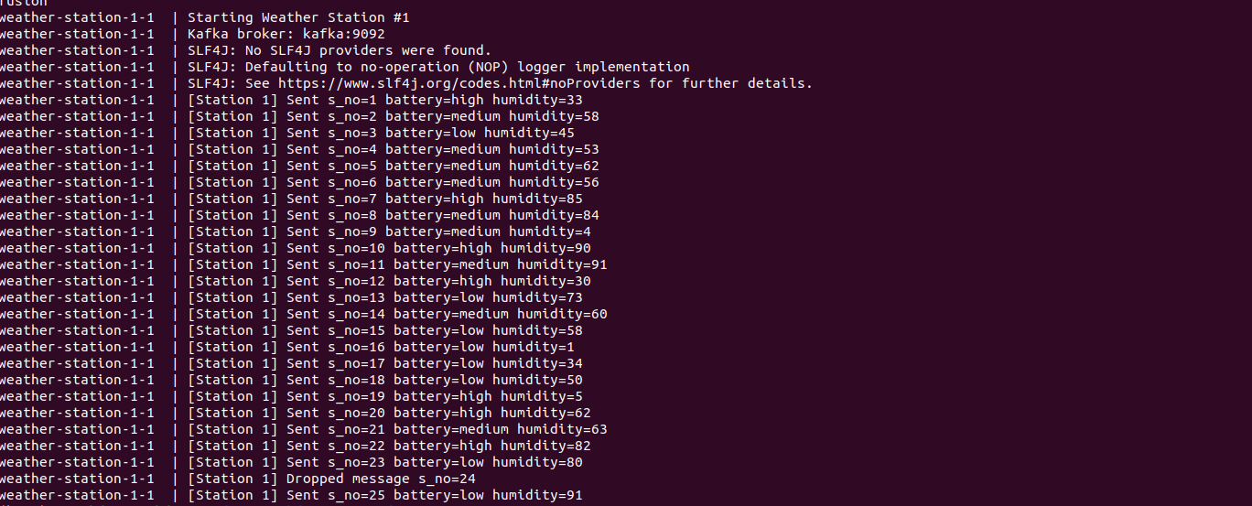
Figure 1: Weather Station console logs — messages with battery status and drop events

4. Kafka Integration (Section B)
The weather stations use the Java Kafka Producer API (kafka-clients library) to publish messages to Kafka. The producer is configured with StringSerializer for both key and value, and LINGER_MS_CONFIG set to 0 to ensure messages are dispatched immediately without batching delay. Each station uses its station ID as the Kafka message key (String.valueOf(stationId)), which guarantees partition affinity — all messages from the same station go to the same Kafka partition, preserving per-station ordering.

5. Rain Detector — Kafka Streams (Section C)
The Rain Detector (RainDetectorProcessor.java) is a Kafka Streams application that consumes from the weather_status topic and filters for weather messages where the humidity exceeds 70%. When a rain condition is detected, the processor constructs a JSON alert containing the station ID, humidity value, and timestamp, then publishes it to the raining_alerts topic. Dropped messages are explicitly filtered out before the humidity check. The processor uses the Kafka Streams DSL with StreamsBuilder, filter(), and mapValues() operations.
Screenshot 3: Rain Detector console output showing RAIN_DETECTED alerts from multiple stations, including the Open-Meteo station (station=999).
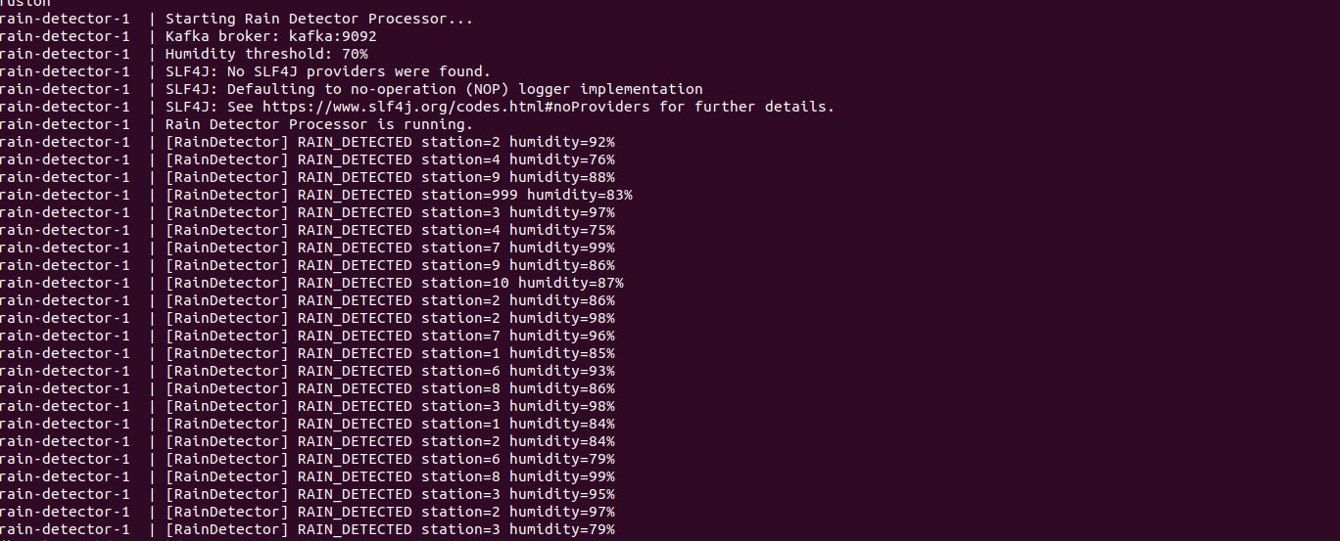
Figure 2: Rain Detector logs — RAIN_DETECTED alerts triggered when humidity > 70%

6. Central Station (Section D)
The Central Station is a Spring Boot application that serves as the core data processing and persistence hub. It consumes from the weather_status Kafka topic and performs two parallel operations: updating the BitCask key-value store with the latest reading per station, and archiving all messages (including drop markers) to Parquet files for historical analysis.

6.1 BitCask Riak Implementation
The BitCask implementation (BitCask.java) follows the Riak BitCask model as discussed in lectures. It is an append-only, log-structured key-value store with an in-memory hash table (KeyDir) for O(1) lookups.

Segment Files
Data is written to append-only segment files. Each entry in a segment file follows the binary format: [timestamp: 8 bytes][key_size: 4 bytes][value_size: 4 bytes][key: N bytes][value: M bytes]. When a segment file exceeds 1 MB, the active file is rotated and a new segment is created.

Hint Files
Alongside each segment file, a corresponding hint file is maintained. Hint files store the key metadata without the full value data: [timestamp: 8 bytes][key_size: 4 bytes][value_size: 4 bytes][value_pos: 8 bytes][key: N bytes]. During crash recovery, hint files allow the KeyDir to be rebuilt without scanning entire segment files, dramatically reducing startup time.

Compaction
Compaction is scheduled to run every 5 minutes via a ScheduledExecutorService. The compaction process merges all non-active (old) segments into a single compacted segment, retaining only the latest value for each key. A new hint file is generated for the compacted segment, and old segment and hint files are deleted. Compaction runs under a write lock to maintain consistency.

Recovery
On startup, the recover() method scans the data directory for existing segment files. For segments that have corresponding hint files, recovery is fast — only the hint file is read. For segments without hint files (e.g., after a crash before a hint was written), the full segment file is scanned and a hint file is regenerated. The recovery process respects timestamps to ensure only the most recent value per key is loaded into the KeyDir.
Screenshot 4: BitCask data directory showing segment and hint files on disk.
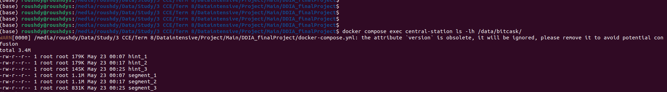
Figure 3: BitCask directory listing — segment and hint files

6.2 BitCask Client
The BitCask Client (bitcask_client.sh) is a bash script that interacts with the Central Station’s REST API (BitCaskController.java) to query and export data from the BitCask store. The REST controller exposes endpoints at /api/bitcask/all (all key-value pairs), /api/bitcask/key/{key} (single key lookup), and /api/bitcask/compact (manual compaction trigger).

View All (--view-all)
Exports all keys and their latest JSON values to a timestamped CSV file. The script calls the /api/bitcask/all endpoint and formats the output with a key,value CSV header.
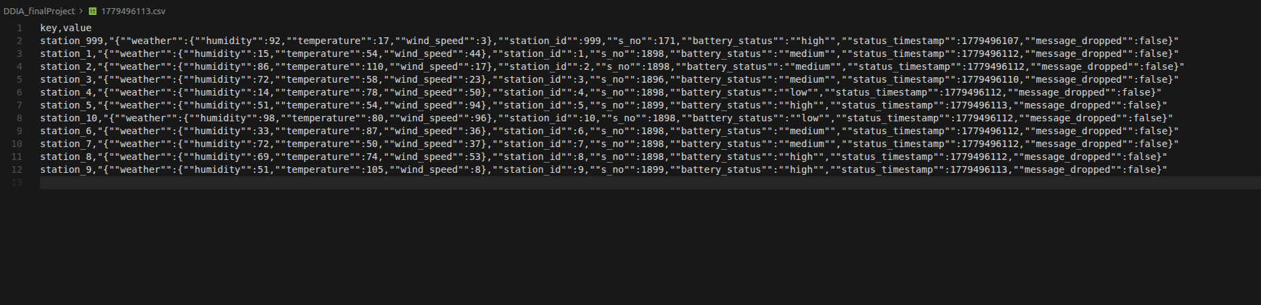
Figure 4: BitCask Client --view-all CSV output — all station keys with latest weather data

View Key (--view --key=station_1)
Retrieves and prints the latest JSON value for a specific station key.
Figure 5: BitCask Client --view --key=station_1 output

Performance Test (--perf --clients=100)
Spawns 100 concurrent threads (bash background processes), each querying all keys and writing the results to a separate timestamped CSV file. This tests the Central Station’s ability to handle concurrent read load on the BitCask store.
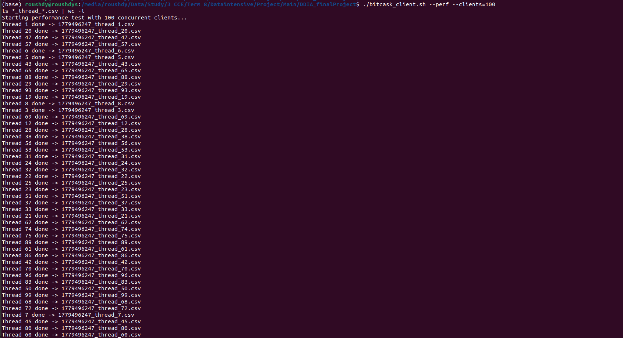
Figure 6: BitCask Client --perf --clients=100 — 100 concurrent threads completing successfully

6.3 Parquet Archiver
The Parquet Archiver (ParquetArchiver.java) buffers all incoming weather status messages and writes them in batches of 10,000 records to Apache Parquet files using the Avro-Parquet writer with Snappy compression. Records are partitioned by date (date=YYYY-MM-DD) and station ID (station_id=N), creating a hierarchical directory structure suitable for efficient querying. The Avro schema includes station_id, s_no, battery_status, status_timestamp, message_dropped, humidity, temperature, and wind_speed fields.
Screenshot 8: Parquet partition tree showing the date= and station_id= directory structure with batch files.
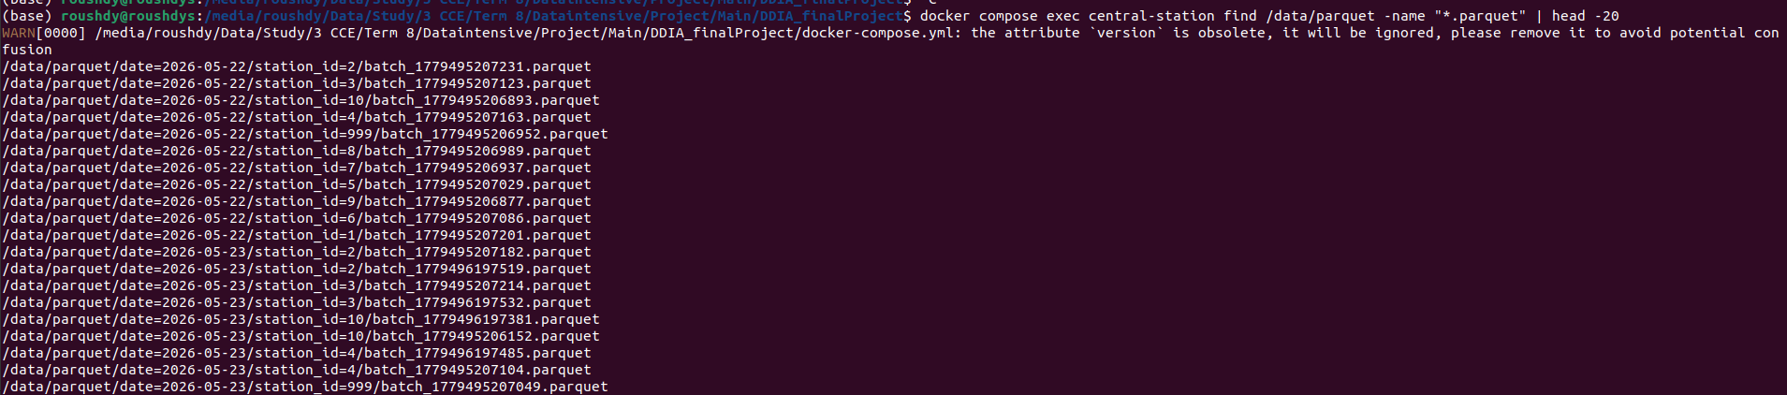
Figure 7: Parquet partition tree — date and station_id partitioned directory structure

7. Elasticsearch & Kibana Analytics (Section E)
The Parquet Shipper (shipper.py) is a Python service that runs in a loop, scanning the shared Parquet directory every 10 seconds for new files. When a new Parquet file is detected, it reads the file using pandas, prepares bulk actions with document IDs based on station_id_s_no, and indexes them into the weather-status Elasticsearch index using the elasticsearch-py bulk helper. A state file tracks which Parquet files have already been processed to avoid duplicate indexing.

Battery Status Distribution Visualization
The Kibana pie chart below confirms the battery status distribution across all non-dropped messages. The observed percentages closely match the expected distribution: low at 30%, medium at approximately 39.66%, and high at approximately 30.34%. This is consistent with the configured 30/40/30 ratio, with minor variance due to random sampling.
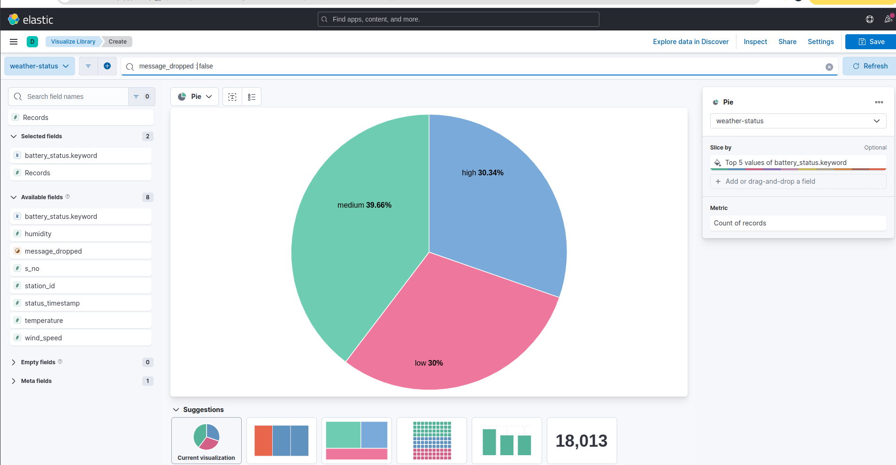
Figure 8: Kibana — Battery status pie chart showing ~30% low / ~40% medium / ~30% high distribution

Dropped Messages Visualization
The stacked bar chart below shows total messages versus dropped messages per station. The blue portions (dropped) are approximately 10% of the total green portions (all messages) for each station, confirming the 10% drop rate implementation. Station 999 (Open-Meteo) shows significantly fewer messages as expected, since it polls every 10 seconds rather than every 1 second and does not simulate drops.
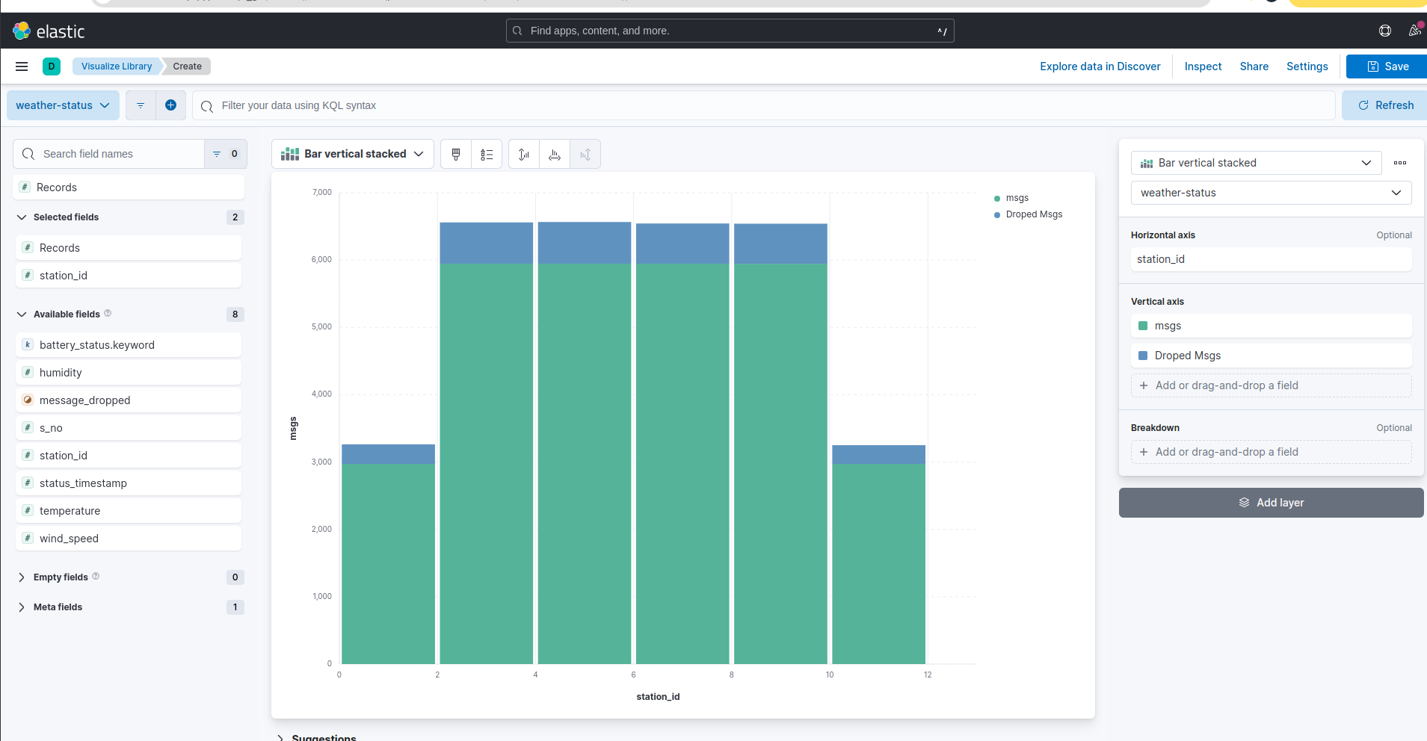
Figure 9: Kibana — Dropped messages bar chart confirming ~10% drop rate per station

Kibana Discover — Raw Documents
The Kibana Discover view shows the raw indexed documents in the weather-status index with 30,000 hits. The table displays selected fields including station_id, battery_status, message_dropped, and humidity, confirming that the full data pipeline from weather stations through Kafka, Parquet archival, and Elasticsearch indexing is functioning correctly.
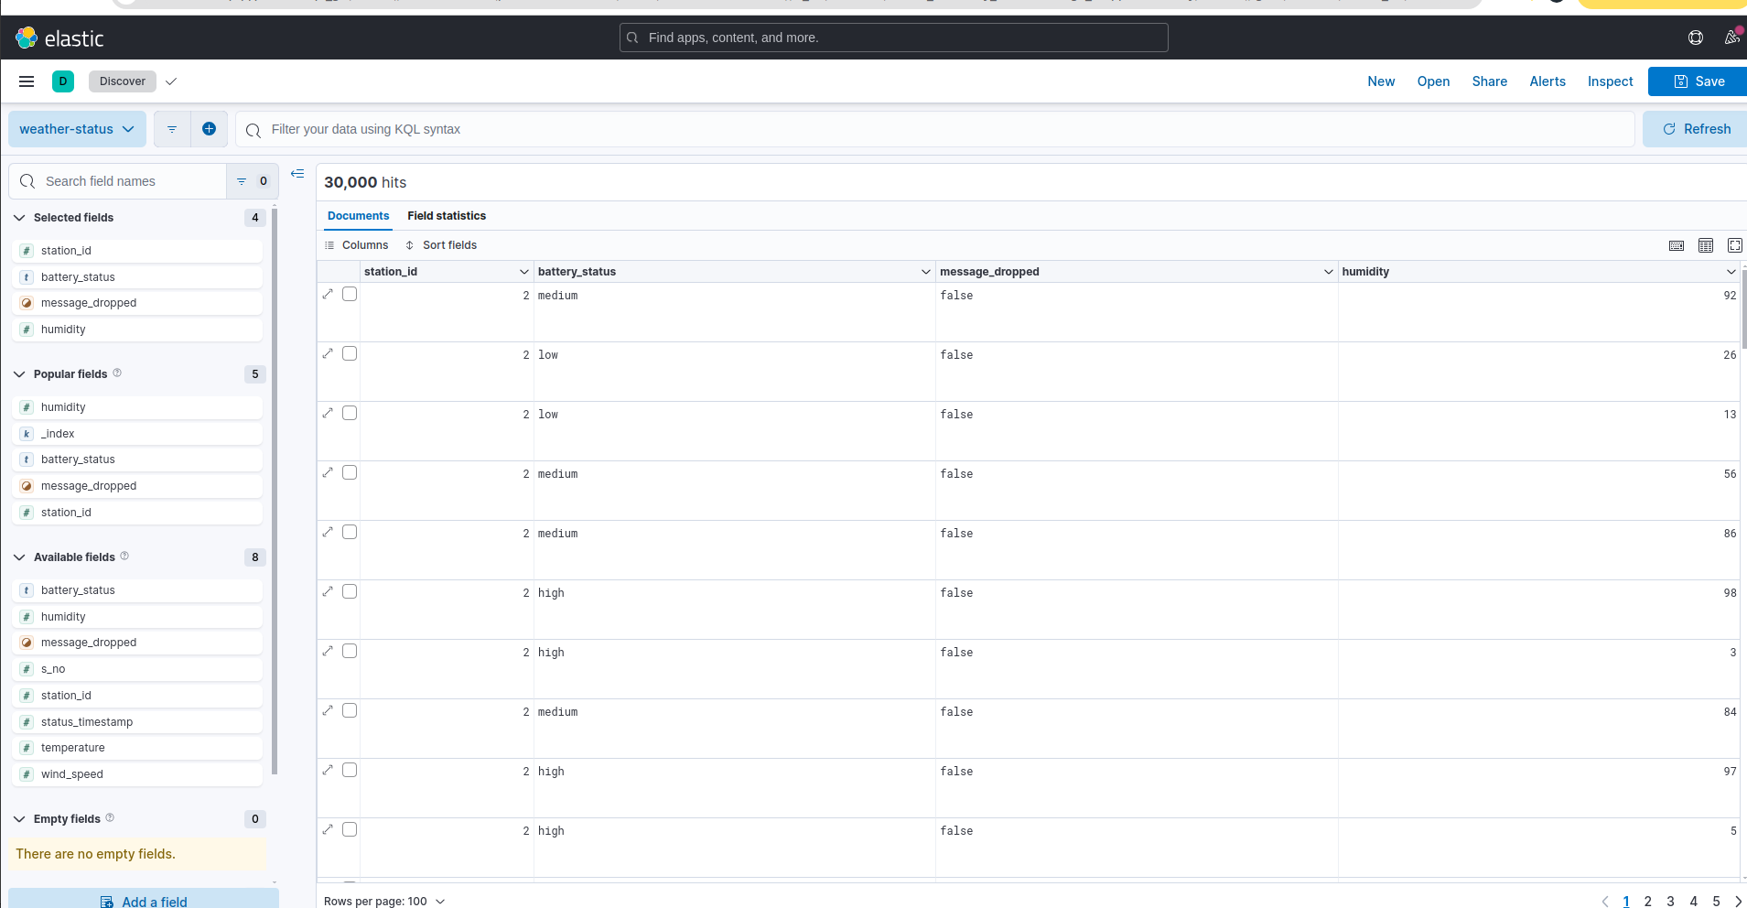
Figure 10: Kibana Discover — raw documents in the weather-status index

8. Docker & Kubernetes Deployment (Section F)

Docker Compose Deployment
The docker-compose.yml defines the complete system with 17 services: 10 weather stations, 1 central station, 1 rain detector, 1 parquet shipper, 1 open-meteo integration, and the infrastructure services (Kafka, Zookeeper, Elasticsearch, Kibana). Shared data between the central station and parquet shipper is facilitated through a Docker named volume (shared-data) mounted at /data. All application services include Dockerfiles that build multi-stage Maven images for the Java services and a pip-based image for the Python shipper.
Screenshot 1: Docker Compose showing all services running and healthy.
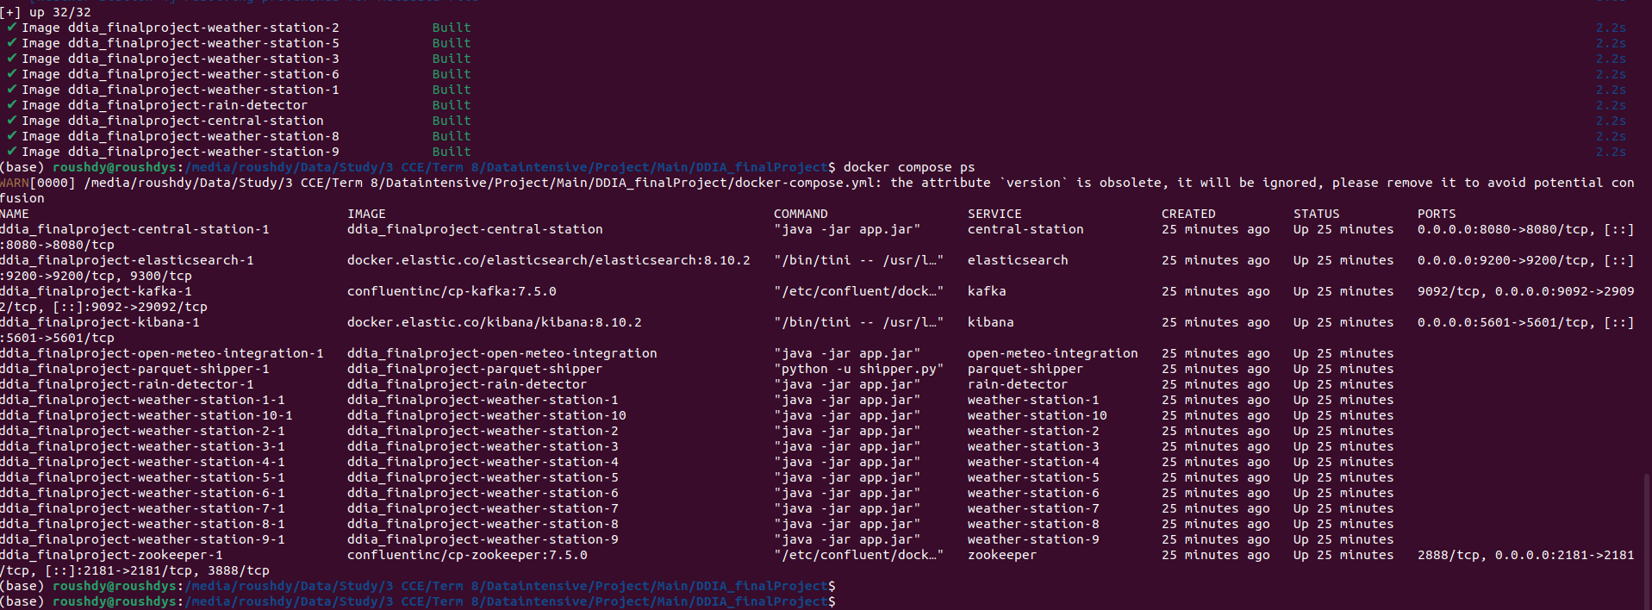
Figure 11: docker compose ps — all 17 services running

Kubernetes Deployment
The Kubernetes deployment (k8s/deployment.yaml) defines all services within the weather-monitoring namespace. It includes Deployments and Services for Zookeeper, Kafka, Elasticsearch, Kibana, Central Station, Rain Detector, Parquet Shipper, Open-Meteo Integration, and all 10 weather stations. A PersistentVolumeClaim (shared-pvc) provides 2Gi of shared storage with ReadWriteMany access mode for Parquet and BitCask data. Central Station and Kibana are exposed via NodePort services for external access.
Screenshot 17: Kubernetes pods in the weather-monitoring namespace.
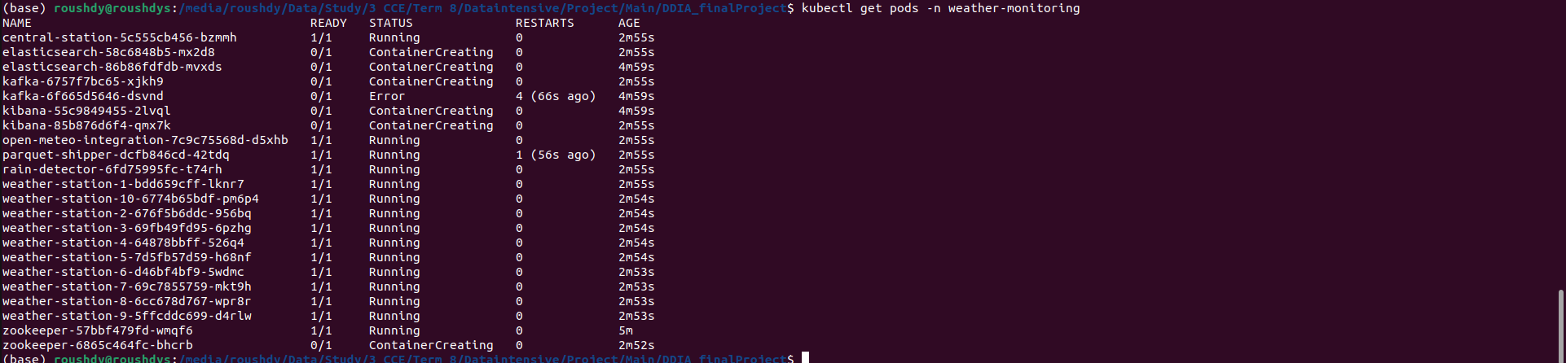
Figure 12: kubectl get pods — application pods in weather-monitoring namespace
Screenshot 18: Kubernetes services with ClusterIP and NodePort configurations.
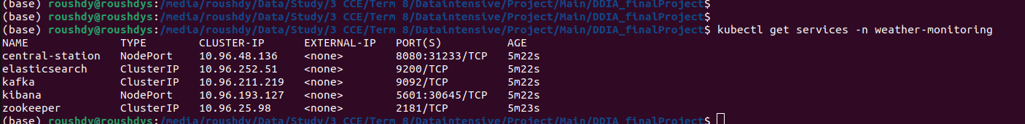
Figure 13: kubectl get services — service endpoints in weather-monitoring namespace

9. JFR Profiling (Section G)
Java Flight Recorder (JFR) was used to profile the Central Station for a 1-minute recording session. The recording was captured using the -XX:StartFlightRecording JVM flag and analyzed in JDK Mission Control (JMC). The recording.jfr file was extracted from the Docker container for offline analysis.
Screenshot 13: The recording.jfr file extracted from the central-station container (1.1 MB).
Figure 14: recording.jfr file on disk (1.1 MB)

Top 10 Classes by Memory Allocation
The JMC Memory view reveals the top 10 classes by total memory allocation during the recording period. The dominant allocator is byte[] at 493 MiB (63.5%), followed by java.lang.String at 82.5 MiB (10.6%), and java.net.URL at 79 MiB (10.2%). The high byte[] allocation is expected given the heavy I/O operations involving serialization, Kafka message processing, and file writes for BitCask and Parquet. The ConcurrentHashMap$Node[] and ConcurrentHashMap$Node entries reflect the in-memory KeyDir structure of the BitCask store.
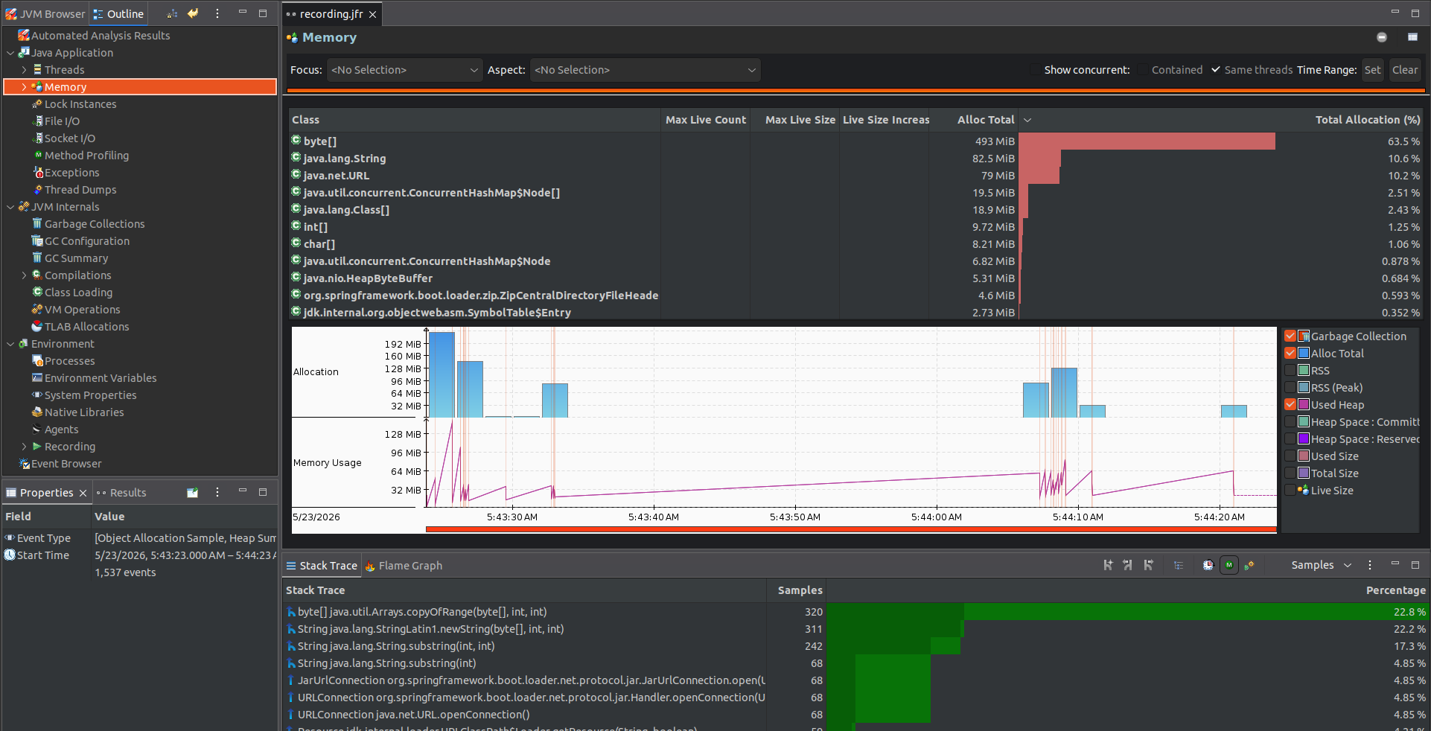
Figure 15: JMC — Top 10 classes by total memory allocation

GC Pause Count and Maximum Duration
The GC Summary shows a total of 43 garbage collection events during the recording. Young generation (G1New) collections occurred 28 times with an average pause of 3.311 ms and a maximum of 9.082 ms. Old generation (G1Old) collections occurred 15 times with an average pause of 10.397 ms and a maximum of 27.698 ms. The overall average pause time was 2.686 ms with the longest single pause at 9.082 ms (young generation). The total pause time was 112.820 ms across all collections, indicating low GC overhead relative to the recording duration.
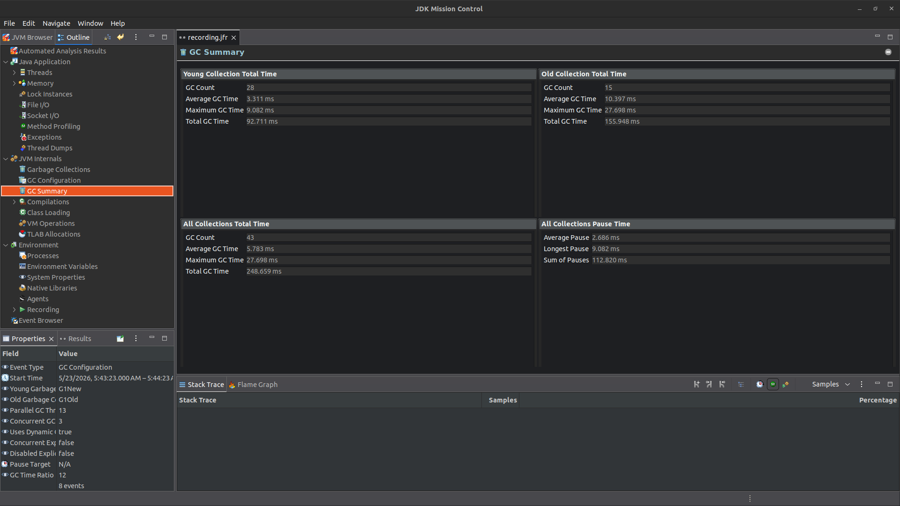
Figure 16: JMC — GC Summary showing pause counts and durations

I/O Operations List
The File I/O view lists all file operations during the recording. The most significant I/O operations involve the application JAR (/app/app.jar, 109.734 ms total I/O time, 163 MiB read) and the BitCask hint files (e.g., /data/bitcask/hint_7 at 67.711 ms with 137,475 read operations and 178 KiB read). The stack trace at the bottom confirms that the dominant I/O operations originate from RandomAccessFile.read() calls within the BitCask.recoverFromHintFile() method, validating that the hint file recovery mechanism is the primary source of file I/O during startup.
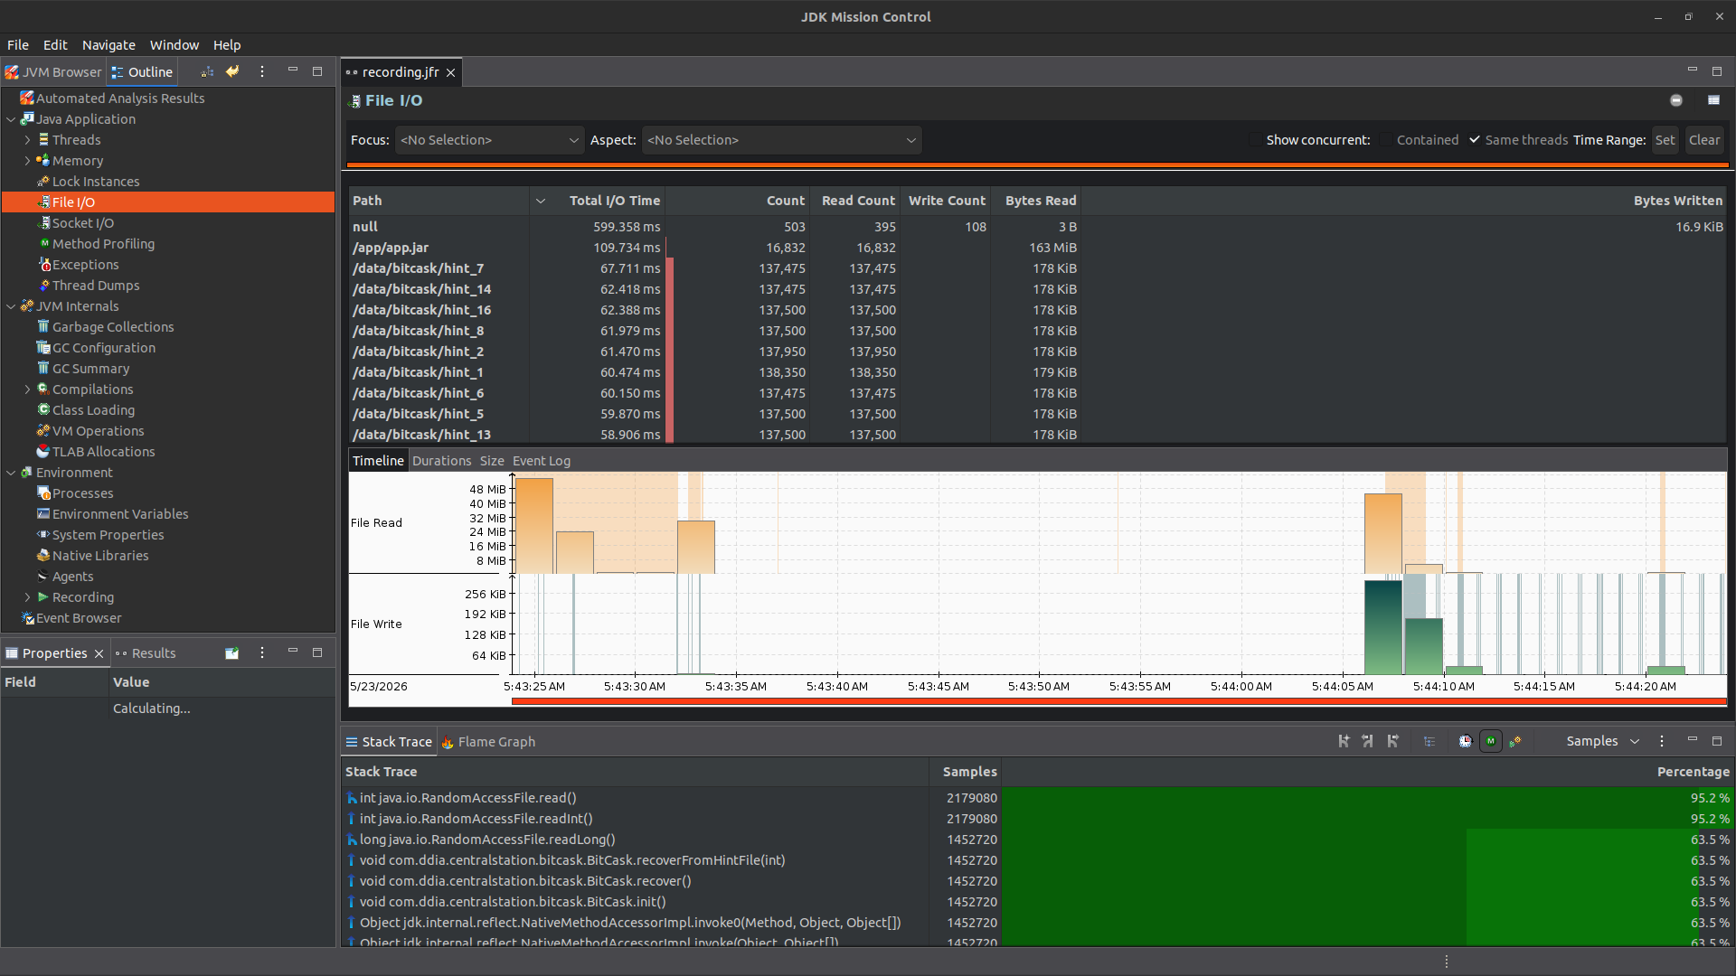
Figure 17: JMC — File I/O operations showing BitCask hint file reads and app.jar loading

10. Bonus: Open-Meteo Integration & EIP Patterns
The Open-Meteo Integration module (open-meteo-integration) connects to the Open-Meteo public weather API (https://open-meteo.com/) and feeds real weather data into the same Kafka pipeline used by the mock stations. This integration is built using Spring Integration and implements several Enterprise Integration Patterns (EIP):
- Polling Consumer: The Open-Meteo API is polled every 10 seconds using a Spring Integration MessageSource with a fixed-delay poller.
- Channel Adapter: A KafkaProducerMessageHandler serves as the outbound channel adapter, pushing transformed messages to the weather_status Kafka topic.
- Envelope Wrapper: The raw Open-Meteo JSON response is transformed into the standard WeatherStatusMessage domain object, wrapping external data in the internal message format with station_id=999.
- Invalid Message Channel: Messages that fail validation (e.g., missing current_weather field) are routed to a dedicated invalidMessageChannel for logging and discarding.
- Dead Letter Channel: Errors during Kafka publishing are trapped and routed to a deadLetterChannel via an ExpressionEvaluatingRequestHandlerAdvice, ensuring failures do not crash the pipeline.
- Idempotent Receiver: A MetadataStoreSelector-based IdempotentReceiverInterceptor deduplicates messages by s_no, ensuring that if the same sequence number is processed again (e.g., on restart), it is discarded to the invalid message channel.

11. Conclusion
This project successfully implements a complete distributed weather monitoring system that covers the full data pipeline from acquisition through archival and analysis. All project requirements have been met: 10 weather station mocks produce correctly formatted messages at 1 message per second with the specified battery distribution (30/40/30) and 10% drop rate. Kafka Streams rain detection correctly filters humidity above 70%. The custom BitCask Riak implementation provides efficient key-value storage with hint files, crash recovery, and scheduled compaction. Parquet archival with date and station ID partitioning enables efficient historical queries. Elasticsearch and Kibana dashboards confirm the expected data distributions. The system is fully containerized with Docker Compose and deployable on Kubernetes. JFR profiling demonstrates reasonable memory usage and low GC pause times. The bonus Open-Meteo integration demonstrates 6 Enterprise Integration Patterns using Spring Integration.

