


A Course Project Work Report on

“Smart Academic Management System: An Integrated Platform for Leave, Attendance, and Intelligent Timetable Management”
Submitted in partial fulfillment of the requirements of CCA Phase-1 for

BUILDING ENTERPRISE APPLICATIONS (BCS703B)
in

COMPUTER SCIENCE AND ENGINEERING

By

MOHAMMED HUZAIFA USN: 1BY23CS125
GIRISH GULAGANJI USN: 1BY23CS076
HARSHITH H S USN: 1BY23CS086
GOKUL S USN: 1BY23CS077

Under the guidance of

Prof. Jagadish P
Assistant Professor

2026-2027

TABLE OF CONTENTS

Sl. No. Contents Page No.

1 Abstract 1

2 Introduction & Motivation 2

3 Problem Statement 3

4 SOFTWARE REQUIREMENTS SPECIFICATION (SRS) 5

5 MULTI-TIER ARCHITECTURAL SPECIFICATIONS 7

6 TECH STACK SELECTION JUSTIFICATION 12

7 REFERENCES 16

ABSTRACT

Educational institutions often rely on manual and disconnected processes to manage student leave applications, attendance records, academic timetables, and administrative activities, resulting in data inconsistencies, scheduling conflicts, excessive paperwork, and difficulties in monitoring attendance eligibility. The proposed Smart Academic Management System aims to address these challenges by providing an integrated web-based platform that automates academic administrative workflows. The system is developed using ReactJS for the frontend, Node.js and Express.js for backend services, MySQL for relational data storage, Sequelize ORM for database interaction, and JSON Web Token (JWT) for authentication and role-based access control. The development methodology involves modular system design, RESTful API development, database modelling, and integration testing within a modern web development environment. The system provides dedicated student and administrator portals, online leave application and approval workflows, daily attendance management, subject-wise attendance analytics, a smart leave planner that evaluates the potential impact of leave on the minimum 75% attendance requirement, and an intelligent timetable generator designed to detect and resolve faculty, classroom, and scheduling conflicts. Additional capabilities include holiday management, attendance reports, timetable publishing, and printable timetable views. The target architectural outcome is a modular, secure, responsive, and maintainable three-tier web application that centralizes academic information, improves data consistency, reduces repetitive administrative work, and supports informed decision-making through automated calculations and analytics. The system is intended to provide a scalable foundation for efficient academic administration and improved coordination between students and administrators.

INTRODUCTION & MOTIVATION

INTRODUCTION:
The Smart Academic Management System operates in the educational technology domain, focusing on the digital transformation of academic and administrative activities in educational institutions. Managing student leave applications, attendance records, academic timetables, and administrative approvals through manual or disconnected systems can lead to paperwork, data inconsistencies, scheduling conflicts, and difficulties in monitoring attendance requirements. This project addresses these challenges by integrating essential academic management activities into a centralized web-based application.
The system follows a three-tier architecture consisting of the presentation layer, application layer, and data layer. The presentation layer is developed using ReactJS to provide interactive and responsive interfaces for students and administrators. The application layer uses Node.js and Express.js to implement business logic and RESTful APIs. The data layer uses MySQL for relational data storage, with Sequelize ORM simplifying database operations and relationships. JSON Web Token (JWT) and role-based access control are used to authenticate users and restrict access according to their roles. The modular design allows individual functionalities to be maintained and extended independently within the application.
MOTIVATION:
The primary motivation for selecting this application is the need to improve the efficiency, reliability, and transparency of academic administration. A centralized system reduces repetitive manual work and enables students to apply for leave and monitor their attendance, while administrators can manage approvals, attendance records, holidays, and timetables. Subject-wise attendance analytics help identify attendance shortages, and the Smart Leave Planner estimates the effect of planned absences on the minimum 75% attendance requirement. The clash-free timetable generator further supports efficient scheduling by identifying and resolving faculty, classroom, and period conflicts. The team selected this solution because it combines practical institutional requirements with full-stack web development, database management, authentication, automation, and analytical capabilities. It also provides opportunities to apply enterprise application design principles, modular development, secure data handling, and maintainable software architecture to a real-world academic problem.

PROBLEM STATEMENT
- Problem Statement
Educational institutions often manage student leave applications, attendance records, timetable scheduling, and administrative approvals through manual procedures or separate systems. These disconnected processes make it difficult to maintain consistent academic records, monitor subject-wise attendance, prevent scheduling conflicts, and evaluate the impact of planned student absences. The Smart Academic Management System addresses this problem by integrating these activities into a centralized web-based platform with dedicated student and administrator interfaces.

Problem Root Cause:
The primary root cause is the fragmentation of academic administrative workflows and the absence of a unified system connecting leave management, attendance tracking, and timetable scheduling. Manual calculations, repeated data entry, limited automation, and inadequate coordination between these activities can result in inconsistent records, scheduling errors, delayed approvals, and difficulties in making timely academic decisions.
  - Operational Impact:
These limitations increase administrative workload, consume time, reduce transparency, and negatively affect the user experience of students and administrators. Inconsistent attendance records may also lead to incorrect attendance calculations, while uncoordinated timetable scheduling can create faculty and classroom conflicts. Limited access control may expose sensitive student information if security is not properly implemented.

  - Target Outcome:
The project aims to develop a centralized, secure, and responsive academic management platform that integrates leave workflows, attendance management, attendance analytics, and timetable scheduling. The target is to achieve 100% successful completion of defined functional test cases, eliminate duplicate attendance records through appropriate validation, enforce role-based access controls, and detect scheduling conflicts before timetable publication. The system also aims to support students in maintaining the minimum 75% attendance requirement through subject-wise analytics and smart leave impact estimation. These outcomes will be evaluated through functional, integration, and security testing rather than assumed without verification.
- Objectives
The major objectives of the project are:
- To develop a centralized web application for managing student leave applications and administrative approvals.
- To implement secure authentication and role-based access control for student and administrator portals.
- To automate daily attendance recording and synchronize approved leave information with attendance records.
- To provide subject-wise attendance analytics, percentage calculations, and attendance shortage identification.
- To develop a Smart Leave Planner that estimates the impact of planned absences on the 75% attendance requirement.
- To implement a timetable generator that identifies and resolves faculty, classroom, and scheduling conflicts.
- To provide holiday management, attendance reports, timetable publishing, and printable timetable views.
- Scope
The project covers the design, development, integration, and testing of a web-based academic administration system. It includes student and administrator portals, authentication, leave application and approval workflows, attendance management, subject-wise attendance analytics, smart leave planning, timetable generation, holiday management, and academic reporting. The application uses ReactJS for the frontend, Node.js and Express.js for backend services, MySQL for data storage, Sequelize ORM for database operations, and JWT for authentication. The system is intended to support academic administrative activities within an educational institution.
Limitation: The system depends on accurate student, attendance, subject, faculty, room, and timetable data. Attendance predictions are based on available records and configured scheduling rules; they do not guarantee future attendance outcomes. The timetable generator can produce a valid schedule only when the supplied resources and constraints permit a feasible solution. The current scope does not include direct integration with external university databases, biometric attendance devices, or official university examination systems unless separately implemented. Large-scale deployment, production infrastructure, and performance under substantial concurrent workloads require additional evaluation before enterprise-wide adoption.

SOFTWARE REQUIREMENTS SPECIFICATION (SRS)

Functional Requirements (FRs):

FR-1: User Authentication and Authorization: The system shall provide secure login for students and administrators using JWT-based authentication and role-based access control to ensure that users can access only authorized functionalities.

FR-2: Leave Management: The system shall allow students to submit leave applications with relevant details and supporting documents. Administrators shall be able to review, approve, or reject applications, and students shall be able to view their leave history and status.

FR-3: Attendance Management: The system shall allow administrators to mark and manage daily class attendance. It should maintain student-wise attendance records and synchronize approved leave information with the attendance system.

FR-4: Attendance Analytics and Reports: The system shall calculate overall and subject-wise attendance percentages, display attendance status, identify attendance shortages, and provide attendance reports to support academic monitoring.

FR-5: Smart Leave Planner: The system shall estimate the impact of planned leave on subject-wise attendance and identify potential risks of falling below the minimum 75% attendance requirement based on available attendance and timetable data.

FR-6: Timetable Management and Generation: The system shall allow administrators to manage academic timetables and generate schedules while detecting and resolving applicable faculty, classroom, and period conflicts.

FR-7: Holiday Management: The system shall allow administrators to maintain academic holiday records and incorporate applicable holidays into attendance calculations and leave planning.

FR-8: Dashboard and Timetable Publishing: The system shall provide role-specific dashboards, display relevant academic information, and allow administrators to publish timetables and access printable timetable views.

4.2 Non-Functional Requirements (NFRs):

NFR-1: Security: The system shall protect user accounts and academic information through password hashing, JWT-based authentication, role-based access control, and server-side authorization checks. Unauthorized access to protected resources shall be rejected.

NFR-2: Performance: The system should respond to routine user actions and database operations within an acceptable time under the expected institutional workload. Performance shall be evaluated through appropriate response-time and workload testing.

NFR-3: Reliability and Data Integrity: The system shall maintain consistent relationships between users, students, leave applications, attendance records, and timetable data. Validation and database constraints shall be used to prevent invalid or duplicate records where applicable.

NFR-4: Usability and Maintainability: The system shall provide a responsive, user-friendly interface for students and administrators across desktop, tablet, and mobile devices. Its modular architecture, reusable components, and structured backend services shall support future maintenance and enhancement.

MULTI-TIER ARCHITECTURAL SPECIFICATIONS

The Smart Academic Management System follows a modular three-tier web application architecture, organized into logical, technical, data, and infrastructure views for architectural analysis. These four views describe the system's user-facing components, backend processing, persistent data storage, and execution environment. The architecture separates presentation, business logic, and data access responsibilities to improve maintainability, security, and extensibility.

5.1 Logical Layer

The logical layer represents the interaction between users, interface components, request handlers, and application modules. Students interact with the system to submit leave applications, view attendance analytics, access timetables, and plan leave. Administrators manage attendance, approve leave requests, configure holidays, and generate or publish timetables.

Key components:

Presentation layer: ReactJS pages, dashboards, forms, navigation, and responsive UI components.

Authentication and authorization: Login, JWT session handling, and role-based route protection.

Application controllers: Handle incoming requests and coordinate application operations.

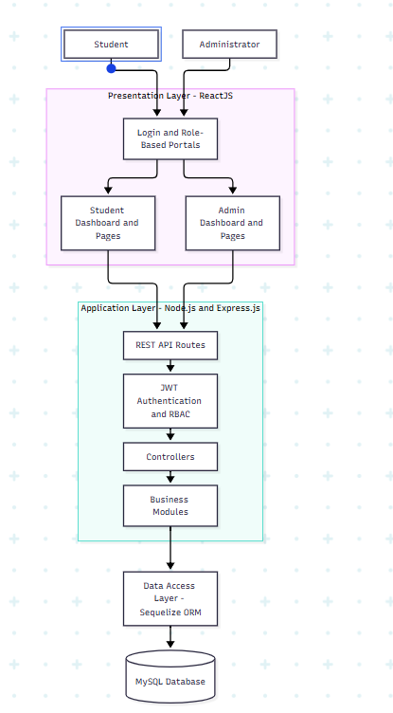
Core modules: Leave Management, Attendance Management, Smart Leave Planner, Timetable Management, Analytics, and Holiday Management.

5.2 Technical Layer

The technical layer explains how application requests move through REST APIs, middleware, controllers, business logic, and database operations. The backend is developed using Node.js and Express.js. JWT authentication and role-based authorization middleware protect restricted endpoints, while Sequelize ORM translates application operations into relational database queries.

Key components:

REST API endpoints: Handle login, leave applications, attendance, analytics, and timetable operations.

Middleware: Performs authentication, authorization, and request validation.

Controllers and services: Execute workflow rules, attendance calculations, leave impact simulations, and timetable scheduling.

Data translation: Sequelize maps JavaScript models and operations to MySQL tables and queries.

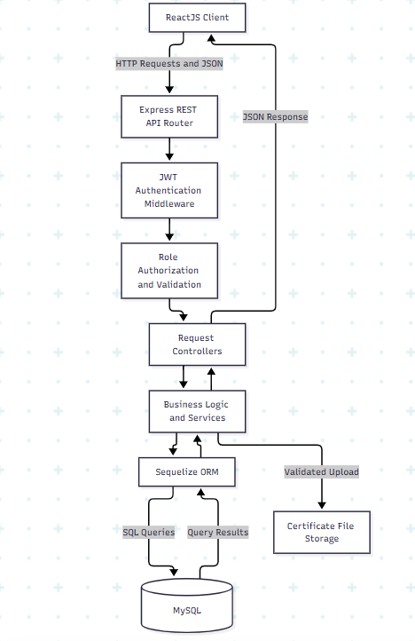
File handling: Leave certificates are stored in the backend certificate-upload directory, subject to upload validation.

5.3 Data Layer

The data layer manages persistent academic records, relationships, and uploaded documents. MySQL provides relational storage, and Sequelize ORM defines models and associations between application entities. Referential integrity and appropriate validation help maintain consistency between student records, leave applications, attendance entries, and timetable schedules.

Principal entities:

Entity/Table Purpose

User Stores account information, password hashes, and roles.

Student Stores student-specific academic and profile information.

Leave Stores leave applications, dates, reasons, and approval status.

Attendance Stores student attendance records by date and status.

Subject Stores subject details and subject codes.

Faculty Stores faculty information.

Room Stores classroom and laboratory resources.

Timetable Stores timetable configuration and publication details.

TimetableSlot Stores scheduled subjects, days, periods, rooms, and faculty assignments.

Holiday Stores academic holiday information.

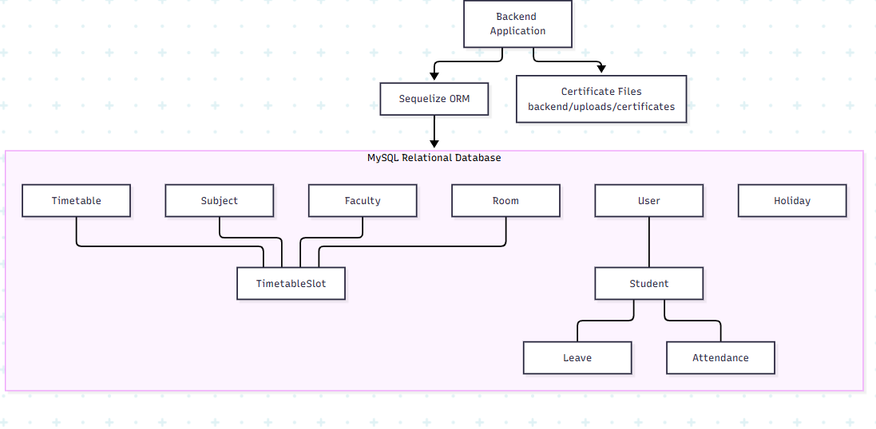
The certificate-upload directory stores leave-related documents separately from relational records. Exact table columns, foreign keys, indexes, and cascade rules should be taken from the implemented Sequelize models and database schema.

5.4 Infrastructure Layer

The infrastructure layer describes the software runtime, project organization, and communication between the frontend, backend, database, and file storage. During development, the ReactJS frontend runs through Vite, the Express backend runs on Node.js, and MySQL provides database services. The frontend communicates with the backend over HTTP using REST APIs.

Infrastructure components:

Frontend runtime: ReactJS application served by Vite during development and built into static assets for production.

Backend runtime: Node.js with Express.js REST API services.

Database runtime: MySQL relational database.

File storage: Backend certificate-upload directory.

Build process: npm scripts and the Vite production build.

Configuration: Environment variables for database credentials, authentication secrets, and service settings.

The development environment can use separate frontend and backend processes with a MySQL service. A production deployment may host the frontend as static assets and run the backend on a server or managed runtime, with MySQL and uploaded files stored in appropriately secured persistent environments. Specific cloud providers, containers, automated CI/CD pipelines, and production hosting arrangements are outside this specification unless they are actually configured and verified.
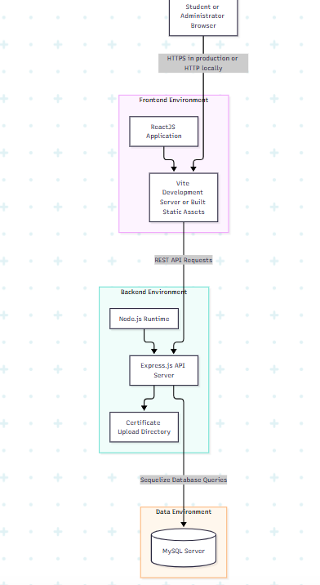

5.5 Architectural Summary

The proposed architecture separates user interaction, request processing, data persistence, and runtime infrastructure into clearly defined responsibilities. This separation supports secure access control, reusable business modules, structured database management, and easier testing and maintenance. The system's functional correctness and scalability should be evaluated through integration tests, security tests, and workload testing before deployment in a large institutional environment.

TECH STACK SELECTION JUSTIFICATION

The Smart Academic Management System uses a ReactJS frontend, Node.js and Express.jsbackend,
MySQL relational database, Sequelize ORM, and JSON Web Token (JWT) authentication. These technologies were selected based on the application's requirements for structured academic data, secure role-based access, workflow automation, and maintainable web application development. The following sections explain the architectural reasoning behind each selection.

6.1 Frontend: ReactJS

Architectural choice: Component-based single-page web application.

ReactJS was selected because the system contains multiple interactive modules, including student dashboards, leave application forms, attendance registers, analytics views, and timetable management pages. Its component-based architecture enables reusable interface elements, reducing duplication and simplifying maintenance. Client-side routing supports navigation between modules without requiring a full-page reload for every interaction. Compared with developing every page independently using traditional server-rendered HTML, ReactJS provides a more suitable structure for a responsive, interactive application with role-specific interfaces.

6.2 Backend: Node.js and Express.js

Architectural choice: Centralized REST API backend with modular request handling.

Node.js was selected because its asynchronous, event-driven execution model is suitable for handling multiple web requests and database operations. Express.js provides a lightweight routing and middleware framework for organizing API endpoints, authentication, authorization, validation, and error handling. This approach separates frontend presentation from backend business logic and allows the same API layer to serve different client interfaces. A custom request handler for every endpoint would introduce unnecessary duplication, whereas reusable routes and middleware provide a more consistent structure.

6.3 Database: MySQL

Architectural choice: Relational database management system.

MySQL was selected because the application manages structured and interrelated records such as users, students, leave applications, attendance entries, subjects, faculty, rooms, and timetable slots. These entities require defined relationships and consistent updates. A relational database supports primary keys, foreign keys, unique constraints, and transactions, helping preserve data integrity across related workflows. For example, leave approval and attendance synchronization require consistent relationships between student, leave, and attendance records.
A document-oriented database such as MongoDB could support flexible records, but its schema flexibility is not a primary requirement for these strongly related academic entities. Therefore, MySQL is the more appropriate choice for the current data model.

6.4 Database Access: Sequelize ORM

Architectural choice: Object-relational mapping between JavaScript application logic and relational tables.
Sequelize was selected to define database models, associations, validations, and query operations using JavaScript. It reduces repetitive SQL handling and provides a structured interface between backend services and MySQL. Model associations help represent relationships among students, leaves, attendance records, and timetable resources. Where a workflow requires multiple related changes, database transactions and suitable constraints can help maintain consistency. Raw SQL remains an option for specialized queries when required.

6.5 Authentication and Authorization: JWT with Role-Based Access Control

Architectural choice: Token-based authentication combined with server-side role enforcement.

JWT was selected to represent authenticated sessions between the client and backend without requiring the server to maintain a traditional session record for every request. Role-based access control distinguishes student operations from administrator operations. Authentication middleware validates the token, while authorization middleware checks whether the authenticated user is permitted to perform the requested action. Sensitive permissions must be enforced on the backend rather than relying only on frontend navigation. This approach supports protected APIs and helps prevent unauthorized access to attendance, leave approvals, and other restricted resources.

6.6 API Architecture: RESTful Services

Architectural choice: Resource-oriented HTTP APIs using JSON.
RESTful APIs were selected to establish a clear communication contract between ReactJS and the backend. Resources such as leave applications, attendance records, students, and timetables can be accessed through organized endpoints using appropriate HTTP methods and status codes. JSON provides a convenient data exchange format between JavaScript-based frontend and backend components. This separation makes individual modules easier to test, maintain, and extend.

6.7 Architectural Style: Three-Tier Architecture
Architectural choice: Presentation, application, and data layers.
The system separates the ReactJS presentation layer, the Node.js/Express.js application layer, and the MySQL data layer. This separation prevents user-interface code from directly accessing the database and centralizes business rules and security checks in the backend. It also enables each layer to be maintained and tested independently. Compared with a tightly coupled monolithic structure in which interface, business logic, and data access are mixed together, the three-tier design provides clearer responsibilities and supports future modification.
6.8 Development and Deployment Tools

Architectural choice: Modular JavaScript development with npm and Vite.

npm manages project dependencies and development scripts. Vite provides a development server and production build process for the ReactJS frontend. Separating frontend and backend development environments allows each component to be built and tested independently. Environment variables keep environment-specific configuration outside application source code. Actual production hosting, automated CI/CD, containerization, and cloud infrastructure should be introduced only when required by deployment needs and verified in the implementation.

6.9 Overall Selection Justification

The selected stack provides a consistent JavaScript-based development environment across the frontend and backend, while MySQL supplies relational data integrity for academic workflows. Express middleware supports centralized request processing and access control, Sequelize structures database interaction, and JWT-based authentication supports protected user operations. The resulting architecture is appropriate for an integrated academic management application because it balances maintainability, security, development simplicity, and functional requirements without introducing the operational complexity of a distributed microservices architecture.

EVALUATION RUBRICS

S.No | Evaluation Criteria | Excellent | Good | Needs Improvement | Max Marks | Marks Obtained
1. | Problem & SRS | Defines the problem statement completely using a standard structure (Problem Root Cause Impact Target Outcome),  Complete SRS (>=8 Functional Requirements, >=4 Non FRs)  (9-10 marks) | Defines the problem statement but lacks the standard structure.  SRS  (5-7 FRs,  2-3 NFRs)  (6-8 marks) | Vague problem statement;  incomplete SRS (<5 FRs, NFRs)  (0-5 marks) | 10
2. | Multi-Tier Diagrams | Complete diagrams for Logical, Technical, Data, and Infrastructure layers.  (13-15 marks) | Lacks diagrams, but minor overlap or missing detail in one layer.  (9-12 marks) | Incomplete diagrams; missing major architectural layers.  (0-8 marks) | 15
3. | Tech Stack Choice | Strong justification for architecture patterns and chosen tech stack.  (9-10 marks) | Fair reasoning for tech stack and architecture choices.  (6-8 marks) | Weak or no justification for technical decisions.  (0-5 marks) | 10
4. | Presentation & Q&A | Professional slides, good team coordination, clear answers to Q&A.  (4-5 marks) | Clean slides, good presentation, answered most Q&A.  (3 marks) | Unorganized slides, poor time management, unable to answer Q&A.  (0-2 marks) | 5
TOTAL MARKS

Signature of Course Co-Ordinator
REFERENCES/BIBLIOGRAPHY
[1] H. Algethami and W. Laesanklang, “A Mathematical Model for Course Timetabling Problem With Faculty-Course Assignment Constraints,” IEEE Access, vol. 9, pp. 111666–111682, 2021, doi: 10.1109/access.2021.3103495.
[2] S. Lohkare, S. Salpe, P. Gupta, S. Aote, and T. Shah, “A Comparative Analysis of Constraint Programming and Genetic Algorithms for Automated University Timetable Generation,” in 2025 IEEE Pune Section International Conference (PuneCon), IEEE, Dec. 2025, pp. 1–6. doi: 10.1109/punecon67554.2025.11379218.
[3] Ghazi Alnowaini and Amjad Abdullah Aljomai, “Genetic Algorithm for Solving University Course Timetabling Problem Using Dynamic Chromosomes,” Mar. 2021, doi: 10.1109/ictsa52017.2021.9406539.
[4] G. Chandwani, N. Gautam, and M. Chaudhary, “Student Attendance Monitoring Dashboard: Analytical Insights & Predictive Modeling,” 2025 International Conference on Intelligent and Secure Engineering Solutions (CISES), pp. 340–344, Aug. 2025, doi: 10.1109/cises66934.2025.11265585.
[5] A. Vijayaraj, V. Sabapathi, S. K. R, Karthiga. R, R. Megavannan, and N. Mageshkumar, “Enhanced Intelligent Attendance Management System for Smart Campus Using Computer Vision,” in 2025 2nd International Conference on Computing and Data Science (ICCDS), IEEE, July 2025, pp. 1–6. doi: 10.1109/iccds64403.2025.11209706.
[6] M. Iqbal, H. M. Mont, and R. Matulevičius, “STAMP: Blockchain and DAO-based Student Attendance Management Platform,” 2024 7th International Balkan Conference on Communications and Networking (BalkanCom), pp. 26–30, June 2024, doi: 10.1109/balkancom61808.2024.10557210.
[7] G. Taye, S. Sharma, P. Shah, and Yohanes Getinet Nuriye, “Exploring the Role of Artificial Intelligence in Class Scheduling and Management: A Comprehensive Survey and Review,” Oct. 2023, doi: 10.1109/cset58993.2023.10346898.
[8] N. R, V. M, and H. E, “Smart Timetable Optimization Using Reinforcement Learning Algorithm,” in 2026 International Conference on Electronics and Renewable Systems (ICEARS), IEEE, Feb. 2026, pp. 1177–1184. doi: 10.1109/icears67481.2026.11416574.
[9] S. S, Y. U. J. Ugli, D. Saitxanova, D. K. Sahu, and A. K., “Academic Exam Scheduling Using Constraint Satisfaction Solver for Conflict-Free Timetables,” in 2025 International Conference on AI-Driven STEM Education and Learning Technologies (AISTEMEDU), 2025, doi: 10.1109/AISTEMEDU67077.2025.11403893.
[10] G. K. Muralee Krishnan, N. C. K, and A. K. Nair, “A Zone-Based RFID Attendance System Using Firebase for Secure and Location-Aware Student Tracking,” 2026 9th International Conference on Computing Methodologies and Communication (ICCMC), pp. 234–239, July 2026, doi: 10.1109/iccmc69250.2026.11625059.

