## VISVESVARAYA TECHNOLOGICAL UNIVERSITY JNANA SANGAMA, BELGAVI-590018



**An Internship Report On**

## “WEB DEVELOPMENT.”

*Submitted in the partial fulfilment for the award of degree of 8th Sem.*

#### BACHELOR OF ENGINEERING

**In**

**COMPUTER SCIENCE & ENGINEERING**

**Submitted by**

#### MOHAMMED JABIR 1VJ19CS034

Internship Carried Out At

**“HQV Technologies”**

### Internal Guide External Guide

Dr Naveen G, PhD Mr. Mohammed Viqar Ahmed

Professor Director HQV Technologies

Dept. Of CSE

## DEPARTMENT OF COMPUTER SCIENCE AND ENGINEERING

**VIJAYA VITTALA INSTITUTE OF TECHNOLOGY 2022-2023**

# VIJAYA VITTALA INSTITUTE OF TECHNOLOGY

**BENGALURU-560077**

**DEPARTMENT OF COMPUTER SCIENCE & ENGINEERING**



**CERTIFICATE**

This is to certify that the Internship Presentation entitled “**WEB DEVELOPMENT**” Carried out at “**HQV Technologies**” by MOHAMMED JABIR bearing USN:1VJ19CS034, a bonafide VIII Semester student of Vijaya Vittala Institute of Technology, Bengaluru, in partial fulfillment for the award of Bachelor of Engineering in Computer Science and Engineering of the Visvesvaraya Technological University, Belagavi during the academic year 2022-2023. It is certified that all corrections/suggestions indicated for Internal Assessment have been incorporated in the report. The Internship report has been approved as it satisfies the academic requirements in respect of internship prescribed for the said degree.

Signature of Internal Guide Signature of HOD Mrs. Signature of Principal

Dr Naveen G, PHD, Mangala Patil Dr. S.Rajendra

Professor, Dept. of CSE Prof. & HOD Dept. of CSE Principal, VVIT

Name of the Examiners

Signature with Date

1

2

## DECLARATION

I, **Mohammed Jabir** student of VIII semester Bachelor of Engineering in Computer Science and Engineering, Vijaya Vittala Institute of Technology, Bengaluru, hereby declare that the dissertation work entitled **“Web Development”** has been carried out under the supervision of **Dr. Naveen G** Professor, Department of Computer Science and Engineering of VVIT, Bengaluru, for the partial fulfillment of the requirements for the award of the degree of Bachelor of Engineering in Computer Science and Engineering by Visvesvaraya Technological University, Belagavi during the academic year 2022-2023. Further the matter embodied in the dissertation has not been submitted previously by anybody for the award of any degree or diploma to any other university.

**PLACE: BENGALURU Mohammed Jabir**

**DATE: (1VJ19CS034)**

## INTERNSHIP CERTIFICATE

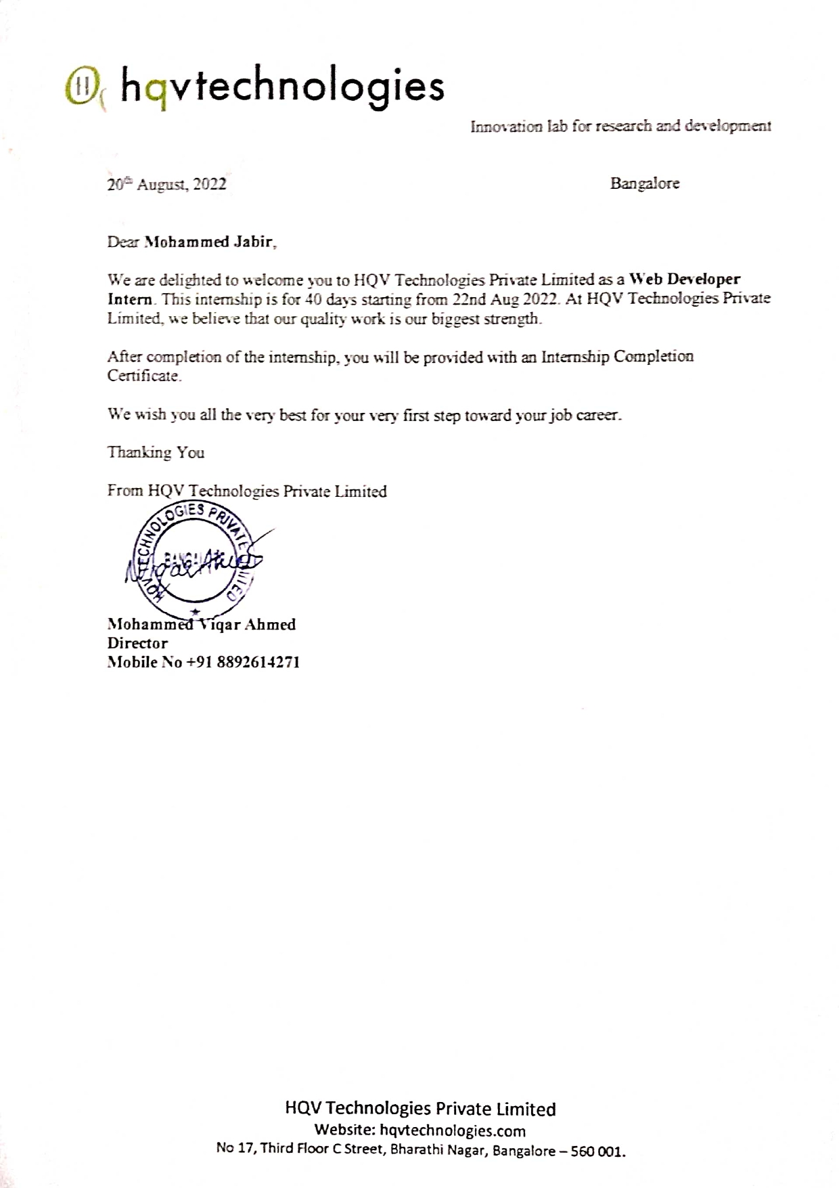

The satisfaction and euphoria that accompany the successful completion of any task would be incomplete without the mention of the people who made it possible, whose constant guidance and encouragement crowned the efforts with success.

I would like to express my deepest sense of gratitude to my Internship Coordinator **Dr Naveen G, PhD** Professor, Department of Computer Science & Engineering for his constant support and guidance throughout this Internship.

It gives me immense pleasure to thank **Mrs Mangala Patil** Professor and Head of the Department for her constant support and encouragement.

I would like to express my thanks to the Principal **Dr Rajendra S.** for his encouragement that motivated us for the successful completion of this Internship.

I would like to profoundly thank the **Management of Vijaya Vittala Institute of Technology** for providing such a healthy environment for the successful completion of the Internship.

Last, but not least, I would hereby acknowledge and thank our parents who have been a source of inspiration and also instrumental in the successful completion of the Project Phase I work.

**Mohammed Jabir [1VJ19CS034]**

I was offered an internship at HQV Technologies Private Limited after successful round of interview. The internship was for 40 days from 21-Aug-2022 to 01-Oct-2022. The role, I was assigned was that of a web developer.

The study aimed to analyze, to design, to implement, to test some Backend (Rest API, RDBMS) like location API’s for an ongoing project, I learnt a lot about the procedures used in the industry and the techniques to work on a project like this. This location API’s are intended to be used in a project for finding the bed availability in hospitals in a particular area.