Jnana Sangama, Belgavi-590018, Karnataka, INDIA



**TECHNICAL SEMINAR REPORT**

**on**

**“CROP SUITABILITY AND FERTILIZER RECOMMENDATION”**

Submitted in partial fulfillment of the requirements for the award of the degree

**BACHELOR OF ENGINEERING**

**IN**

**COMPUTER SCIENCE and ENGINEERING**

**FOR THE ACADEMIC YEAR 2022-2023**

**BY**

**MOHAMMED JABIR 1VJ19CS034**

**Under the Guidance of Dr. Naveen G BE MTech Phd**

**Department of Computer science and Engineering VVIT, Bengaluru-560077**

**Department of Computer Science and Engineering**

#### Vijaya Vittala Institute of Technology

**Hennur – Bagalur Road, Doddagubbi post Bengaluru -560077**

**Hennur – Bagalur Road, Doddagubbi post, Bengaluru -560 077**



**Department of Computer Science and Engineering**

# CERTIFICATE

Certified that the project work entitled **“Crop Suitability and Fertilizer Recommendation ”**, bonafide work carried out by **Mohammed Jabir** , bearing USN **1VJ19CS034** student of **Vijaya VittalaInstitute of Technology** in partial fulfillment for the award of **Bachelor of Engineering in Computer Science & Engineering** of the **Visvesvaraya Technological University,** Belgavi during the year 2020-2021. It is certified that all corrections/suggestions indicated for Internal Assessment have been incorporated in the Report deposited in the departmental library. The technical seminar report has been approved as it satisfies the academic requirements in respect of project work prescribed for the said Degree.

***Signatures:***

|  |  |  |
| --- | --- | --- |
| Signature of Internal Guide | Signature of HOD | Signature of Principal |
| **Dr. Naveen G** | **Prof. Mangala Patil** | **Dr. S. Rajendra** |
| Asst.Professor, Dept of CSE | Prof. & HOD, Dept of CSE | Principal |
| VVIT, Bengaluru | VVIT, Bengaluru | VVIT, Bengaluru |
|  | **EXTERNALVIVA** |  |
| **Name of the Examiners**  **1.** |  | **Signature with Date** |
| **2.** |  |  |

#### DECLARATION

**Mohammed Jabir** students of VIII semester B.E in Computer Science & Engineering at Vijaya Vittala Institute of Technology, hereby declare that the project work entitled “**Crop Suitability and Fertilizer Recommendation Using Data Mining Techniques**” has been carried out under the supervision of Mr. William Deepan, Assistant Professor, Dept. of CSE, Vijaya Vittala Institute of Technology and submitted in partial fulfilment of the course requirements for the award of degree in B.E in Computer Science & Engineering of Visvesvaraya Technological University, Belagavi during the year 2022-2023. We further declare that the report has not been submitted to another University for the award of any other degree.

Place: Bengaluru **Mohammed Jabir (1VJ19CS034)**

Date:

# ACKNOWLEDGEMENT

I hereby, take this opportunity to express my gratitude and thankfulness to all those concerned in helping me in completing the Final report

I thank my technical seminar guide **Dr. Naveen G** , Dept. of Computer Science and Engineering, Vijaya Vittala Institute of Technology, for their valuable guidance and all encouragement leading me throughout the completion of this project work.

I would like to thank **Prof. Mangala Patil**, Prof & HOD, Computer Science and Engineering, Vijaya Vittala Institute of Technology, for providing us with all the resources required for the project.

I express my gratitude to **Dr. S. Rajendra,** Principal, Vijaya Vittala Institute of Technology for providing an opportunity to do this project as a part of my curriculum in the partial fulfilment of the degree course.

I would like to acknowledge my gratitude to our chair person, **Mrs. Rukmini T** of Vijaya Vittala Institute of Technology for providing necessary infrastructure and creating good environment.

Finally, I am indebted to my family, all my faculties and friends for constantly supporting and encouraging directly or indirectly.

**Mohammed Jabir (1VJ19CS034)**

# TABLE OF CONTENTS

DECLARATION i

ACKNOWLEDGEMENT ii

ABSTRACT iii

CHPATER I – INTRODUCTION [1-7]

* 1. Machine Learning 2
  2. Plant Root Loss 4
  3. Soil Leaching 4
  4. Purpose 6
  5. Objectives 7

CHAPTER II – LITERATURE SURVEY [8-9]

CHAPTER III – ANALYSIS PHASE 10

CHAPTER IV – EXISTING SYSTEM 11

4.1 Drawbacks of existing system [11-12]

CHAPTER V – PROPOSED SYSTEM 13

5.1 Proposed system objectives 13

CHAPTER VI – SYSTEM REQUIREMENTS 14

* 1. Hardware Requirements 14
  2. Software Requirements 14

CHAPTER VII – SYSTEM DESIGN [15-19]

* 1. Architectural Design 15
  2. Data Flow Diagram 16
  3. Use Case Diagram 18
  4. Class Diagram 19
  5. Sequence Diagram 20

REFERENCES [21-23]

### LIST OF FIGURES

|  |  |  |
| --- | --- | --- |
| **FIGURE NO.** | **DESCRIPTION** | **PAGE NO.** |
| 1 | On-Ground Analysis | 01 |
| 1.1 | Machine Learning Classification | 03 |
| 1.3 | Soil Leaching | 05 |
| 7.1 | Block Diagram | 15 |
| 7.2 | Data flow Diagram | 17 |
| 7.3 | Use case Diagram | 18 |
| 7.4 | Class Diagram | 19 |
| 7.5 | Sequence Diagram | 20 |

**CHAPTER I**

**INTRODUCTION**

Agriculture plays a very important role in national economic growth. Agriculture contributes 17-18% to India's GDP and ranks second worldwide in farm outputs. Plants need fertilizers and fertilizers replace the nutrients which crops take from the top layer of the soil. The absence of fertilizers can cause a drastic reduction in the volume of crop output. But fertilization requires precise action. Rainfall patterns and the amount of nutrients needed for a certain crop must be considered when using fertilizers. Machine learning is the current technology that can solve this problem by using available data for crop fertility and rainfall. Farmers can greatly benefit from the support of robust information about crops. The proposed model also uses a machine learning algorithm (random forest algorithm with k-fold cross-validation technique) and takes two inputs from the user that are crop and location. After applying the algorithm, the model predicts the amount of nutrients required along with the best time to use fertilizers. The website is built using Flask Python (web framework) to provide access on all platforms and can be shared among users.

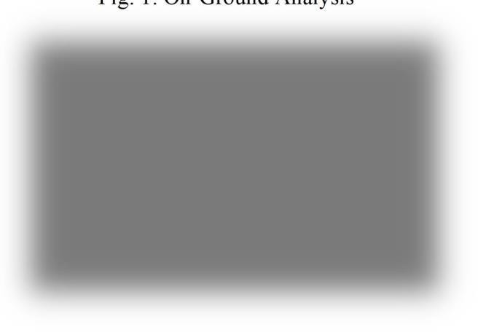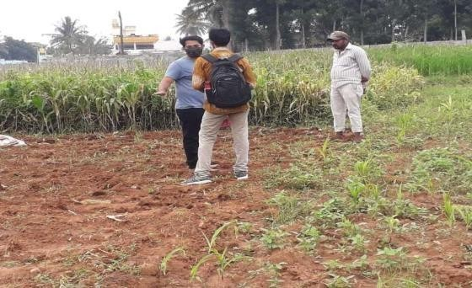

Fig. 1: On-Ground Analysis

##### Machine Learning

The study of machine learning (ML) focuses on comprehending and developing "learning" techniques, that employ data to enhance performance on a variety of tasks. It is considered a component of artificial intelligence. Without the need for explicit programming, machine learning algorithms create a model from training data and use it to generate predictions or judgments. When it is difficult or impossible to develop conventional algorithms, many industries, including speech recognition, medicine, computer vision and email filtering use machine learning techniques. However, machine learning goes beyond simple statistical learning. Computational statistics, a branch of machine learning that focuses on computer-based prediction. Mathematical optimization research benefits machine learning by providing tools, theory, and application fields.

###### What makes machine learning so crucial?

Machine learning is significant because it aids in the development of new goods and provides businesses with a picture of trends in consumer behaviour and operational business patterns. Many of the largest companies operating in the world today, like Uber, Facebook, and Google, heavily rely on machine learning. Machine learning has become a major point of competitive difference for many firms.

###### What are the various kinds of machine learning?

How an algorithm learns to improve its prediction accuracy is a common way to classify traditional machine learning. There are four fundamental strategies: reinforcement learning, semi-supervised learning, unsupervised learning, and supervised learning. The kind of data that data scientists wish to predict determines the kind of algorithm they use. Different kinds of machine learning algorithms are:

* + - *Supervised learning:* With this kind of machine learning, data scientists feed algorithms labelled training data and tell them specific variables to seek for correlations between. Both the input and the output of the algorithm are given.
    - *Unsupervised learning:* This kind of machine learning employs algorithms that train on unlabeled data. Data sets are searched by the algorithm for any significant relationships. Both the forecasts or suggestions generated by algorithms and the data used to train them are predefined.
    - *Semi-supervised learning:* The above two forms of machine learning are combined in this method. An algorithm may be fed mostly labelled training data by data scientists, but the algorithm is allowed to analyse the data on its own and come to its own conclusions about the data set.
    - *Reinforcement learning:* Data scientists typically use reinforcement learning to program a machine to complete a multi-step procedure according to pre-established norms. Data scientists design an algorithm to achieve a goal, giving it valuable feedback as it decides how to do so. The algorithm often makes the decision by itself, though..

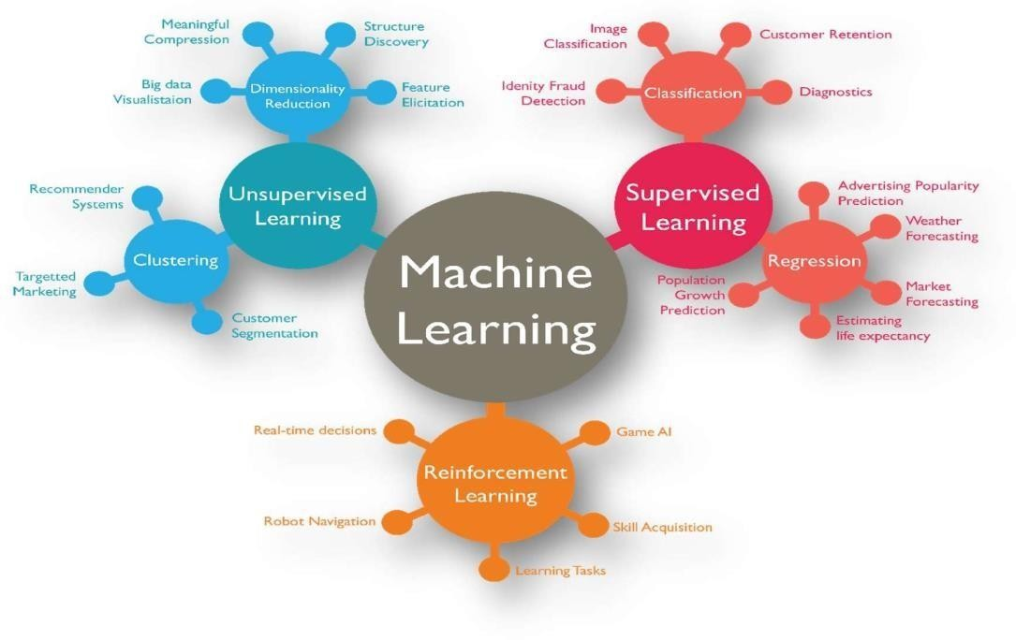

Fig 1.1: Machine Learning Classification

##### Plant Root Loss

Farmers face a number of challenges every year like, heavy rainfall or unpredictable weather, including high interest rates, an overreliance on traditional crops, and a lack of water. Crops may be submerged in water as a result of flooding, which could cause catastrophic losses. As soon as a plant is submerged, its foliage starts to deteriorate because its leaves are unable to exchange gases with the air above (mainly oxygen & carbon dioxide). Producers face flooding or continuously flooded soil more frequently, which hinders roots' ability to absorb nutrients. If the soil is completely soaked for an extended period of time, root loss may result. Because they can't exchange gases, root cells in waterlogged soils risk dying.

Depending on how long the soil is entirely soaked, different amounts of root loss may occur. Plant mortality and complete crop failure would ensue from total root loss. Lower plant performance and crop output would result from partial root loss. Conditions that are too moist might have other detrimental effects on crop productivity. Unusually excessive rainfall can wash away nutrients from the soil, particularly nitrogen. Granular fertilizer that has been put to the soil as nitrogen is particularly susceptible to leaching. If this happens, farmers would either have to pay more money to reapply fertilizer or see a decrease in crop yield due to nitrogen shortage.

##### Soil Leaching

Leaching is the downward transport of pollutants via porous soils, such as water-soluble pesticides or fertilizers. The majority of pesticides, notably clay, adhere to soil particles, become stationary, and do not drain. However, the multiple degradation mechanisms and leaching to groundwater can be seen as competitors in the fate of mobile pesticides. Groundwater does not continuously dilute the pollutants that enter it, in contrast to surface water. It could take many years to remove a contaminated plume from groundwater. Chemical deterioration is slowed by the soil's depth, the freezing temperatures, the limited microbial activity, the lack of sunlight, and the low oxygen levels. As a result, once pesticides enter an aquifer, there is little to no degradation, if any at all. This leads to water pollution.

Fig 1.3: Soil Leaching

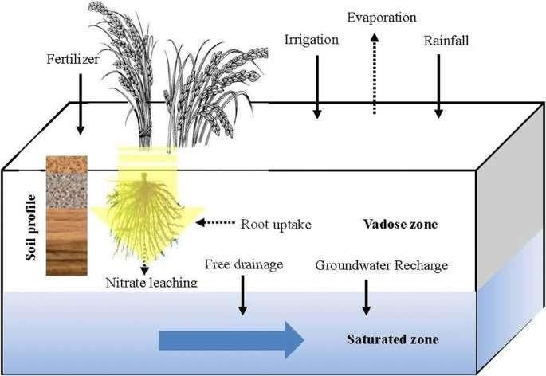

###### Soil Features that Influence Leaching:

* + - *Organic Matter:* The amount of organic matter in a soil is thought to be the single factor that has the greatest impact on how microorganisms break down pesticides. Pesticides are less likely to leach into groundwater because organic matter in the soil improves the surface area available for adsorption, boosts the soil's capacity to retain water and break down pesticides, and nourishes microorganisms. Crop leftovers can be added to the soil, manure can be added, and cover crops can be grown to increase the organic matter in the soil.
    - *Soil Texture:* The amounts of sand, silt, and clay in the soil have an impact on how water moves through it. Large pores and high permeability characterize coarse-textured soils with more sand particles, which allow water to pass through quickly. Groundwater is more likely to become contaminated by pesticides delivered by water via soil with a coarse texture. Soils with a clay texture have less permeability. More water is retained and more chemicals are absorbed from the water by soil with high clay content. This lessens the likelihood of groundwater pollution, increases the likelihood of chemical breakdown and binding to soil particles, and slows the downward migration of the pollutants.
    - *Soil Structure:* Water can travel through the soil quickly because to loosely packed soil particles. Tightly compacted soil acts as a dam, holding water back and preventing its free flow. Openings and channels can be made for water flow in a number of different ways. For instance, animals and earthworms generate openings for water to flow through when they dig burrows. In soil and rock, freezing and thawing causes fissures or splits that dislodge compacted particles. When plant roots decay and die, they pierce the soil and make great water routes. Even through some clay soils, these apertures and channels might allow for a somewhat quick water flow.
    - *Soil Water Content:* Rain or irrigation can recharge the groundwater and perhaps cause pesticides to seep into the aquifer, depending on how much water is already present in the soil. Once soil moisture content is getting close to or near saturation, soluble substances are much more likely to enter groundwater. When it rains and there is snowmelt in the spring, saturation is normal. Contrarily, when soils are dry, the additional water simply fills soil pores close to the soil surface, decreasing the likelihood that it will contact the groundwater supply.

##### Purpose

The main motive behind Eco-Fertilization is to reduce farmers losses by providing useful insights about the amount and use of fertilizers, and to reduce water pollution by slowing down the process of leaching. It serves as a link between farmers and modern technology and enables them to increase yields while using less inputs. The system is designed as a website to provide platform-independent functionality, so that the user can access it from any device. The user interface has been kept simple with more emphasis on functionality and can be used by any naive user. It takes inputs such as crop, state and city using the drop- down menus provided in the website and applies machine learning algorithms to estimate the correct amount of nitrogen, potassium and phosphorus content required. This system provides a good accuracy in itsdecision about the nutrients required for the crop.

##### Objectives

Crop production is essential to the global food and biofuel economies, and ML is significantly enhancing farmers' contributions on both fronts. To enhance crop productivity and yield, herbicides, insecticides, and fungicides must all be applied at the right time. Even if crop spraying is possible later in the season as soil moisture decreases, crop yields will almost certainly be harmed. Every year, farmers make hundreds of intricate and connected decisions that affect their risk, sustainability, and financial results.

The goal of employing machine learning in our project is to provide relevant insight for nutrient requirement for crops by taking short-term weather forecasts (specifically for seven days) into account, as well as to prevent water pollution by slowing down the leaching process.

**CHAPTER II**

**LITERATURE SURVEY**

A comprehensive study of the available literature presents a catalog of previous studies to address this issue. The authors show in [1] that predicting fertilizer usage can assist farmers to attain a proper yield with little waste by preventing toxicity and deficiency in plants to some extent. Paper [2] makes use of fuzzy logic systems that enable the reduction of fertilizer usage which results in an increase in crop productivity. Additionally, [10] shows that the enhanced efficiency of fertilizers is not sufficient for complications that can be caused by compaction. These issues can be prevented by improving the fertilizer recommendation which requires the establishment of a quantifiable relation under N and P for fertilizer usage, in terms of agricultural yield, nitrogen need, and nitrate remnant level which is shown in [11] and paper [4] seconds this by providing a comprehensive measure to estimate the weightage of nutrient requirements and also the role of the chemical properties of soil.

It is a difficult task to predict crop yield due to stochastic rainfall patterns and also temperature variation. So, we can apply different data mining techniques as propounded in [3] for crop yield prediction. Laura J.T. Hess et al. in [5] state that nitrogen leaching is prone in areas that have no-till management and this may cause crop loss. In [7] the authors suggest a novel metric for ‘soil health and quality’ including refinement of soil’s health.

The objective of the paper [8] is to examine the characteristic changes in the creation and elements of soil populaces and capabilities because of the collaboration between long haul treatment and precipitation variances, to decide if preparation history affects the water- obstruction of soil microorganisms. Also, Paper [13] predicts agricultural yield as a function of rainfall. This is accomplished by giving a general summary of how production is affected by rainfall and how much a given crop can yield given the amount of rainfall received. Because it examines all regression procedures, the suggested method of evaluation is superior to other existing methods of evaluation.

Potnuru Sai Nishant et al. in paper [6] predict the yield of practically all types of crops in India. This script makes innovative use of straightforward criteria such as state, district and area, allowing the user to forecast crop yields in any year. Paper [12] suggests the use oTransfer Learning techniques to create a pre-trained model for detecting patterns in the dataset, which we then used to predict crop yields. In [14], supervised algorithms that boost crop yields, reduce human labor, time, and energy exerted on various agricultural tasks, and plant suggestions based on particular soil parameters are used to produce a complete way to predict crop sustainability. The study [16] demonstrated the capabilities of a machine learning model that can interpret and evaluate results, can be utilized to create the most useful information in long- term fertilizer studies, and that these methods can be employed in other long-term experiments. Paper [17] develops an interesting decision-based system on climatic, crop, and insecticide/pesticide data. This is done

Senthil Kumar Swami Durai et al. in [18] propose an integrated solution to Pre- Cultivation activities. The goal of this study is to assist a small farm in becoming more efficient and achieving a high production at a low cost. It also aids in the estimation of total growth expenses. It will assist one in planning forward. Pre-cultivation activities lead to an integrated solution in agriculture. M.S. Suchithra and Maya L. Pai propose solutions to soil nutrient classification problems utilizing the rapid learning classification technique called an Extreme Learning Machine (ELM) with various activation functions in [19].

Crop diseases are one of the primary causes that impact the overall yield. Paper [15] conducts this study using an IoT system in the Kashmir Valley, it proposes an apple disease prediction model using data analysis and machine learning. The challenges of incorporating new technology into traditional agricultural practices are discussed in this paper.

**CHAPTER III**

### ANALYSIS PHASE

Economy of India highly depends on agriculture. Still traditional ways of recommendations are used for agriculture. Currently, agriculture is done based on various approximations of fertilizers quantity and the type of crop to be grown or planted. Agriculture highly depends on the nature of soil and climate. Therefore, it becomes important to make advancement in this field. The analysis proposes development of an ontology-based recommendation system for crop suitability and fertilizers recommendation. It bridges the gap between farmers and technology. The system predicts suitable crop for the field under consideration based on region in Maharashtra state of India and type of soil. It aims to provide proper recommendation of fertilizers to the farmers. Fertilizer recommendation is done based on nitrogen, phosphorus, and potassium (NPK) contents of soil and using past research data that is stored in ontology. Along with fertilizer recommendation system also provides suggestions about crop suitability in particular region. Recommendation system uses random forest algorithm.

**CHAPTER IV**

### EXISTING SYSTEM

This system uses two data mining techniques to provide recommendations. Recommendations of suitable crop in the field and fertilizers for crops to farmers are provided with the help of data stored in ontology. Proposed system provides crop recommendation based on region, type of crop, and fertilizer recommendation based on NPK content of soil, available on their mobile phones.

##### 4.1 Drawbacks of existing system

The existing system uses two algorithms and a longer processing time due to having no multiple path access. Also, for recommending the most suitable crop for the field, knowledge base contains past 3 years data about yields of crops. It is taken as training set. This knowledge is collected from state government, department of agriculture. This knowledge is stored in the form of ontology. Web Ontology Language (OWL) is used for ontology representation. But this data is local, and it is not wide based, also requires multiple accesses.

The drawbacks can be summarized as follows:

* Low efficiency.
* Doesn’t use weather data.
* Low accuracy
* Regional application
* Uses old data.

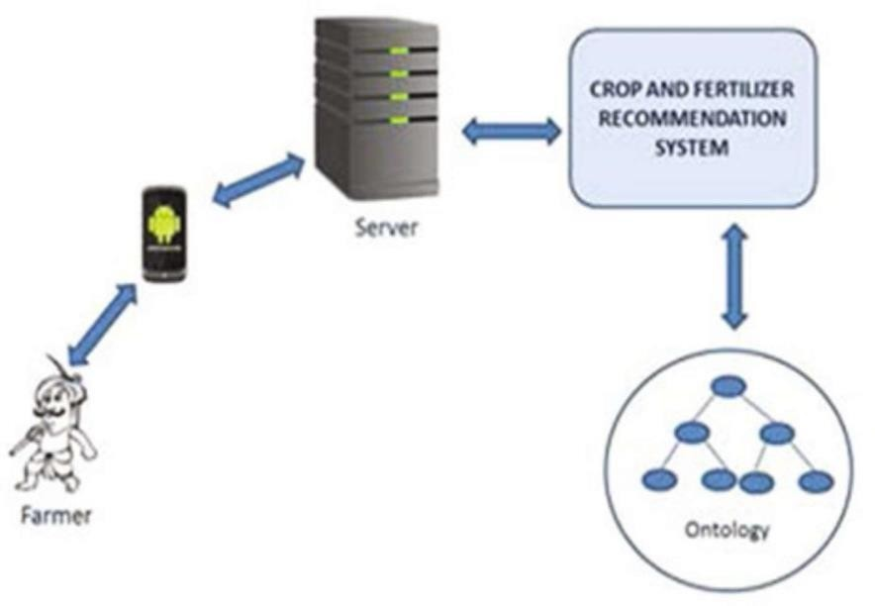

Above is the system architecture of the existing system which displays inefficiency.

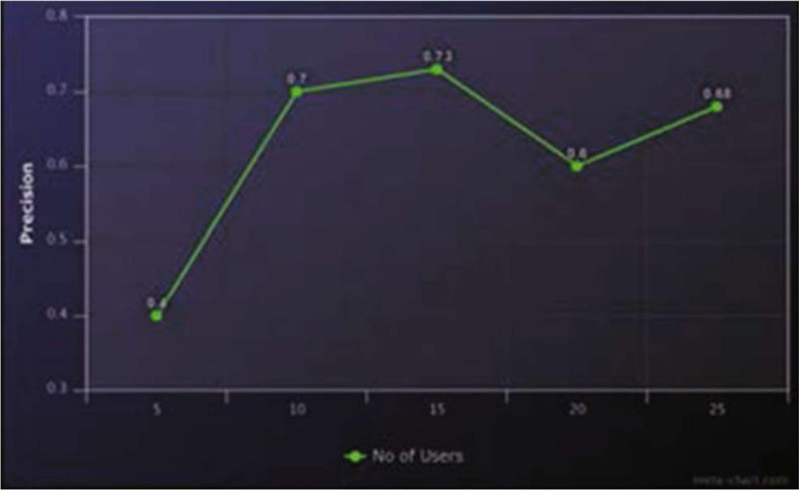

Above shows the precision of the existing system which displays low efficiency.

**CHAPTER V**

### PROPOSED SYSTEM

In this system, a predictive model for the nutrients required for crops will be obtained using random forest. Random forest regression with the k-fold cross-validation technique representsthe model and the model with acceptable accuracy for the prediction is then obtained. A total of seven features have been used to evaluate the algorithm. The algorithm requires input fromthe user (such as location and crop). The location is fed to the Weather API which will return certain characteristics (eg: temperature, humidity, rainfall) and if there is a possibility of heavy rainfall, a precautionary message is displayed to the user, otherwise, the proposed algorithm is followed.

Random forest (RF) is a collection of multiple decision trees that have variable hyper- parameters and are trained using varying subsets of data. In our project, we are going to take crop and location as input, and based on it, we will predict the value of N, P, and K. First, wewill divide our dataset into the training and the test datasets, where training dataset is 80% ofthe original data and the rest 20% is test data. Then we will create three different random forests of size 50 (decision tree) for each N, P, and K and outputs the mean of the classes as the prediction of all the trees.

##### 5.1 Proposed system objectives

To provide nutrient recommendations using an updated iteration of the random forest algorithm which is based on time-series data to forecast the required quantity of nutrients forvarious crops by examining rainfall patterns and crop fertility.

The method suggested here, will improve soil fertility by providing nutrient recommendationsfor optimum conditions for crop growth and reducing leaching and runoff potential

**CHAPTER VI**

### SYSTEM REQUIREMENTS SPECIFICATION

##### Hardware Requirements

Processor: Intel(R) Core (TM) i3-4005U CPU @ 1.70GHz  RAM: 4.00 GB



64-bit operating system, x64-based processor Network Interface Card



Keyboard Mouse



##### Software Requirements

Operating System (any) Google Chrome (web browser) Visual Studio Code



Jupyter Notebook

## SYSTEM DESIGN

##### CHAPTER VII

The process of defining a system's architecture, modules, components, interfaces, and data in order to meet predetermined requirements is known as system design. We could think of systems design as the applications of systems approach to the creation of products.

##### Architectural Design

A conceptual model known as system architecture describes the structure and behavior of the system. It consists of the system's elements and the connections between them that explain how the whole system is implemented. The Fig 4.1 below shows the system’s architecture and the various components added to them.

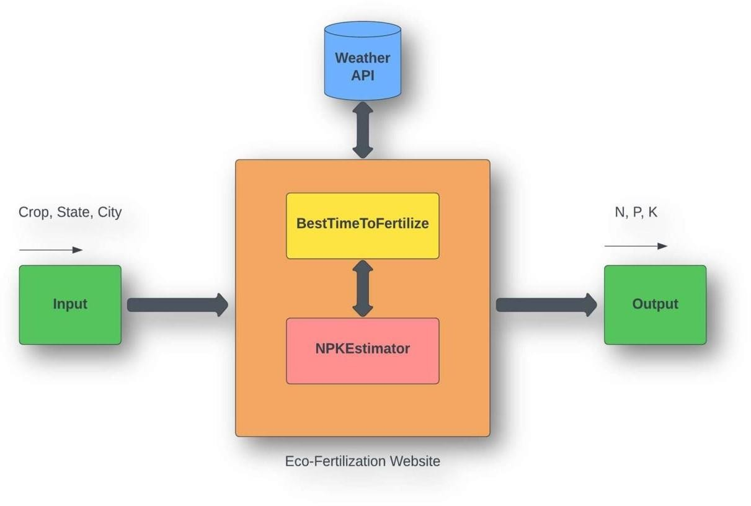

Fig 4.1: Block Diagram

The description of each component from the block diagram above and their major functionalities with respect to the Eco-Fertilization as a complete unit is described in the table below.

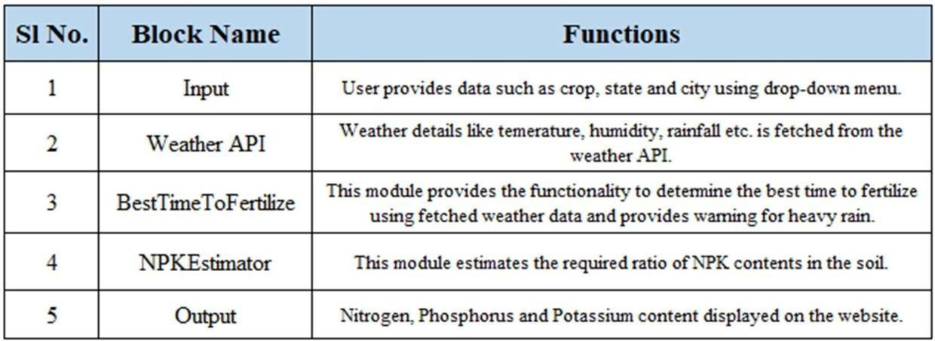

Table 4.1: Block Diagram functionalities

##### Data Flow Diagram

A data flow diagram is a visual representation of how data "flows" throughout a data system, simulating certain features of its operation. It is frequently used as an initial stage to develop, without going into great depth, an overview of the system that may then be expanded upon. They may also be utilized to display data processing.

The type of data that will be input into and generated by the system, how well the data will move through the system, and how the data will be kept are all displayed in a data flow diagram. Unlike a flowchart, which additionally displays information about timing and whether processes will run in succession or parallel, it does not provide this information.

As shown in Fig 4.2, the system requires input from the user (such as location and crop). The location is fed to the Weather API which will return certain characteristics (e.g. temperature, humidity, rainfall) and if there is a possibility of heavy rainfall, a precautionary message is displayed to the user, otherwise, the proposed algorithm is followed.

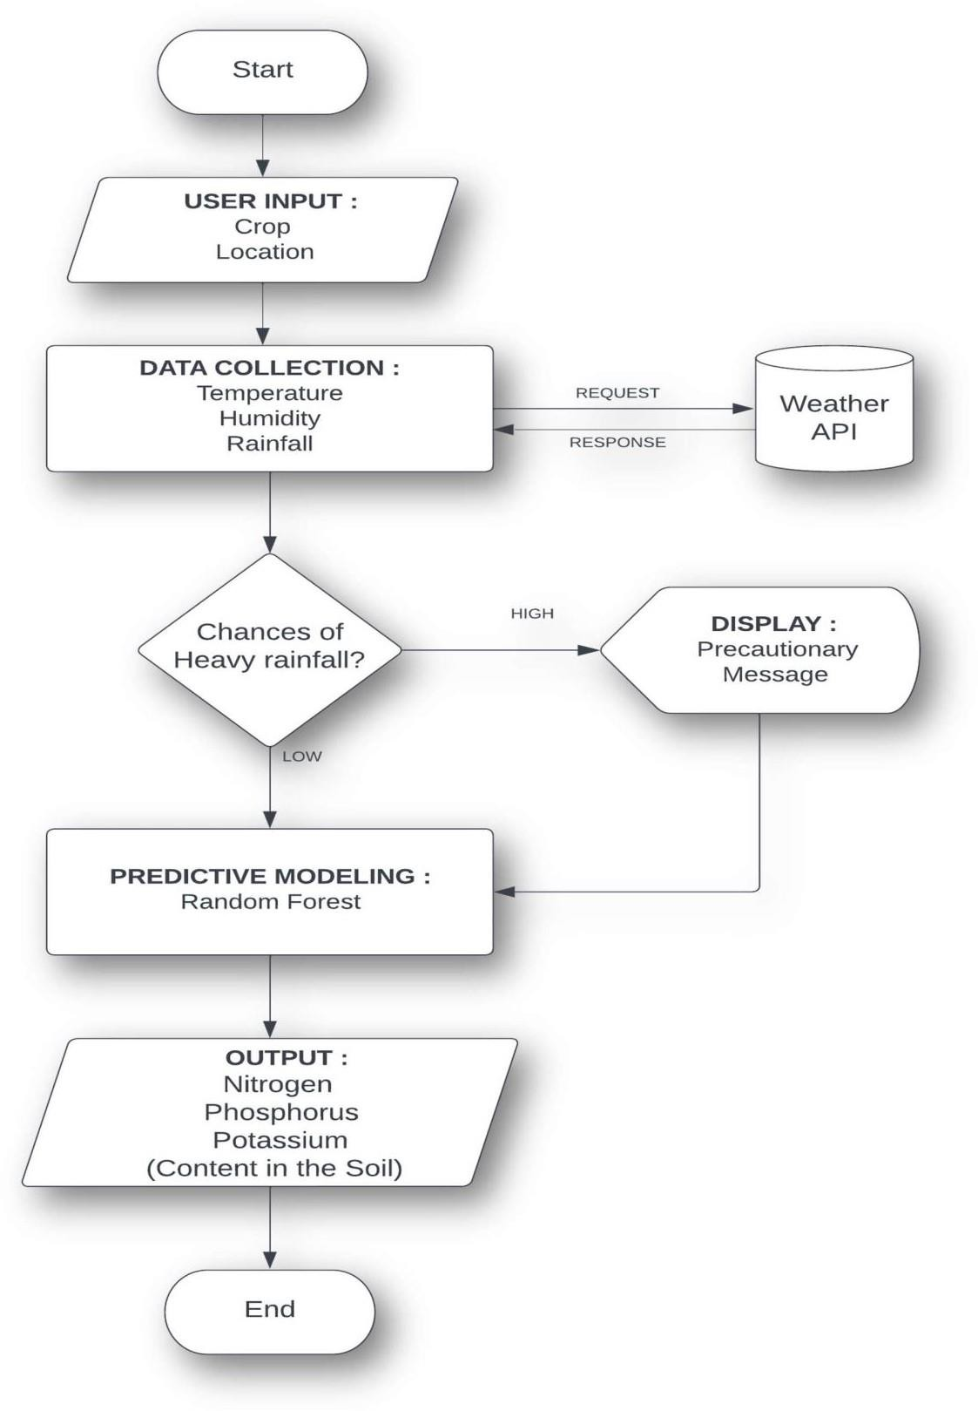

Fig 4.2: Data flow Diagram

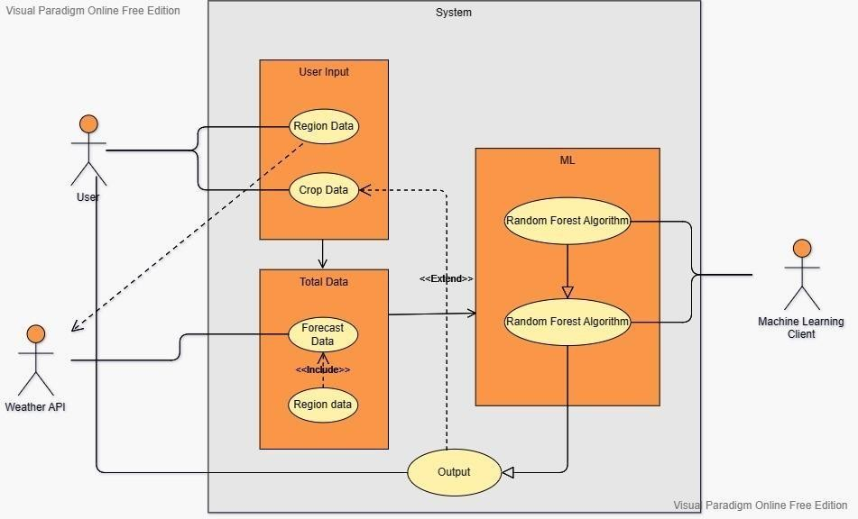

##### Use Case Diagram

A **use case diagram** is a graphical depiction of a user's possible interactions with a system. A use case diagram shows various use cases and different types of users the system has and will often be accompanied by other types of diagrams as well. The use cases are represented by either circles or ellipses. The actors are often shown as stick figures.

##### Class Diagram

Static diagrams include class diagrams. It represents the application's static view. Class diagrams are used to create executable code for software applications as well as for visualizing, explaining, and documenting various elements of systems.

A collection of classes, interfaces, affiliations, collaborations, and constraints are displayed in a class diagram. A structural diagram is another name for it.

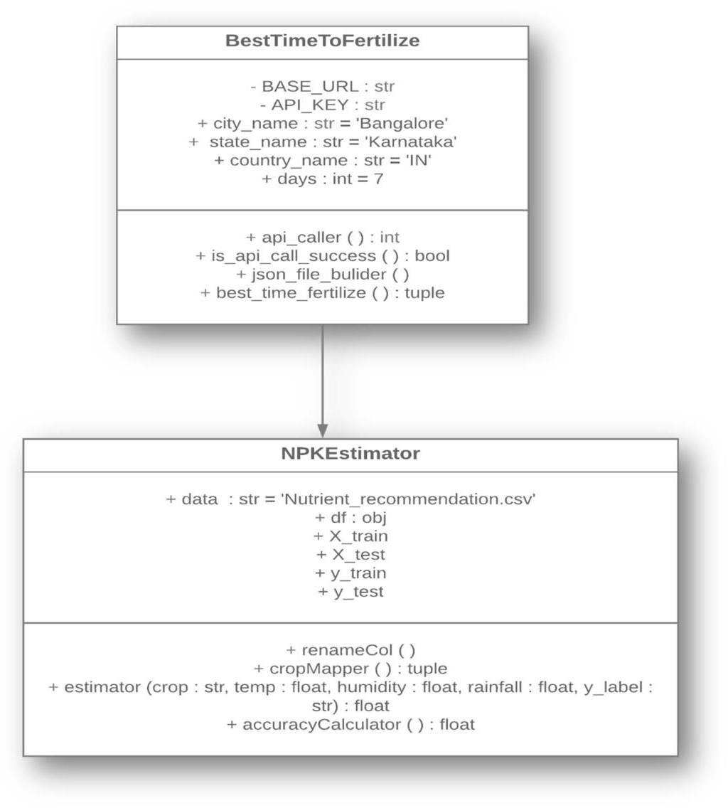

Fig 4.3: Class Diagram

##### Sequence Diagram

Object interactions are arranged in temporal sequence in a sequence diagram. It shows the classes and objects engaged in the scenario as well as the flow of messages that must be exchanged for the objects to work as intended. Inside the logical view of the system being developed, sequence diagrams are often connected to use case realizations. Event diagrams and event scenarios are other names for sequence diagrams.

A sequence diagram is made up of vertical parallel lines (called "lifelines") that represent several processes or things that exist at the same time and horizontal arrows that represent the messages sent between them in the chronological order in which they take place. This enables the graphical specification of straightforward runtime scenarios.

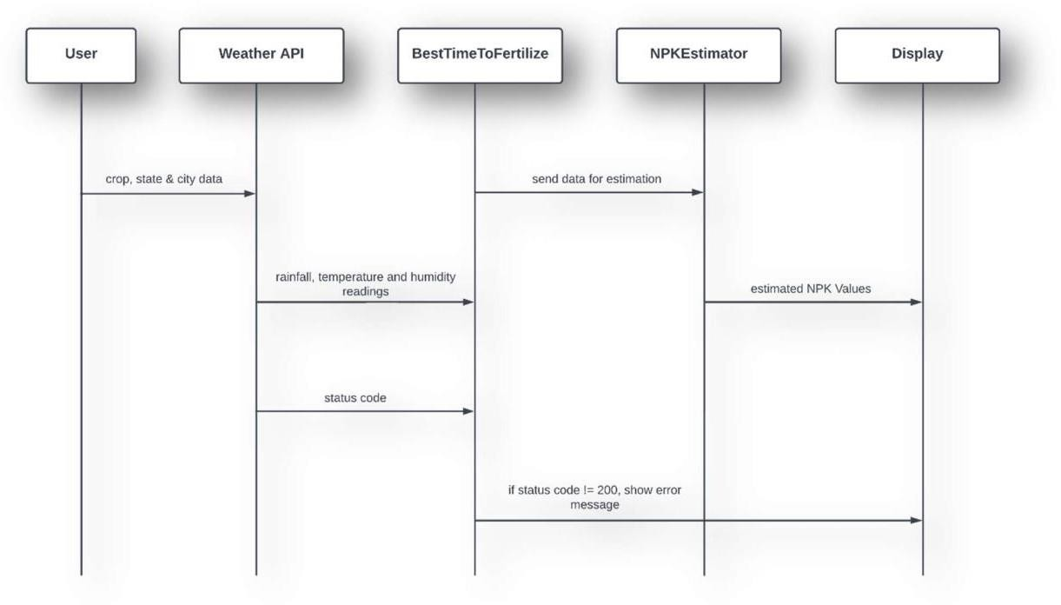

Fig 4.3: Sequence Diagram

**REFERENCES**

1. A.Hussein, Diogenes L. Antille, Shreevatsa Kodur, GuangnanChen, Jeff N.Tullberg, “Controlled traffic farming effects on productivity of grain sorghum, rainfall and fertilizer nitrogen use efficiency,”

Journal of Agriculture and Food Research, vol-3, 2021, PP. 1-17

1. Zujiao Shi, Donghua Liu, Miao Liu, Muhammad Bilal Hafeez, Pengfei Wen, Xiaoli Wang, Rui Wang, Xudong Zhang, Jun Li, “Optimized fertilizer recommendation method for nitrate residue control in a wheat–maize double cropping system in dryland farming,” Field Crops Research, vol-271, 2021, PP. 1- 10
2. Janmejay Pant, R.P. Pant, Manoj Kumar Singh, Devesh Pratap Singh, Himanshu Pant, “Analysis of agricultural crop yield prediction using statistical techniques of machine learning,” Materials Today:

Proceedings, vol-46, 2021, PP. 1-10

1. Benny Antony, “Prediction of the production of crops with respect to rainfall.,”

Environmental Research, vol-202, 2021, PP. 1-5

1. Akash Manish Lad, K. Mani Bharathi, B. Akash Saravanan, R. Karthik, “Factors affecting agriculture and estimation of crop yield using supervised learning algorithms,”

Materials Today: Proceedings, 2022, PP. 1-10

1. Raves Akhtar, Shabbir Ahmad Sofi, “Precision agriculture using IoT data analytics and machine learning,” Journal of King Saud University - Computer and Information Sciences, 2021, PP. 1-17
2. Saheed Garnaik, Prasanna Kumar Samant, Mitali Mandal, Tushar Ranjan Mohanty, Sanat Kumar Dwibedi, Ranjan Kumar Patra, Kiran Kumar Mohapatra, R.H. Wanjari, Debadatta Sethi, Dipaka Ranjan Sena, Tek Bahadur Sapkota, Jagmohan Nayak, Sridhar Patra, Chiter Mal Parihar, Hari Sankar Nayak, “Untangling the effect of soil quality on rice productivity under a 16-years long-term fertilizer experiment using conditional random forest,” Computers and Electronics in Agriculture, vol-197,2022,

PP. 1-10

1. Rubby Aworka, Lontsi Saadio Cedric, Wilfried Yves Hamilton Adoni, Jérémie Thouakesseh Zoueu, Franck Kalala Mutombo, Charles Lebon Mberi Kimpolo, Tarik Nahhal, Moez Krichen, “Agricultural decision system based on advanced machine learning models for yield prediction: Case of East African countries,” Smart Agricultural Technology, vol-3, 2022,

PP. 1-9

1. Senthil Kumar Swami Durai, Mary Divya Shamili, “Smart farming using Machine Learning and Deep Learning techniques,” Decision Analytics Journal, vol-2, 2022, PP. 1-30
2. M.S. Suchithra, Maya L. Pai, “Improving the prediction accuracy of soil nutrient classification by optimizing extreme learning machine parameters,” Information Processing in Agriculture, vol-7, 2022,

PP. 1-11

1. Kaggle, “ https:/[/www.kaggle.com/datasets/atharvaingle/crop-recommendation-dataset](http://www.kaggle.com/datasets/atharvaingle/crop-recommendation-dataset) ” (accessed on 16th November 2021)