TestMate: LLM Benchmarking & Performance Report
1. Objective
The purpose of this report is to evaluate and compare the performance of two state-of-the-art Large Language Models (LLMs) in extracting software features from GitHub repositories for the TestMate project. The benchmarking focuses on Inference Speed and Extraction Accuracy.
2. Methodology & Environment
- Hardware: NVIDIA T4 GPU (Google Colab Environment).
- Framework: llama-cpp-python with CUDA acceleration.
- Models Compared:
  - Qwen 2.5 Coder 7B Instruct: Optimized for programming and technical tasks.
  - Meta Llama 3 8B Instruct: A highly versatile general-purpose model.
- Test Dataset: Real-world repositories from the SWE-bench dataset, specifically pallets/flask and psf/requests.
3. Quantitative Analysis (Inference Speed)
The following data represents the time taken in seconds for each model to process the README files and generate structured JSON features:
Repository | Qwen 2.5 Time (s) | Llama 3 Time (s) | Speed Difference
pallets/flask | 297.26 | 204.22 | Llama is 31% faster
psf/requests | 195.09 | 176.65 | Llama is 9% faster
[Inference Time Comparison Chart]
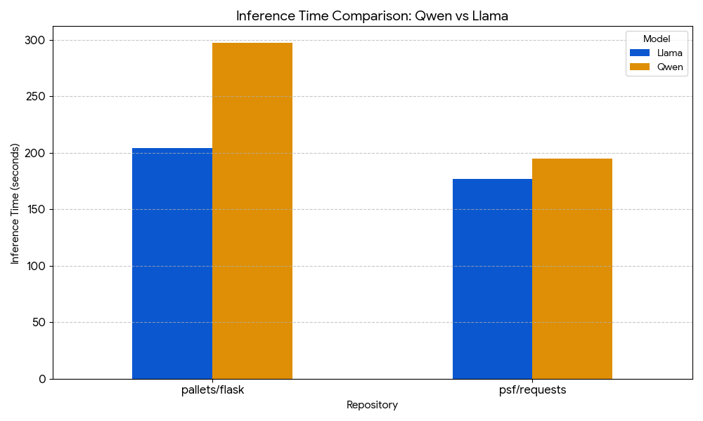
4. Qualitative Analysis (Extraction Quality)
Beyond speed, we analyzed the content of the extracted features:
- Qwen 2.5 Coder: Showed superior technical depth. For example, in the flask repository, it successfully identified internal dependencies like Werkzeug and Jinja, which are crucial for test case generation.
- Llama 3: Provided cleaner, more concise summaries but was less specific about technical sub-dependencies (e.g., it marked Flask dependencies as "Not specified" while they were present in the text).
5. Final Decision & Recommendation
Based on the results:
- For Speed-Critical Tasks: Llama 3 is the preferred choice as it significantly reduces latency.
- For Accuracy-Critical Tasks (TestMate Core): Qwen 2.5 Coder is recommended. Despite being slower, its ability to extract detailed technical requirements and dependencies is vital for building accurate test suites.
Conclusion: The TestMate project will proceed with Qwen 2.5 Coder as the primary engine for feature extraction to ensure the highest quality of generated test cases.
6. Appendix
The full raw data used for this benchmark is stored in final_comparison_results.json.

