|  |  |  |
| --- | --- | --- |
|  | | |
|  | **CMPS 350 Project Phase 2 – Conference Management System (ConfPlus)**  **(15% of the course grade)** | |
| **Group Id:** | | G? |
| **Group Members:** | | Ahmed Ahmed (201907019)  Mohammed Al-Qeraisi (201909907)  Abdelbari Kecita (StudentId)  Mustafa Hussein (201906257)  **Emails:** student1@student.qu.edu.qa; student2@student.qu.edu.qa; student3@student.qu.edu.qa; |

**Grading Rubric - In the Functionality column please specify either: *Working (completed x%)*, *Not Working (completed x%)* or *Not done or Not Applicable*.**

|  |  |  |  |  |
| --- | --- | --- | --- | --- |
| **Criteria** | **Weight** | **Functionality**\* | **Quality of the implementation** | **Grade** |
| **Improvement over the first phase:**  *Depending on the implantation status of the previous phase, the following might apply:*   * *Completing missing functionalities;* * *Improving the design and implementation of paper submission: paper status, etc.* * *Improving the design and implementation of paper review: distinction between reviewed papers and papers to review, etc.* * *Various filtering possibilities for the conf schedule* * *Correct interpretation of session* * *Clarity of the various UIs.*   *By default, if no improvement is made, the student will have the same grade of previous phase for this category.*  *Everything you improve will add up to your previous grade that will be used as a baseline.* | 25 |  |  |  |
| Design and implement the Data Model.  Clarity of data entities, their attributes and relations (in Prisma and the conceptual model (the diagram)) | 10 |  |  |  |
| Init DB: populate the database with the data from the json files. | 5 |  |  |  |
| Repository Implementation to read/write data from the database | 10 |  |  |  |
| Database:   * The design and implementation of the statistics page * All other use-cases use the database, not JSON files or local storage. * All queries function correctly. | 40 |  |  |  |
| **Design and Testing Documentation**  **\* Design documentation:**  - 3 key lessons learned from Phase 1.  - Data Model diagram.  - UI Design table  - Data caching table  **\* Testing documentation:** with evidence of working implementation using snapshots illustrating the results of your solution testing (you must use the provided template).  * **Discussion of the project contribution** of each team member [-10pts if not done] | 10 |  |  |  |
| **Total** | 100 |  |  |  |
| Bonus - successful deployment of the app and the Database to a cloud hosting service such as <https://vercel.com/> - successful implementation of use authentication. | 5 |  |  |  |
| Bonus- authentication through another service provider e.g. Google, Github, etc. | 5 |  |  |  |
| Copying and/or plagiarism or not being able to explain or answer questions about the implementation. | 0 |  |  |  |

# Application Design

# Improvement over the first phase

Give details and proof about:

* What was missing in your previous phase
* Your improvements + proofs
* What was not improved and still missing

# Data Model diagram

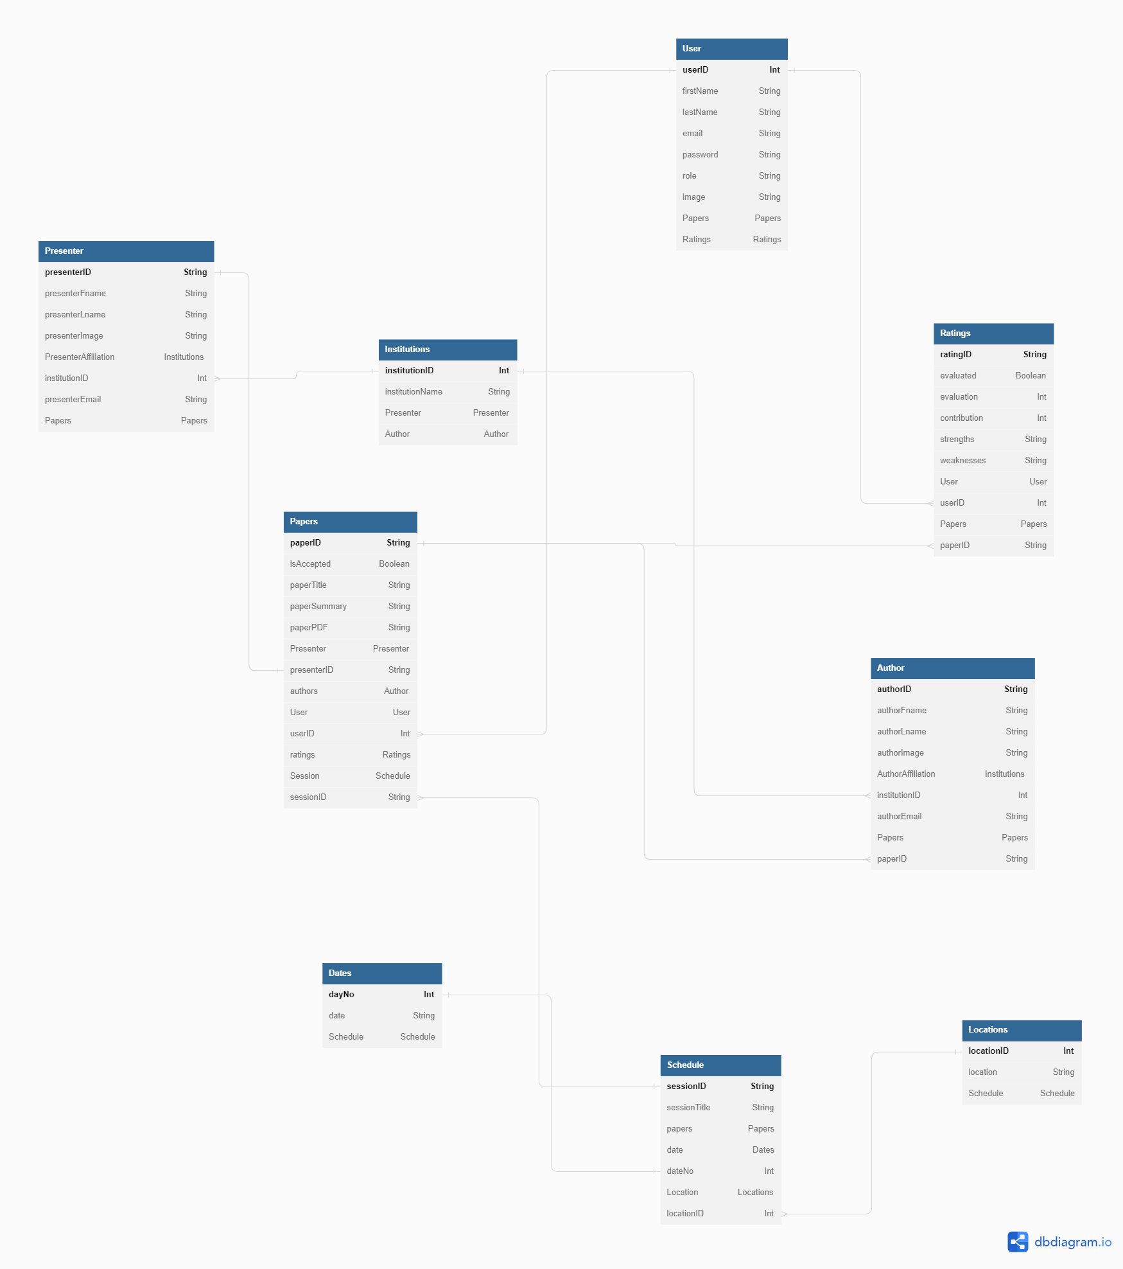

# Database population

Give details and proofs with screenshots how you have populated database, the current content ..

# Database

Give details and proofs about how you have updated your application to use database. This applies to all use-cases.

Detail your statistics page

Give the list of your Prisma queries

# 3 technical lessons learned from your submitted solution vs. the model solution

# Testing

# Custom Login

# Login using 2 Authentication Providers

# Submit paper

# Review paper

# Get conference schedule

# Edit conference schedule

# Conference Statistics Report

# Discussion of the project contribution of each team member