**INDUSTRIAL AUTONOMOUS ROBOTIC VEHICLES:**

**Introduction:**

A self-driving vehicle is also denoted as autonomous vehicle, driverless vehicle, and robotic vehicle. This kind of vehicle has a capability to recognize the environment and drive autonomously without input from human. Lidar, Radar, Sonar, GPS, Odometry and some other inertial measurement units are used in this robotic vehicle to sense and take decisions quickly and accurately. The robotic vehicle is supposed to read the signage in the driving path, should recognize the navigation path, and should avoid obstacles automatically. These activities will be monitored and interpreted with the sensory information using highly sophisticated control systems. This autonomous technology is used in different domains such as robot-taxis, connected vehicle platoons, defense based aerial vehicles, marine based gliders and so on. This robotic system requires varies stages in the development. There is no fully functionable autonomous driving systems in the market today. As per the system of SAE (Society of Automotive Engineers), the vehicle autonomy is classified in six different levels. In simple terms, Level 0 - no automation; Level 1 - hands on/shared control; Level 2 - hands off; Level 3 - eyes off; Level 4 - mind off, and Level 5 - steering wheel optional. According to research, the vehicle which lies above the level 3 has a vital role in the market and takes marginal portion as well. For the first time, the company WAYMO has released driverless taxies for the first time. Even though its autonomous still it has a remote human operation. The first legal level 3 vehicle is shown by Honda. consequently, Toyota has introduced level 4 system in Tokyo. Examples of autonomous vehicles, CNH autonomous tractor, Tiger X-1, Slocum G3 Glider, The [Marker unmanned ground vehicle](https://fpi.gov.ru/projects/fiziko-tekhnicheskie-issledovaniya/marker/) (UGV).

**Literature review:**

*Figure 1: Sixty five years of automotive baby steps (Ross, 2014, p. 62)*

From the figure 2, we can recognize that the development of autonomous vehicles scientific research completely for last decade, which clearly represents the gradual increase of the interest in autonomous technology. In addition to that, vital achievements that speaks the development and research especially in DARPA grand challenge. Between the year 2004 and 2005 or the urban challenge in the end of 2007, that were primary vital competitions in the field of autonomous systems. Moreover, between the year 2013 and 2014 a drastic raise of 60.8 percent can be observed.

*Figure 2: Analysis of Publications over time*

**Robot vehicle design and operation:**

The CNH industrial autonomous tractor has been manufactured with the aim of remote deployment, monitoring and machine controls. The tractor released in two different versions. IH Magnum and New Holland T8 high-horsepower conventional tractors operations is based on satellite signals of GPS for ultra-precise guidance and quick processing of real-time on-field data. To completely remove the operator from cab, IH Magnum concept is used and to maintain the flexibility with traditional human works for roadway transportation, the new HOLLAND T8 NHDrive is used. The driverless technology is capable of using conventional engine, chassis, transmission and so on. The sophisticated headlights, designed bonnet, silhouette and developed by carbon fiber front fenders. For the sake for status lights, two tone back and red wheel rims and LED are used. The tractor is highly secured where it can record, transfer data and provide feedback securely. For human interactive experience, an interactive interface has been designed to operate the vehicle. By inputting the boundary map of the field, the tractor operation can be started. Then the user needs to plot the path of the field using the path planning software which is pre-installed in the system. By doing this, high profit with minimal complexity and drastic accuracy can be achieved. The CNH tractor technology can play a vital role in cultivation, planting, spraying, and mowing because this works requires less operator intervention. Path plotting can be done manually if in case requires refueling or when custom paths are essential. Consequently, after finishing the path plotting, from the pre-programmed toolbar, the user can select the job by simply choosing it where the whole process requires less then 30 seconds. On the other hand, the entire system workings can be spectated or monitored with the use of desktop screen or through tablet interface. This will enhance the efficiency and productivity by taking right decisions by transmitting the real-time data to the user. However, the user will have the entire ownership of their own data.

*Fig 1. CNH autonomous tractor*

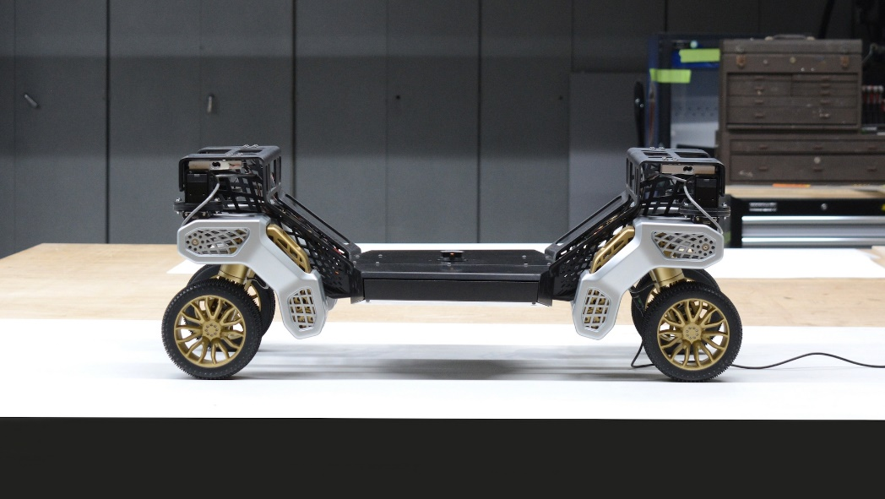

*Fig 2. Hyundai X-1*

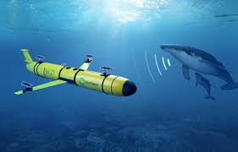

*Fig 3. Slocum G3 Glider*

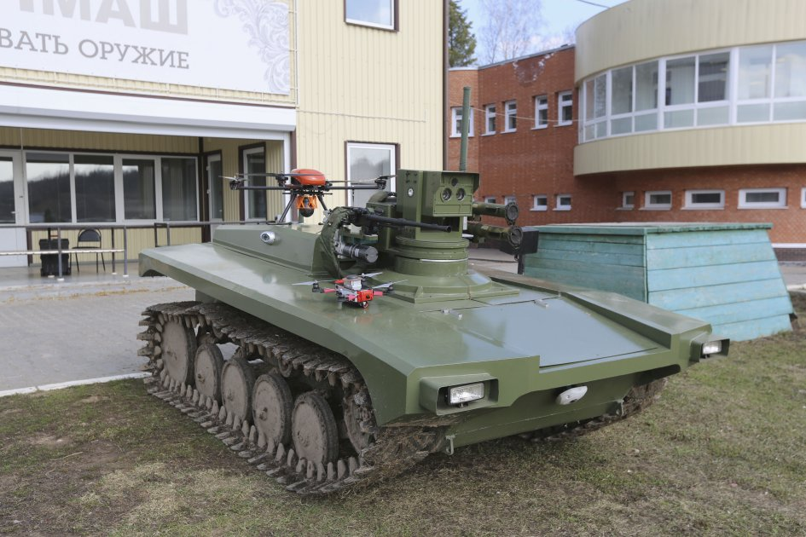

*Fig 4. The*[*Marker unmanned ground vehicle*](https://fpi.gov.ru/projects/fiziko-tekhnicheskie-issledovaniya/marker/)

**Human Interaction with the robotic vehicle:**

A sensing and perception package has been included which has radar, LiDAR, and high definition 3-D cameras to avoid obstacles and obstructions in the path of the vehicle. This technology not only ensures safety but also ensures trouble-free production. When an object be detected, the tractors path, visual and audio warnings will be appeared in the interface of the user (Desktop or tablet) which gives the choice of user defining response (waiting for human intervention, driving around the obstacle, driving onwards). For an instance, if a neighboring machine crosses its path and moves continuously, then the system will stop and move off once if the path is clear. In case of loss of critical machine control function, the automatic system stops for safety purpose, while if needs in emergency case, stop button is activated manually for safety reasons to stop the robotic vehicle.

**Bibliography:**

<https://media.cnhindustrial.com/EUROPE/CNH-INDUSTRIAL-CORPORATE/cnh-industrial-brands-reveal-concept-autonomous-tractor-development--driverless-technology-to-boost-/s/a2259742-061a-412a-8a12-d307dbaedd88>

literature review:

https://michaelbartl.com/wp-content/uploads/Lit-Review-AD_MoI.pdf