# Development of AI tool to support precision diagnosis for faster decision making in breast cancer treatment.

## Introduction:

Breast cancer is a disease in which cells in the breast grow out of control. There are different kinds of breast cancer. Types of breast cancer include ductal carcinoma in situ, invasive ductal carcinoma, inflammatory breast cancer, and metastatic breast cancer. The kind of breast cancer depends on which cells in the breast turn into cancer. Breast cancer can begin in different parts of the breast. Breast cancer starts when cells in the breast (such as cells lining the ducts and lobules) begin to grow abnormally. These cells have the potential to grow out of control and invade the surrounding tissue. When this occurs, this is called invasive breast cancer. In 2020, breast cancer is the most common disease which affected over 2.26 million people which tremendously surpasses lung cancer (Cancer, 2022) and as per American Cancer Society report, 1 in 8 women in United Kingdom is getting affected by breast cancer in their lifetime (Cancer Research UK, 2019). This latest data has been revealed by International Agency for Research on Cancer under WHO. This disease drastically endangers the life and health of women. The overall 5-year relative survival rate for breast cancer is 90% (Nuffieldtrust, 2021). This means 90 out of 100 women are alive 5 years after they've been diagnosed with breast cancer. The 10-year breast cancer relative survival rate is 84% (84 out of 100 women are alive after 10 years) (Webmd, 2020). Cells, tissues, or gland of the breast are vulnerable for breast cancer. Breast cancer happens when cells in your breast grow and divide in an uncontrolled way, creating a mass of tissue called a tumor. Tumors may spread to surrounding tissues through the blood and lymph systems. The breast tumour is commonly known as two types: benign and malignant. Benign tumors are those that stay in their primary location without invading other sites of the body. They do not spread to local structures or to distant parts of the body. Benign tumors tend to grow slowly and have distinct borders. Benign tumors are not usually problematic, but benign tumors can be serious if they press on vital structures such as blood vessels or nerves. The benign tumour is not cancerous and it’s not a highly risky factor whereas the malignant is highly risky which is the primary cause of breast cancer. Malignant tumors have cells that grow uncontrollably and spread locally and/or to distant sites. Malignant tumors are cancerous (i.e., they invade other sites). They spread to distant sites via the bloodstream or the lymphatic system. This spread is called metastasis. Breast cancer is a malignant tumor that grows in or around the breast tissue, mainly in the milk ducts and glands. A tumor usually starts as a lump or calcium deposit that develops as a result of abnormal cell growth. Most breast lumps are benign, but some can be premalignant (may become cancer) or malignant. Tumor size is an important factor in breast cancer staging, and it can affect a person's treatment options and outlook. Tumors are likely to be smaller when doctors detect them early, which can make them easier to treat. Tumor size, lymph node status, and lymphatic or vascular invasion were positively associated with breast density among screen-detected cancers. Histologic grade and mitotic index were negatively associated with breast density in women diagnosed with an interval cancer. Positive bags are generated from malignant images whereas negative bags are generated from benign images. The use of modern whole-slide digital scanners to digitise histological specimens provides not only the benefit of easy image storage, visualisation, and analysis, but also the ability to apply automatic image analysis techniques to digital histological slides to provide accurate quantifications (e.g., tumour extent and nuclei counts) and classifications of tumour sub-types, with the goal of reducing both inter- and intra-reader variability. For detection of breast cancer, pathological diagnosis is widely used which intern has a benchmark in cancer detection. histopathological images are primarily used for pathological diagnosis. The pathologist determines the precise type and severity (stage) of the cancer and may also work with other members of the care team to recommend a treatment strategy that could include observation, surgery, chemotherapy, radiation therapy, or a combination of these approaches.

The idea of this research is to develop an AI tool to support precision diagnosis for faster decision making. The computational pathology will play a significant role in achieving this because the availability of digital pathology slides and associated meta-data for remote analysis. The aim of such AI tool is to identify images likely to contain tumor cells, compute mitotic counts, improve the accuracy and precision of immunohistochemistry scoring, or apply standardized histological scoring criteria such as the Gleason score, which can be critically important in the management of cancer and guiding treatment strategy. Spatial relationships among immune cells within the stromal or tumor compartments of the tumor microenvironment can also be evaluated using such AI tool and correlated to response with immunotherapy. An ideal decision support tool would incorporate such AI into a user‐friendly system, aiding clinicians in making the best treatment decisions, while avoiding information overload and decision paralysis.

This research is a continuation of my final year research project where I have explored and achieved a best method for locating cells, recognize their types, estimate density of tumor cells (histogram), and localize areas with the use of histopathological images using Resnet 152 model. I have created several models like Resnet 50, Resnet 101, Resnet 152 and so on. The moto of creating multiple models is to find the best model which is more capable enough to predict the tumor density from pathological image slide by comparing one with another. The comparison took place with the validation loss and learning efficiency of the models. From that comparison, it is concluded that, the Resnet 152 model where the 5th layer only trainable has resulted a good outcome it terms of accuracy, validation loss, and with some standard regression metrics. Hence, with the continuity of my final year research project, I’d like to continue my research in the “development of AI tool to support precision diagnosis” which I have specified above.

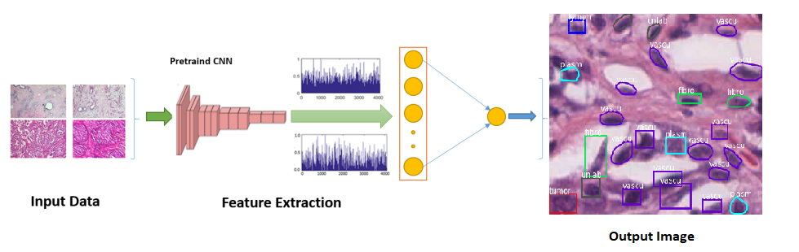

Figure 1: The input histopathological images and cell count has been sent to the pretrained model for feature extraction and each layer of the model extracts different feature from the image. With the learnt feature, the model will be able to locate the cells, recognize their types, estimate density of tumor cells (histogram), and localize areas.

Figure 2: Input Image Figure 3: Augmented Images

Figure 4: Output Image

Deep neural networks require more image for training, so data augmentation and pre-processing steps will take place before the feature extraction process.

As per UN sustainability development goals, they were delivering on the UN SDGs by creating a healthier, fairer, and greener world, through the research, collaborations, and partnerships. It is contributed 21,571 research publications across all 17 SDGs over the past five years – representing 4% of the UK’s research on the goals. The five research beacons are – advanced materials, biotechnology, cancer, energy, and global inequalities – are examples of pioneering work tackling the world’s biggest challenges (Manchester, 2022). Our research is a part of UN’s research beacons which comes under the category called cancer. This research helps the development of tackling cancer growth in our country. Offering opportunities to local, national, and international communities for solving 21st centuries challenges is a part of UN sustainability development goals (Manchester, 2022). Thus, the breast cancer is one of the deadliest disease and challenge of this era. As I’m from an international community and my research belongs to one of the research beacons of the UN sustainability development goals, my research links to UN SDG effectively. As per decent work and economic growth, each pound invested in cancer research generates a continuous stream of benefits equal to earning every year (Cancer Research UK, 2014).

## References:

CANCER RESEARCH UK, 2019. *Our research into breast cancer* [online]. Available from: <https://www.cancerresearchuk.org/our-research-by-cancer-type/our-research-into-breast-cancer> [Accessed 13th May 2022].

CANCER, 2022. *Breast Cancer: Statistics* [online]. Available from: <https://www.cancer.net/cancer-types/breast-cancer/statistics> [Accessed 13th May 2022].

NUFFIELDTRUST, 2021. *Cancer survival rates* [online]. Available from: <https://www.nuffieldtrust.org.uk/resource/cancer-survival-rates> [Accessed 13th May 2022].

WEBMD, 2020. *Breast Cancer Survival Rates* [online]. Available from: <https://www.webmd.com/breast-cancer/guide/breast-cancer-survival-rates> [Accessed 11th May 2022].

CANCER RESEARCH UK, 2014. *Investing in cancer research boosts economy as well as health* [online]. Available from: <https://news.cancerresearchuk.org/2014/06/16/investing-in-cancer-research-boosts-economy-as-well-as-health/> [Accessed 13th May 2022].

MANCHESTER, 2022. *Top ten in the world for sustainable development* [online]. Available from: <https://www.manchester.ac.uk/discover/social-responsibility/sdgs/> [Accessed 13th May 2022].