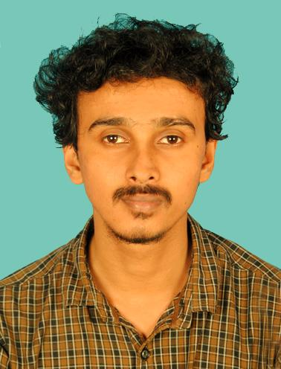**MOHAMMED RIFAD A**

Vadakkumbad, Thalassery

Mob: 8281299404, 9746020404

Email: mohammedrifad17@gmail.com

**OBJECTIVES:**

To associate with an organization which progress dynamically and give me a chance to update my knowledge and enhance my skills of IT technologies and be a part of the team that excess in work towards the growth of the organization

**EDUCATIONAL QUALIFICATION:**

|  |  |  |  |
| --- | --- | --- | --- |
| **Course** | **Institution** | **Board/University** | **Year** |
| BCA | Gramika Institute of Management & Communication, Kuthuparamba | Kannur  University | 2015–2018 |
| Plus Two | MES Bava Senior Secondary  School Thalassery | CBSE | 2014–2015 |
| SSLC | Sanjos Metropolitan School  Thalassery | CBSE | 2012–2013 |

**PROFESSIONAL QUALIFICATION:**

* Django
* Flutter
* Dot Net
* Entity Framework
* Angular 7
* PHP
* Desktop Engineering
* CCNA
* MCSA 2012 Server with windows8
* RHCE: Redhat System Administrator
* IT-infrastructure Library
* Microsoft Virtualisation-Hyper-v
* Microsoft Cloud-System Centre
* Redhat Virtualisation-RHEV
* Redhat Cloud-Openstack
* Redhat Storage Server Administrator

**AREA OF INTEREST:**

* Software Development
* Networking

**ACADEMIC PROJECT UNDERTAKEN:**

**Project Name** :e-Shoppy

**Team Size** :3

**Role** :Team Head

**Front-End** :C#.net

**Back-End** : MS Sql Server

**PERSONAL SKILLS:**

* Trustworthy
* Willing to work hard
* Punctual
* Dedicated

**PROFESSIONAL EXPERIENCE:**

* Currently working as a software trainer at Spinox Innovations, Kannur ( 3 Years).
* 6-months experience as Software Developer Trainee at Sysosis , Thalassery

**PERSONAL DETAILS:**

Full Name : Mohammed Rifad A

Father’s Name : Rahim

Age & Date of Birth : 26, 24-12-1995

Gender : Male

Marital Status : Single

Language Known : English and Malayalam

**DECLARATION**

I hereby declare that the above-mentioned details are true to the best of my knowledge and belief.

Mohammed Rifad A