## TABLE OF CONTENTS:-

**SL.NO PARTICULARS PAGE NO**

1. **Introduction 3**
2. **Problem Statement 3**
3. **Existing Systems 3**
4. **Schema & Table Creation 4**
5. **Technologies Used 5**
6. **Screenshots of the interface 6**

## INTRODUCTION:

The project topic is Electricity Bill. In this Project I have used Tkinter Module of python for frontend and MySQL for backend database storage. This project is for those people who is working as bill generator not for customer. First the user has to generate the bill and add bill to database. And user can check the bill on the data base. And also user can search the bill using its meter number Or customer Name.

Description of the technologies used, database system, queries used, schema diagram and screenshots of the interface is attached below.

## PROBLEM STATEMENT:

Running a Electricity Bill software isn’t as easy as it sounds. software are constantly changing and evolving to keep up with the times and provide their patrons with the best possible experience. Developers are responsible for a lot of tasks to keep everything running smoothly. They have to keep up with technology to be efficient.

## EXISTING SYSTEMS:

The existing systems are majorly created for big scale Electricity Bill software, these systems are very complex to be used for small scale Electricity Bill software systems.

Therefore this project is useful as it can be managesmall scale Electricity Bill software systems.

## SCHEMA DIAGRAM:-

|  |  |  |  |  |
| --- | --- | --- | --- | --- |
| Name | Meter_No | Previous_Unit | Current_Unit | Bill_Amount |

**CREATION OF TABLE:-**

CREATE TABLE customer_record` (

`Name` VARCHAR(20) NOT NULL,

`Meter_No` INT NOT NULL,

`Previous_Unit` INT NOT NULL,

`Current_Unit` INT NOT NULL,

`Bill_Amount ` INT NOT NULL, PRIMARY KEY (`Meter_No`));

## desc customer_record;

+ + + + + + +

| Field | Type | Null | Key | Default | Extra |

+ + + + + + +

| Name | varchar(20) | NO | | NULL | |

| Meter_No | int | NO | PRI | NULL | |

| Previous_Unit | int | NO | | NULL | |

| Current_Unit | int | NO | | NULL | |

| Bill_Amount | int | NO | | NULL | |

+ + + + + + +

(Note: $ indicate variable name)

## INSERTION:-

INSERT INTO ‘customer_record (Name, Meter_No , Previous_ Unit, Current_Unit , Bill_Amount )

VALUES

($nameentry,$mitNoentry,$prNoentry,$currNoentry);

## TECHNOLOGIES USED:-

### FRONTEND :

* PYTHON TKINTER

### BACKEND :

* MYSQL

## PYTHON TKINTER:-

**Graphical User Interface(GUI)** is a form of user interface which allows users to interact with com

puters through visual indicators using items such as icons, menus, windows, etc. It has advantages over the Command Line Interface(CLI) where users interact with computers by writing commands using keyboard only and whose usage is more difficult than GUI.

**Tkinter** is the inbuilt python module that is used to create GUI applications. It is one of the most commonly used modules for creating GUI applications in Python as it is simple and easy to work with. You don’t need to worry about the installation of the Tkinter module separately as it comes with Python

already. It gives an object-oriented interface to the Tk GUI toolkit.

## MYSQL:-

**What is a Database?**

A database is a separate application that stores a collection of data. Each database has one or more distinct APIs for creating, accessing, managing, searching and replicating the data it holds.

Other kinds of data stores can also be used, such as files on the file system or large hash tables in memory but data fetching and writing would not be so fast and easy with those type of systems.

Nowadays, we use relational database management systems (RDBMS) to store and manage huge volume of data. This is called relational database because all the data is stored into different tables and relations are established using primary keys or other keys known as **Foreign Keys**.

A **Relational DataBase Management System (RDBMS)** is a software that −

* + Enables you to implement a database with tables, columns and indexes.
  + Guarantees the Referential Integrity between rows of various tables.
  + Updates the indexes automatically.
  + Interprets an SQL query and combines information from various tables.

## MySQL Database

MySQL is a fast, easy-to-use RDBMS being used for many small and big businesses. MySQL is developed, marketed and supported by MySQL AB, which is a Swedish company. MySQL is becoming so popular because of many good reasons −

* + MySQL is released under an open-source license. So you have nothing to pay to use it.
  + MySQL is a very powerful program in its own right. I
  + t handles a large subset of the functionality of the most expensive and powerful database packages.
  + MySQL uses a standard form of the well-known SQL data language.
  + MySQL works on many operating systems and with many languages including PHP, PERL, C, C++, JAVA, etc.
  + MySQL works very quickly and works well even with large data sets.
  + MySQL is very friendly to PHP, the most appreciated language for web development.

## Screenshots Of The Interface :-

### Below figure shows HOME PAGE to Electricity Bill

Figure 1: Home Page

# After Clicking “Show Data” Button

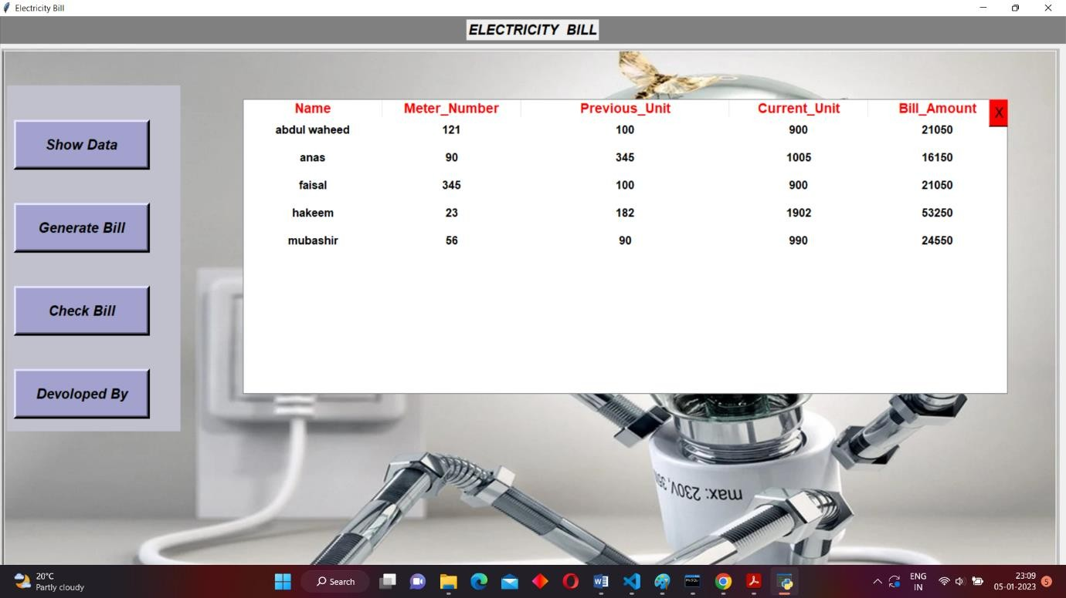

Figure 2

## After Clicking “Generate Bill” Button

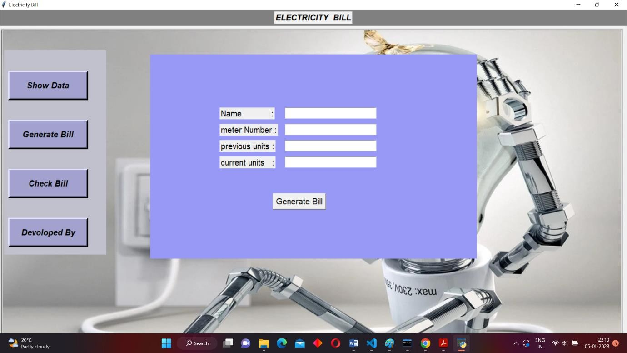

Figure 3

## Fill The Information

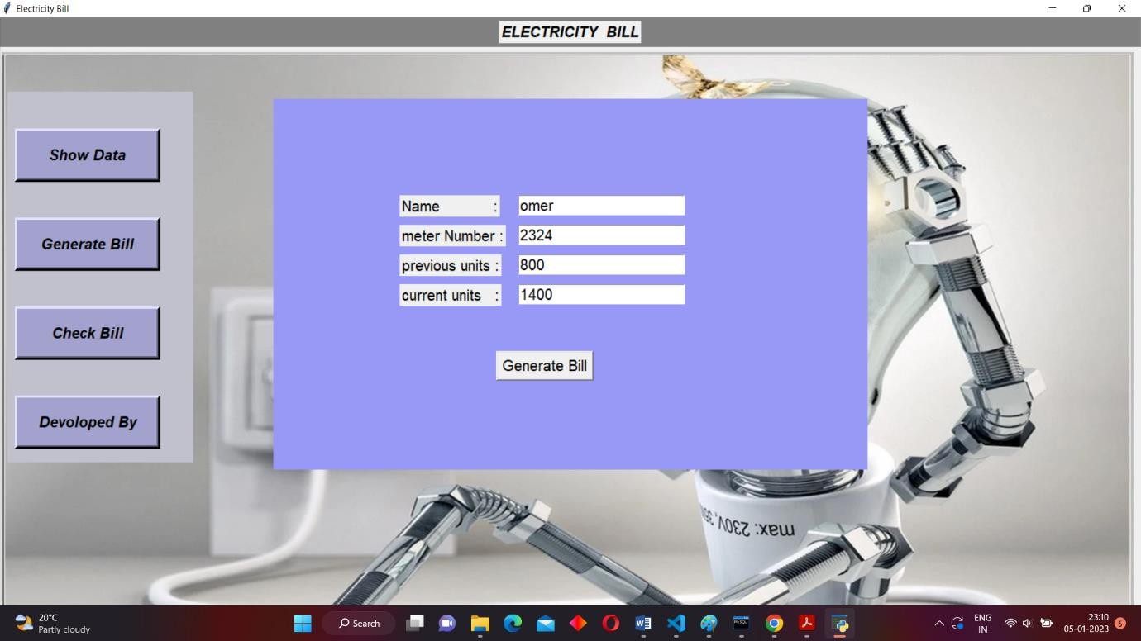

Figure 4

### After clicking “Generate Bill” Button

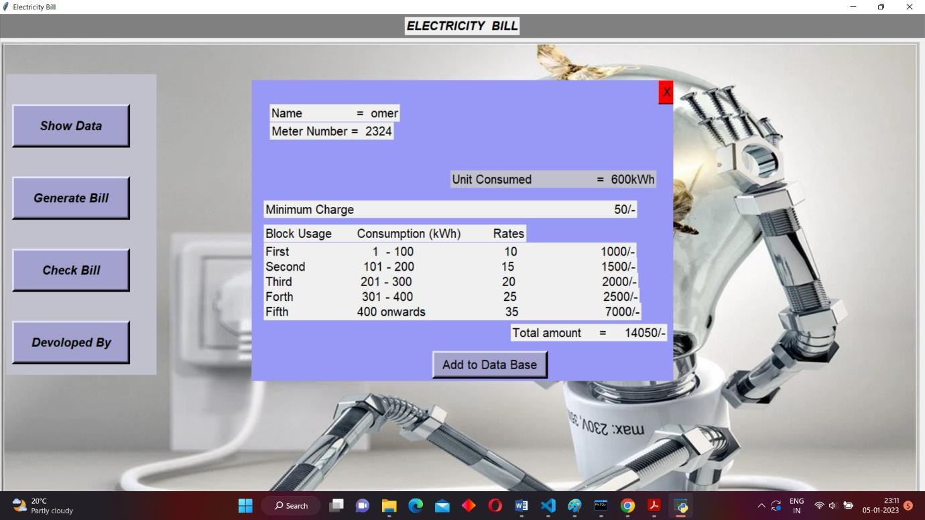

Figure 5

## After clicking “Add to Data Base” Button

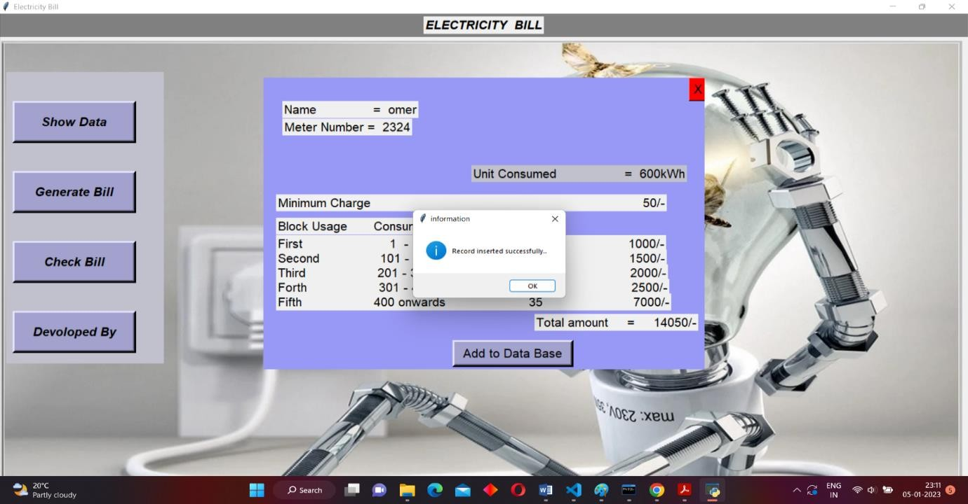

Figure 6

## Enter the Name Or Meter Number

Figure 7

## After clicking “Search Bill” Button

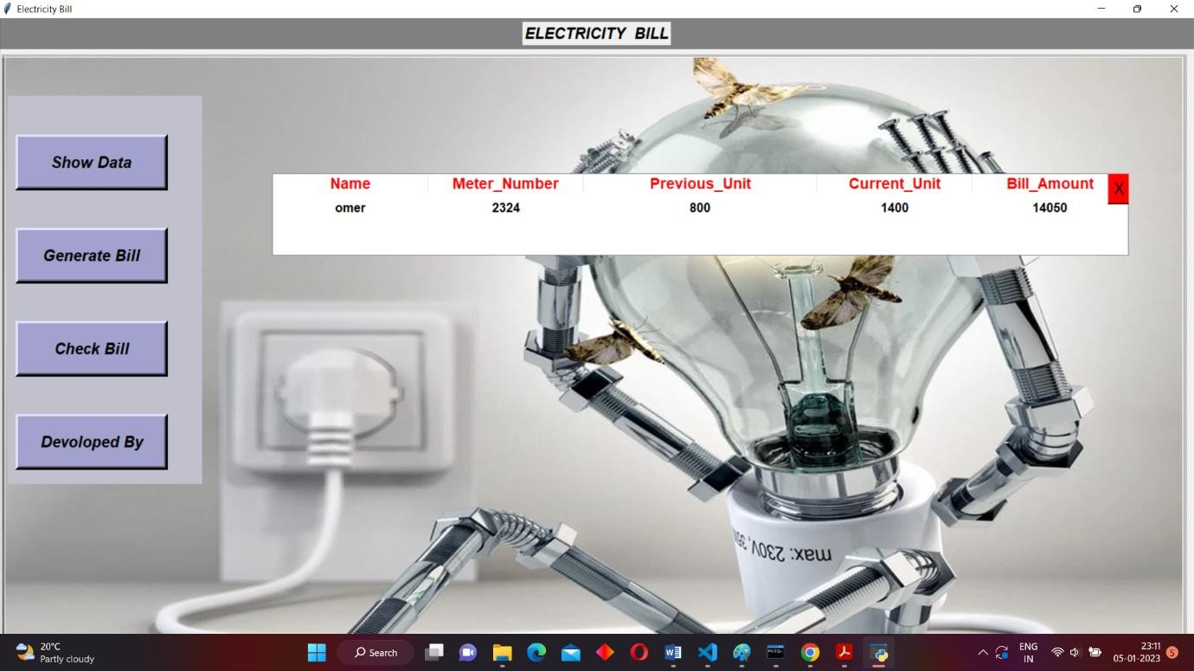

Figure 8

## After clicking “Show Data” Button

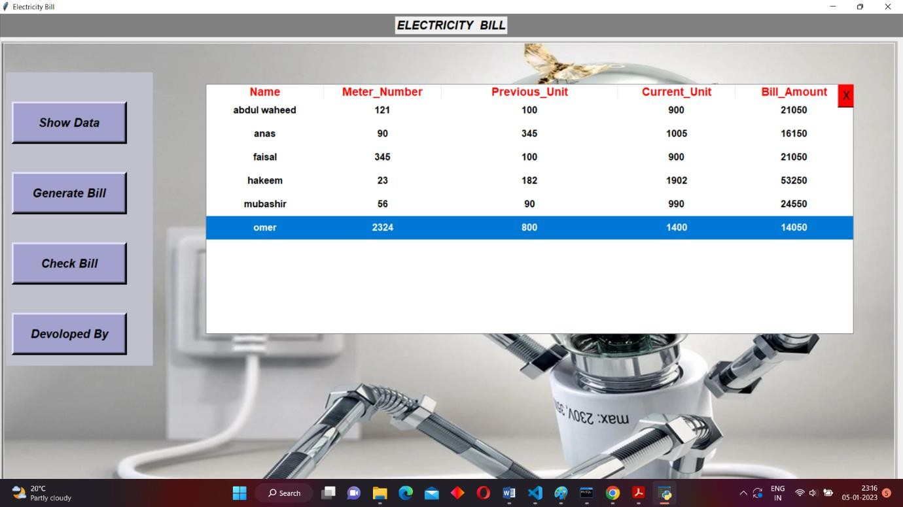

Figure 9