

**CSE326 Project Report**

**Topic: - Mobile App Development Website**

**Ali Mishal (12218946)**

**Adil Muhammed K M (12220729)**

**Mohammed Sinan A A (12220964)**

**ACKNOWLEDGEMENT**

I would like to express my sincere thanks of gratitude to my teacher **Dr. Krishan Bansal**, for his valuable guidance and support in completing my project.

I would also like to express my gratitude towards our Chancellor and Vice-chancellor, for providing me with all the facility that was required, and I am also thankful to my classmates who helped a lot in completing my project.

**INTRODUCTION**

We developed this project for clients who are searching for Mobile App Developers who can develop applications according to their clients request or desire for their business or personal requirements.

Clients can easily login or sign-up to our website, and they can easily choose which app they prefer since we allow them to choose variety of apps.

Our variety of applications include:

1. Lifestyle Mobile Apps:
   * Fitness
   * Dating
   * Food
   * Music
   * Travel
2. Social Media Mobile Apps:
   * Facebook
   * Instagram
   * Flashlight
   * Weather
3. Utility Mobile Apps:
   * Reminders
   * Calculators
   * Flashlight
   * Weather
4. Games/Entertainment Mobile Apps:
   * Competitive
   * Action
   * Story Mode and many more….
5. Productivity Mobile Apps:
   * Docs
   * Sheets
   * Wallet/Pay
6. News/Information Outlets Mobile Apps
   * Buzzfeed
   * Smartnews
   * Google News and Weather
   * Feedly
   * LinkedIn Pulse

**SCREENSHOTS**

Home Page

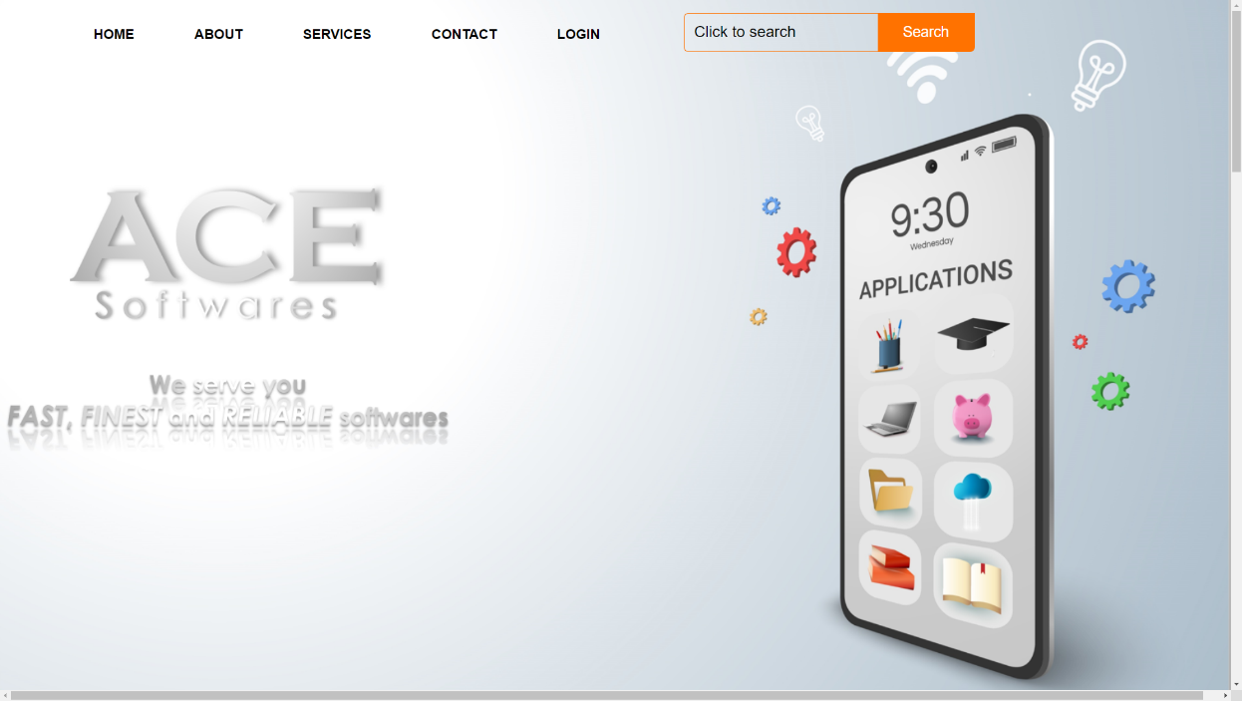

Our Services

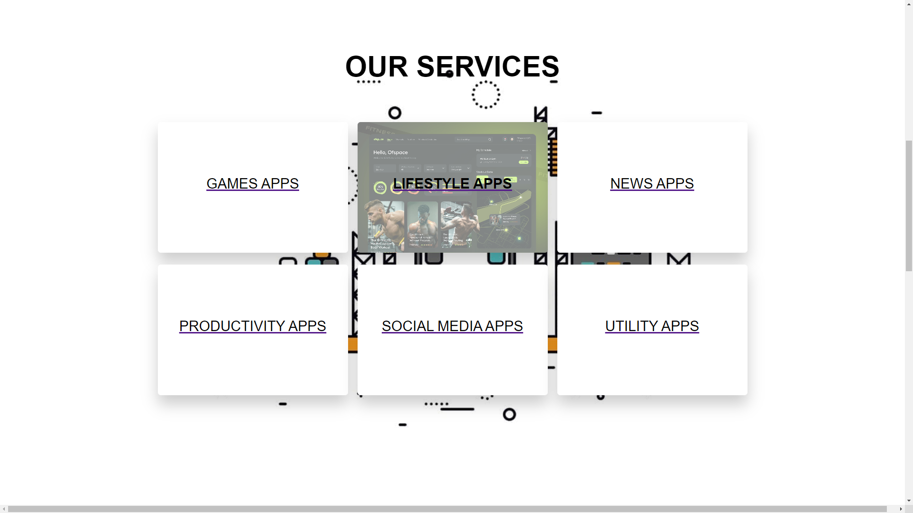

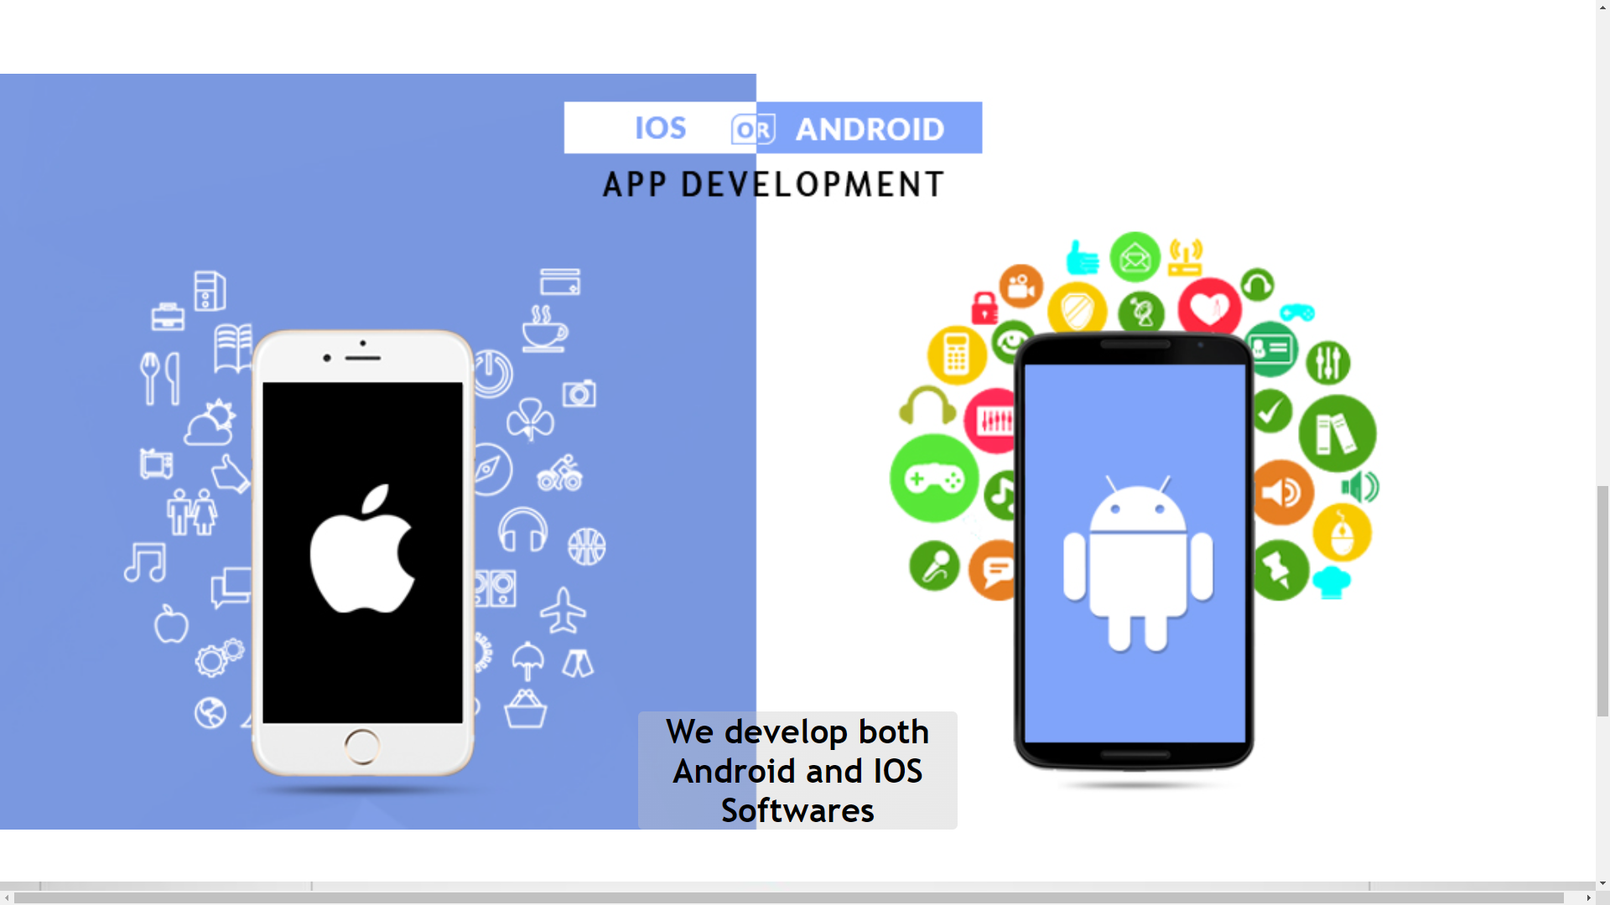

About Us

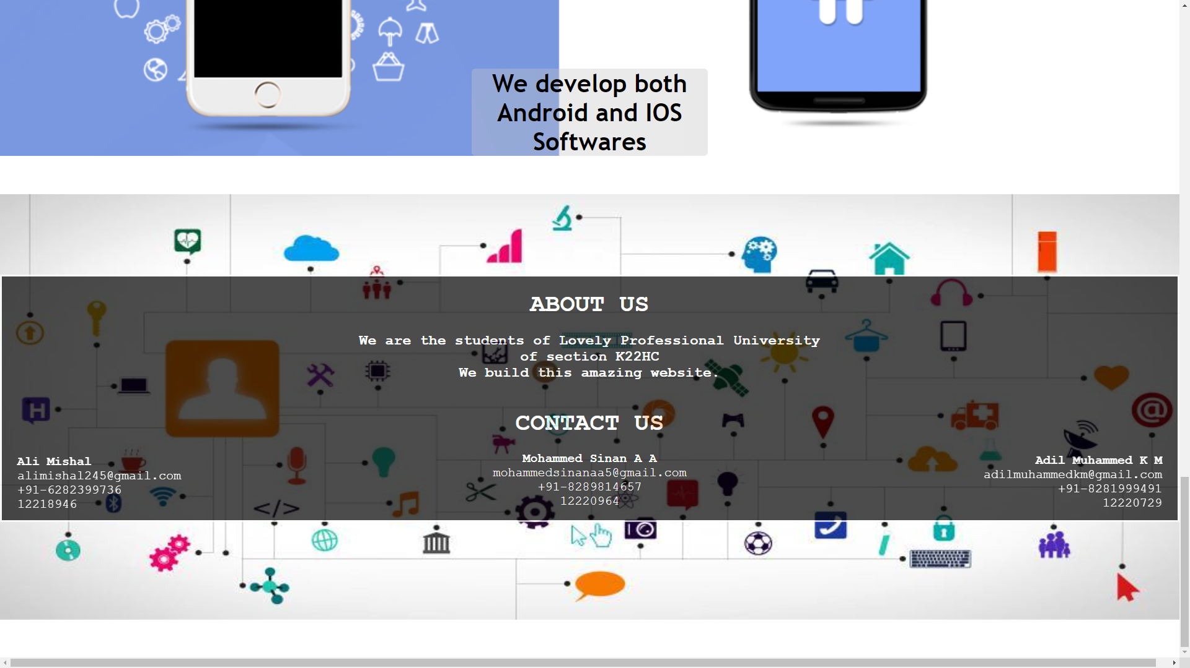

Login Page

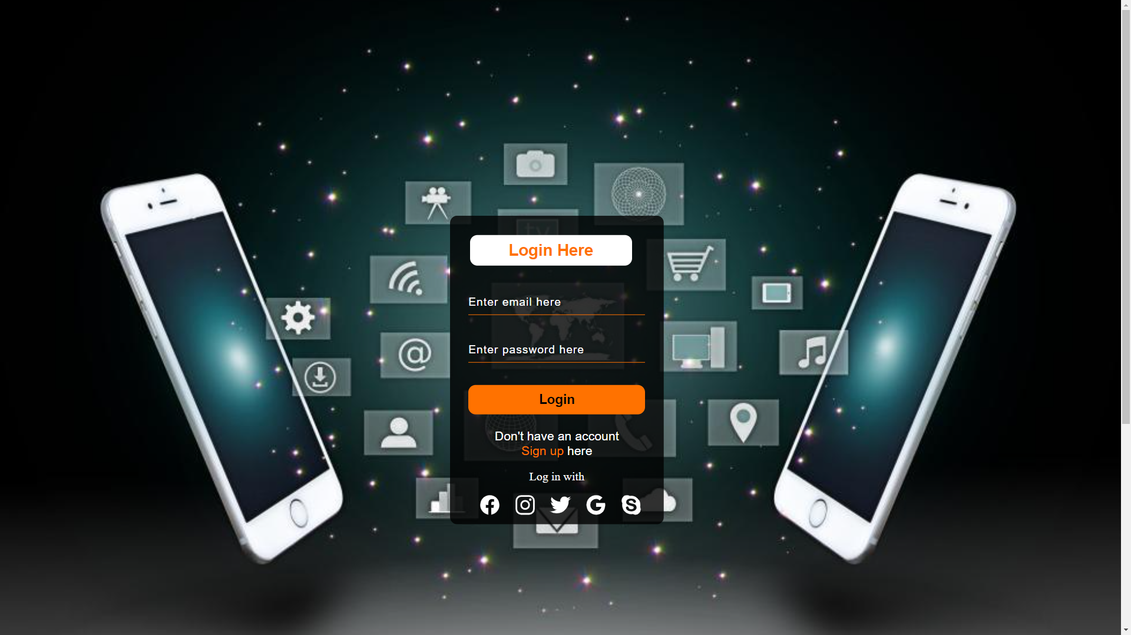

**HARDWARE REQUIREMENTS**

|  |  |
| --- | --- |
| **Processor** | Core i3 or higher/AMD Processors. |
| **Hard Disk** | 3GB or higher free space (Recommended). |
| **RAM** | 2GB or higher (Recommended) |
| **OS** | Windows 7 or higher (Recommended). |

**CONCLUSION**

Today's App development websites need a good page design which is essential because bad design will lead to the loss of visitors and that can lead to a loss of business. In general, a good page layout must attract a user to the webpage. Nowadays, there are a lot of app development websites available on internet, so we have built an app development website using HTML and CSS in order to stand out. In our website we are giving the user different types of apps to select and which type of application they need, and we will submit the information provided by the user.