- Create internal and external customer tables and load data into them.
Create Internal Table:
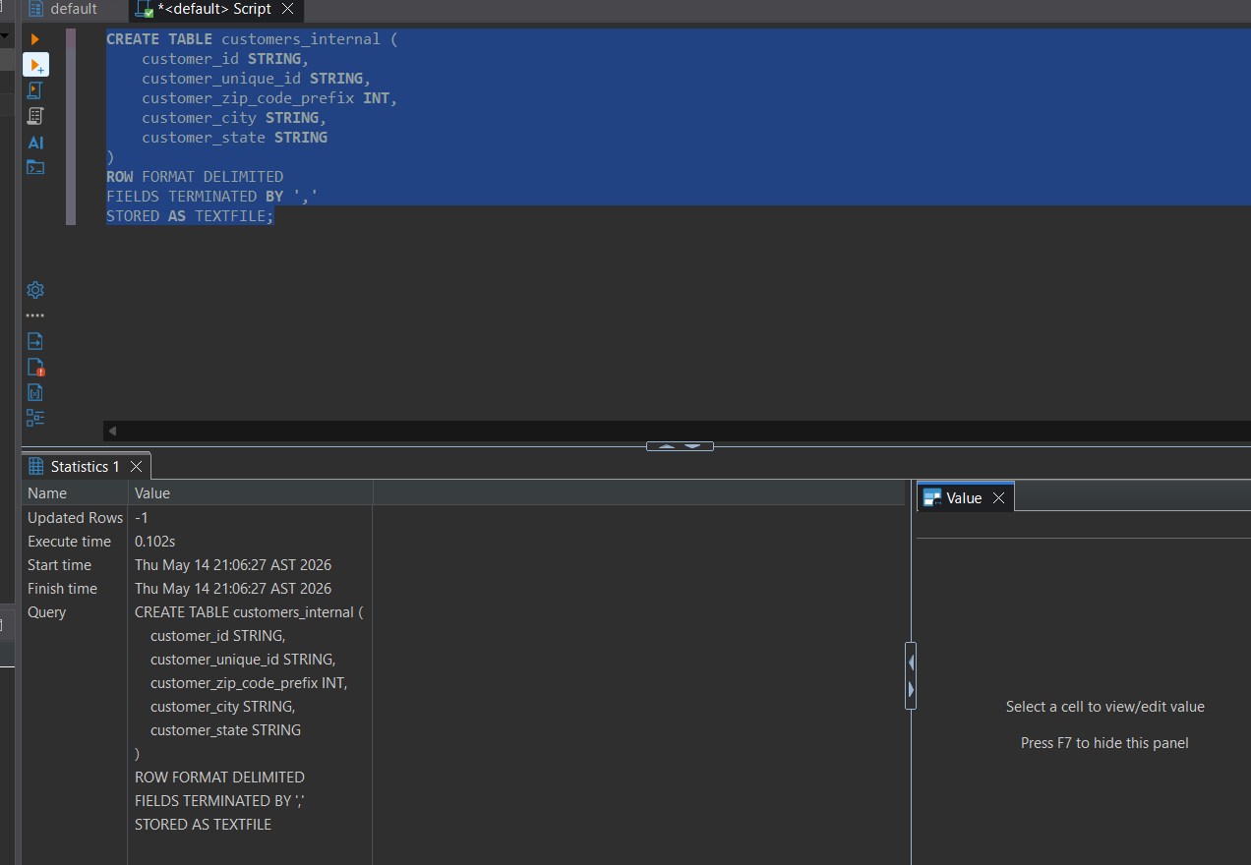

CREATE External Table:
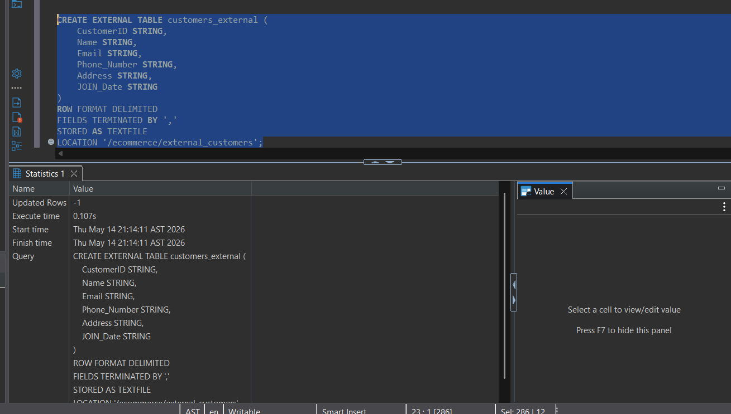

- Notice the issue related to delimiter inside the address column value, find a solution to make hive read the file properly without changing the separator. (Do some web search)
Solution: Use OpenCSVSerde
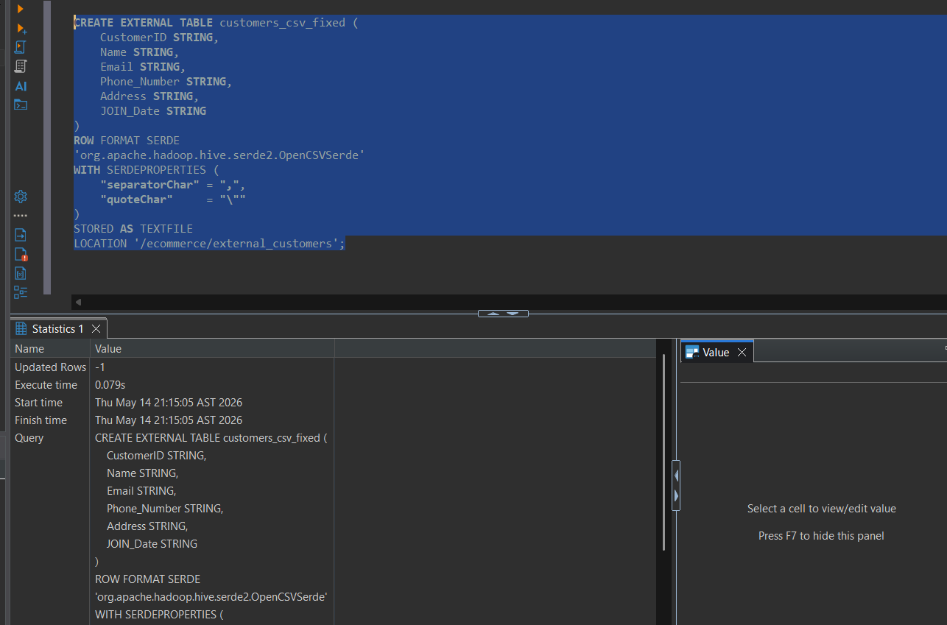
- Try to drop both external and internal tables and notice what happens to the data.
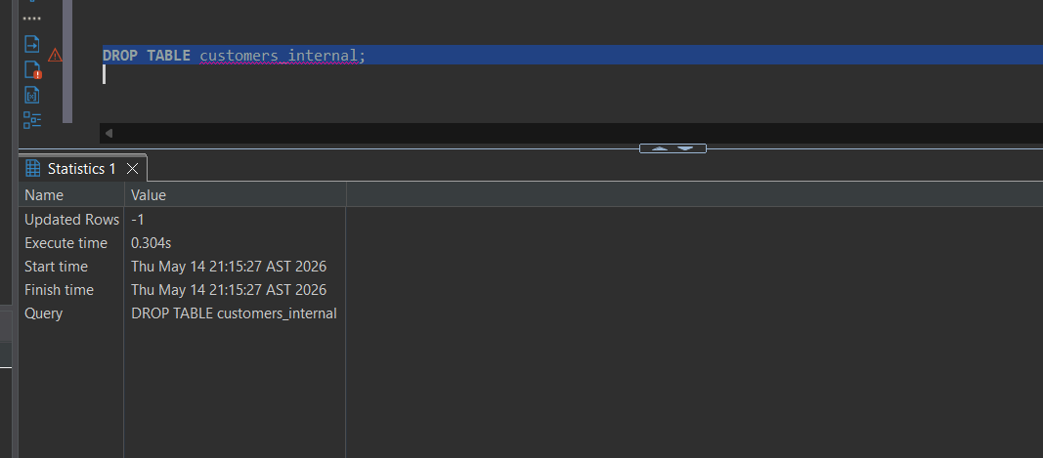
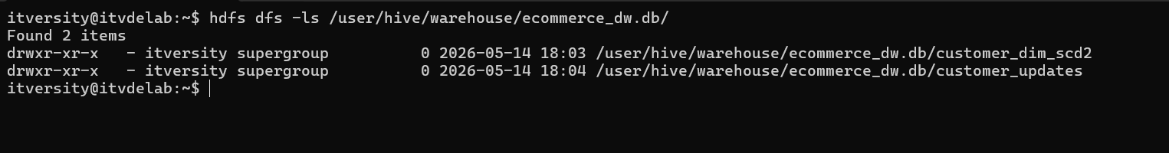
internal table data deleted

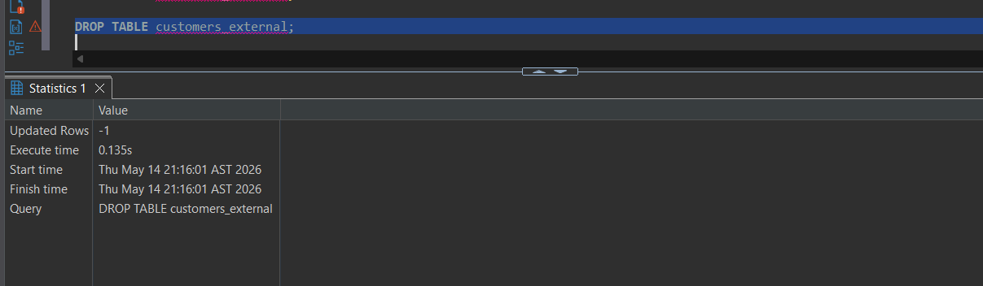
files still exist
- Create customer dimension (Slowly changing dimension type 2) as “customer_scd2_mixed.csv” file.
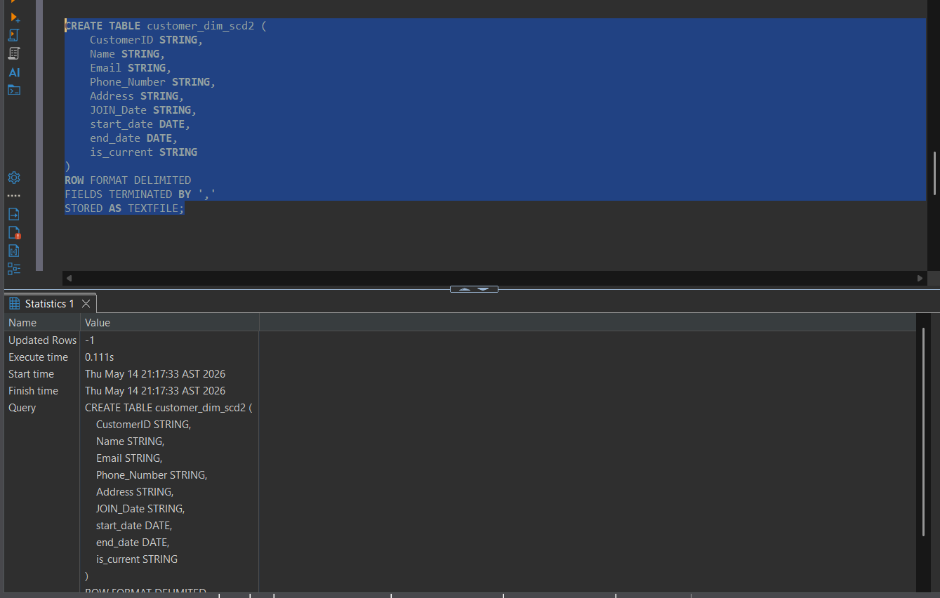
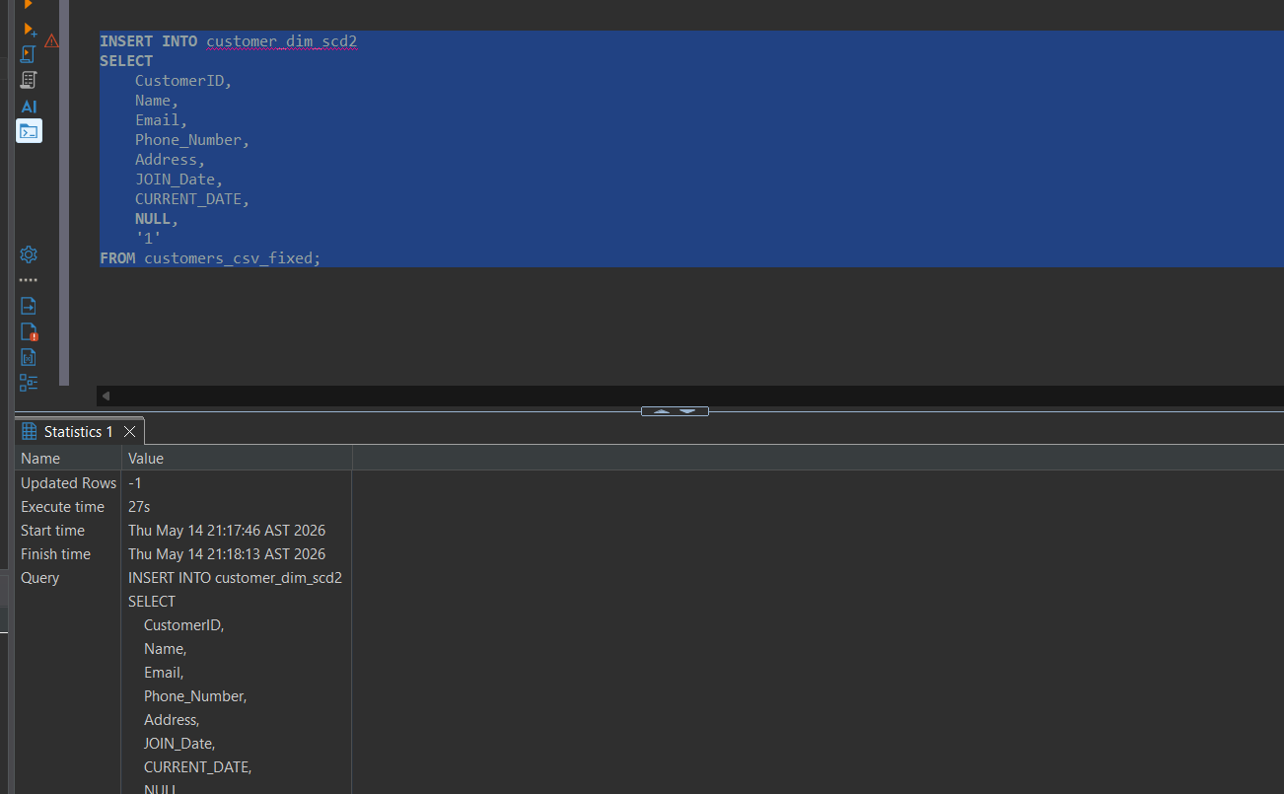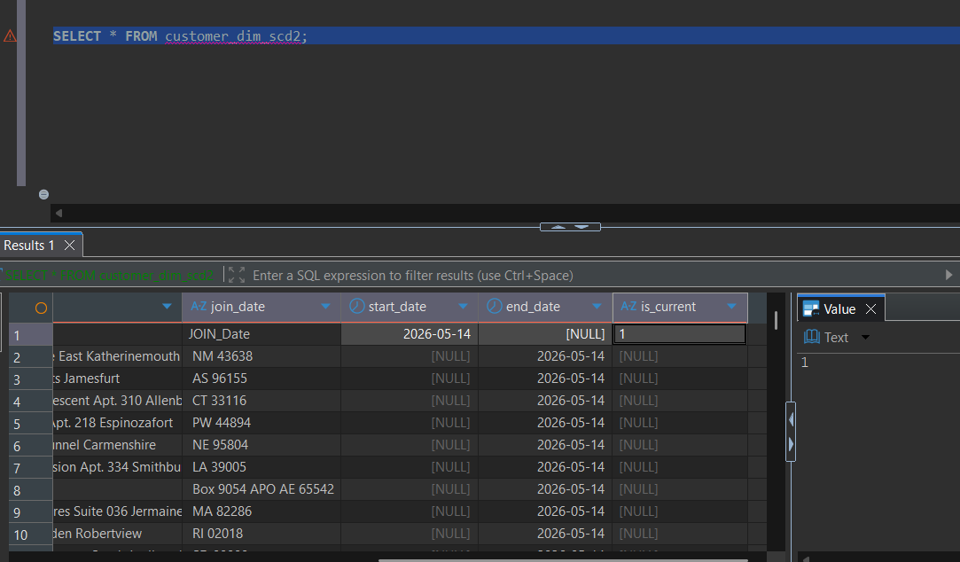

- Use “customer_updated.csv” file to insert new data with end_date = null and is_current = ‘1’ and update changed data to be with end_date and is_current = “0” to track history.
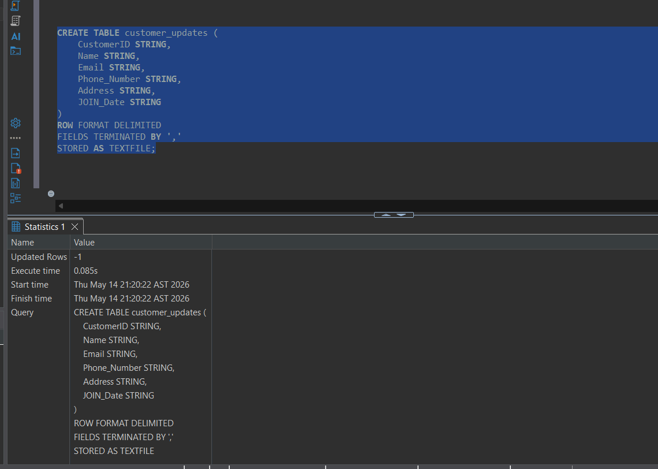
- “Hive doesn’t support update or deletes so find a work around to make this SCD type 2 without using Transactional tables”
