Before:

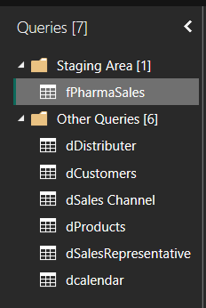\

Data Model:

