**Enigma**

Self-driven car

**Graduate project**

**Main Features**

* Road sign detection and identification
* Objects detection and recognition
* Detection and recognition of traffic lights
* Detection and recognition of lane lines
* Road light detection and recognition
* Auto Parking
* GPS
* Follow Left & Right Curves
* Make 90-Degree Right Turn
* Make 90-Degree Left Turn
* Application Car

**Software requirement**

* C/C++ programing language
* Flutter cross platform
* MySQL DB
* Arduino
* Adobe XD
* Adobe Photoshop
* Adobe illustrator

**Hardware requirement**

* Servo motor
* Wires
* Raspberry pi 3
* Arduino uno
* Battery
* CAMERA
* L298N motor driver
* Ultrasonic HC-SR04

**Model Design**

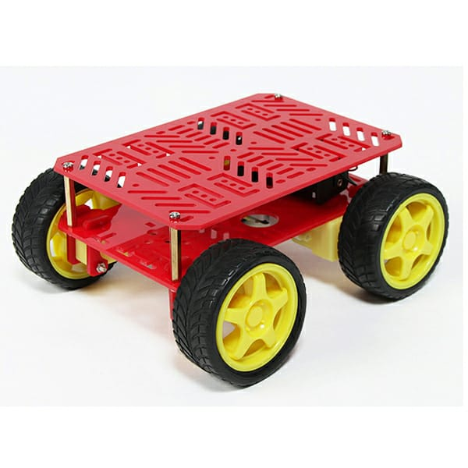

**Specifications**:

* Acrylic Body
* Four 4.5v Gear Motors
* 4 x AA Battery Holder
* Size: 180mm x 155mm
* Wheel Diameter: 67mm
* Wheel Width: 26mm
* No load current: 125mA

**Team member**

* Islam Ashraf Nour Elden
* Mohammed Gamal Mahmoud
* Mohammed Ashour Ibrahim
* Ahmed Mustafa abo Almaged
* Mohmmed Ashraf Tolba
* Mohmmed Khalil Abd ALzaher
* Adel Abdelsatar Basione
* Fatma Alaa abbas
* Kamala saad Ismael