EDA
DISTRIBUTION OF PRODUCT CATEGORY:-
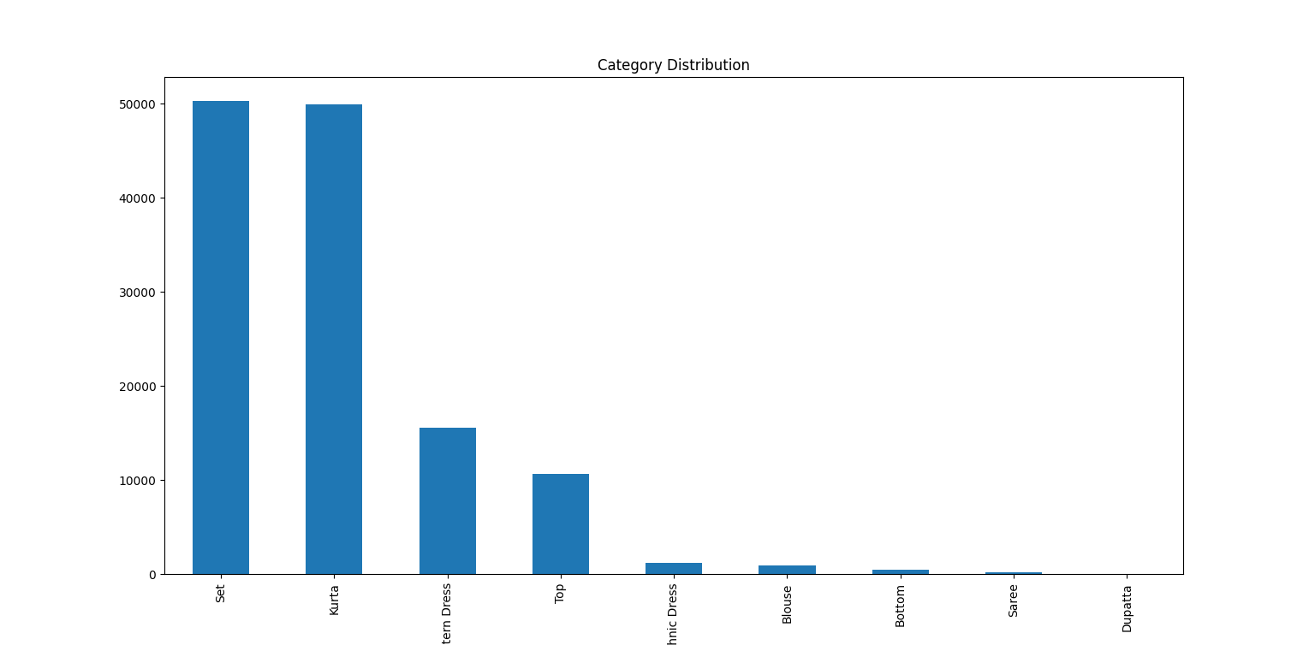
DISTRIBUTION OF PRODUCT SIZE:-
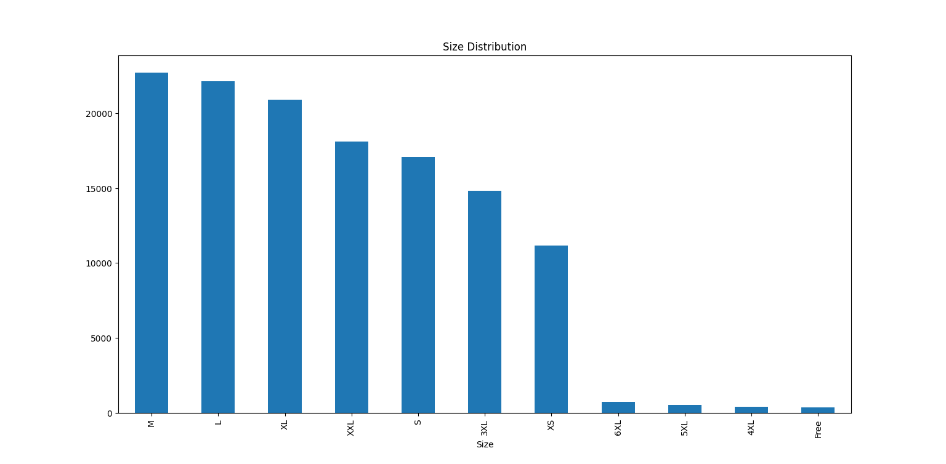

DISTRIBUTION OF STATUS:-
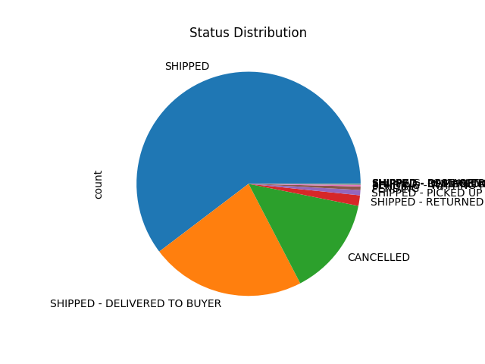
COUNT OF ORDERS BASED ON SHIP-CITY:-
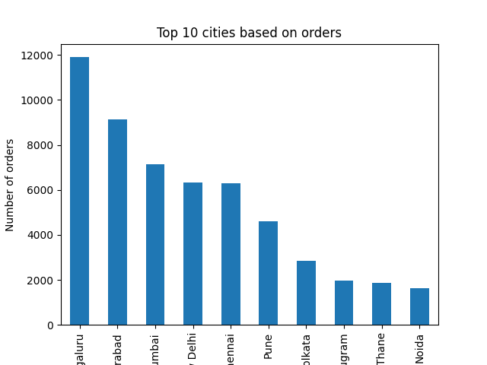
COUNT OF ORDERS BASED ON SHIP-STATE:-
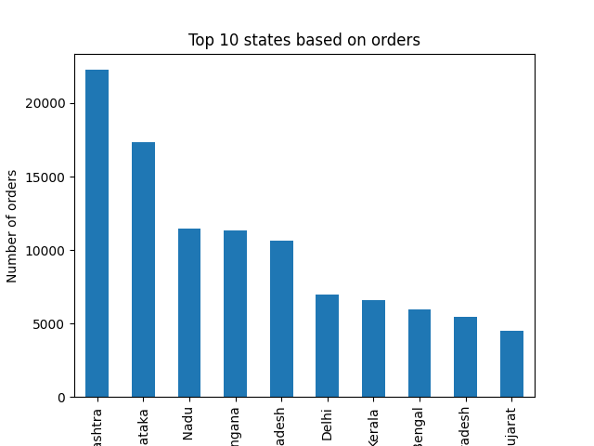
COUNT OF PRODUCT SIZE BASED ON PRODUCT CATEGORY :-
