Basic Docker Commands
- docker --version docker -v
This command is used to get the current version of the docker

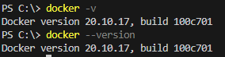

- docker pull: Pull an image or a repository from a registry
Syntax:docker pull [OPTIONS] NAME[: TAG|@DIGEST] To download an image or set of images (i.e. A Repository) Ex: docker pull hello-world
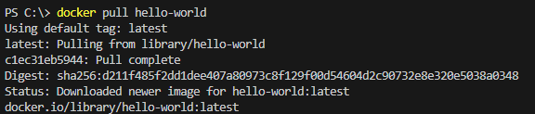

- docker run: This command is used to create a container from an image
Syntax : docker run [OPTIONS] IMAGE [COMMAND] [ARG...]
Example : docker run hello-world

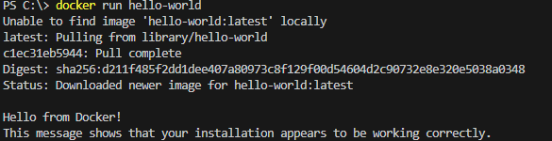

- docker psThis command is used to list all the containers Syntax : docker ps [OPTIONS]
Example :docker ps (lists currently running containers)
Command : docker ps -a -a or -all : Lists all containers that are running & stopped

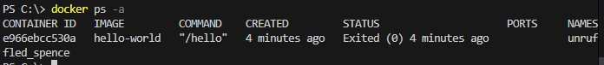

- docker restart
This command is used to restart one or more containers. Syntax: docker restart [OPTIONS] CONTAINER [CONTAINER...] Example:docker restart my_container

6 docker kill
This command is used to kill one or more containers. Syntax: docker kill [OPTIONS] CONTAINER [CONTAINER...] Example:$ docker kill my_container

7Build an Image from a Dockerfile docker build -t <image_name> Ex: docker build -t
8 List local images
docker images
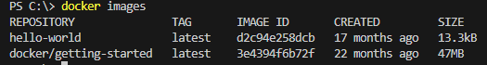

9docker searchTo search for an image in Docker Hub.
docker search <image_name>
Ex: docker search hello-world
10Delete an Image
docker rmi <image_name>
Ex: docker rmi hello-world Login into Docker
docker login -u <username>
Publish an image to Docker Hub
docker push <username>/<image_name> Container commands
Create and run a container from an image, with a custom name:
docker run --name <container_name><image_name>
Run a container with and publish a container’s port(s) to the host.
docker run -p <host_port>:<container_port><image_name>

Run a container in the background docker run -d <image_name> Start or stop an existing container:
docker start|stop <container_name> (or <container-id>)
Remove a stopped container:
docker rm <container_name>

Week 7: Create a Simple Java Containerized Application using Docker

Choose an application:
Choose a simple application that you want to containerize. Forexample, a Python script or any Java program
Here we use simple Java program and containerize it using docker

1 Create an application folder
- Open the Visual Studio Code and select Open Folder from File menu
- Now select the application folder that is created and open
- From the explorer bar, click on the application folder
- Now click on NewFile button to create a file Now ,Create a simple Java program as below public class Test
{
public static void main(String[] args)
{
int a=20,b=30,c; c=a*b;
System.out.println("Hello world"); System.out.println("value of c is "+c);
}
}
Save it as with .java extension

Now again create another file and name the file as Dockerfile
Create a Dockerfile for the above Java program
In the Dockerfile, specify the base image, copy the application into thecontainer, and specify the command to run the application

Dockerfile
FROM openjdk # uses the base image –openjdk with java installed

WORKDIR /sam# Set the working directory
COPY. /sam# Copies all the files to working directory

RUN javac Test.java# Compile the Java program

CMD ["java", "Test"]# Set the default command to run the Java program

Save the Java file and Docker file
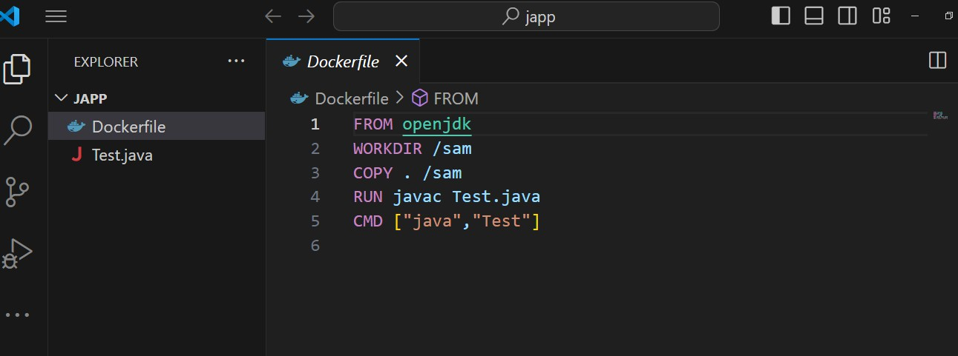

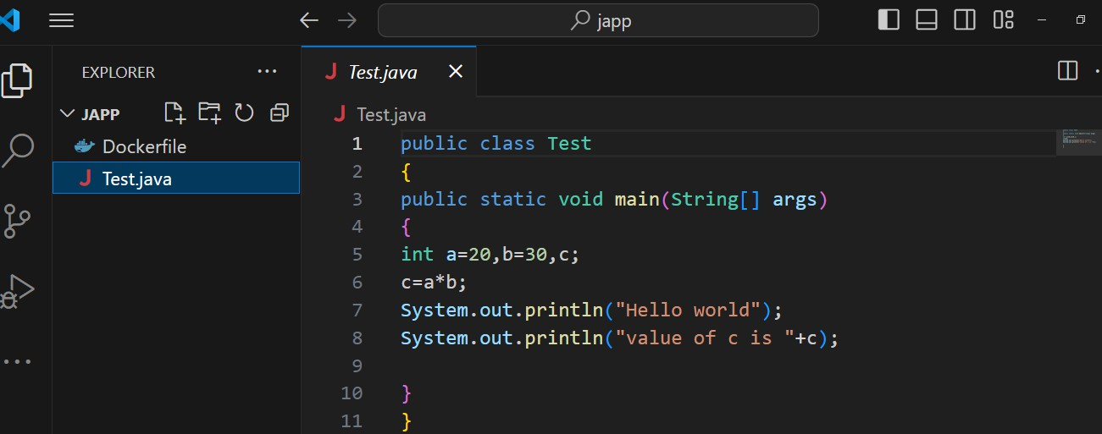

Start the New Terminal from Visual studio
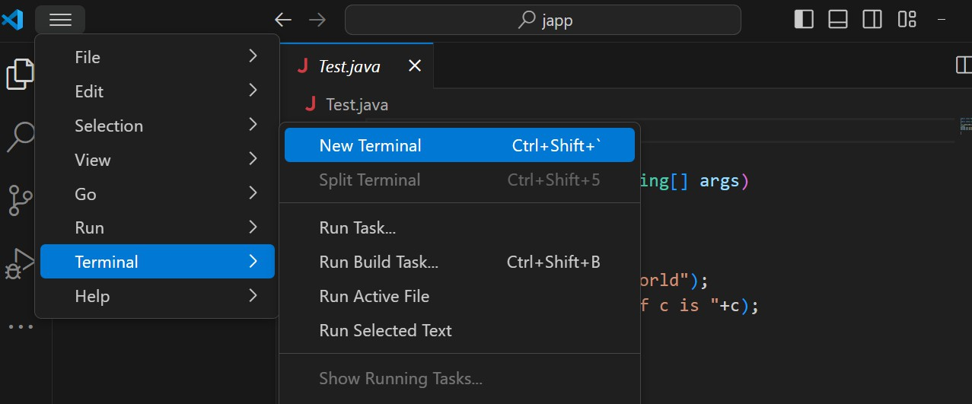

Type the command to list all the images ::::docker images
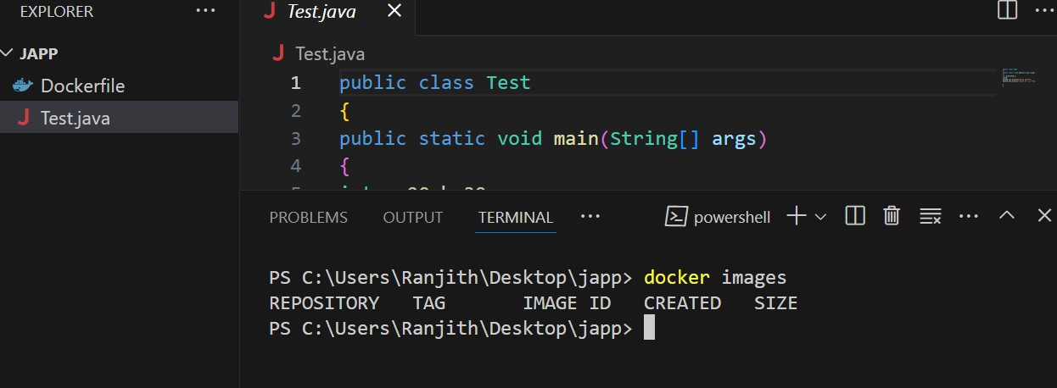

Start the Dockerdesktop
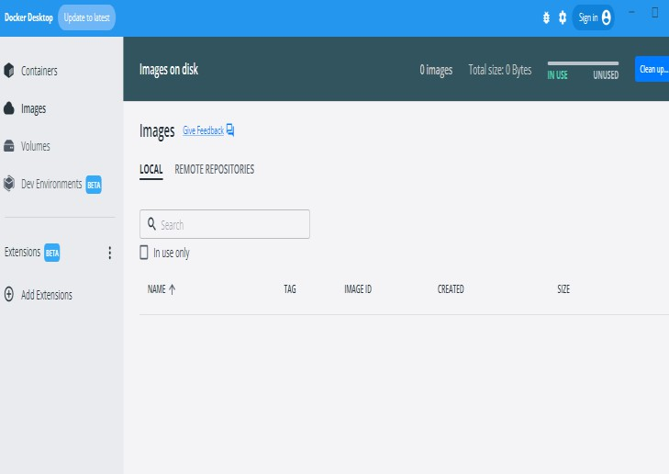

Build the Docker image using the docker build command. This command builds a new Docker image using the Dockerfile and tags theimage with the name
Command :docker build -t "any name for your docker image" .
Example :docker build -t helloworld .

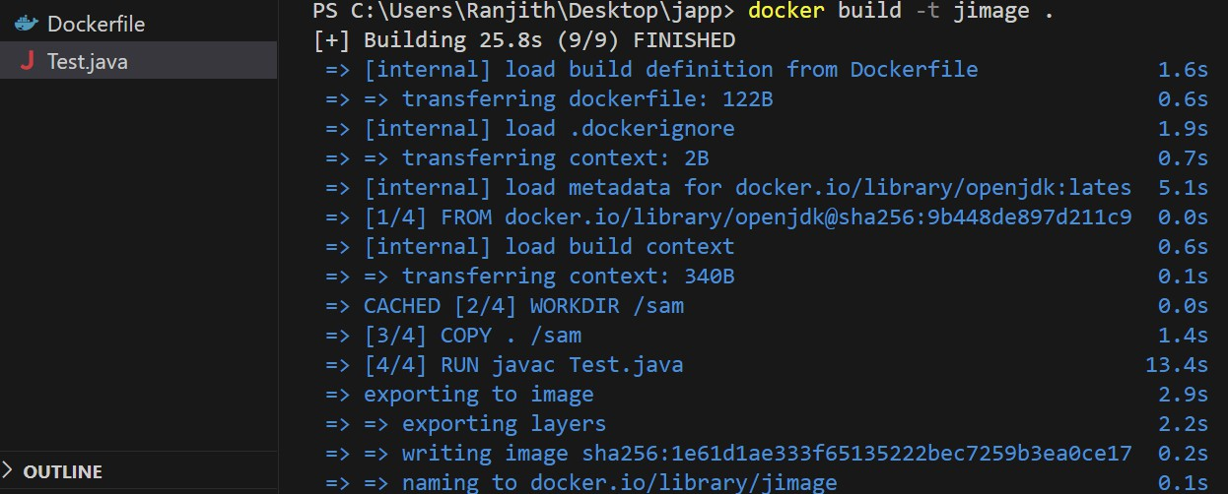

View the image created in the docker
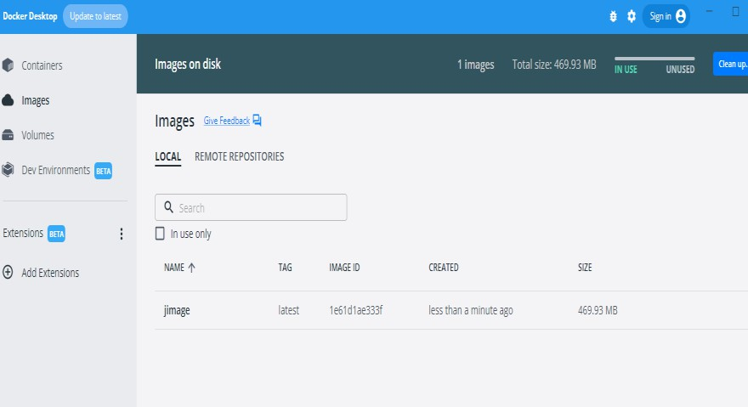

Run the Docker container:
Run the following command to start a new container based on the image:
$ docker run --name mycontainermyimage
This command starts a new container named "mycontainer" based on the "myimage" image and runs the Java code inside the container.

Example
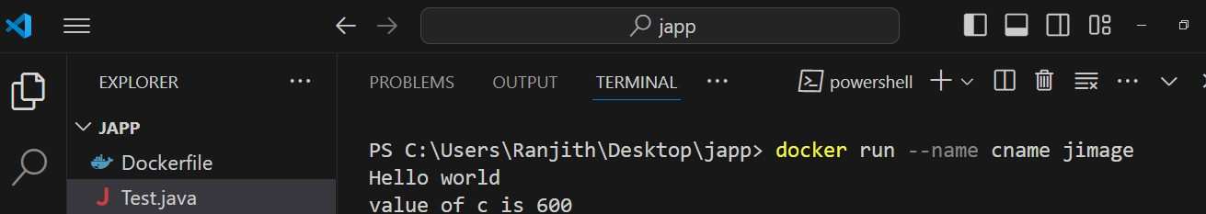


Verify the output:

Run the following command to verify the output of the container:
$ docker logs mycontainer
This command displays the logs of the container and should show the programs output
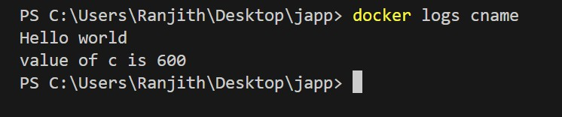

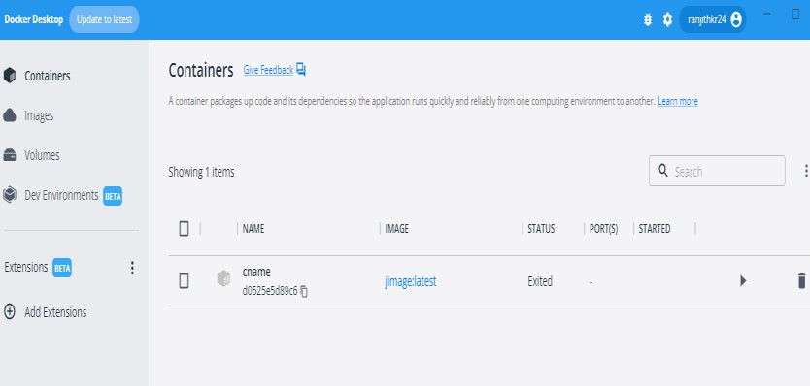

Pushing images into the docker hub Create a repository

Login to Dockerhub,Select Create Repository, name it and choose it to make itas public or private
Tag the Imageuse the command
docker tag <image name><dockerhub-user name>/<repo-name><version>
Log into Docker
docker login give login credentials
Push the Imageuse the command docker push <docker-hub-username>/<image name><version name>

Login into Docker hub
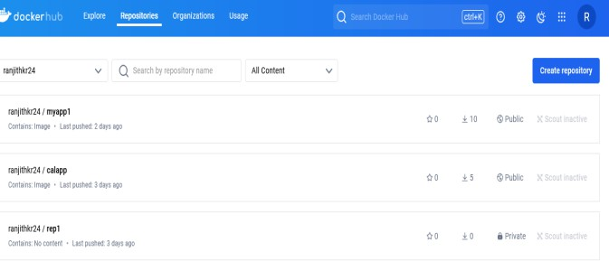

Tagging docker image and login into docker hub

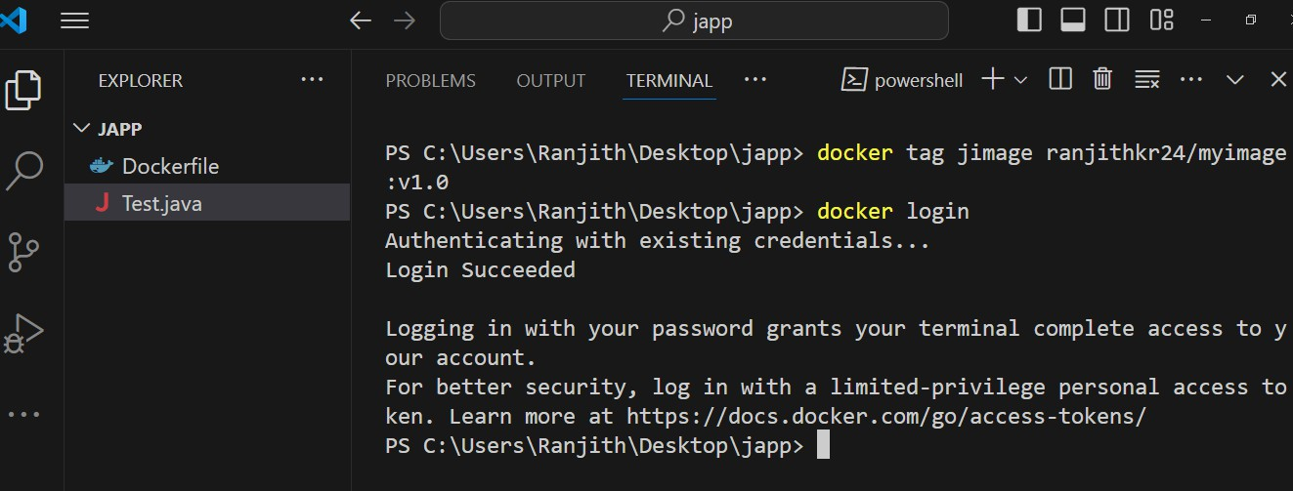

Issuing docker push command to push the image

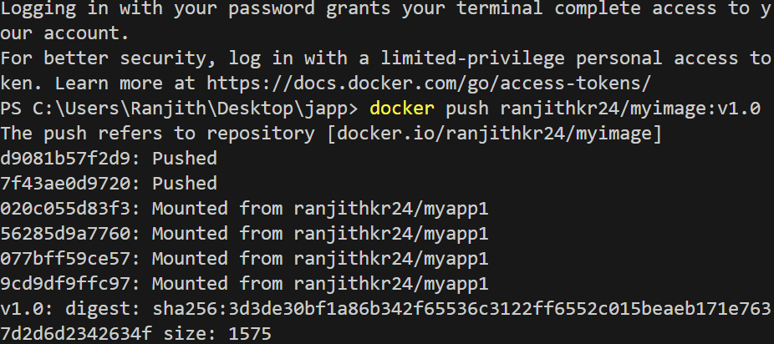

Pushed image can be viewed in dockerhub

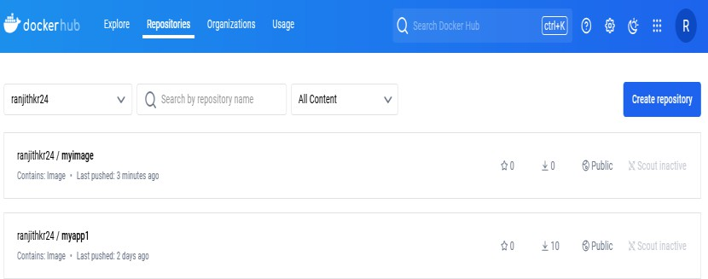

Week 8: Integrate Kubernetes with Docker
Aim:
To enable Kubernetes on Docker Desktop and prepare system to run Kubernetes commands.
Kubernetes
Kubernetes, also known as K8s, is an open-source system for automatingdeployment, scaling, and management of container-based applications in different kinds of environments like physical, virtual, and cloud-native computing foundations.
Some of the benefits of Kubernetes


Container Orchestration: Kubernetes manages the placement and scheduling of containers across a cluster of machines, ensuring that the desired state of the application is maintained.
Scalability: Kubernetes allows applications to scale horizontally by automatically adding or removing containers based on resource utilization and user-defined rules.
Self-Healing: Kubernetes monitors the health of containers. It automatically restarts failed containers or replaces them with new ones to ensure the desired state of the application is maintained.
Rolling Updates and Rollbacks: Kubernetes supports rolling updates, allowing applications to be updated with minimal downtime. If any issues arise, it also facilitates rollbacks to previous versions.
Storage Orchestration: Kubernetes provides a way to manage persistent storage volumes and attach them to containers as needed.
Differences between Docker and Kubernetes

Docker is used for building, shipping, and running containers—it provides the means to create isolated environments for applications.
On the other hand, Kubernetes focuses on orchestrating containers, meaning it helps manage, scale, and ensure the smooth operation of large collections of containers.

Docker manages individual containers, whereas Kubernetes manages multiple containers across clusters.
Integrating Kubernetes with Docker

- Start the Docker Desktop
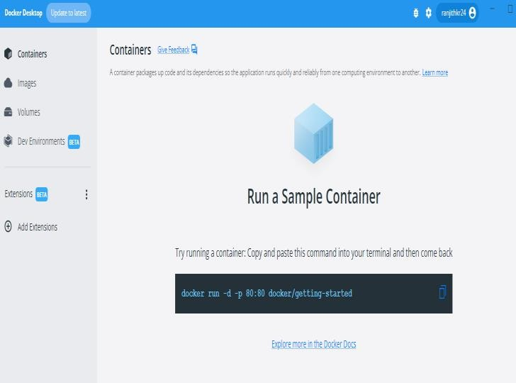

- Select Settings on the top right side from the Docker Desktop Dashboard
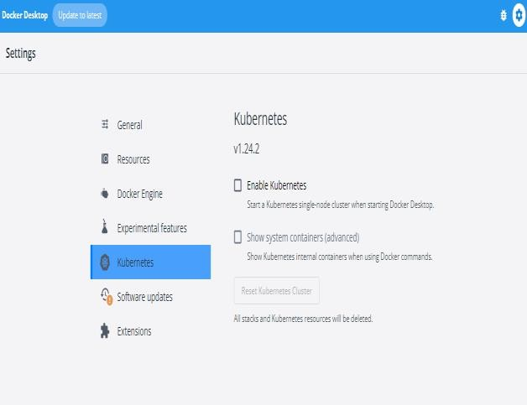
- Select Kubernetes from the left side bar
- Check the Enable Kubernetes checkbox

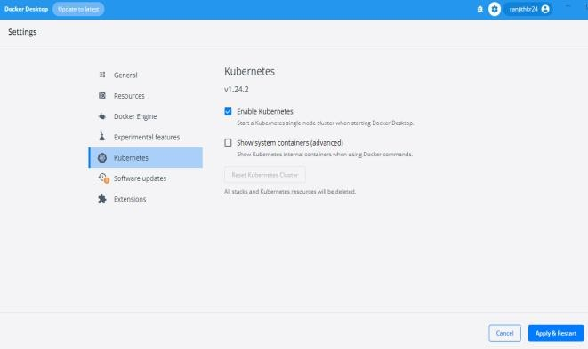

- Select Apply & restart to save the settings
- Select Install to confirm
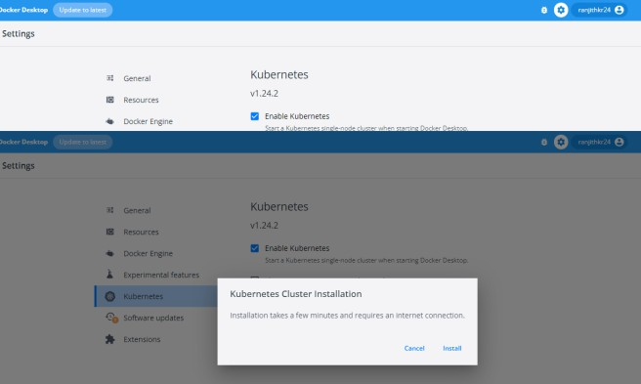

7.Go to Kubernetes website ,https://kubernetes.io/releases/download/#binaries
Download kubectlconvert.exe for Windows OS
8 Save this file kubectlconvert.exein a folderand copy the folder into C//Windows//System32
- Set the path in environment path variable for the kubectlconvert.exe file
- Open command prompt and type the following commands
kubectl version –client kubectl get pods
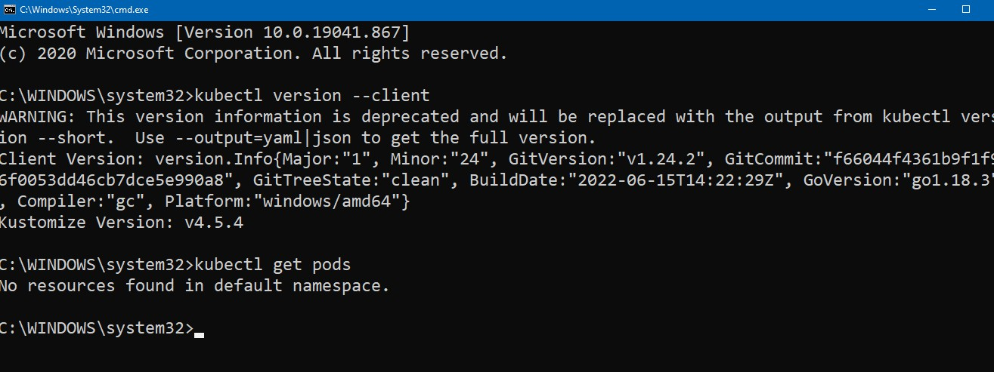

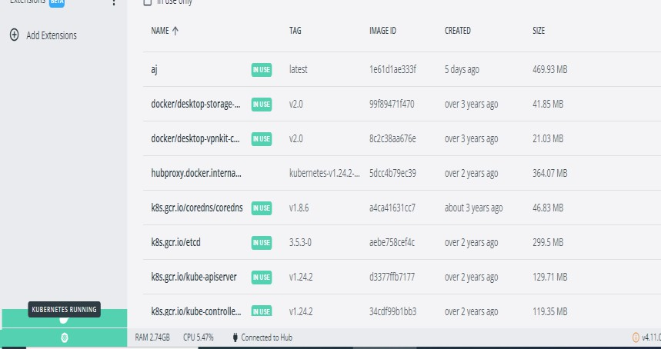

Week 9: Automate the Running of a Containerized Application

Kubernetes is an open-source platform for managing containerized workloads and services. It provides a robust framework for automating deployments, scaling, and managing containerized applications
Prerequisites
following prerequisites are required:
  - Kubernetes Cluster: A running Kubernetes cluster. You can set up a local cluster using Minikube or use a managed service like Google Kubernetes Engine (GKE).
  - kubectl: The command-line tool for interacting with your Kubernetes cluster.
  - Docker: Installed and running on your machine.
  - Containerized Application: Your application packaged into a Docker image.

Kubernetes Cluster Architecture
Kubernetes comes with a client-server architecture. It consists of master and worker nodes
The master node, contains the components such as API Server, controller manager, scheduler, and etcddatabase for stage storage. kubelet to communicate with the master, the kube-proxy for networking, and a container runtime such as Docker to manage containers.

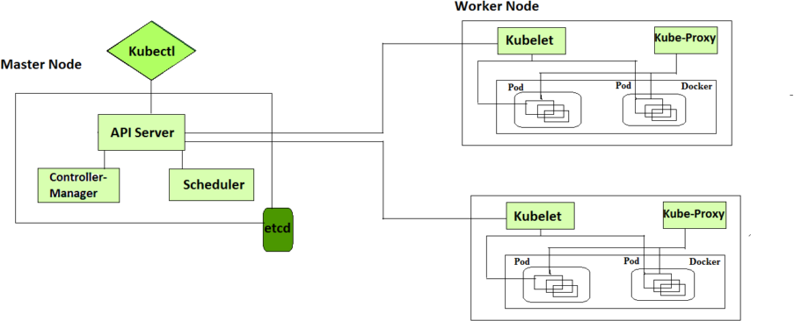

Kubernetes Components
Kubernetes is composed of a number of components, each of which plays a specific role in the overall system. These components can be divided into two categories:
  - nodes: Each Kubernetes cluster requires at least one worker node, which is a collection of worker machines that make up the nodes where our container will be deployed.
  - Control plane: The worker nodes and any pods contained within them will be under the control plane.

Control Plane Components
It is basically a collection of various components that help us in managing the overall health of a cluster. For example, if you want to set up new pods, destroy pods, scale pods, etc. Basically, 4 services run on Control Plane:
- Kube-API server
- Kube-Scheduler
- Kube-Controller-Manager
- etcd
Node Components
These are the nodes where the actual work happens. Each Node can have multiple pods and pods have containers running inside them.
- Container runtime
- kubelet
- kube-proxy

Test.java
import java.io.IOException;
import java.net.InetSocketAddress;
import com.sun.net.httpserver.HttpServer;

public class Test {
public static void main(String[] args) throws IOException
{
int port = 8080; // Port on which the server will listen System.out.println("Starting server on port " + port);
HttpServer server = HttpServer.create(new InetSocketAddress(port), 0); server.createContext("/", (exchange -> {
String response = "Hello, Kubernetes!"; exchange.sendResponseHeaders(200, response.getBytes().length); exchange.getResponseBody().write(response.getBytes()); exchange.close();
}));
server.setExecutor(null); server.start();
System.out.println("Server is running at http://localhost:" + port);
}
}

Step 1: Create a Docker Image
First, create a Docker image for your application. This involves writing a Dockerfile that specifies the base image, copies the application code, and sets the command to run the application.
Dockerfile
# Use OpenJDK base image FROM openjdk:17-alpine

# Set working directory WORKDIR /app
# Copy all files to the working directory COPY . /app
# Compile the Java application RUN javac Test.java
# Expose port 8080 for the application EXPOSE 8080
# Run the Java application CMD ["java", "Test"]

Build the Docker image using the Dockerfile:
- docker build -t my-java-app .
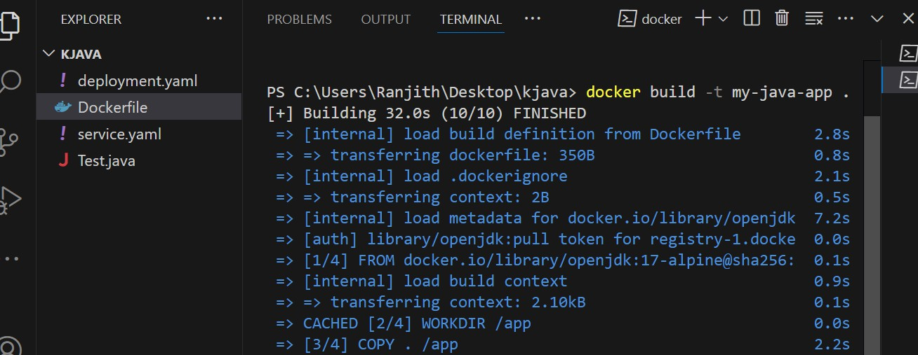

Tagging the image and login into dockerhub

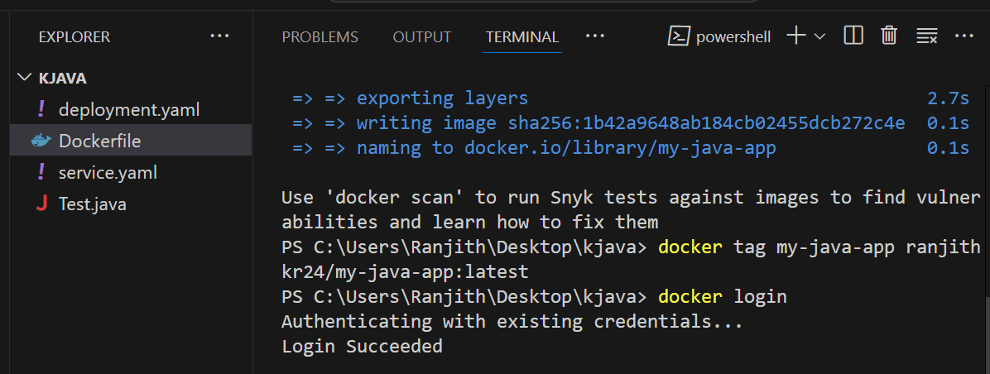

Step 2: Push the Docker Image to a Registry
Push the Docker image to a container registry like Docker Hub
docker tag my-java-app:latest<your-docker-hub-username>/my-java-app:latest docker push <your-docker-hub-username>/my-java-app:latest
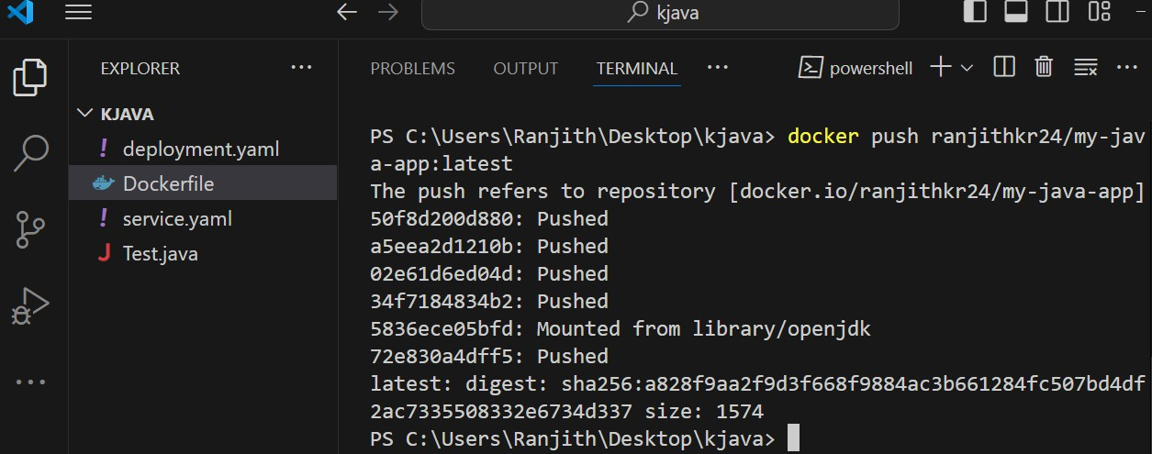

Step 3: Create a Kubernetes Deployment
A Kubernetes Deployment is a resource that manages the rollout of new versions of an application. It ensures that a specified number of replicas (i.e., copies) of your application are running at any given time.
Create a YAML file named deployment.yaml with the following content: apiVersion: apps/v1
kind: Deployment metadata:

name: my-java-app spec:
replicas: 3 selector:
matchLabels:
app: my-java-app template:
metadata:
labels:
app: my-java-app spec:
containers:
- name: my-java-app
image: ranjithkr24/my-java-app:latest ports:
  - containerPort: 8080 env:
  - name: PORT value: "8080"

Apply the deployment configuration to your Kubernetes cluster: kubectl apply -f deployment.yaml
Step 4: Create a Kubernetes Service
A Kubernetes Service provides a network identity and load balancing for accessing your application. Create a YAML file named service.yaml with the following content:
apiVersion: v1 kind: Service

metadata:
name: my-java-app-service spec:
selector:
app: my-java-app ports:
- protocol: TCP
port: 80 # Port exposed inside the cluster targetPort: 8080 # Port your Java app is running on nodePort: 30007 # External port
type: NodePort
Apply the service configuration to your Kubernetes cluster:
kubectl apply -f service.yaml
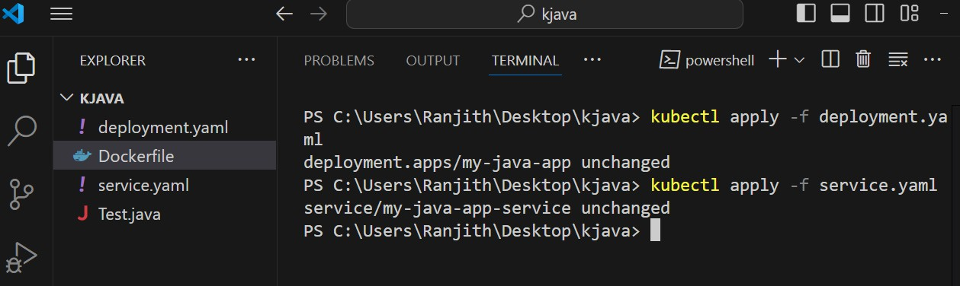

Step 5: Verify the Deployment
Check the status of your deployment and service:
kubectl get deployments

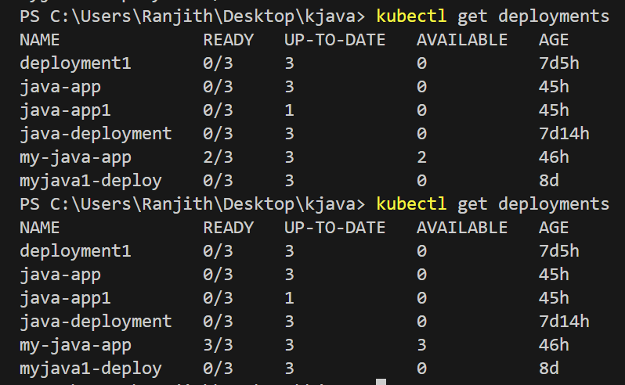

kubectl get pods
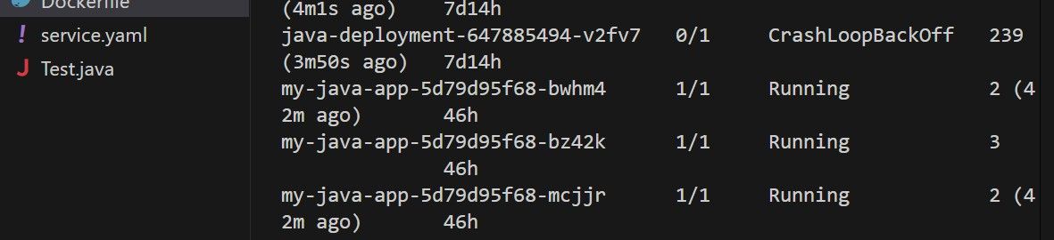

kubectl get svc
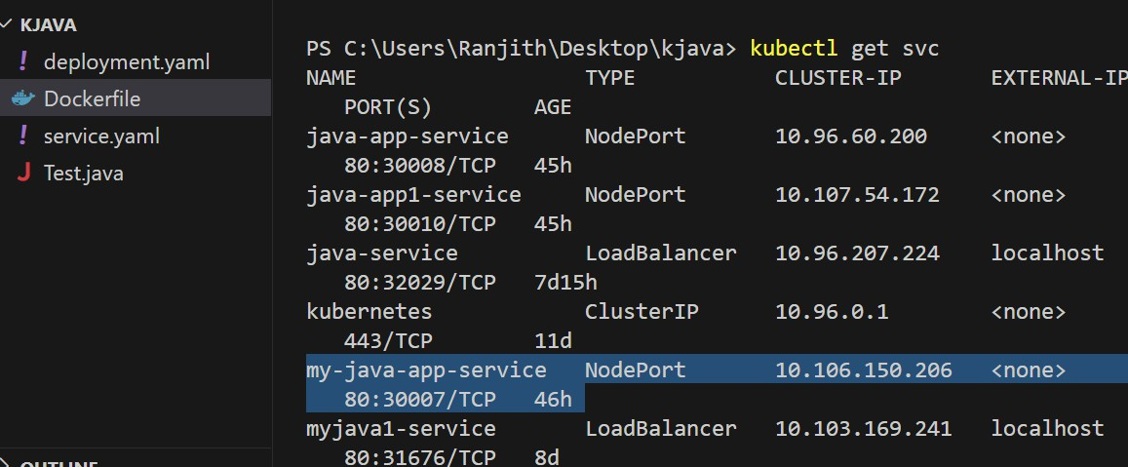

Step 6: Access the Application
To access your application, you need to get the external IP address of the service:

Open a web browser and navigate to the external IP address to access your application.
Type: http://localhost:port number of the application service
Type in the browser -- http://localhost:30007 to access the application for the above example

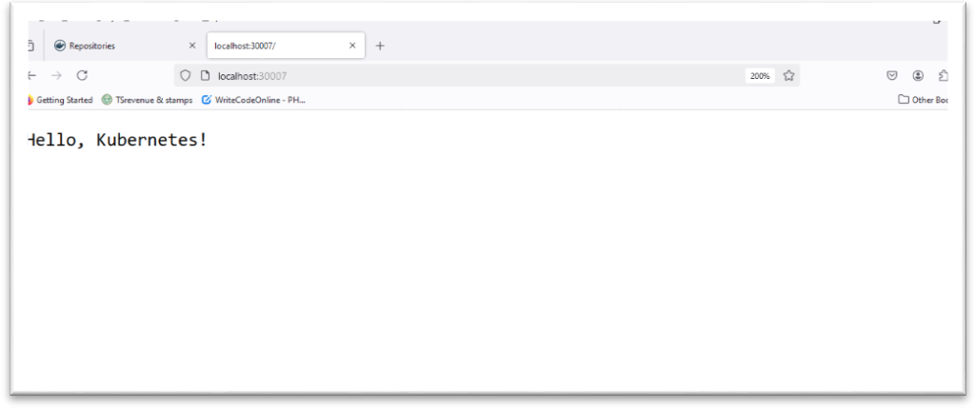

10 Install and Explore Selenium for automated testin

What is Selenium?
Selenium is an open-source tool used for automating web browsers. It provides a suite of tools for testing web applications across different browsers and platforms. The Selenium WebDriver API allows you to interact with web pages programmatically by simulating user actions like clicking, typing, navigating, etc.

Installation of Selenium WebDriver Step 1: Install Node.js and npm
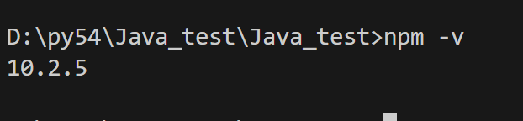
If you don’t have Node.js installed, download it from Node.js official website. Follow the instructions for your operating system.
- Verify the installation by running the following commands in the terminal: node -v
npm -v
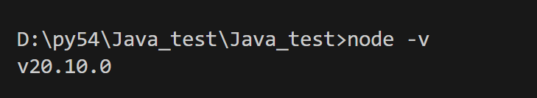
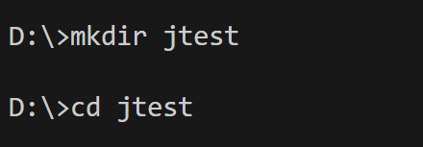

Step 2: Create a Project Folder
- Open Visual Studio Code.
- Create a new folder named SeleniumLab.

- Open the terminal in VS Code and initialize a Node.js project: npm init -y
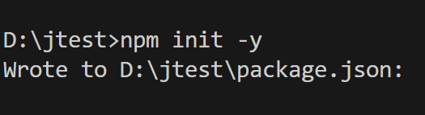
Step 3: Install Selenium WebDriver
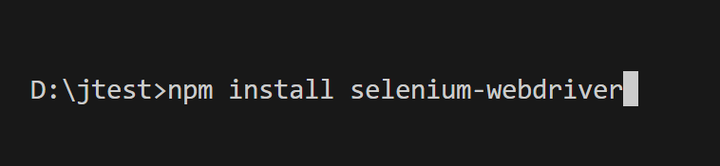
- Install the selenium-webdriver package: npm install selenium-webdriver
- Download the ChromeDriver that matches your Chrome browser version from ChromeDriver Downloads.
- Extract the downloaded ChromeDriver and place it in the project folder.

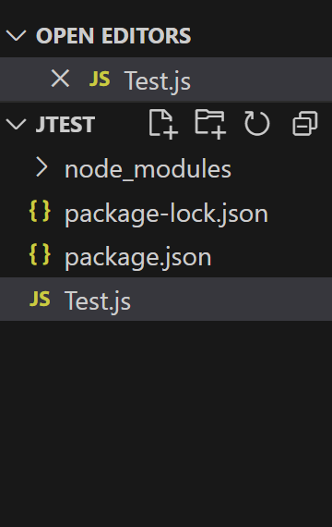

Part 3: Writing a Simple Selenium Test Script Step 1: Create a JavaScript Test File
- Inside the SeleniumLab folder, create a new file named test.js.
- Copy and paste the following code into test.js:
Test.js
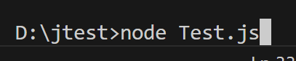
const { Builder, By, Key, until } = require('selenium-webdriver'); async function testGoogleSearch() {
// Step 1: Launch the Chrome browser
let driver = await new Builder().forBrowser('chrome').build(); try {
// Step 2: Open the Google homepage

await driver.get('https://www.google.com');

// Step 3: Locate the search box and enter a search query
await driver.findElement(By.name('q')).sendKeys('Selenium WebDriver', Key.RETURN);

// Step 4: Wait for the search results to load
await driver.wait(until.titleContains('Selenium WebDriver'), 5000);

// Step 5: Print the page title in the console let title = await driver.getTitle(); console.log('Page Title:', title);

// Step 6: Check if the search results are displayed if (title.includes('Selenium WebDriver')) {
console.log('Test Passed: Search results loaded successfully.');
} else {
console.log('Test Failed: Search results not loaded.');
}
} catch (error) { console.error('Error:', error);
} finally {
// Step 7: Close the browser await driver.quit();
}
}

testGoogleSearch(); Explanation of the Code:
- Import Selenium WebDriver:
  - Builder: Used to create a new browser instance.
  - By: Used to locate elements on the web page.
  - Key: Simulates keyboard actions.
  - until: Used for waiting until a condition is met.
- testGoogleSearch Function:
  - Step 1: Launches the Chrome browser.
  - Step 2: Opens https://www.google.com.
  - Step 3: Finds the search box using its name attribute and types a query (Selenium WebDriver).
  - Step 4: Waits until the page title includes "Selenium WebDriver".
  - Step 5: Prints the page title.
  - Step 6: Verifies if the search results are displayed correctly.
  - Step 7: Closes the browser.

Part 4: Running the Selenium Test Script Step 1: Running the Script
- Make sure that ChromeDriver is in the project folder.
- Open the terminal in Visual Studio Code.
- Run the test script: node Test.js
Expected Output:
  - The Chrome browser should open, navigate to Google, perform a search for "Selenium WebDriver", and display the search results.
  - The terminal should display:

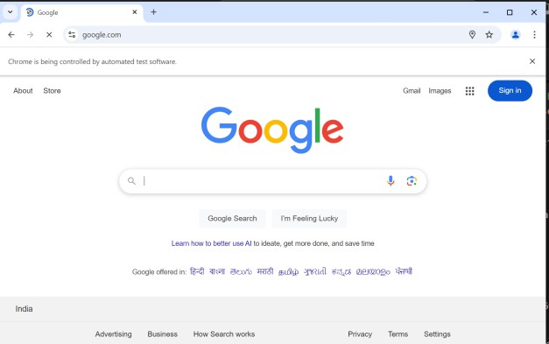

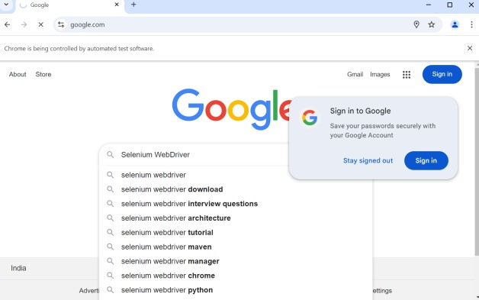
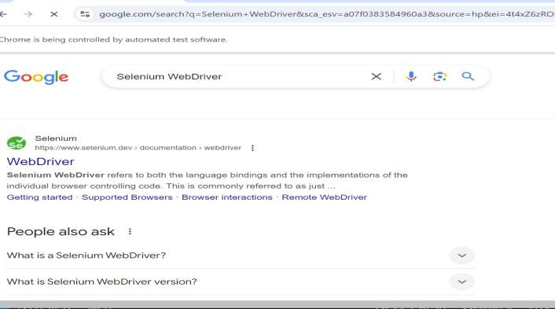

Page Title: Selenium WebDriver - Google Search Test Passed: Search results loaded successfully.

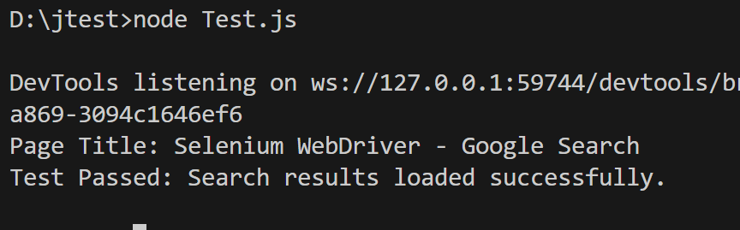

Part 5: Exploring Selenium Commands Commonly Used Selenium Commands
- Navigating to a URL:
await driver.get('https://example.com');
- Locating Elements:
  - By ID:
await driver.findElement(By.id('elementId'));
  - By Class Name:
await driver.findElement(By.className('className'));
  - By Name:
await driver.findElement(By.name('elementName'));
- Performing Actions:
  - Click an Element:
await driver.findElement(By.id('buttonId')).click();
  - Enter Text:
await driver.findElement(By.name('inputName')).sendKeys('Hello World');
- Waiting for Elements:
await driver.wait(until.elementLocated(By.id('elementId')), 5000);
- Closing the Browser: await driver.quit();

11 JavaScript Registration Form Testing using Selenium

Objective:
To create a simple registration form using HTML and JavaScript, and perform automated functional testing using Selenium.

Firstly we have to download npm and nodejs
To check whether npm is downloaded or not use this command.

To check whether nodejs is downloaded or not use this command. nodejs –v
And then follow below steps

Step 1: Creating the Registration Form
- Open Visual Studio Code.
- Create a folder named RegistrationForm.
- Inside the folder, create a file named index.html with the following content:
<!DOCTYPE html>
<html lang="en">
<head>
<meta charset="UTF-8">
<meta name="viewport" content="width=device-width, initial-scale=1.0">
<title>Registration Form</title>
<!-- Inline CSS -->

<style>
body {
font-family: Arial, sans-serif; text-align: center;
margin-top: 50px; background-color: #f5f5f5;
}
form {
display: inline-block; text-align: left; background-color: #ffffff; padding: 20px;
border-radius: 8px;
box-shadow: 0 4px 8px rgba(0, 0, 0, 0.1);
}
input {
width: 100%; padding: 10px; margin: 10px 0;
box-sizing: border-box; border-radius: 4px; border: 1px solid #ccc;
}
button {
background-color: #4CAF50; color: white;
padding: 10px 20px; border: none; border-radius: 4px;

cursor: pointer;
}
button:hover {
background-color: #45a049;
}
#message { color: green;
font-weight: bold; margin-top: 20px;
}
.error { color: red;
}
</style>
</head>
<body>
<h2>Registration Form</h2>
<!-- Registration Form -->
<form id="registrationForm">
<label for="username">Username:</label><br>
<input type="text" id="username" name="username" placeholder="Enter username" required><br>

<label for="email">Email:</label><br>
<input type="email" id="email" name="email" placeholder="Enter email" required><br>

<label for="password">Password:</label><br>
<input type="password" id="password" name="password" placeholder="Enter password" required><br>

<button type="submit">Register</button>
</form>

<!-- Message Display -->
<p id="message"></p>

<!-- Inline JavaScript -->
<script>
document.getElementById("registrationForm").addEventListener("submit", function(event) {
event.preventDefault(); // Prevent form from submitting

// Get input values
const username = document.getElementById("username").value; const email = document.getElementById("email").value;
const password = document.getElementById("password").value; constmessageElement = document.getElementById("message");

// Validate inputs
if (username === "" || email === "" || password === "") { messageElement.textContent = "All fields are required!"; messageElement.classList.add("error");
return;
}

// Check for valid email format constemailPattern = /^[^\s@]+@[^\s@]+\.[^\s@]+$/;
if (!emailPattern.test(email)) { messageElement.textContent = "Invalid email format!"; messageElement.classList.add("error");

return;
}

// If all validations pass, show success message messageElement.textContent = "Registration Successful!"; messageElement.classList.remove("error"); messageElement.style.color = "green";

// Clear the form document.getElementById("registrationForm").reset();
});
</script>
</body>
</html>
Step 2: Running the Web Application
- Open the terminal in Visual Studio Code.
- Use the following command to start a simple HTTP server: npx http-server
- Open your browser and go to http://localhost:8080 to view the form.

Part 2: Testing the Registration Form using Selenium Step 1: Setting up Selenium in Node.js
- Initialize a Node.js project: npminit–y

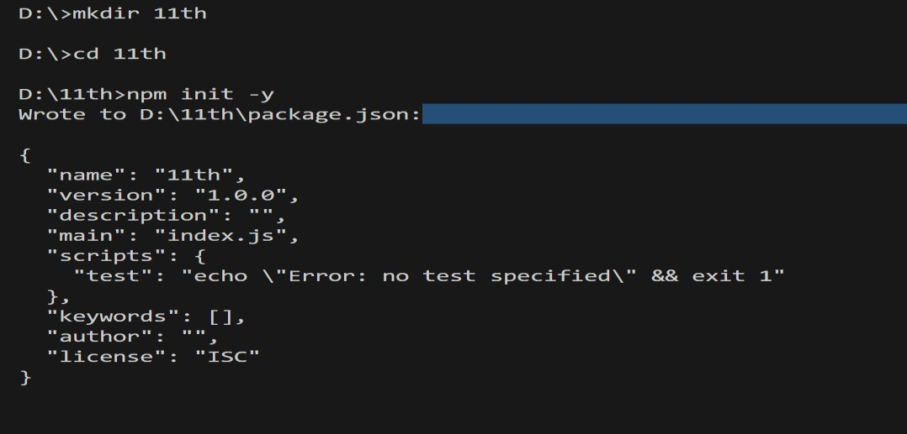

- Install the Selenium WebDriver package: npm install selenium-webdriver
- Download the ChromeDriver that matches your Chrome browser version from ChromeDriver Downloads.
- Extract the downloaded chromedriver and place it in the project folder.
Step 2: Writing the Selenium Test Script
Create a file named test.js and add the following code: javascript
const { Builder, By, Key, until } = require('selenium-webdriver');

async function testRegistrationForm() {
// Set up WebDriver
let driver = await new Builder().forBrowser('chrome').build(); try {
// Navigate to the registration form awaitdriver.get('http://localhost:8080');

// Enter username

awaitdriver.findElement(By.id('username')).sendKeys('student1');

// Enter email
await driver.findElement(By.id('email')).sendKeys('student1@example.com');

// Enter password awaitdriver.findElement(By.id('password')).sendKeys('password123');

// Click the Register button awaitdriver.findElement(By.css('button[type="submit"]')).click();

// Wait for the success message to appear awaitdriver.wait(until.elementLocated(By.id('message')), 5000);

// Get the message text
let message = await driver.findElement(By.id('message')).getText(); console.log('Test Result:', message);

// Check if registration is successful
if (message === 'Registration Successful!') { console.log('Test Passed');
} else { console.log('Test Failed');
}
} finally {
// Close the browser

awaitdriver.quit();
}
}

testRegistrationForm();
Step 3: Running the Selenium Test
- Ensure your HTTP server is running: npx http-server
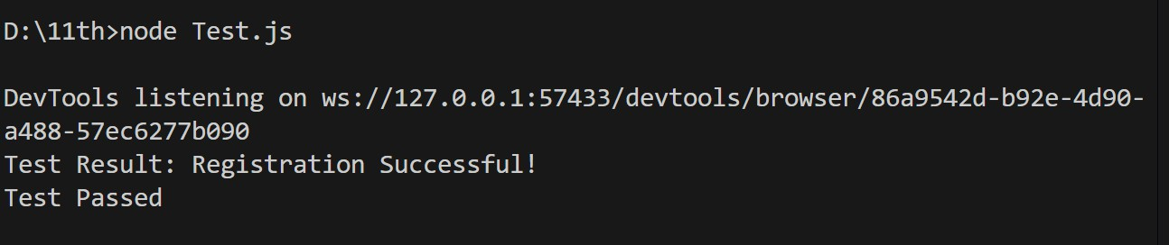
- Open a new terminal and run the Selenium test script: node test.js

Expected Output:
  - The console should display: Test Result: Registration Successful!
Test Passed

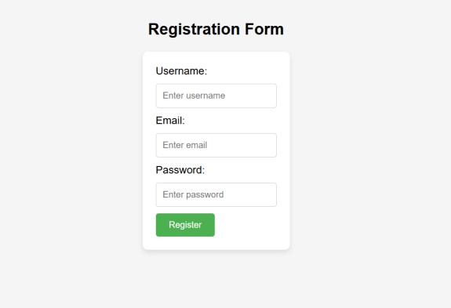
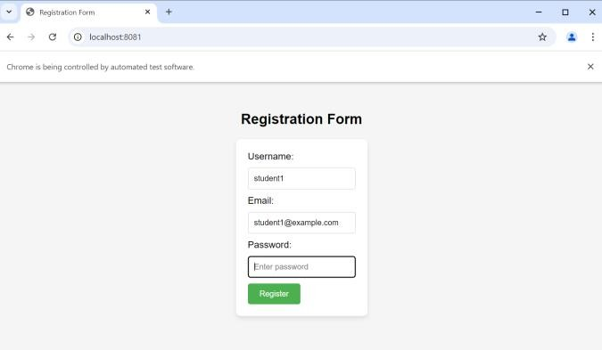

12 Node.js Registration Form, Docker Containerization, and Selenium Testing

Overview:
This project consists of a simple Node.js registration form hosted in a Docker container, with automated testing using Selenium WebDriver. The main steps involved are:

- Setting up a Node.js registration form.
- Dockerizing the application.
- Writing Selenium tests to automate the form submission and validate the result.

Step 1: Create a Node.js Registration Form
  - package.json

The package.json file defines the project metadata and dependencies. It includes necessary packages like express for the server and body-parser for handling form submissions.

express: A lightweight web framework for Node.js that simplifies routing and HTTP handling.

body-parser: Middleware to parse the incoming request bodies, enabling us to handle form submissions easily.

Project Structure

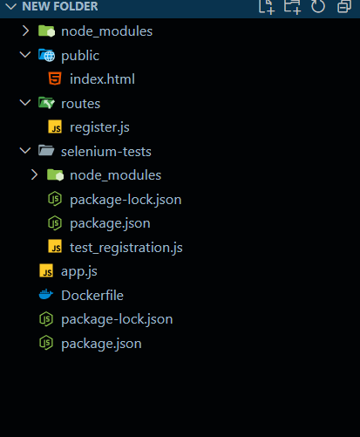

{

"name": "nodejs-registration", "version": "1.0.0",
"description": "Simple Node.js registration form", "main": "app.js",
"scripts": {

"start": "node app.js"

},

"dependencies": { "express": "^4.18.2",
"body-parser": "^1.20.2"

}

}

Create a file app.js

  - app.js

const express = require('express'); constbodyParser = require('body-parser'); const path = require('path');
const app = express();

// Middleware to handle form data app.use(bodyParser.urlencoded({ extended: true })); app.use(express.static('public'));

// Serve registration form app.get('/', (req, res) => {
res.sendFile(path.join( dirname, 'public', 'index.html'));

});

// Handle form submission app.post('/register', (req, res) => {
const{ username, email, password } = req.body; console.log(`Username: ${username}, Email: ${email}`); res.send('Registration successful!');
});

// Start the server on port 3000 const PORT = 3000;

app.listen(PORT, () => {

console.log(`Server is running on http://localhost:${PORT}`);

});

Express server setup: Sets up an Express server that listens on port 3000.
Static files: Serves static files (like index.html) from the public/ folder.

POST route: Handles registration form submissions and logs the data to the console.

  - public/index.html

This is the HTML form where users can input their registration details (username, email, and password). Upon submission, the data is sent to the server.

<!DOCTYPE html>

<html lang="en">

<head>

<meta charset="UTF-8">

<title>Registration Form</title>

</head>

<body>

<h2>Registration Form</h2>

<form method="POST" action="/register">

<label for="username">Username:</label>

<input type="text" id="username" name="username" required><br>

<label for="email">Email:</label>

<input type="email" id="email" name="email" required><br>

<label for="password">Password:</label>

<input type="password" id="password" name="password" required><br>

<button type="submit">Register</button>

</form>

</body>

</html>

Step 2: Create a Dockerfile

A Dockerfile is used to containerize the Node.js application. It includes instructions to install dependencies, copy the application code, and run the app inside a container.
# Use Node.js base image
FROM node:14
# Set the working directory
WORKDIR /usr/src/app
# Copy package.json and install dependencies
COPYpackage.json ./
RUNnpm install
# Copy application files
COPY . .
# Expose port 3000
EXPOSE 3000
# Start the application
CMD ["npm", "start"]
Base image: We use the official node:14 Docker image as a base. Dependencies: It copies the package.json file and installs the dependencies. Expose port: Port 3000 is exposed, which is the port the application runs on. CMD: Runs npm start to launch the app in the container

Step 3: Build and Run Docker Container

To build and run the Docker container, execute the following commands: # Build the Docker image
docker build -t nodejs-registration-app .

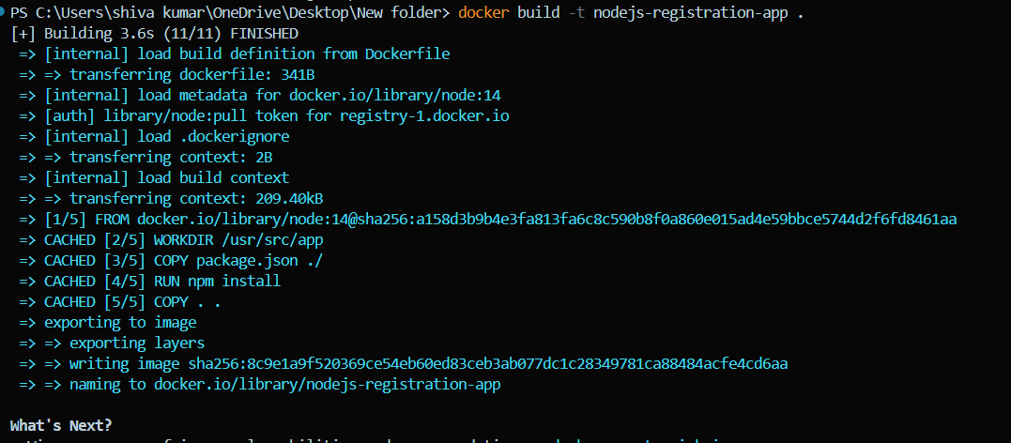

# Run the container

docker run -d -p 3000:3000 --name nodejs-registration nodejs-registration-app
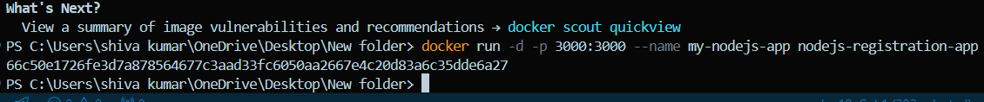

After running the container, the app is accessible at http://localhost:3000.

Step 4: Set Up Selenium for Automated Testing

To automate testing for the registration form, we use Selenium WebDriver to simulate a user filling out the form and submitting it.

  - Install Selenium WebDriver

Inside the selenium-tests directory, initialize a new Node.js project and install
selenium-webdriver and chromedriver:

By following command Npm init -y
npm install selenium-webdriverchromedriver

  - Create test_registration.js

This file contains the test logic for Selenium, which fills out the registration form and checks if the registration is successful.

Copy the command

const{ Builder, By, until } = require('selenium-webdriver'); const chrome = require('selenium-webdriver/chrome');

async function runTest() {

let driver = await new Builder().forBrowser('chrome').build();

try {

// Open the registration form

await driver.get('http://localhost:3000');

// Fill in the registration form

await driver.findElement(By.id('username')).sendKeys('testuser');

await driver.findElement(By.id('email')).sendKeys('testuser@example.com'); await driver.findElement(By.id('password')).sendKeys('password123');

// Submit the form

await driver.findElement(By.tagName('button')).click();

// Wait for the response

await driver.wait(until.elementLocated(By.tagName('body')), 5000);

// Verify the result

let bodyText = await driver.findElement(By.tagName('body')).getText();

if (bodyText.includes('Registration successful!')) { console.log('Test Passed: Registration was successful.');
} else {

console.log('Test Failed: Registration was not successful.');

}

} finally {

await driver.quit();

}

}

runTest();

Step 5: Run Selenium Test Cases

To run the automated tests, execute the following command:

First run this app.js
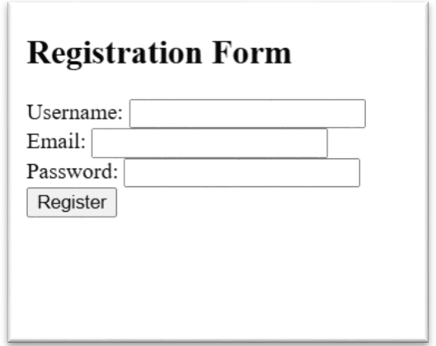

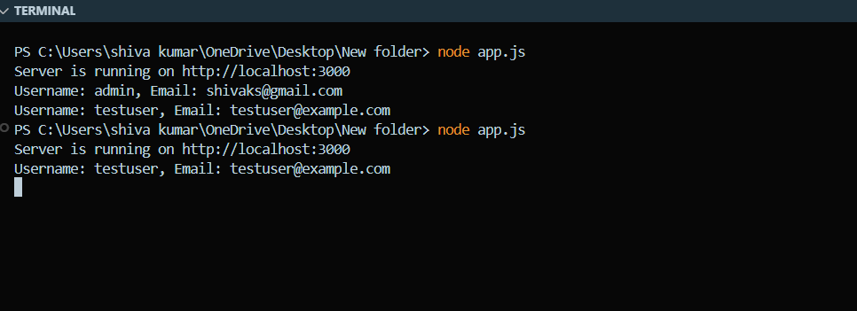
And then node test_registration.js(make sure change the directory to selenium)
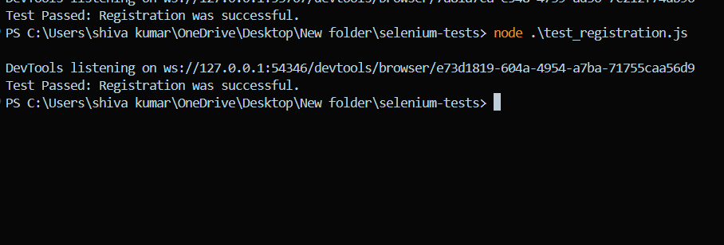

If the registration is successful, you will see the output: Test Passed: Registration was successful

