• Configure DHCP failover on windows server core.
=====
1-intial Setup for failover DHCP Server (Windows server Core 2022)
Computer Name : CORE
ip 192.168.1.5/24
command power shell to give ip
netsh interface ip set address name="Ethernet0" static 192.168.1.5 255.255.255.0
gateway : empty
DNS :192.168.1.2
Alternate DNS 192.168.1.3
then join it to domain ABC.Local
like that

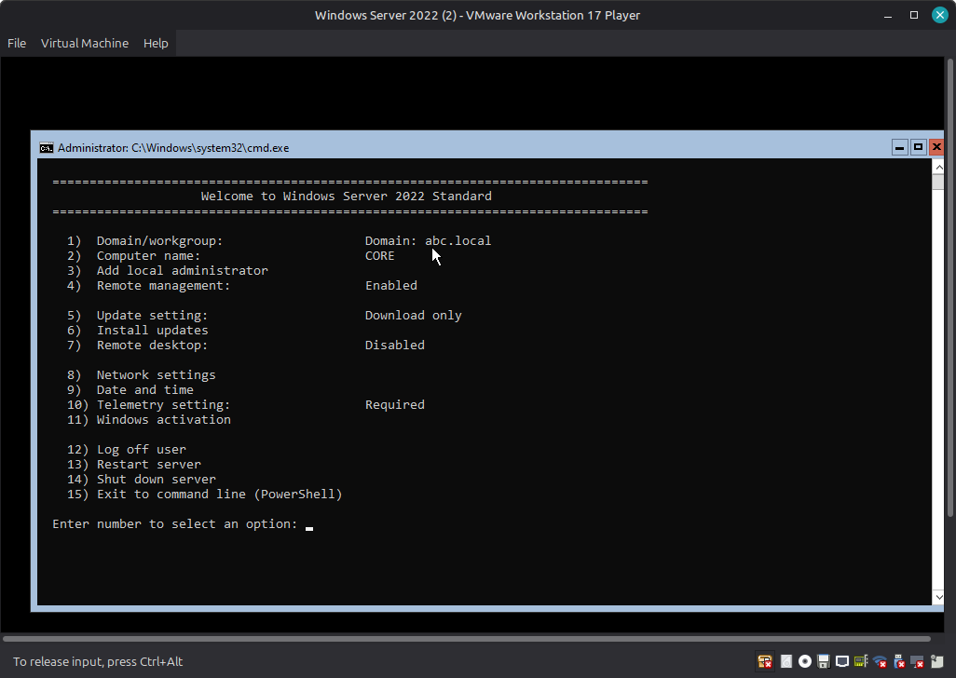

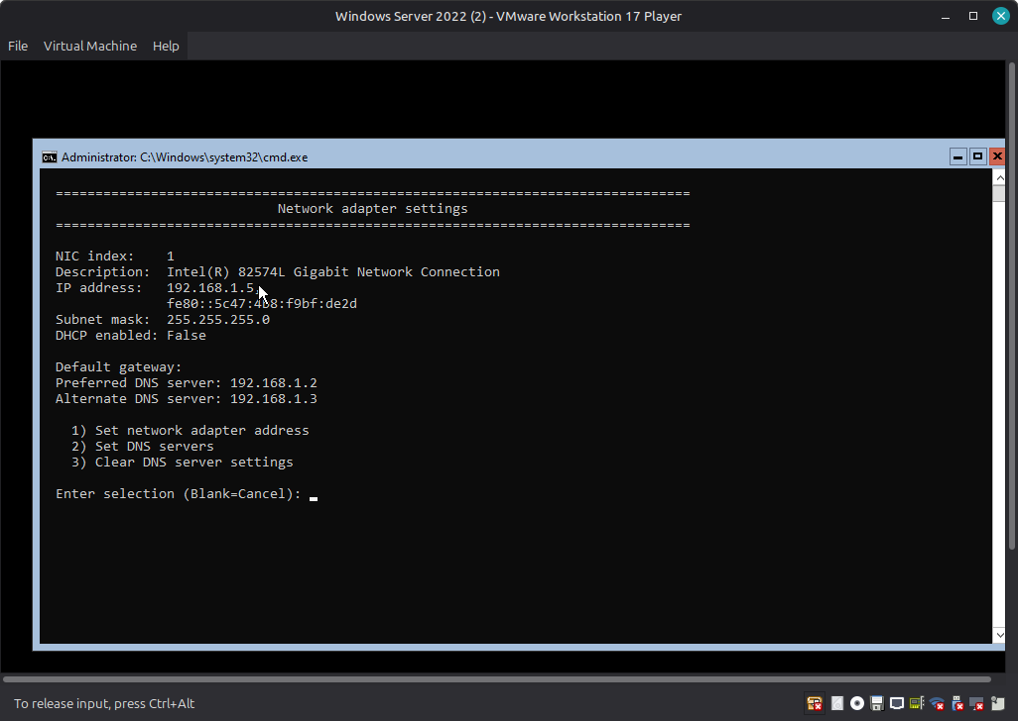
==============
2- open server manger from PDC To Add this device (CORE 192.168.1.5) As a Server
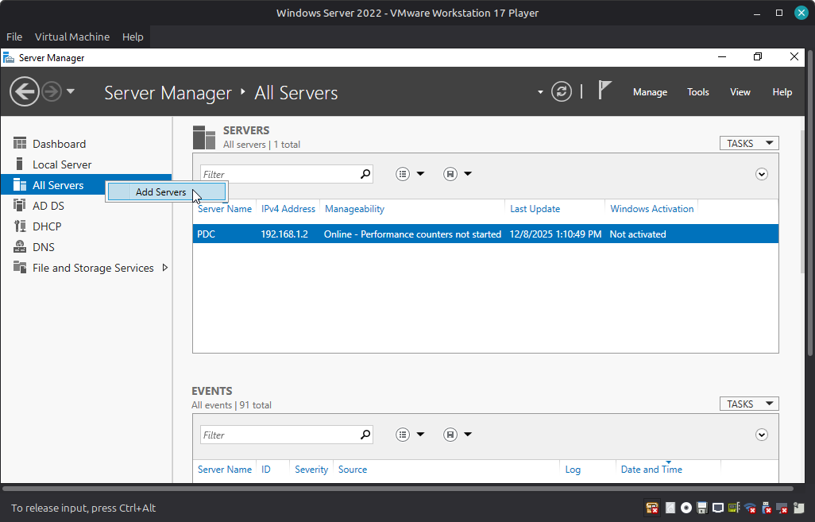

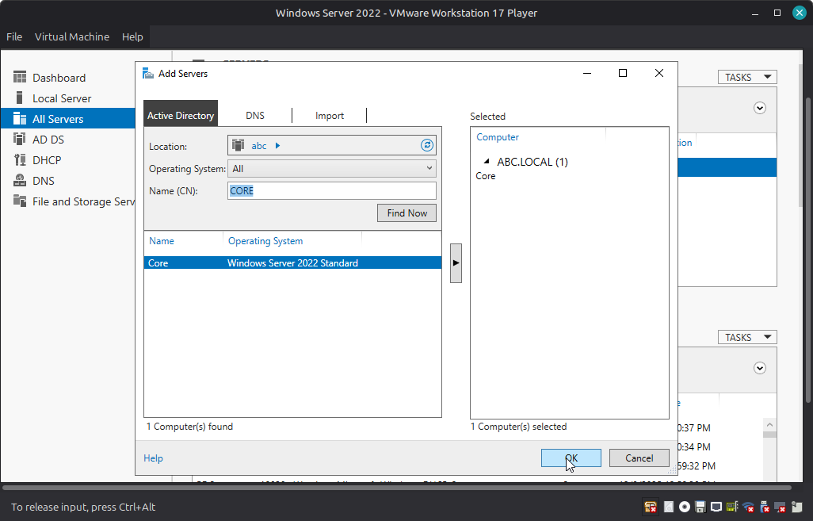

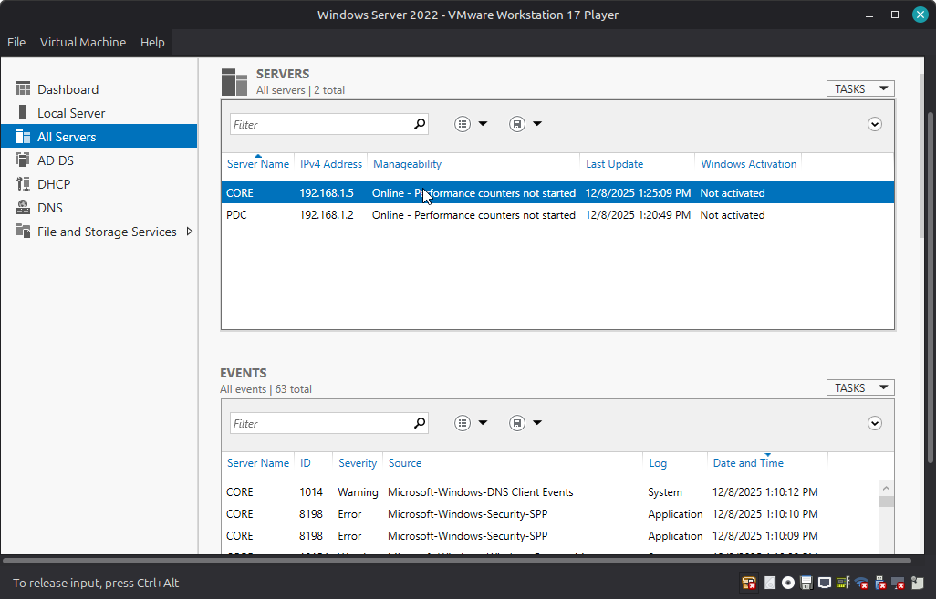

we finshed add this server to server manger

