Covid 19 wearhouse MS

Main points:

Main Pages.

User control.

Roles Privileges.

User control:

This will explain how to add new user and set a role for any users .

1. **Add user**

* Login into admin panel with provided credential

http://[server ip : port configured ]/admin/

* The list contain confirmation tables find User table and click it

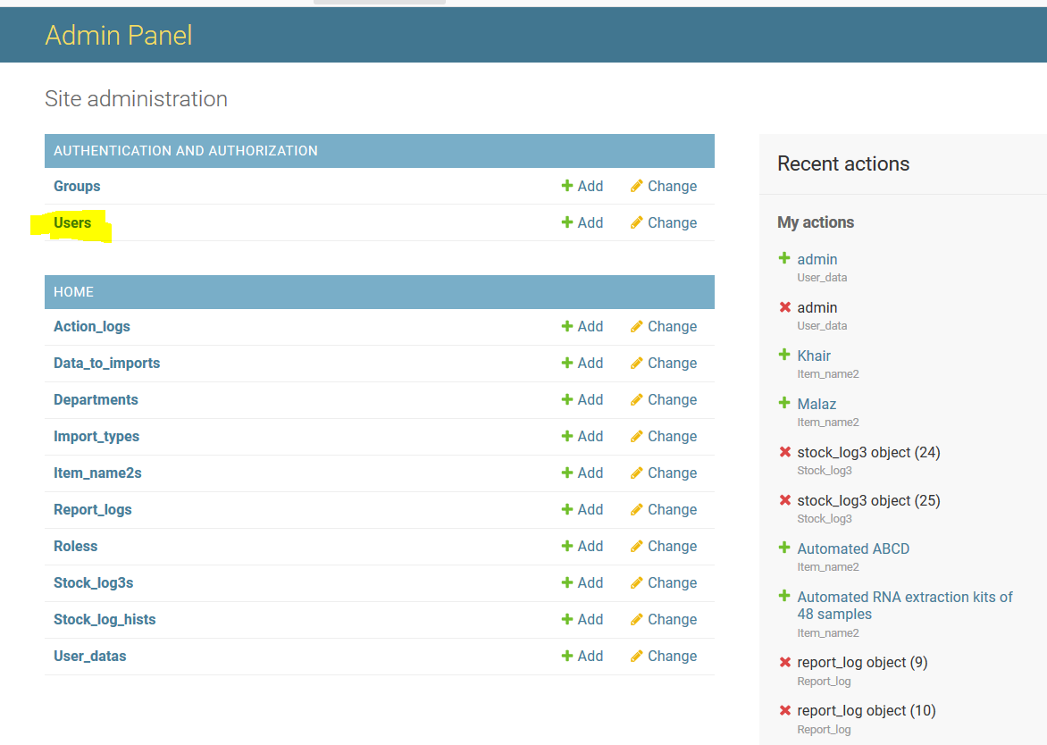

* Click **ADD USER** in the top right corner

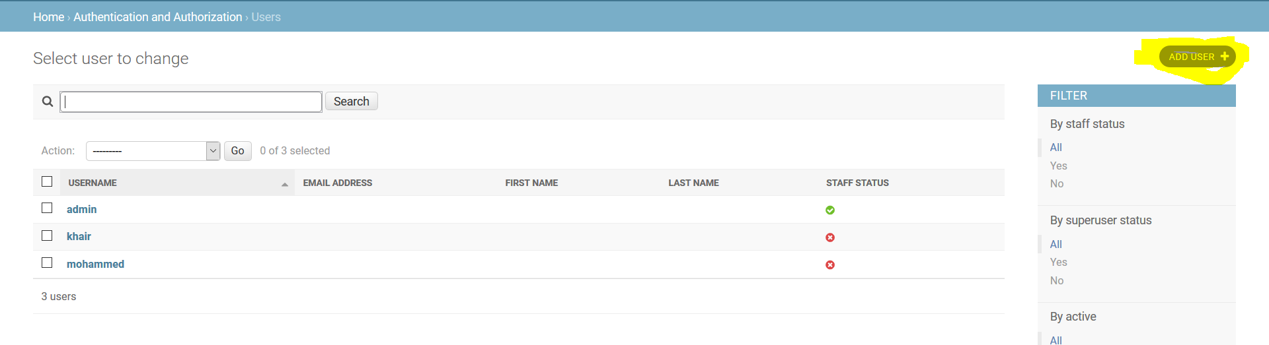

* Fill information needed and **save.**

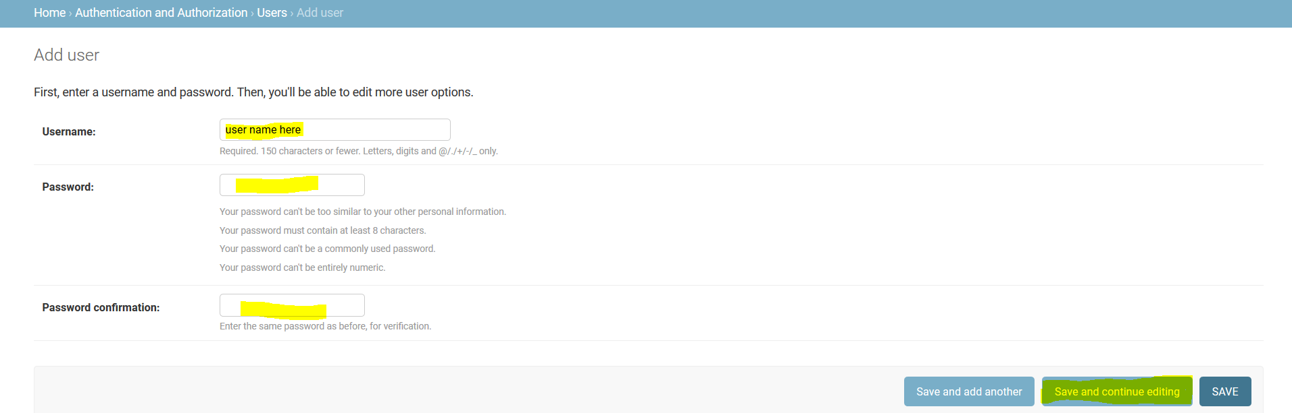

B)Set Role

After add roles every user should have role attached to his name to control the privileges .

* Choose **user_data** table to add new role Currently there is 4 roles configured in roles table
* 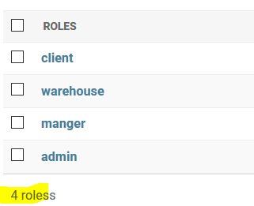
* To assign role to user **NOTE user name should equal and match user name in User table**

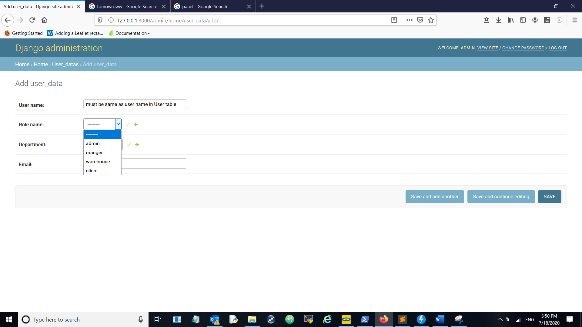

* Now a new user is set and role is attached to him.