JavaScript is the programming language of HTML and the Web.

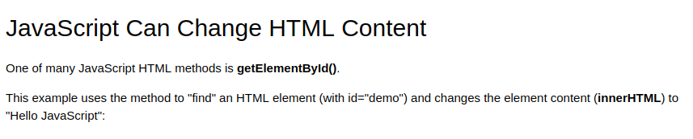
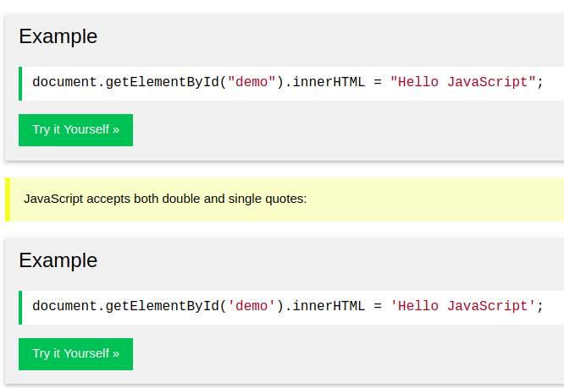
Nice Example
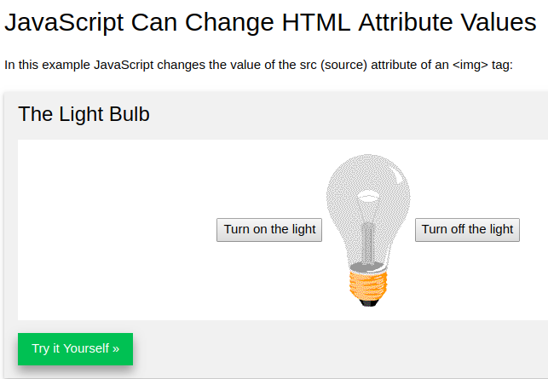
https://www.w3schools.com/js/tryit.asp?filename=tryjs_intro_lightbulb

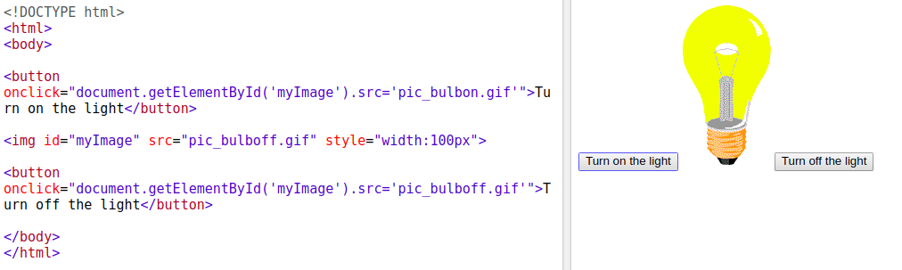
JS css Example

JavaScript Can Hide HTML Elements
https://www.w3schools.com/js/tryit.asp?filen

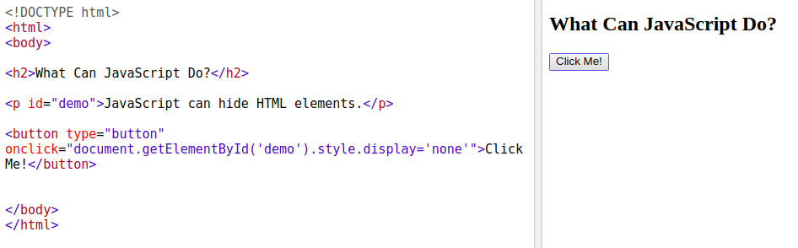

JavaScript in <head> or <body>
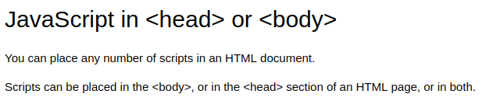

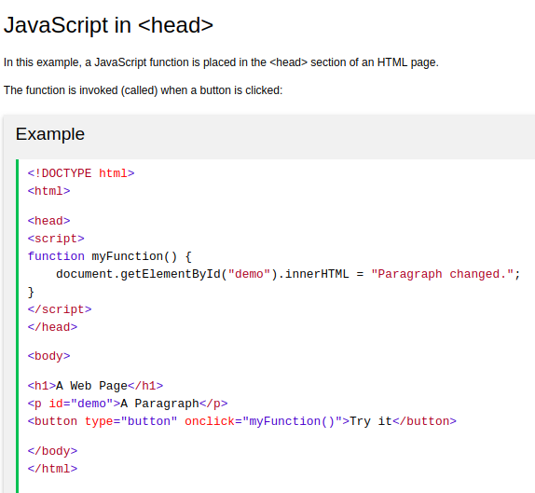
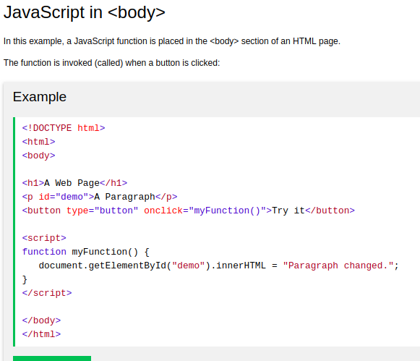

External JavaScript
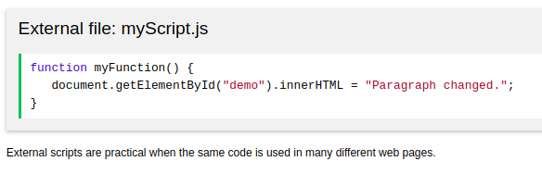
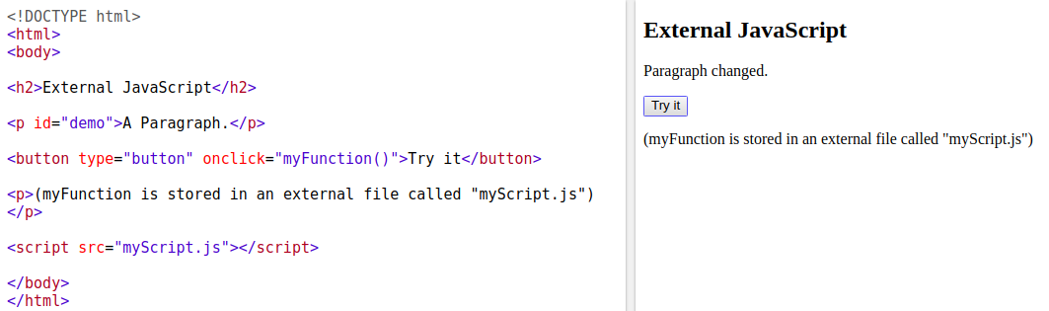
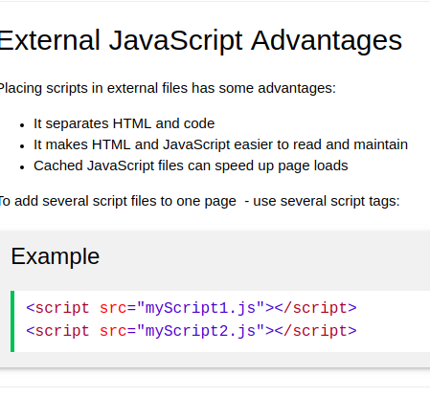
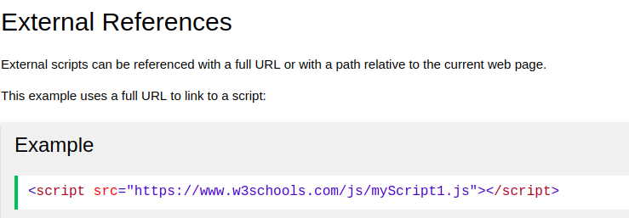

What is Hoisting in JavaScript ? Most important question in JS developer interview

In JavaScript, a variable can be used before it has been declared يعلن - يعرف .

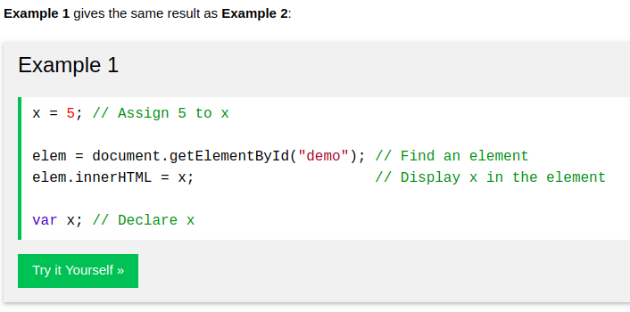

Hoisting is JavaScript's default behavior of moving all declarations to the top of the current scope (to the top of the current script or the current function).

The math operations with Converting the ‘string’

the + operation converts (the number when adding to string ‘’) to string.

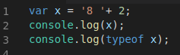
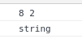
the - * / % operations convert (the string ‘’ when adding to number) to number.

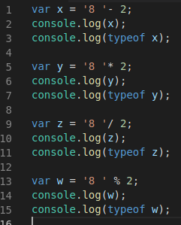

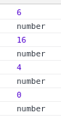

JS HTML DOM addEventListener()

-The addEventListener() method attaches an event handler to the specified element. تقوم بإرفاق معالج أحداث بالعنصر المحدد.

- element.addEventListener(event, function, useCapture)
- event : Required. A String that specifies the name of the event.
events: https://www.w3schools.com/jsref/dom_obj_event.asp

- function: Required. Specifies the function to run when the event occurs.

- document.getElementById("id").addEventListener("click", function(){});
- Tip: Use the removeEventListener() method to remove an event handler that has been attached with the addEventListener() method.
-Tip: Use the document.addEventListener() method to attach an event handler to the document.

Ex:

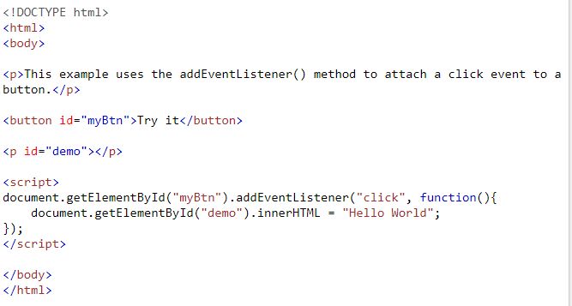

In Browser

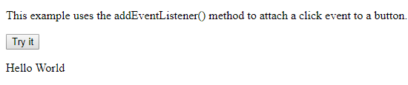

Logical operation ! && ||

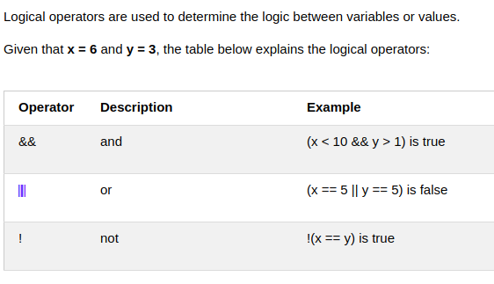
who execute first :
1 not !
2 and &&
3 or ||

Conditional (Ternary ثلاثي) Operator
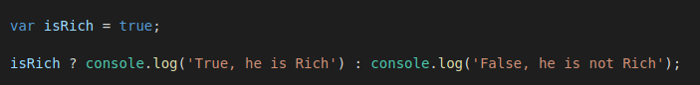
That means :

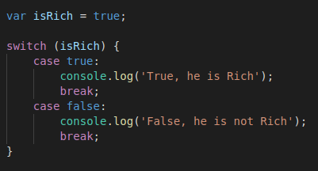

Switch Statement
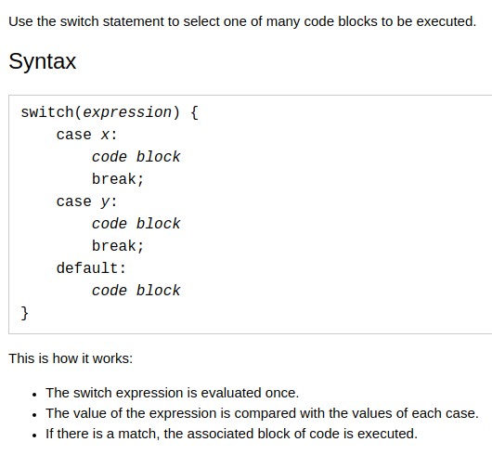

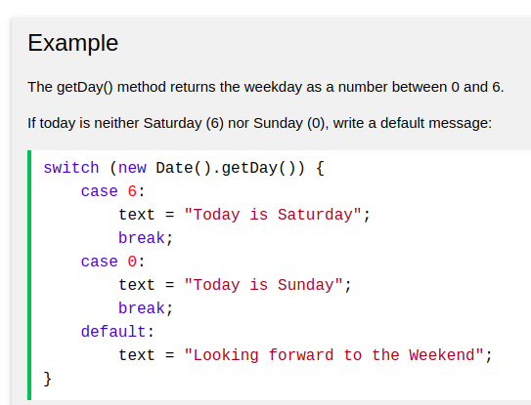

Operator precedence - order
The following table is ordered from higheWst (20) to lowest (1) precedence.
https://developer.mozilla.org/en-US/docs/eb/JavaScript/Reference/Operators/Operator_Precedence

logical for numbers and string
0 zero as logic is false

all numbers else zero as logic is true

‘ ‘ as logic is false

‘ncjdncjdnccdkl’ as logic is true

empty array as logic is false

To insert variables inside string

use ` `

not ‘ ‘

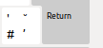
ex:

The else if Statement ( note : and the another down if will not be executed ) that means only one if will be executed
if (condition1) {
block of code to be executed if condition1 is true and the another down will not be executed
}

else if (condition2) {
block of code to be executed if the condition1 is false and condition2 is true and the another down will not be executed
}

else {
block of code to be executed if the condition1 is false and condition2 is false
}

css Example
Css Example

css Example
Css Example

https://www.w3schools.com/js/js_output.asp

