You will also need the following softwares −
- Linux 7.1 or Windows xp/7/8 operating system
- Java JDK 8
- Microsoft Notepad or any other text editor

How to install Oracle Java JDK 8 9 on Ubuntu 18.04

java -version
sudo apt-add-repository ppa:webupd8team/java
sudo apt-get update
sudo apt-get install oracle-java8-installer
java -version

url: https://www.youtube.com/watch?v=x-ZxVW7WT8c

Setting Up the Path for Linux Ubuntu 18.04
https://www.youtube.com/watch?v=OcFhTaXj5M0

First Java Program
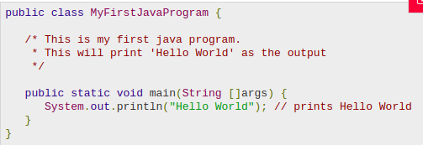
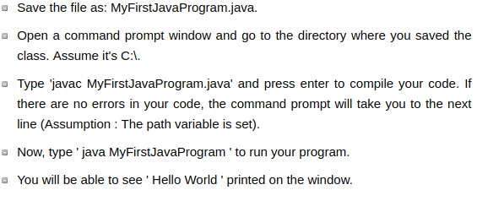

Output
C:\> javac MyFirstJavaProgram.java
C:\> java MyFirstJavaProgram
Hello World

Basic Syntax
-Case Sensitivity
-Class Names − For all class names the first letter should be in Upper Case. If several words are used to form a name of the class, each inner word's first letter should be in Upper Case.
Example: class MyFirstJavaClass
-Method Names − All method names should start with a Lower Case letter. If several words are used to form the name of the method, then each inner word's first letter should be in Upper Case.
Example: public void myMethodName()
-Program File Name − Name of the program file should exactly match the class name.
When saving the file, you should save it using the class name (Remember Java is case sensitive) and append '.java' to the end of the name (if the file name and the class name do not match, your program will not compile).
Example: Assume 'MyFirstJavaProgram' is the class name. Then the file should be saved as 'MyFirstJavaProgram.java'
-public static void main(String args[]) − Java program processing starts from the main() method which is a mandatory part of every Java program.

Java Identifiers
All Java components require names. Names used for classes, variables, and methods are called identifiers.
All identifiers should begin with a letter (A to Z or a to z), currency character ($) or an underscore (_).
- After the first character, identifiers can have any combination of characters.
- A key word cannot be used as an identifier.
- Most importantly, identifiers are case sensitive.
- Examples of legal identifiers: age, $salary, _value, __1_value.
- Examples of illegal identifiers: 123abc, -salary.

Java Modifiers
Like other languages, it is possible to modify classes, methods, etc., by using modifiers. There are two categories of modifiers −
- Access Modifiers − default, public , protected, private
- Non-access Modifiers − final, abstract, strictfp
We will be looking into more details about modifiers in the next section.

Java Enums تتضمن التعدادات
Enums were introduced in Java 5.0. Enums restrict قيد a variable to have one of only a few predefined values. The values in this المعددة enumerated list are called enums.
With the use of enums it is possible to reduce the number of bugs الأخطاء in your code.
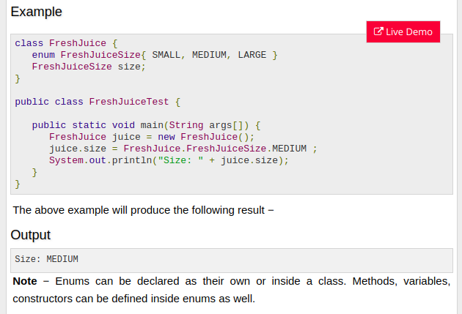

Inheritance
In Java, classes can be derived from classes. Basically, if you need to create a new class and here is already a class that has some of the code you require, then it is possible to derive your new class from the already existing code.
This concept allows you to reuse the fields and methods of the existing class without having to rewrite the code in a new class. In this scenario, the existing class is called the superclass and the derived class is called the subclass.

css Example
Css Example

css Example
Css Example

css Example
Css Example

https://www.tutorialspoint.com/java/java_object_classes.htm

