**Traffic Sign Classifier**

The goals / steps of this project are the following:

* Load the data set (see below for links to the project data set)
* Explore, summarize, and visualize the data set
* Design, train and test a model architecture
* Use the model to make predictions on new images
* Analyze the softmax probabilities of the new images
* Summarize the results with a written report

**Data Set Summary and exploration**

1. **Provide a basic summary of the data set**

I have loaded the training, validation and testing data set using pickle python library and numpy library to calculate the unique classes/labels for the traffic signs, then calculated some basic information about the traffic signs data set:

* The size of the training set is **34799 images**
* The size of the validation set is **12630 images**
* The size of the testing set is **4410 images**
* The shape of a traffic sign image is **(32x32x3)**
* The number of unique classes/labels in the data set is **43**

1. **Include an exploratory visualization of the dataset**

Here is an exploratory visualization of samples for the training data set.

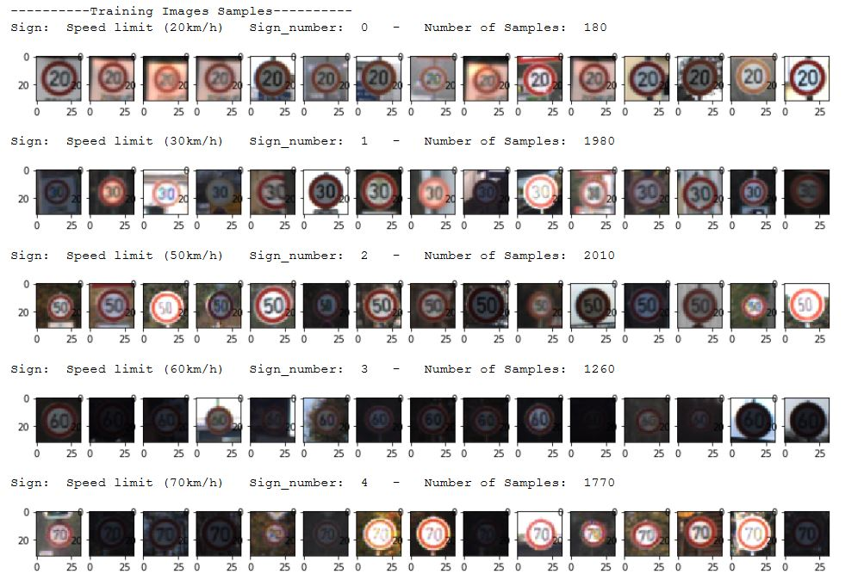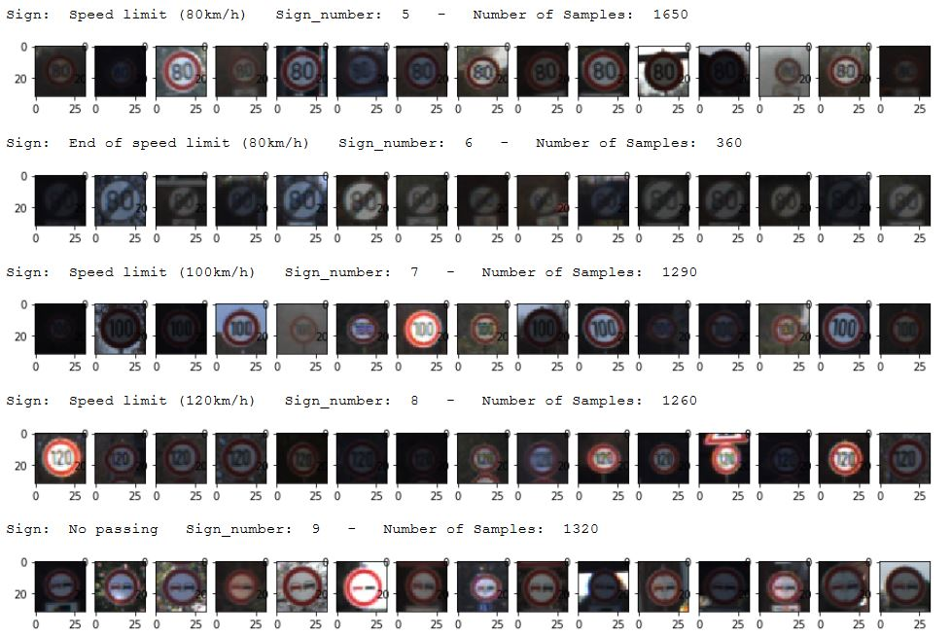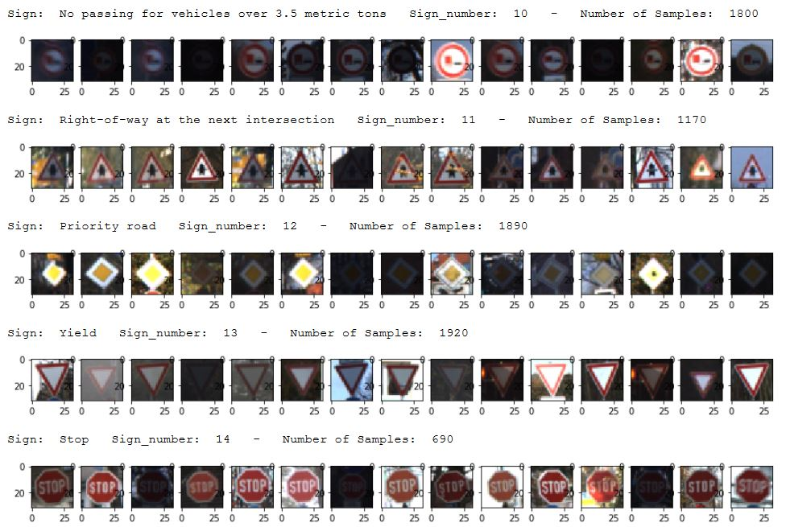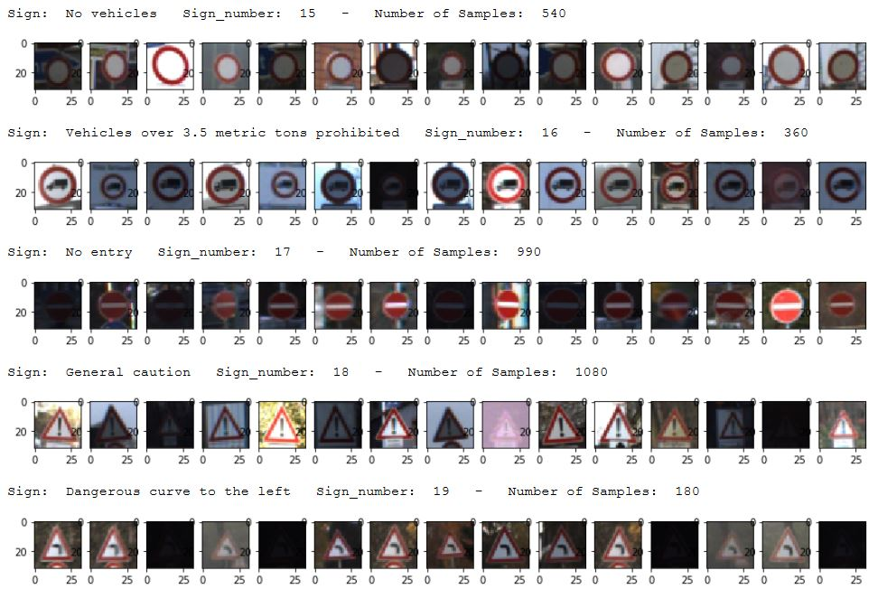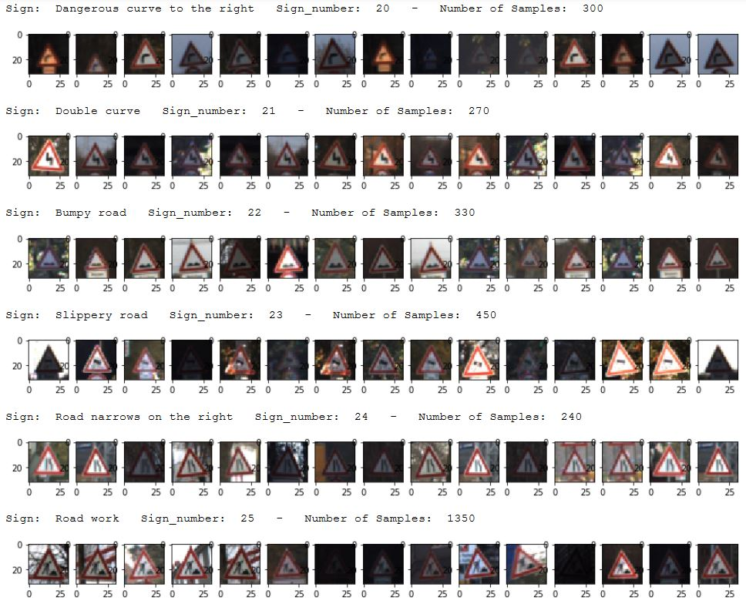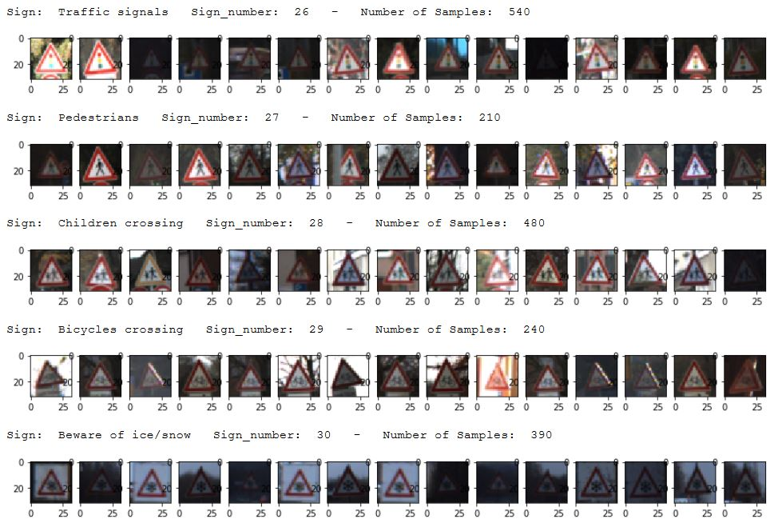 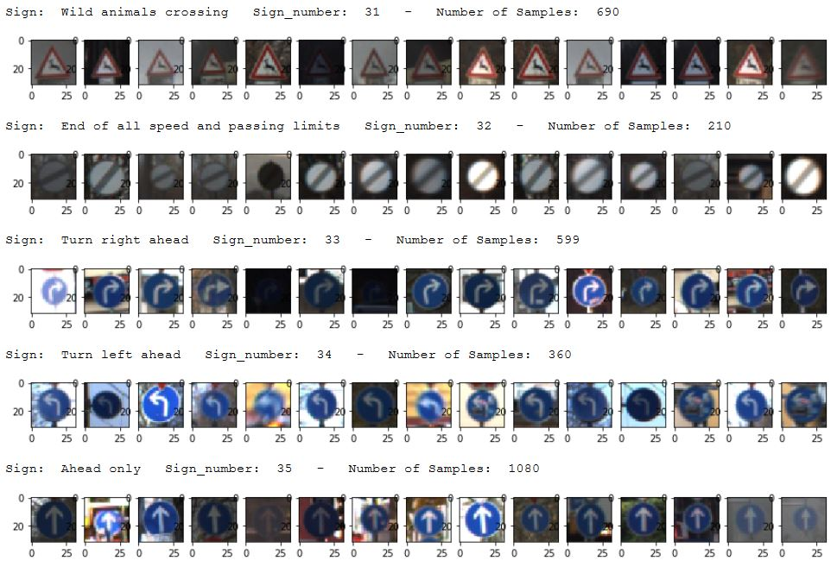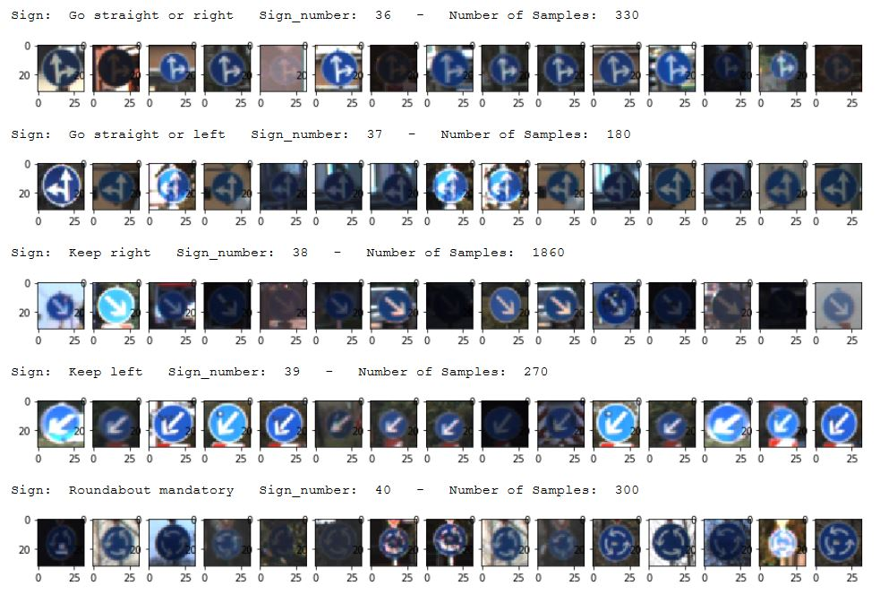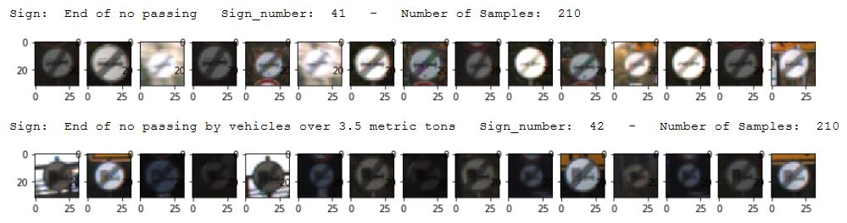

Here a bar chart or a histogram for the training data that shows the number of images in each traffic sign label:

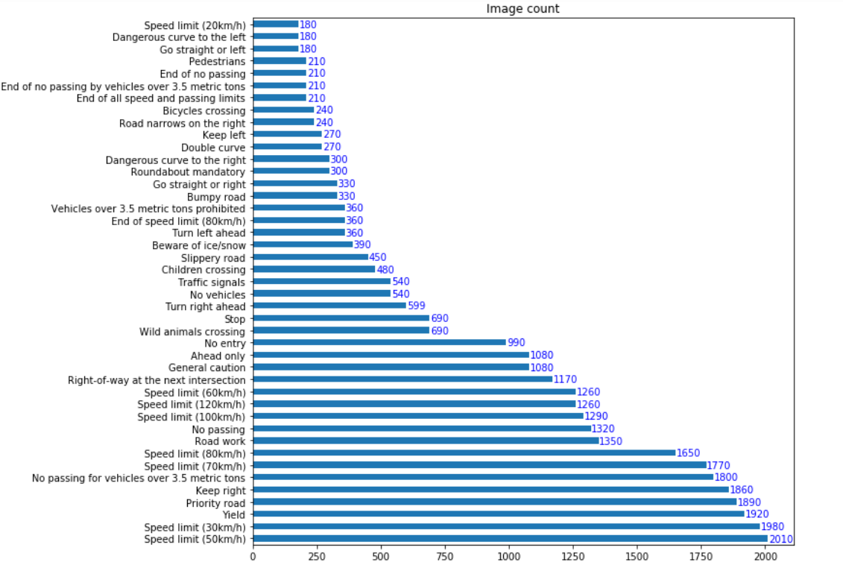

Here a bar chart or a histogram for the validation data that shows the number of images in each traffic sign label:

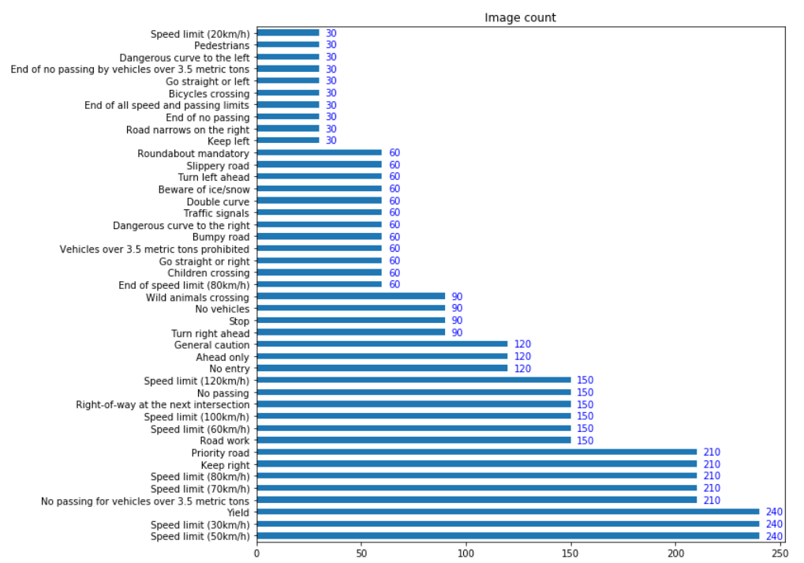

Here a bar chart or a histogram for the testing data that shows the number of images in each traffic sign label:

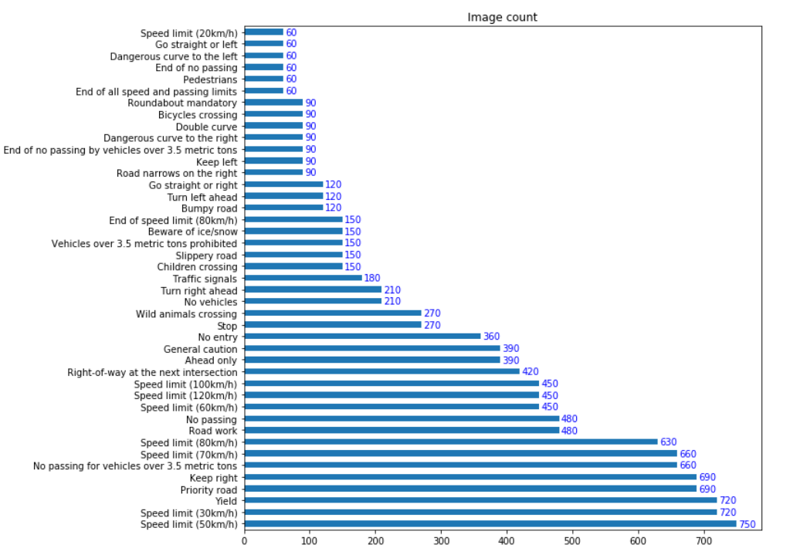

**Design and test the Model Architecture**

1. **Preprocessing phase**

As a first step, I decided to convert the images to grayscale this in order to remove the color information from the images for the aim of generalization well for these images. Here is an exploratory visualization of samples for the training data set after the grayscale conversion for the images.

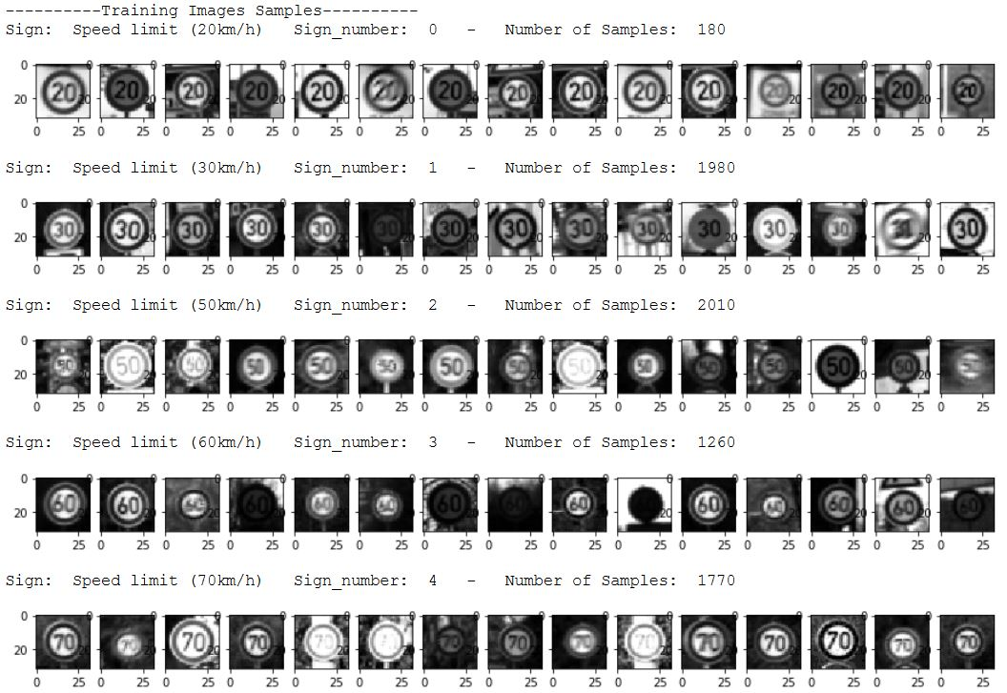 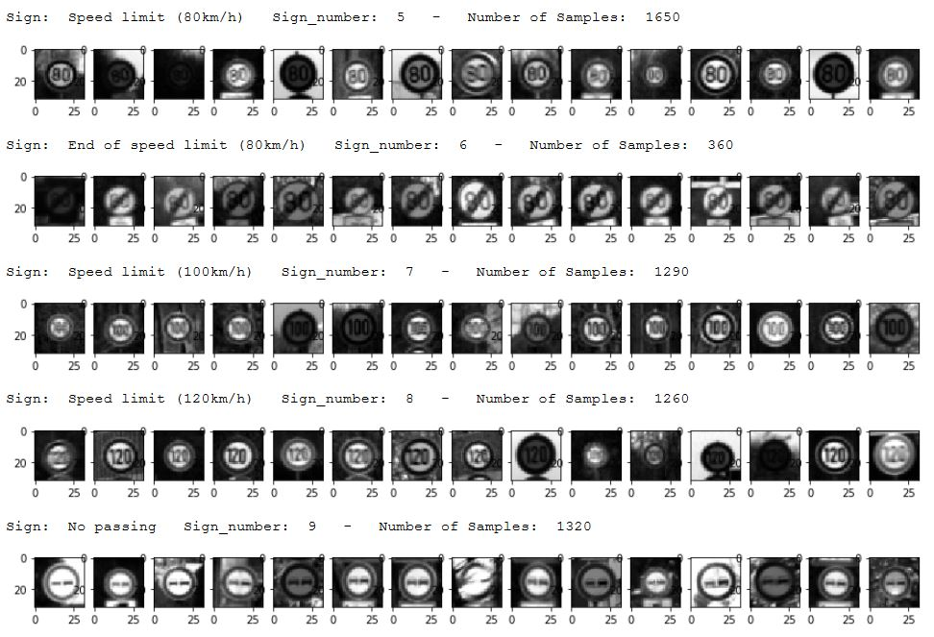 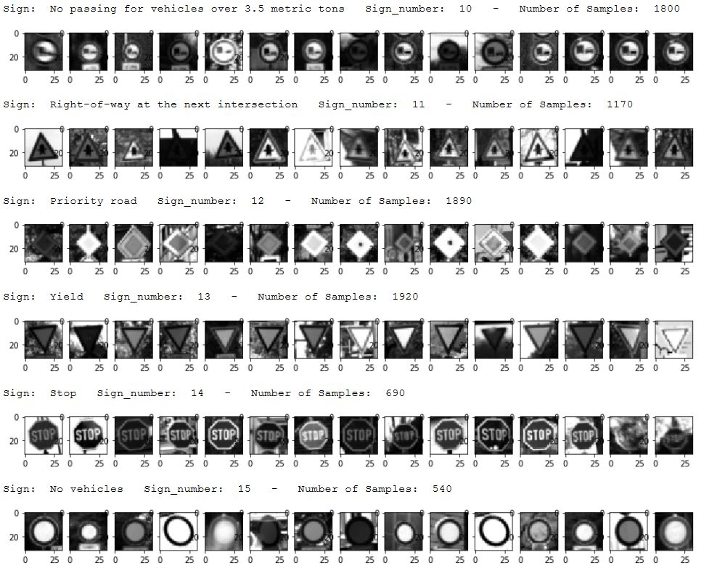 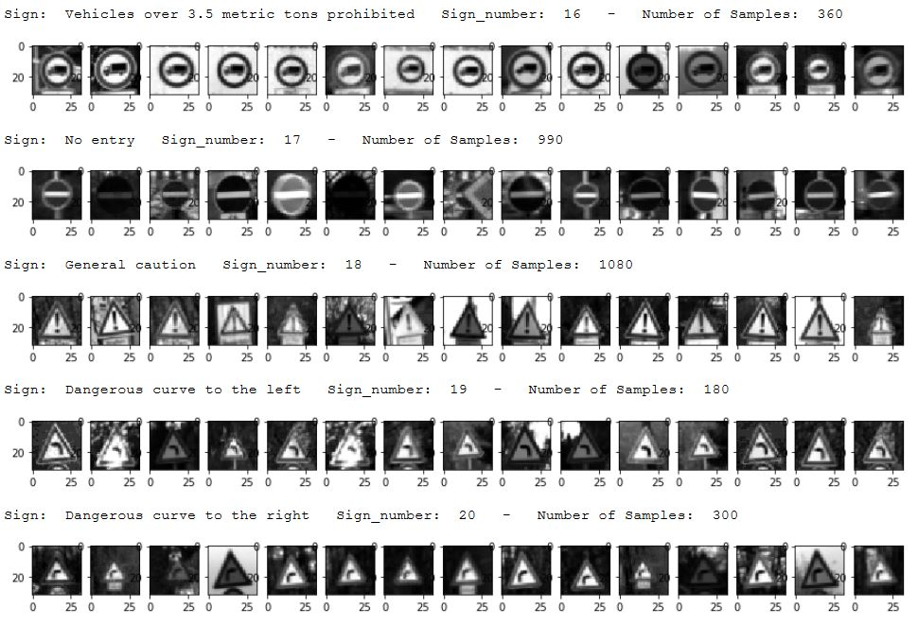 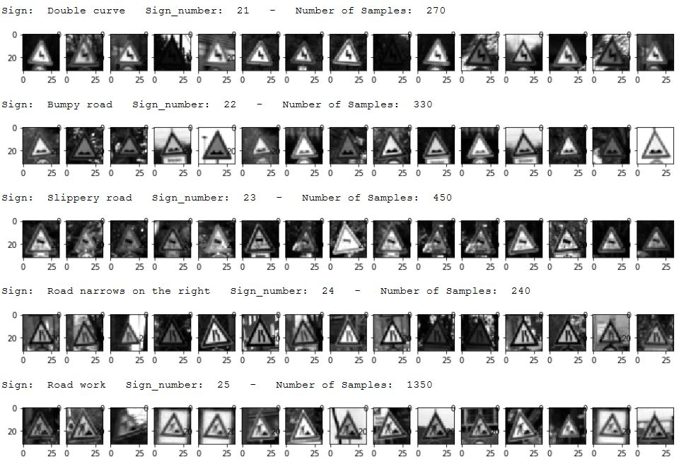 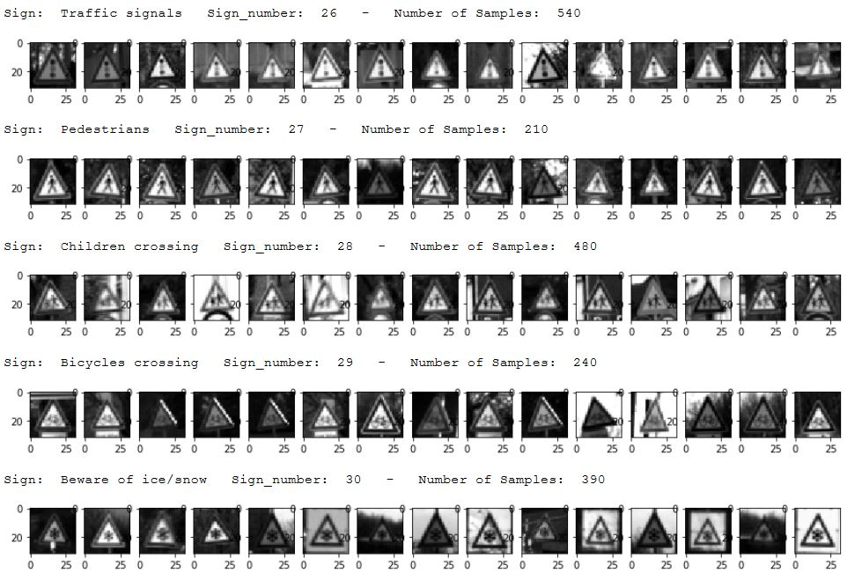 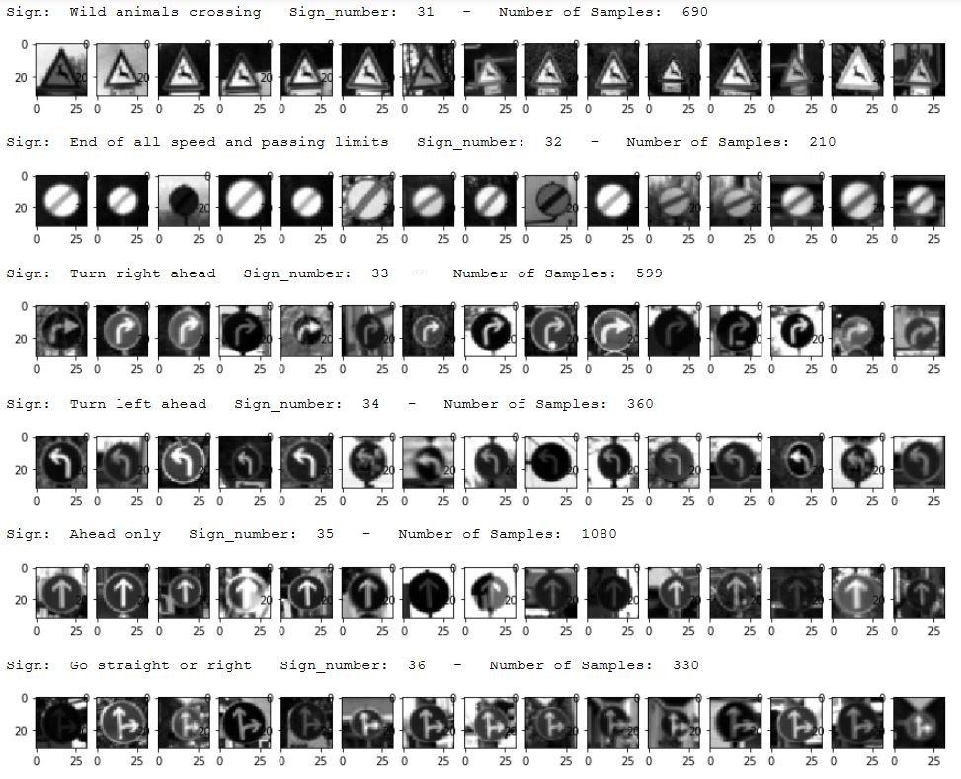 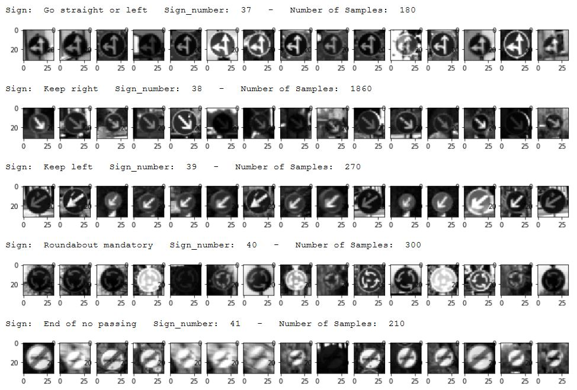 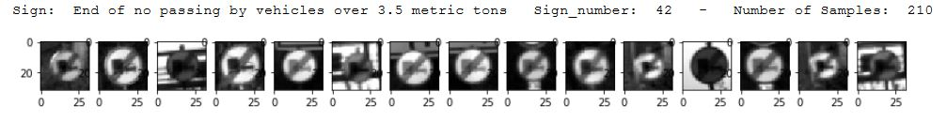

As a last step, I normalized the image data in order to achieve the same distribution for the whole data which means that the whole data will have the same mean, and variance values.

1. **Final Value Architecture**

As we know that the LeNet is considered as a strong base for the task of traffic sign classifications, so I used LeNet as a basic implementation for the final architecture with adding some modifications as we will see.

My final model consists of the following layers:

|  |  |
| --- | --- |
| **Layer** | **Description** |
| ­Input | 32x32x1 grayscale image |
| Convolution 5x5 | 1x1 stride, Valid padding, outputs 28x28x48 |
| RELU | Activation Function |
| Max pooling | 2x2 stride, outputs 14x14x48 |
| Dropout Regularization | Keep probability = 0.5 |
| Convolution 5x5 | 1x1 stride, Valid padding, outputs 10x10x96 |
| RELU | Activation Function |
| Max pooling | 2x2 stride, outputs 5x5x96 |
| Dropout Regularization | Keep probability = 0.5 |
| Convolution 5x5 | 1x1 stride, Valid padding, outputs 3x3x172 |
| RELU | Activation Function |
| Max pooling | 2x2 stride, outputs 2x2x172 |
| Flatten | Flatten 2x2x172 to be 688 |
| Dropout Regularization | Keep probability = 0.5 |
| Fully Connected | Outputs 84 |
| RELU | Activation Function |
| Dropout Regularization | Keep probability = 0.5 |
| Fully Connected | Outputs 43 (number of classes) |

1. **Description for how the model was trained**

To train the model, I used the following:

* Adam Optimizer with learning rate = **0.0009**
* Batch Size = 128
* Number of epochs = 35
* Keep\_prob = 0.5
* Hyper parameters: miu = 0, sigma = 0.1 for the truncated normal initialization of weights.

1. **Description for the approach for finding the solution**

The approach taken for finding a solution and getting the validation set accuracy to be at least 0.93 is LeNet with some modifications done like: the preprocessing over the input data set, adding a new convolution layer before the concatenation, adding a dropout regularization factor at each layer in the model. We have done some modifications on the LeNet architecture because the accuracy of the validation data set was less than 0.93

My final model results accuracies can be summarized as follows:

* Training set accuracy of **0.999**
* Validation set accuracy of **0.982**1
* Testing set accuracy of **0.963**

These accuracies are calculated in **(Train, Validate and Test the Model)** cells in the IPython notebook.

As this approach depends on LeNet approach, this means that the number of steps needed for this step to converge will be near to its steps. In addition to that, I have run the model initially with larger number of steps, then waited for the accuracies to saturate on a certain value. After that, I have noticed the steps needed to start saturation. This means that I have used the **Early Stopping** approach for choosing the steps number.

**Test the model on New Images**

1. **Choose five German traffic signs**

Here are some German traffic signs that I found on the web:

**C:\Nano-Degree_Self_Driving_Car\Project_2_Traffic_Sign_Classifier\CarND-Traffic-Sign-Classifier-Project\Testing_Images\40-1.PNGC:\Nano-Degree_Self_Driving_Car\Project_2_Traffic_Sign_Classifier\CarND-Traffic-Sign-Classifier-Project\Testing_Images\38-3.PNGC:\Nano-Degree_Self_Driving_Car\Project_2_Traffic_Sign_Classifier\CarND-Traffic-Sign-Classifier-Project\Testing_Images\38-1.PNGC:\Nano-Degree_Self_Driving_Car\Project_2_Traffic_Sign_Classifier\CarND-Traffic-Sign-Classifier-Project\Testing_Images\37-1.PNGC:\Nano-Degree_Self_Driving_Car\Project_2_Traffic_Sign_Classifier\CarND-Traffic-Sign-Classifier-Project\Testing_Images\36-1.PNGC:\Nano-Degree_Self_Driving_Car\Project_2_Traffic_Sign_Classifier\CarND-Traffic-Sign-Classifier-Project\Testing_Images\35-1.PNGC:\Nano-Degree_Self_Driving_Car\Project_2_Traffic_Sign_Classifier\CarND-Traffic-Sign-Classifier-Project\Testing_Images\32-1.PNGC:\Nano-Degree_Self_Driving_Car\Project_2_Traffic_Sign_Classifier\CarND-Traffic-Sign-Classifier-Project\Testing_Images\31-1.PNGC:\Nano-Degree_Self_Driving_Car\Project_2_Traffic_Sign_Classifier\CarND-Traffic-Sign-Classifier-Project\Testing_Images\25-2.PNGC:\Nano-Degree_Self_Driving_Car\Project_2_Traffic_Sign_Classifier\CarND-Traffic-Sign-Classifier-Project\Testing_Images\19-1.PNGC:\Nano-Degree_Self_Driving_Car\Project_2_Traffic_Sign_Classifier\CarND-Traffic-Sign-Classifier-Project\Testing_Images\18-3.PNGC:\Nano-Degree_Self_Driving_Car\Project_2_Traffic_Sign_Classifier\CarND-Traffic-Sign-Classifier-Project\Testing_Images\18-1.PNGC:\Nano-Degree_Self_Driving_Car\Project_2_Traffic_Sign_Classifier\CarND-Traffic-Sign-Classifier-Project\Testing_Images\17-1.PNGC:\Nano-Degree_Self_Driving_Car\Project_2_Traffic_Sign_Classifier\CarND-Traffic-Sign-Classifier-Project\Testing_Images\14-1.PNGC:\Nano-Degree_Self_Driving_Car\Project_2_Traffic_Sign_Classifier\CarND-Traffic-Sign-Classifier-Project\Testing_Images\13-1.PNGC:\Nano-Degree_Self_Driving_Car\Project_2_Traffic_Sign_Classifier\CarND-Traffic-Sign-Classifier-Project\Testing_Images\12-3.PNGC:\Nano-Degree_Self_Driving_Car\Project_2_Traffic_Sign_Classifier\CarND-Traffic-Sign-Classifier-Project\Testing_Images\12-1.PNGC:\Nano-Degree_Self_Driving_Car\Project_2_Traffic_Sign_Classifier\CarND-Traffic-Sign-Classifier-Project\Testing_Images\11-2.PNGC:\Nano-Degree_Self_Driving_Car\Project_2_Traffic_Sign_Classifier\CarND-Traffic-Sign-Classifier-Project\Testing_Images\11-1.PNGC:\Nano-Degree_Self_Driving_Car\Project_2_Traffic_Sign_Classifier\CarND-Traffic-Sign-Classifier-Project\Testing_Images\9-2.PNGC:\Nano-Degree_Self_Driving_Car\Project_2_Traffic_Sign_Classifier\CarND-Traffic-Sign-Classifier-Project\Testing_Images\9-1.PNGC:\Nano-Degree_Self_Driving_Car\Project_2_Traffic_Sign_Classifier\CarND-Traffic-Sign-Classifier-Project\Testing_Images\7-1.PNGC:\Nano-Degree_Self_Driving_Car\Project_2_Traffic_Sign_Classifier\CarND-Traffic-Sign-Classifier-Project\Testing_Images\3-1.PNGC:\Nano-Degree_Self_Driving_Car\Project_2_Traffic_Sign_Classifier\CarND-Traffic-Sign-Classifier-Project\Testing_Images\2-1.PNGC:\Nano-Degree_Self_Driving_Car\Project_2_Traffic_Sign_Classifier\CarND-Traffic-Sign-Classifier-Project\Testing_Images\1-1.PNGC:\Nano-Degree_Self_Driving_Car\Project_2_Traffic_Sign_Classifier\CarND-Traffic-Sign-Classifier-Project\Testing_Images\0-1.PNG**

1. **Model’s Prediction**

Here are the results of the prediction:

|  |  |
| --- | --- |
| **Image** | **Prediction** |
| **Speed limit (20km/h) C:\Nano-Degree_Self_Driving_Car\Project_2_Traffic_Sign_Classifier\CarND-Traffic-Sign-Classifier-Project\Testing_Images\0-1.PNG** | **Speed limit (20km/h) C:\Nano-Degree_Self_Driving_Car\Project_2_Traffic_Sign_Classifier\CarND-Traffic-Sign-Classifier-Project\Testing_Images\0-1.PNG** |
| **Speed limit (30km/h) C:\Nano-Degree_Self_Driving_Car\Project_2_Traffic_Sign_Classifier\CarND-Traffic-Sign-Classifier-Project\Testing_Images\1-1.PNG** | **Speed limit (30km/h) C:\Nano-Degree_Self_Driving_Car\Project_2_Traffic_Sign_Classifier\CarND-Traffic-Sign-Classifier-Project\Testing_Images\1-1.PNG** |
| **Speed limit (50km/h) C:\Nano-Degree_Self_Driving_Car\Project_2_Traffic_Sign_Classifier\CarND-Traffic-Sign-Classifier-Project\Testing_Images\2-1.PNG** | **Speed limit (50km/h) C:\Nano-Degree_Self_Driving_Car\Project_2_Traffic_Sign_Classifier\CarND-Traffic-Sign-Classifier-Project\Testing_Images\2-1.PNG** |
| **Speed limit (60km/h) C:\Nano-Degree_Self_Driving_Car\Project_2_Traffic_Sign_Classifier\CarND-Traffic-Sign-Classifier-Project\Testing_Images\3-1.PNG** | **Speed limit (60km/h) C:\Nano-Degree_Self_Driving_Car\Project_2_Traffic_Sign_Classifier\CarND-Traffic-Sign-Classifier-Project\Testing_Images\3-1.PNG** |
| **Speed limit (100km/h) C:\Nano-Degree_Self_Driving_Car\Project_2_Traffic_Sign_Classifier\CarND-Traffic-Sign-Classifier-Project\Testing_Images\7-1.PNG** | **Speed limit (80km/h)** |
| **No passing C:\Nano-Degree_Self_Driving_Car\Project_2_Traffic_Sign_Classifier\CarND-Traffic-Sign-Classifier-Project\Testing_Images\9-1.PNG** | **No passing C:\Nano-Degree_Self_Driving_Car\Project_2_Traffic_Sign_Classifier\CarND-Traffic-Sign-Classifier-Project\Testing_Images\9-1.PNG** |
| **No passing C:\Nano-Degree_Self_Driving_Car\Project_2_Traffic_Sign_Classifier\CarND-Traffic-Sign-Classifier-Project\Testing_Images\9-2.PNG** | **No passing C:\Nano-Degree_Self_Driving_Car\Project_2_Traffic_Sign_Classifier\CarND-Traffic-Sign-Classifier-Project\Testing_Images\9-2.PNG** |
| **Right-of-way at  the next Intersection C:\Nano-Degree_Self_Driving_Car\Project_2_Traffic_Sign_Classifier\CarND-Traffic-Sign-Classifier-Project\Testing_Images\11-1.PNG** | **Right-of-way at  the next Intersection C:\Nano-Degree_Self_Driving_Car\Project_2_Traffic_Sign_Classifier\CarND-Traffic-Sign-Classifier-Project\Testing_Images\11-1.PNG** |
| **Right-of-way at  the next Intersection C:\Nano-Degree_Self_Driving_Car\Project_2_Traffic_Sign_Classifier\CarND-Traffic-Sign-Classifier-Project\Testing_Images\11-2.PNG** | **Right-of-way at  the next Intersection C:\Nano-Degree_Self_Driving_Car\Project_2_Traffic_Sign_Classifier\CarND-Traffic-Sign-Classifier-Project\Testing_Images\11-2.PNG** |
| **Priority Road C:\Nano-Degree_Self_Driving_Car\Project_2_Traffic_Sign_Classifier\CarND-Traffic-Sign-Classifier-Project\Testing_Images\12-1.PNG** | **Priority Road C:\Nano-Degree_Self_Driving_Car\Project_2_Traffic_Sign_Classifier\CarND-Traffic-Sign-Classifier-Project\Testing_Images\12-1.PNG** |
| **Priority Road C:\Nano-Degree_Self_Driving_Car\Project_2_Traffic_Sign_Classifier\CarND-Traffic-Sign-Classifier-Project\Testing_Images\12-3.PNG** | **Priority Road C:\Nano-Degree_Self_Driving_Car\Project_2_Traffic_Sign_Classifier\CarND-Traffic-Sign-Classifier-Project\Testing_Images\12-3.PNG** |
| **Yield C:\Nano-Degree_Self_Driving_Car\Project_2_Traffic_Sign_Classifier\CarND-Traffic-Sign-Classifier-Project\Testing_Images\13-1.PNG** | **Yield C:\Nano-Degree_Self_Driving_Car\Project_2_Traffic_Sign_Classifier\CarND-Traffic-Sign-Classifier-Project\Testing_Images\13-1.PNG** |
| **Stop C:\Nano-Degree_Self_Driving_Car\Project_2_Traffic_Sign_Classifier\CarND-Traffic-Sign-Classifier-Project\Testing_Images\14-1.PNG** | **Stop C:\Nano-Degree_Self_Driving_Car\Project_2_Traffic_Sign_Classifier\CarND-Traffic-Sign-Classifier-Project\Testing_Images\14-1.PNG** |
| **No Entry C:\Nano-Degree_Self_Driving_Car\Project_2_Traffic_Sign_Classifier\CarND-Traffic-Sign-Classifier-Project\Testing_Images\17-1.PNG** | **No Entry C:\Nano-Degree_Self_Driving_Car\Project_2_Traffic_Sign_Classifier\CarND-Traffic-Sign-Classifier-Project\Testing_Images\17-1.PNG** |
| **General caution C:\Nano-Degree_Self_Driving_Car\Project_2_Traffic_Sign_Classifier\CarND-Traffic-Sign-Classifier-Project\Testing_Images\18-1.PNG** | **General caution C:\Nano-Degree_Self_Driving_Car\Project_2_Traffic_Sign_Classifier\CarND-Traffic-Sign-Classifier-Project\Testing_Images\18-1.PNG** |
| **General caution C:\Nano-Degree_Self_Driving_Car\Project_2_Traffic_Sign_Classifier\CarND-Traffic-Sign-Classifier-Project\Testing_Images\18-3.PNG** | **General caution C:\Nano-Degree_Self_Driving_Car\Project_2_Traffic_Sign_Classifier\CarND-Traffic-Sign-Classifier-Project\Testing_Images\18-3.PNG** |
| **Dangerous curve to the left C:\Nano-Degree_Self_Driving_Car\Project_2_Traffic_Sign_Classifier\CarND-Traffic-Sign-Classifier-Project\Testing_Images\19-1.PNG** | **Dangerous curve to the left C:\Nano-Degree_Self_Driving_Car\Project_2_Traffic_Sign_Classifier\CarND-Traffic-Sign-Classifier-Project\Testing_Images\19-1.PNG** |
| **Road Work C:\Nano-Degree_Self_Driving_Car\Project_2_Traffic_Sign_Classifier\CarND-Traffic-Sign-Classifier-Project\Testing_Images\25-2.PNG** | **Road Work C:\Nano-Degree_Self_Driving_Car\Project_2_Traffic_Sign_Classifier\CarND-Traffic-Sign-Classifier-Project\Testing_Images\25-2.PNG** |
| **Wild Animal crossing C:\Nano-Degree_Self_Driving_Car\Project_2_Traffic_Sign_Classifier\CarND-Traffic-Sign-Classifier-Project\Testing_Images\31-1.PNG** | **Wild Animal crossing C:\Nano-Degree_Self_Driving_Car\Project_2_Traffic_Sign_Classifier\CarND-Traffic-Sign-Classifier-Project\Testing_Images\31-1.PNG** |
| **End of all speed and passing limit C:\Nano-Degree_Self_Driving_Car\Project_2_Traffic_Sign_Classifier\CarND-Traffic-Sign-Classifier-Project\Testing_Images\32-1.PNG** | **End of all speed and passing limit C:\Nano-Degree_Self_Driving_Car\Project_2_Traffic_Sign_Classifier\CarND-Traffic-Sign-Classifier-Project\Testing_Images\32-1.PNG** |
| **Ahead only C:\Nano-Degree_Self_Driving_Car\Project_2_Traffic_Sign_Classifier\CarND-Traffic-Sign-Classifier-Project\Testing_Images\35-1.PNG** | **Ahead only C:\Nano-Degree_Self_Driving_Car\Project_2_Traffic_Sign_Classifier\CarND-Traffic-Sign-Classifier-Project\Testing_Images\35-1.PNG** |
| **Go straight or right C:\Nano-Degree_Self_Driving_Car\Project_2_Traffic_Sign_Classifier\CarND-Traffic-Sign-Classifier-Project\Testing_Images\36-1.PNG** | **Go straight or right C:\Nano-Degree_Self_Driving_Car\Project_2_Traffic_Sign_Classifier\CarND-Traffic-Sign-Classifier-Project\Testing_Images\36-1.PNG** |
| **Go straight or left C:\Nano-Degree_Self_Driving_Car\Project_2_Traffic_Sign_Classifier\CarND-Traffic-Sign-Classifier-Project\Testing_Images\37-1.PNG** | **Go straight or left C:\Nano-Degree_Self_Driving_Car\Project_2_Traffic_Sign_Classifier\CarND-Traffic-Sign-Classifier-Project\Testing_Images\37-1.PNG** |
| **Keep Right C:\Nano-Degree_Self_Driving_Car\Project_2_Traffic_Sign_Classifier\CarND-Traffic-Sign-Classifier-Project\Testing_Images\38-1.PNG** | **Keep Right C:\Nano-Degree_Self_Driving_Car\Project_2_Traffic_Sign_Classifier\CarND-Traffic-Sign-Classifier-Project\Testing_Images\38-1.PNG** |
| **Keep Right C:\Nano-Degree_Self_Driving_Car\Project_2_Traffic_Sign_Classifier\CarND-Traffic-Sign-Classifier-Project\Testing_Images\38-3.PNG** | **General caution C:\Nano-Degree_Self_Driving_Car\Project_2_Traffic_Sign_Classifier\CarND-Traffic-Sign-Classifier-Project\Testing_Images\18-1.PNG** |
| **Roundabout mandatory C:\Nano-Degree_Self_Driving_Car\Project_2_Traffic_Sign_Classifier\CarND-Traffic-Sign-Classifier-Project\Testing_Images\40-1.PNG** | **Roundabout mandatory C:\Nano-Degree_Self_Driving_Car\Project_2_Traffic_Sign_Classifier\CarND-Traffic-Sign-Classifier-Project\Testing_Images\40-1.PNG** |

The model was able to correctly guess **24 of the 26 traffic signs**, which gives an accuracy of **0.923%**

I have a justification for the second keep right sign which isC:\Nano-Degree_Self_Driving_Car\Project_2_Traffic_Sign_Classifier\CarND-Traffic-Sign-Classifier-Project\Testing_Images\38-3.PNG. The image doesn’t concentrate on the traffic sign itself due to the presence of some background, but the background is not the root cause of that. The root cause is the traffic sign features didn’t extracted well. It is obvious that the first keep right traffic sign C:\Nano-Degree_Self_Driving_Car\Project_2_Traffic_Sign_Classifier\CarND-Traffic-Sign-Classifier-Project\Testing_Images\38-1.PNG is predicted well as the image is concise over the traffic sign itself.

1. **Softmax Predictions for the additional Images**

For the first image, the model is relatively sure that this is a Speed limit(20km/h) (probability of **0.96769**), and the image does contain a Speed limit(20km/h). The top five soft max probabilities were

|  |  |
| --- | --- |
| **Probability** | **Prediction** |
| **0.96769** | Speed limit (20km/h) |
| **0.0193717** | General caution |
| **0.007938** | Speed limit (70km/h) |
| **0.004328** | Speed limit (30km/h) |
| **0.00029531** | Speed limit (60km/h) |

For the Second image, the model is relatively sure that this is a Speed limit(30km/h) (probability of **0.99493**), and the image does contain a Speed limit(30km/h). The top five soft max probabilities were

|  |  |
| --- | --- |
| **Probability** | **Prediction** |
| **0.99493** | Speed limit (30km/h) |
| **0.004** | Speed limit (20km/h) |
| **0.005047** | Speed limit (50km/h) |
| **0.0001277** | Roundabout mandatory |
| **8.55640101e-05** | Speed limit (70km/h) |

For the third image, the model is relatively sure that this is a Right-of-way at the next intersection sign (probability of **0.9999**), and the image does contain a Right-of-way at the next intersection. The top five soft max probabilities were

|  |  |
| --- | --- |
| **Probability** | **Prediction** |
| **0.9999** | Right-of-way at the next intersection |
| **2.43023851e-06** | Beware of ice/snow |
| **4.49315030e-10** | Pedestrians |
| **4.44944483e-13** | Double curve |
| **2.40414432e-13** | Roundabout mandatory |

For the fourth image, the model is relatively sure that this is a Right-of-way at the next intersection sign (probability of **1.0**), and the image does contain a Right-of-way at the next intersection. The top five soft max probabilities were

|  |  |
| --- | --- |
| **Probability** | **Prediction** |
| **1.0** | Right-of-way at the next intersection |
| **9.69679476e-11** | Beware of ice/snow |
| **3.84142825e-15** | Pedestrians |
| **1.43944305e-18** | Roundabout mandatory |
| **2.32028039e-19** | Double curve |

For the fifth image, the model is relatively sure that this is a Priority road sign (probability of **1.0**), and the image does contain a Priority road sign. The top five soft max probabilities were

|  |  |
| --- | --- |
| **Probability** | **Prediction** |
| **1.0** | Priority road |
| **2.74372077e-16** | Roundabout mandatory |
| **1.23394802e-18** | Road work |
| **2.26647811e-20** | Keep right |
| **3.49877876e-24** | Keep left |

For the sixth image, the model is relatively sure that this is a Priority road sign (probability of **1.0**), and the image does contain a Priority road sign. The top five soft max probabilities were

|  |  |
| --- | --- |
| **Probability** | **Prediction** |
| **1.0** | Priority road |
| **8.47423211e-18** | Roundabout mandatory |
| **1.49669254e-18** | Road work |
| **7.79239396e-19** | Keep right |
| **5.85889120e-21** | Yield |

For the seventh image, the model is relatively sure that this is a Yield sign (probability of **1.0**), and the image does contain a Yield sign. The top five soft max probabilities were

|  |  |
| --- | --- |
| **Probability** | **Prediction** |
| **1.0** | Yield |
| **1.69595591e-25** | No vehicles |
| **2.59372747e-27** | Priority road |
| **1.18212888e-29** | Speed limit (50km/h) |
| **2.15729591e-31** | Speed limit (30km/h) |

For the eighth image, the model is relatively sure that this is a stop sign (probability of **0.49755**), and the image does contain a stop sign. The top five soft max probabilities were

|  |  |
| --- | --- |
| **Probability** | **Prediction** |
| **0.49755** | Stop |
| **0.16801** | Speed limit (30km/h) |
| **0.0499336496** | Turn left ahead |
| **0.0471831486** | Speed limit (120km/h) |
| **0.0454424061** | Speed limit (60km/h) |

For the ninth image, the model is relatively sure that this is a No entry sign (probability of **0.99692**), and the image does contain a No entry sign. The top five soft max probabilities were

|  |  |
| --- | --- |
| **Probability** | **Prediction** |
| **0.996919751** | No entry |
| **0.00308020669** | Stop |
| **4.36346888e-08** | No passing |
| **1.07657492e-08** | Ahead only |
| **5.90702265e-10** | Speed limit (120km/h) |

For the tenth image, the model is relatively sure that this is a General caution sign (probability of **1.0**), and the image does contain a General caution sign. The top five soft max probabilities were

|  |  |
| --- | --- |
| **Probability** | **Prediction** |
| **1.0** | General caution |
| **4.16148854e-15** | Traffic signals |
| **4.28877133e-17** | Pedestrians |
| **8.97829721e-20** | Right-of-way at the next intersection |
| **1.06401759e-26** | Road work |

For the eleventh image, the model is relatively sure that this is a Speed General caution sign (probability of **1.0**), and the image does contain a General caution sign. The top five soft max probabilities were

|  |  |
| --- | --- |
| **Probability** | **Prediction** |
| **1.0** | General caution |
| **2.67478573e-08** | Traffic signals |
| **7.99735833e-11** | Pedestrians |
| **8.34462274e-13** | Right-of-way at the next intersection |
| **3.24678354e-13** | Bicycles crossing |

For the twelfth image, the model is relatively sure that this is a Dangerous curve to the left sign (probability of **0.9999**), and the image does contain a Dangerous curve to the left sign. The top five soft max probabilities were

|  |  |
| --- | --- |
| **Probability** | **Prediction** |
| **0.9999** | Dangerous curve to the left |
| **3.09776794e-07** | Slippery road |
| **5.50884172e-10** | Wild animals crossing |
| **1.25654114e-11** | Speed limit (20km/h) |
| **1.23513170e-11** | Double curve |

For the thirteenth image, the model is relatively sure that this is a Speed limit sign (50km/h) (probability of **0.7969**), and the image does contain a Speed limit sign(50km/h). The top five soft max probabilities were

|  |  |
| --- | --- |
| **Probability** | **Prediction** |
| **0.7969** | Speed limit (50km/h) |
| **0.104977034** | Speed limit (80km/h) |
| **0.0869150609** | Speed limit (30km/h) |
| **0.0107664894** | Speed limit (60km/h) |
| **0.000224919611** | Roundabout mandatory |

For the fourteenth image, the model is relatively sure that this is a Road work Sign (probability of **0.9998**), and the image does contain a Road work Sign. The top five soft max probabilities were

|  |  |
| --- | --- |
| **Probability** | **Prediction** |
| **0.9998** | Road work |
| **1.67459773e-04** | Right-of-way at the next intersection |
| **8.39789118e-06** | Double curve |
| **1.20701941e-07** | Beware of ice/snow |
| **1.03107675e-10** | Dangerous curve to the right |

For the fifteenth image, the model is relatively sure that this is a Speed limit(60km/h) (probability of **0.99937**), and the image does contain a Speed limit(60km/h). The top five soft max probabilities were

|  |  |
| --- | --- |
| **Probability** | **Prediction** |
| **0.99937** | Speed limit (60km/h) |
| **6.28302980e-04** | Speed limit (80km/h) |
| **5.81938693e-08** | Speed limit (50km/h) |
| **2.87324369e-08** | No passing |
| **2.38498945e-08** | Speed limit (120km/h) |

For the sixteenth image, the model is relatively sure that this is a Wild animals crossing sign (probability of **0.98542**), and the image does contain a Wild animals crossing sign. The top five soft max probabilities were

|  |  |
| --- | --- |
| **Probability** | **Prediction** |
| **0.98542** | Wild animals crossing |
| **0.0139779979** | Slippery road |
| **5.91569638e-04** | Dangerous curve to the left |
| **1.42527222e-06** | Double curve |
| **1.72659441e-07** | Bicycles crossing |

For the seventeenth image, the model is relatively sure that this is an End of all speed and passing limits sign (probability of **0.99861**), and the image does contain an End of all speed and passing limits sign. The top five soft max probabilities were

|  |  |
| --- | --- |
| **Probability** | **Prediction** |
| **0.99861** | End of all speed and passing limits |
| **0.00134721084** | End of no passing |
| **3.22560481e-05** | End of speed limit (80km/h) |
| **2.85940268e-06** | General caution |
| **2.28997328e-06** | Speed limit (60km/h) |

For the eighteenth image, the model is relatively sure that this is Ahead only sign (probability of **1.0**), and the image does contain Ahead only sign. The top five soft max probabilities were

|  |  |
| --- | --- |
| **Probability** | **Prediction** |
| **1.0** | Ahead only |
| **7.64093717e-14** | Turn left ahead |
| **2.06057841e-14** | Speed limit (60km/h) |
| **3.82535749e-15** | Right-of-way at the next intersection |
| **1.90298742e-15** | Go straight or right |

For the nineteenth image, the model is relatively sure that this is a Go straight or right sign (probability of **1.0**), and the image does contain a Go straight or right sign. The top five soft max probabilities were

|  |  |
| --- | --- |
| **Probability** | **Prediction** |
| **1.0** | Go straight or right |
| **9.02706176e-09** | Ahead only |
| **3.07771114e-10** | Turn left ahead |
| **2.03696074e-10** | End of all speed and passing limits |
| **3.34314867e-11** | Children crossing |

For the twentieth image, the model is relatively sure that this is a Speed Go straight or left sign (probability of **1.0**), and the image does contain a Go straight or left sign. The top five soft max probabilities were

|  |  |
| --- | --- |
| **Probability** | **Prediction** |
| **1.0** | Go straight or left |
| **2.93068694e-12** | Right-of-way at the next intersection |
| **4.20002134e-14** | Priority road |
| **2.14125304e-14** | Ahead only |
| **8.86108877e-18** | Roundabout mandatory |

For the twenty-first image, the model is relatively sure that this is a Keep right sign (probability of **1.0**), and the image does contain a Keep right sign. The top five soft max probabilities were

|  |  |
| --- | --- |
| **Probability** | **Prediction** |
| **1.0** | Keep right |
| **2.87824154e-13** | Turn left ahead |
| **3.69105195e-16** | Beware of ice/snow |
| **3.05324838e-17** | Wild animals crossing |
| **1.04499191e-17** | Double curve |

For the twenty-second image, the model is relatively sure that this is a General caution sign (probability of **0.73126**), and the image **doesn’t** contain a General caution sign as it is a **keep right sign**. The top five soft max probabilities were

|  |  |
| --- | --- |
| **Probability** | **Prediction** |
| **0.73126** | General caution |
| **0.185049921** | Traffic signals |
| **0.0190520957** | Pedestrians |
| **8.33022036e-03** | Turn right ahead |
| **7.19230063e-03** | Road work |

For the twenty-third image, the model is relatively sure that this is a Roundabout mandatory sign (probability of **0.584277**), and the image does contain a Roundabout mandatory sign. The top five soft max probabilities were

|  |  |
| --- | --- |
| **Probability** | **Prediction** |
| **0.584277** | Roundabout mandatory |
| **0.415006191** | Priority road |
| **4.38208488e-04** | Keep right |
| **8.02435388e-05** | Road work |
| **2.86778795e-05** | Speed limit (60km/h) |

For the twenty-fourth image, the model is relatively sure that this is a Speed limit (80km/h) (probability of **0.50555**), and the image doesn’t contain a Speed limit (80km/h) as it is **Speed limit (100km/h)**. The top five soft max probabilities were

|  |  |
| --- | --- |
| **Probability** | **Prediction** |
| **0.50555** | Speed limit (80km/h) |
| **0.358618826** | Speed limit (60km/h) |
| **0.0755442604** | No passing for vehicles over 3.5 metric tons |
| **0.0310752615** | Vehicles over 3.5 metric tons prohibited |
| **0.0100370832** | Speed limit (50km/h) |

For the twenty-fifth image, the model is relatively sure that this is a No passing sign (probability of **0.926024**), and the image does contain a stop sign. The top five soft max probabilities were

|  |  |
| --- | --- |
| **Probability** | **Prediction** |
| **0.926024** | No passing |
| **0.0240340196** | No passing for vehicles over 3.5 metric tons |
| **0.0218105484** | Vehicles over 3.5 metric tons prohibited |
| **0.0217854921** | Speed limit (60km/h) |
| **0.00160254154** | Priority road |

For the twenty-sixth image, the model is relatively sure that this is a No passing sign (probability of **0.99985**), and the image does contain a No passing sign. The top five soft max probabilities were

|  |  |
| --- | --- |
| **Probability** | **Prediction** |
| **0.99985** | No passing |
| **6.13386510e-05** | No passing for vehicles over 3.5 metric tons |
| **5.49120305e-05** | Vehicles over 3.5 metric tons prohibited |
| **2.51378751e-05** | Speed limit (60km/h) |
| **4.27430859e-06** | End of no passing |