Land Cover Classification from Sentinel-2 Satellite Imagery
Milestone 1: Project Proposal and Experimental Plan
Mohammed Alroomi (202250760) Abdelrahman Osman (202253120)

1. Problem Definition
Problem. Producing land cover maps, which record whether an area of ground is forest, cropland, pasture, water or built-up. Making them by manual interpretation does not scale: the European Space Agency's Sentinel-2 satellites revisit most of the globe every few days and generate imagery far faster than analysts can label it. We are building a classifier that assigns a land cover category to a satellite image patch automatically.
Input. A single 64 by 64 pixel RGB image patch taken from a Sentinel-2 scene, covering roughly 640 metres square on the ground at 10 metre spatial resolution.
Output. One land cover label out of ten mutually exclusive categories, together with the predicted probability across all ten.
Why it matters. Land cover maps underpin deforestation monitoring, agricultural planning and post-disaster damage assessment. Classifying the same region at two points in time and comparing the results shows where forest has been converted to cropland, which is the basic operation behind deforestation monitoring. The same comparison supports crop area estimation and urban expansion tracking.
Task type. Classification, specifically multi-class single-label image classification over ten classes. Each input patch receives exactly one categorical label from a fixed set.

2. Dataset
Dataset. EuroSAT, introduced by Helber et al. (2019), derived from Sentinel-2 Level-1C imagery covering 34 European countries. Two versions are published, one using the three visible bands and one containing all 13 spectral bands. We use the RGB version, which lets us initialise from standard ImageNet-pretrained backbones.
Size. 27,000 labelled image patches, each 64 by 64 pixels, across ten classes.
Labels. A single categorical land cover label per patch, drawn from ten classes: AnnualCrop, Forest, HerbaceousVegetation, Highway, Industrial, Pasture, PermanentCrop, Residential, River and SeaLake.
Class balance. Close to balanced but not exactly: classes hold between roughly 2,000 and 3,000 images each. Table 1 lists the reported counts, which we verify against our own inspection script.
Class | Images | Class | Images
AnnualCrop | 3,000 | Pasture | 2,000
Forest | 3,000 | PermanentCrop | 2,500
HerbaceousVegetation | 3,000 | Residential | 3,000
Highway | 2,500 | River | 2,500
Industrial | 2,500 | SeaLake | 3,000
Table 1. Land cover classes and reported image counts.
Sample inspection. We loaded the dataset and programmatically reviewed all 27,000 samples across all ten classes, not just a manual subsample. Every one of the 27,000 patches is genuinely 64 by 64 pixels in RGB, and none were corrupted or unreadable. Visually, AnnualCrop and PermanentCrop are the pair most likely to be confused, since both show regularly furrowed cropland at this ground resolution, and Forest and HerbaceousVegetation share similar green textures. Per-class mean pixel brightness ranges from 39.4 (Forest, the darkest class) to 127.7 (Industrial, the brightest); for each class we flagged the images in its brightest 2% as likely haze- or cloud-affected outliers rather than discarding them, since EuroSAT's published preprocessing already screens out heavily cloud-obscured tiles. We did not find any patches that appeared evidently mislabelled.
Licensing and access. EuroSAT is released under the MIT License and is freely downloadable without registration; the underlying Sentinel-2 imagery is distributed by the European Space Agency under an open data policy. We confirmed this directly: the dataset's GitHub repository (github.com/phelber/eurosat) states an MIT License, and the Zenodo download page for the RGB release states the same terms. We cite Helber et al. (2019) as the dataset authors require.
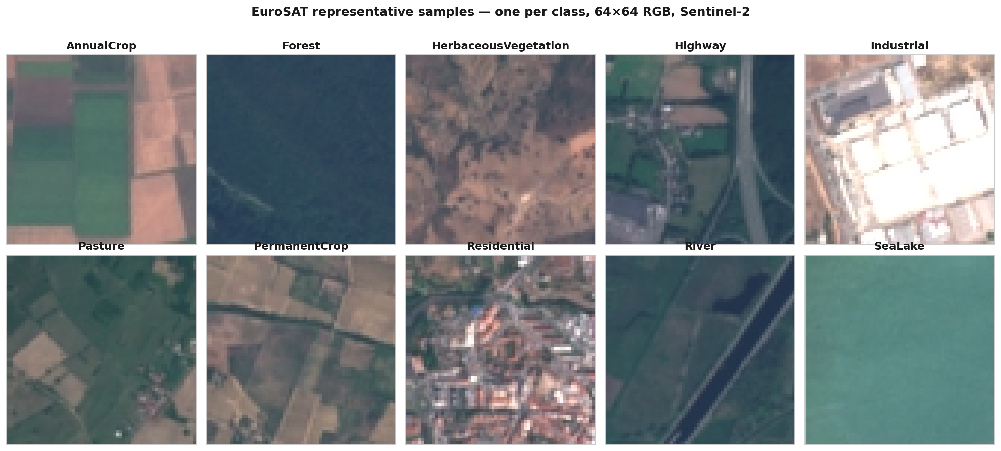
Figure 1. Representative patches from each of the ten land cover classes.
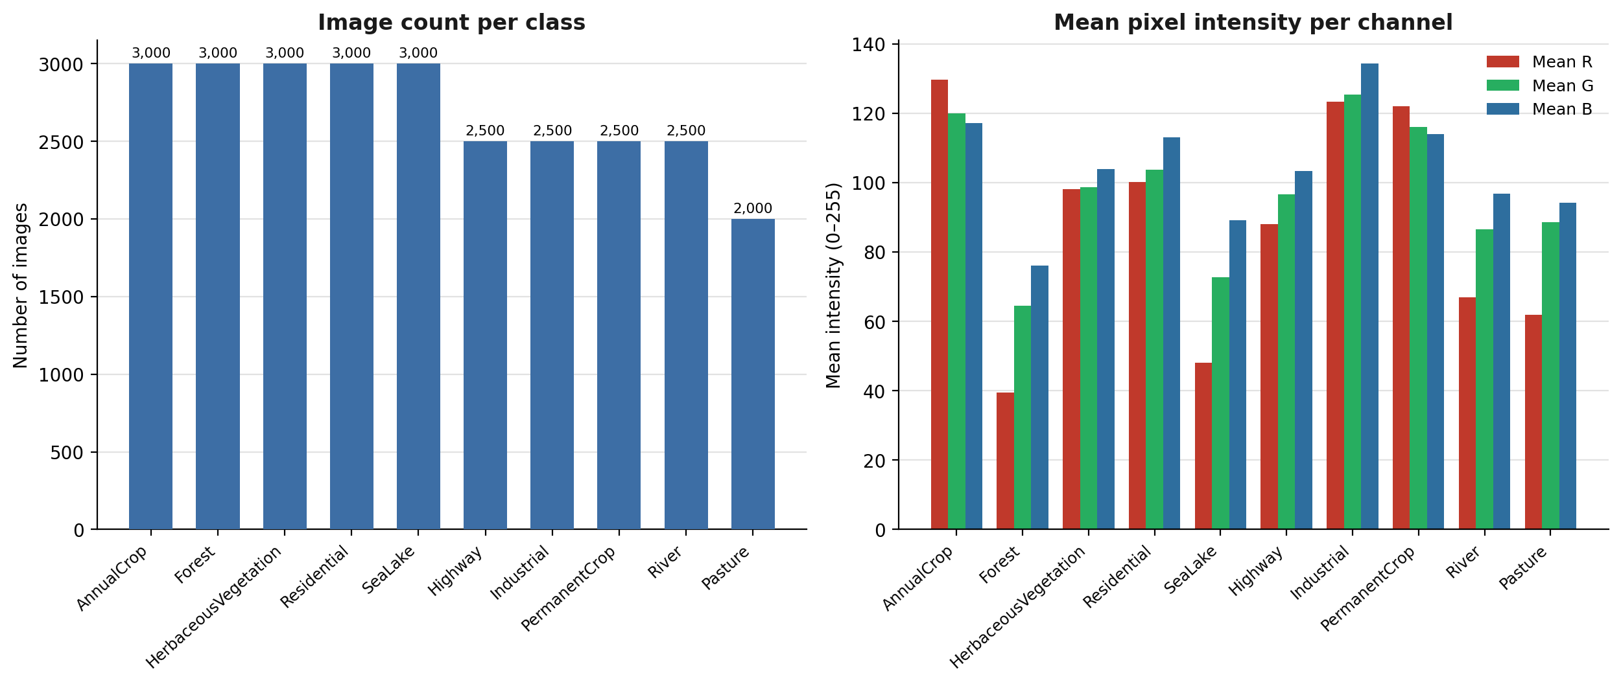
Figure 2. Image counts per class, alongside per-class mean pixel intensity in each colour channel.
Figure 2 pairs the class counts with a colour summary deliberately: the counts document the mild imbalance that motivates our metric, while the intensity summary shows how far the classes separate on colour alone, giving a reference point for judging whether a trained network has learned more than that.

3. Train, Validation and Test Split
Planned split. 70% train, 15% validation, 15% test, stratified by class. EuroSAT ships no official partition, so we define this one now, before any model is trained, and will not alter it in response to results.
Split | Share | Images | Purpose
Train | 70% | 18,900 | Fitting model weights
Validation | 15% | 4,050 | Hyperparameter choice and early stopping
Test | 15% | 4,050 | Final evaluation, used once
Table 2. Planned data partition.
Stratifying by class ensures each partition preserves the overall class proportions. We fix the random seed and commit the resulting index lists to the repository, making the partition reproducible and identical across every experiment. The test split is held out entirely until final evaluation.
The table below confirms this class-by-class: every one of the ten classes is split at exactly 70% train, 15% validation and 15% test, so no class is over- or under-represented in any split.
Class | Train | Val | Test | Total
AnnualCrop | 2,100 | 450 | 450 | 3,000
Forest | 2,100 | 450 | 450 | 3,000
HerbaceousVegetation | 2,100 | 450 | 450 | 3,000
Highway | 1,750 | 375 | 375 | 2,500
Industrial | 1,750 | 375 | 375 | 2,500
Pasture | 1,400 | 300 | 300 | 2,000
PermanentCrop | 1,750 | 375 | 375 | 2,500
Residential | 2,100 | 450 | 450 | 3,000
River | 1,750 | 375 | 375 | 2,500
SeaLake | 2,100 | 450 | 450 | 3,000
Total | 18,900 | 4,050 | 4,050 | 27,000
Table 3. Per-class breakdown of the stratified train/validation/test split, confirming the exact 70%/15%/15% proportion is preserved within every class.

4. Validation Metric
Validation metric. Macro-averaged F1, computed on the validation split.
Although EuroSAT is close to balanced, it is not exactly balanced: the largest classes hold around 3,000 images while Pasture holds around 2,000. Overall accuracy would weight the larger classes more heavily and could mask weak performance on the smaller ones. Macro-F1 averages the per-class F1 scores with equal weight, so a model that performs badly on Pasture cannot compensate by performing well on Forest. We will report overall accuracy and a confusion matrix as supporting diagnostics, but model selection and early stopping are governed by macro-F1 alone.

Reference
Helber, P., Bischke, B., Dengel, A., and Borth, D. (2019). EuroSAT: A Novel Dataset and Deep Learning Benchmark for Land Use and Land Cover Classification. IEEE JSTARS, 12(7), 2217-2226.

