Lab 4 – Part 2 Report
Mohammed Wazir Adain
Q1. Batch size = 1
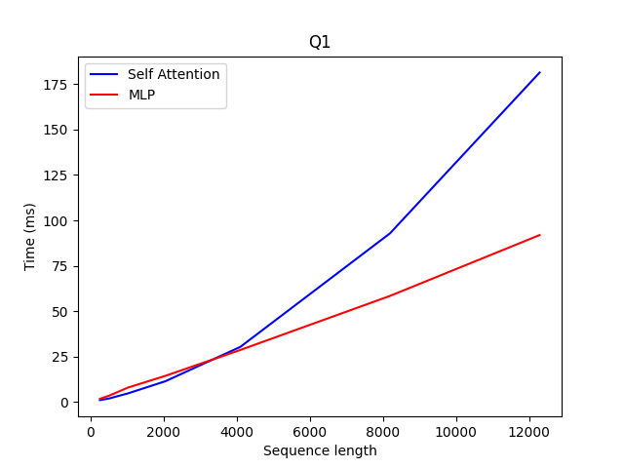
Explanation:

MLP scales linearly, Self attention scales non linearly (quadratically). Reasons:
MLP – O(N) operation
Self attention – O(N^2) operation, as each token has to attend all the tokens before it.
Time taken to move the vectors from HBM to the SMs also increase with the sequence length.

Q2. Seq_len = 1024

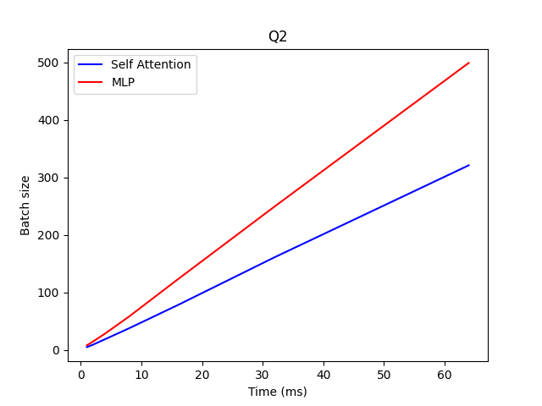

MLP scales linearly with batch size.
Linear Latency Scaling: The constant upward slope indicates that every additional element in the batch adds a fixed amount of data-movement overhead. We are not yet "hiding" the cost of memory access behind computation.
The MLP layer (red) scales more aggressively (steeper slope) than Self-Attention (blue). This is because MLPs typically involve larger weight matrices that must be loaded entirely for each forward pass, whereas Self-Attention's memory footprint at these scales is dominated by the KV cache.

Q3.
bench_decode()
```
def bench_decode(batch: int, seq_len: int, device: torch.device) -> None:
"""
Profile the Decode stage of a single Llama decoder block.

During decode, the model receives ONE new token (seq_len=1) together with
a KV-cache that holds the key/value tensors for all *previous* tokens.
"""
model = LlamaDecoderBlock().to(device).eval()

# The single new token's hidden state: shape (batch, 1, hidden_dim)
hidden = torch.randn(batch, 1, HIDDEN_DIM, device=device)
# Position of the current token (0-indexed)
pos_ids = torch.tensor([[seq_len - 1]], device=device).expand(batch, -1)

########## Solution Block ##########
# Declare random PyTorch tensors that match the shapes of the KV cache.
#
# The KV cache holds key and value tensors for all *previous* tokens.
# At decode step for token at position (seq_len - 1), there are
# (seq_len - 1) cached tokens.
#
# Required shapes:
# past_k : (batch, NUM_HEADS, seq_len - 1, HEAD_DIM)
# past_v : (batch, NUM_HEADS, seq_len - 1, HEAD_DIM)
#
# Store them as a tuple: past_key_value = (past_k, past_v)

past_k = torch.randn(batch, NUM_HEADS, seq_len - 1, HEAD_DIM, device=device)
past_v = torch.randn(batch, NUM_HEADS, seq_len - 1, HEAD_DIM, device=device)

past_key_value = (past_k, past_v) # ← replace with real tensors

########## End Solution Block ##########

if past_key_value is None:
raise RuntimeError(
"past_key_value is not implemented. "
"Fill in the Solution Block in bench_decode()."
)

with torch.no_grad():
# --- Total ---
_, total_ms = _timed(lambda: model(hidden, pos_ids, past_key_value), device)

# --- Self-attention only ---
normed = model.input_layernorm(hidden)
(attn_out, _), attn_ms = _timed(
lambda: model.self_attn(normed, pos_ids, past_key_value), device
)

# --- MLP only ---
post_attn = hidden + attn_out
normed_post = model.post_attention_layernorm(post_attn)
_, mlp_ms = _timed(lambda: model.mlp(normed_post), device)

misc_ms = max(total_ms - attn_ms - mlp_ms, 0.0)

print("Decode Stage Time Results (ms)")
print(f"Input size: Batch={batch}, Seq_len={seq_len}, Hidden_dim={HIDDEN_DIM}")
print(f"{'Self-Attn':>10}, {'MLPs':>10}, {'Misc':>10}, {'Total':>10}")
print(f"{attn_ms:10.3f}, {mlp_ms:10.3f}, {misc_ms:10.3f}, {total_ms:10.3f}")

```

Q4.
Batch = 1
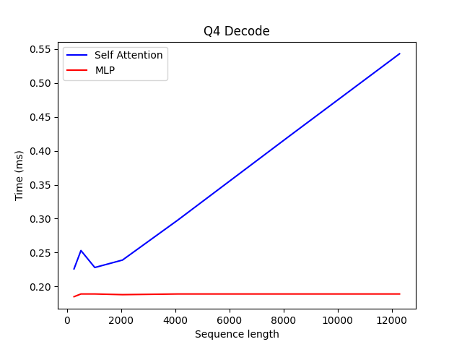
Time taken for MLP decode is independent of sequence length, as only the new token is processed – O(1) time in MLP and for self-attention, the new token attends to the older tokens through the K and V values that are cached.

As the sequence length increases, the time taken to load the KV values from HBM increases, hence the increase in time.

Q5. Seq_len = 1024

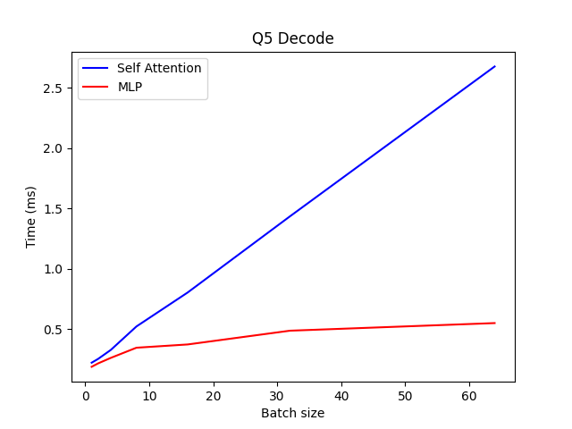

MLP - Sub-linear / Flattening - Weight Reuse: The same model weights are applied to all tokens in the batch, allowing compute units to hide memory latency.
Self Attention – Linear - Data Movement: Unique KV cache entries must be fetched for every batch member; the memory bus is the primary bottleneck.

Q6. What is the dominant operator in Prefill vs. Decode when sequence length is long?

As the sequence length increases, prefill becomes the dominant operator. This is because, Self attention is an O(N^2) operation

Q7.
Throughput vs AI (Arithmetic Intensity)

Seq Len (N) | Time (ms) | Compute (GFLOPs) | AI (FLOPs/Byte) | Throughput (TFLOPs/s)
256 | 129.61 | 17.28 | 42.9 | 0.13
512 | 131.37 | 69.12 | 51.5 | 0.53
1024 | 137.57 | 276.48 | 57.2 | 2.01
2048 | 171.87 | 1105.9 | 60.6 | 6.43

Batch (B) | Time (ms) | Compute (GFLOPs) | AI (FLOPs/Byte) | Throughput (TFLOPs/s)
1 | 124.46 | 1.08 | 42.9 | 0.008
4 | 107.08 | 4.32 | 42.9 | 0.040
8 | 129.36 | 8.64 | 42.9 | 0.066
16 | 129.80 | 17.28 | 42.9 | 0.133
32 | 130.64 | 34.56 | 42.9 | 0.264

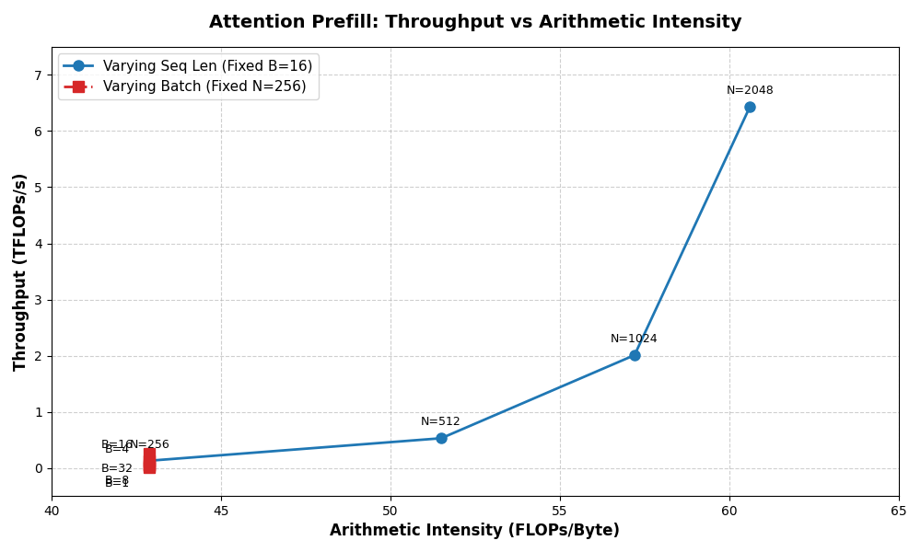

Explanation:
Sequence Length Sweep (Increasing AI) As sequence length N increases, the O(N^2) math operations begin to outpace the O(Nd) memory loads.

The Batch Size Sweep (Static AI) This is where standard eager attention falls flat. Because the arithmetic intensity is locked at 42.9 regardless of batch size, the operation is fundamentally memory-bandwidth bound. Throughput scales linearly purely because you are amortizing fixed overheads, but you hit a hard ceiling quickly.

Q8.
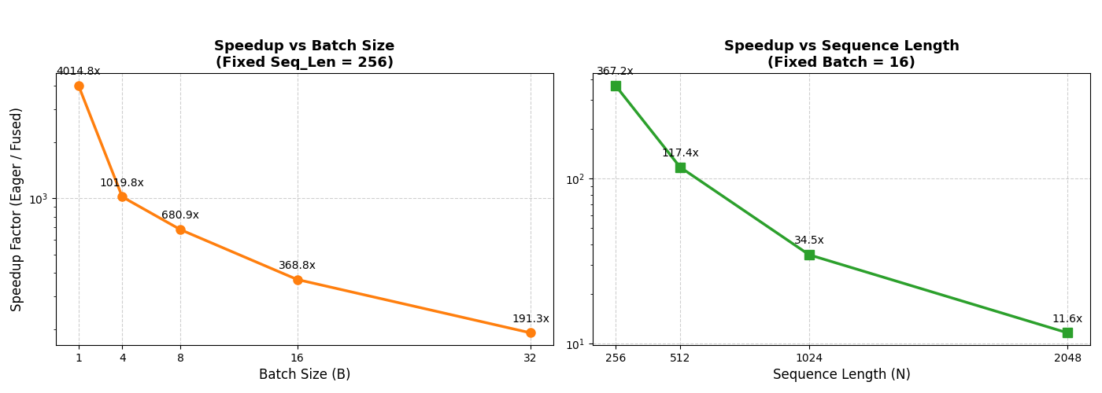

Seq Len (N) | Compute (GFLOPs) | Eager (ms) | Eager (TFLOPs/s) | Fused (ms) | Fused (TFLOPs/s) | Speedup
256 | 17.28 | 129.617 | 0.133 | 0.353 | 48.95 | 367.2x
512 | 69.12 | 131.372 | 0.526 | 1.119 | 61.77 | 117.4x
1024 | 276.48 | 137.570 | 2.010 | 3.986 | 69.36 | 34.5x
2048 | 1105.92 | 171.870 | 6.435 | 14.762 | 74.92 | 11.6x
4096 | 4423.68 | OOM | - | 57.175 | 77.37 | -
8192 | 17694.72 | OOM | - | 224.517 | 78.81 | -
12288 | 39813.12 | OOM | - | 505.265 | 78.80 | -
16384 | 70778.88 | OOM | - | 902.383 | 78.44 | -

Batch (B) | Compute (GFLOPs) | Eager (ms) | Eager (TFLOPs/s) | Fused (ms) | Fused (TFLOPs/s) | Speedup
1 | 1.08 | 124.460 | 0.009 | 0.031 | 34.84 | 4014.8x
4 | 4.32 | 107.081 | 0.040 | 0.105 | 41.14 | 1019.8x
8 | 8.64 | 129.362 | 0.067 | 0.190 | 45.47 | 680.9x
16 | 17.28 | 129.801 | 0.133 | 0.352 | 49.09 | 368.8x
32 | 34.56 | 130.647 | 0.265 | 0.683 | 50.60 | 191.3x

Explanation:
Eager Attention AI (Memory Bound): The standard implementation writes the N x N attention matrix to HBM. It reads and writes to the HBM for every operation, thereby reducing the Arithmetic intensity drastically.

Fused Attention AI (Compute Bound): FlashAttention uses kernel fusion and tiling to keep the N x N matrix in SRAM. It only reads Q, K, V from HBM once and writes the final output O once. The memory traffic drops drastically to roughly 8 x N x d bytes per head.

Thus, Instead of hitting a ceiling, the arithmetic intensity grows linearly with sequence length.

Q9. Bench_attn_decode

```
def bench_attn_decode(
batch: int,
seq_len: int,
num_heads: int,
head_dim: int,
fused: bool,
device: torch.device,
) -> None:
"""
Benchmark self-attention for the Decode stage.

During decode, only ONE new query token is computed; the keys and values
for all previous (seq_len) tokens come from the KV cache.

You must implement the Solution Block below to set up the tensors and
compute each attention step with timing.
"""

scale = head_dim ** -0.5

print("Benchmarking for Attention decode stage in ms")
print(f"Input size: Batch={batch}, Seq_len={seq_len}, Num_heads={num_heads}, Embed_dim={head_dim}")

########## Solution Block — Decode Attention ##########
# Implement decode-stage attention with KV-cache tensors.
#
# In the decode stage:
# - The model generates ONE new token at a time.
# - Q_new is the query for that single new token.
# - K_cache and V_cache hold keys/values for all previous tokens.
# - No causal mask is needed (the single query attends to ALL past positions).
#
# Step 0: Declare random tensors with the correct shapes:
# Q_new : (batch, num_heads, 1, head_dim) ← single query
# K_cache : (batch, num_heads, seq_len, head_dim) ← cached keys
# V_cache : (batch, num_heads, seq_len, head_dim) ← cached values
# Then set: Q, K, V = Q_new, K_cache, V_cache
#
# Then implement and time each step (same pattern as prefill, but no masking).

# 0. Declare KV-cache tensors
Q_new = torch.randn(batch, num_heads, 1, head_dim, device=device)
K_cache = torch.randn(batch, num_heads, seq_len, head_dim, device=device)
V_cache = torch.randn(batch, num_heads, seq_len, head_dim, device=device)
Q = Q_new # ← implement
K = K_cache # ← implement
V = V_cache # ← implement

with torch.no_grad():
# 1. Q·K^T — shape (batch, num_heads, 1, seq_len)
_sync(device)
t0 = time.perf_counter()
scores = torch.matmul(Q, K.transpose(-2, -1)) * scale # ← implement: Q @ K^T * scale
_sync(device)
qkt_ms = (time.perf_counter() - t0) * 1e3

# 2. Softmax — normalize over the last dimension
_sync(device)
t0 = time.perf_counter()
weights = F.softmax(scores, dim=-1) # ← implement: softmax of scores
_sync(device)
softmax_ms = (time.perf_counter() - t0) * 1e3

# 3. Attention · V — shape (batch, num_heads, 1, head_dim)
_sync(device)
t0 = time.perf_counter()
output = torch.matmul(weights, V) # ← implement: weights @ V
_sync(device)
attn_v_ms = (time.perf_counter() - t0) * 1e3

########## End Solution Block — Decode Attention ##########

if Q is None or K is None or V is None:
raise RuntimeError(
"Decode attention not implemented. "
"Fill in the Solution Block in bench_attn_decode()."
)

if fused:
with torch.no_grad():
_, total_ms = _timed(
lambda: F.scaled_dot_product_attention(Q, K, V, is_causal=False),
device,
)
print(f"{'Total':>8}")
print(f"{total_ms:8.3f}")
return

total_ms = qkt_ms + softmax_ms + attn_v_ms

print(f"{'Q_K^T':>8}, {'Softmax':>8}, {'Attn_V':>8}, {'Total':>8}")
print(f"{qkt_ms:8.3f}, {softmax_ms:8.3f}, {attn_v_ms:8.3f}, {total_ms:8.3f}")

```

Q10.
Seq Len (N) | Compute (GFLOPs) | AI (FLOPs/Byte) | Time (ms) | Throughput (TFLOPs/s)
256 | 0.067 | 0.986 | 73.525 | 0.0009
512 | 0.135 | 0.988 | 71.857 | 0.0018
1024 | 0.270 | 0.989 | 71.873 | 0.0037
2048 | 0.540 | 0.990 | 68.303 | 0.0079
4096 | 1.080 | 0.990 | 70.723 | 0.0152
8192 | 2.160 | 0.990 | 72.749 | 0.0296
16384 | 4.320 | 0.990 | 73.172 | 0.0590
32768 | 8.640 | 0.990 | 74.421 | 0.1160
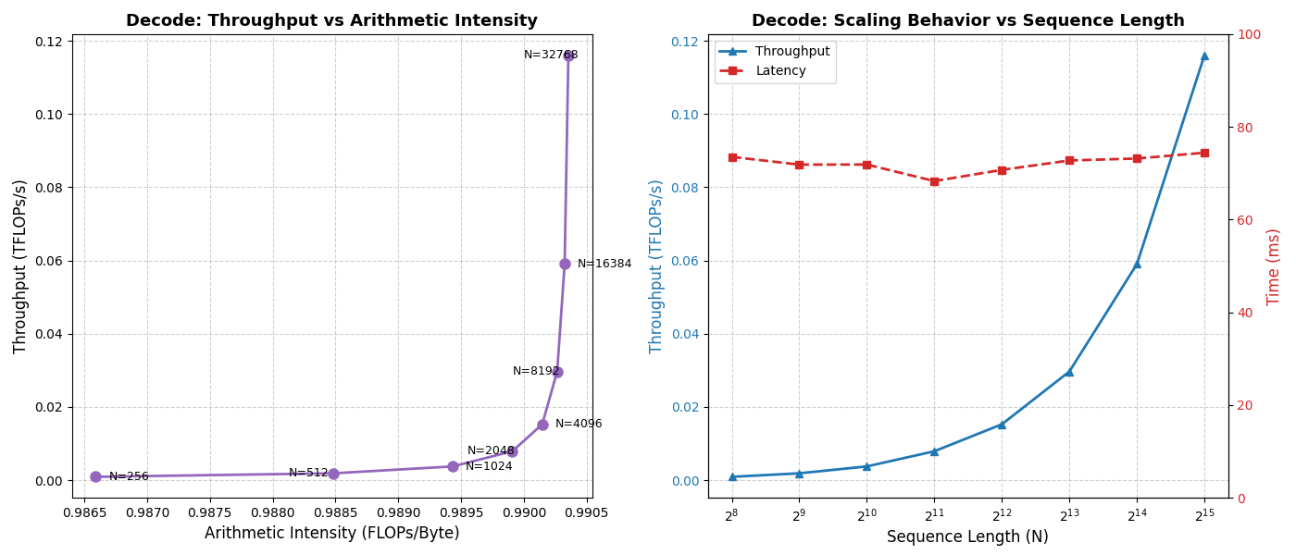

Explanation:
The execution time stays almost constant – which ind

Q11.
Batch (B) | Compute (GFLOPs) | AI (FLOPs/Byte) | Time (ms) | Throughput (TFLOPs/s)
16 | 0.540 | 0.99 | 70.267 | 0.0077
32 | 1.080 | 0.99 | 71.926 | 0.0150
64 | 2.160 | 0.99 | 69.000 | 0.0313
128 | 4.320 | 0.99 | 69.600 | 0.0621
256 | 8.640 | 0.99 | 74.852 | 0.1154
512 | 17.281 | 0.99 | 77.435 | 0.2232
1024 | 34.561 | 0.99 | 96.347 | 0.3587
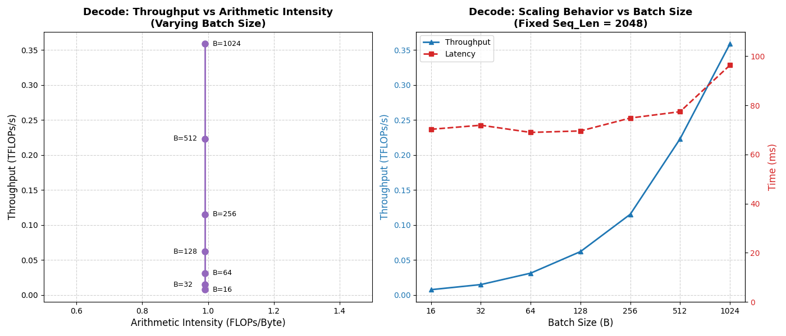

Explanation:
Arithmetic Intensity is independent of batch size.
Throughput increases with batch size.

The Vertical AI Line: Because Arithmetic Intensity never changes (~0.99), plotting Throughput vs. AI yields a straight vertical stack of points. You are restricted to the memory-bound slope of the Roofline model.

Throughput Scaling via Amortization: If the workload is so memory-bound, why does throughput increase from 0.007 to 0.358 TFLOPs/s?
- Between B=16 and B=128, the execution time is basically flat (~70 ms). This indicates the GPU is still starving for work, and the latency is entirely consumed by Python dispatch overhead and kernel launch times.
- By batching up to 1024, you are forcing the GPU to load ~17 GB of KV Cache in a single pass. The framework overhead finally becomes amortized over a massive payload, driving the throughput metric up.
The Latency Rise: Notice that at B=256 through B=1024, the latency finally begins to climb (from ~74 ms up to ~96 ms). This is the exact moment the sheer volume of memory transfers begins to legitimately saturate the GPU's HBM bandwidth.

Q12.
Seq Len (N) | Eager (ms) | Fused (ms) | Speedup
256 | 73.525 | 0.123 | 597.8x
512 | 71.857 | 0.233 | 308.4x
1024 | 71.873 | 0.454 | 158.3x
2048 | 68.303 | 0.900 | 75.9x
4096 | 70.723 | 1.862 | 38.0x
8192 | 72.749 | 3.773 | 19.3x
16384 | 73.172 | 7.481 | 9.8x
32768 | 74.421 | 15.087 | 4.9x

Batch (B) | Eager (ms) | Fused (ms) | Speedup
16 | 70.267 | 0.890 | 79.0x
32 | 71.926 | 1.858 | 38.7x
64 | 69.000 | 3.770 | 18.3x
128 | 69.600 | 7.591 | 9.2x
256 | 74.852 | 15.315 | 4.9x
512 | 77.435 | 31.171 | 2.5x
1024 | 96.347 | 63.273 | 1.5x

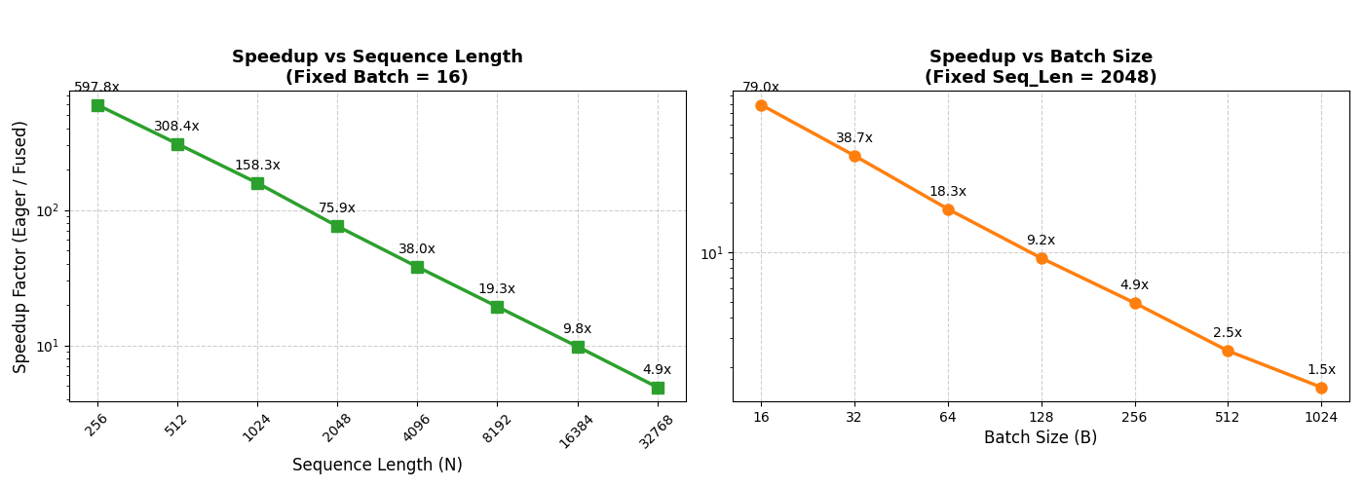

Explanation:
The Numerator (Eager Overhead): As established, the eager PyTorch latency is "flat" at ~70ms for most of these runs. It is not bound by the GPU's memory or math; it is entirely bottlenecked by the sequential Python kernel launch overheads.
The Denominator (Fused Linearity): By fusing the operations, FlashAttention bypasses the framework overhead. You can see this because the Fused time perfectly doubles every time the workload doubles (0.12 to 0.23 to 0.45 to 0.90 ms). It is executing exactly at the hardware's memory bandwidth limit.
The 1/x Decay Curve: Because you are dividing a constant (Eager overhead) by a linearly increasing variable (Fused memory traffic), the resulting speedup mathematically decays proportionally to 1/x.

