NHS Emergency Hospital Admissions - COVID-19 Lockdown Impact by Diagnosis

COMP4037 Research Methods · Coursework 2: Data Visualization · Mohammed Adnan · University of Nottingham

Research Question: Which NHS emergency hospital admission categories were most suppressed by the COVID-19 lockdown (2020/21), and did they recover to pre-pandemic levels by 2022/23?
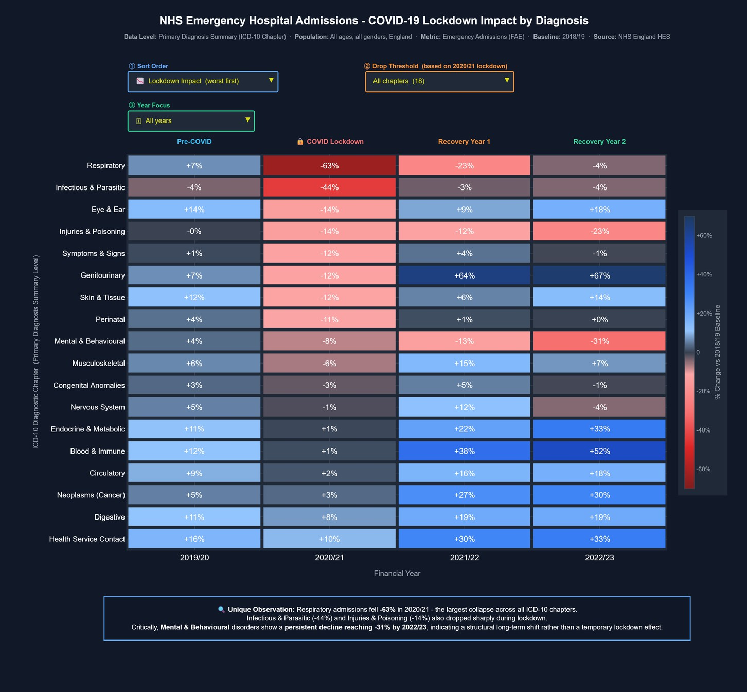

Figure 1: Year-on-Year % Change in NHS Emergency Admissions vs 2018/19 Baseline by ICD-10 Diagnostic Chapter
| England | Financial Years 2019/20–2022/23 | Source: NHS England Hospital Episode Statistics (HES)

Visual Design Type:
Annotated Diverging Heatmap - an advanced interactive visualization where the colour of each cell shows the percentage change in emergency admissions compared to the 2018/19 baseline. The rows are sorted by the 2020/21 lockdown impact, so the most affected categories appear at top which makes it easy to spot the pattern immediately.

Name of Tool:
Python 3 with Plotly library was used to build this interactive standalone HTML visualization. The diagram has 3 dropdown filters built in and hover tooltips that show detailed information for each cell. The interactive version is hosted at the link provided below and the source code is available in the Colab notebook link also provided.
Interactive Diagram URL: https://mohammedadnan04.github.io/Research_Methods_CW2/
Source Code URL: https://colab.research.google.com/drive/1UUhS-AGn_aNzYC0PKXkq67srJGp-86U-?usp=sharing

Focus Cohort:
The visualization covers financial years 2019/20 through to 2022/23 with 2018/19 used as the baseline for comparison. All age groups are included from age 0 to 90+ and the hover tooltip on each cell shows the top 3 age groups contributing to admissions in that particular category and year. The data covers all genders across England.

Variables and Why Chosen:
The main variable chosen is Emergency Hospital Admissions which is the finished admission episodes classified as emergency. I chose this specific metric rather than total admissions because it directly captures unplanned urgent demand, which is the most sensitive indicator of how COVID-19 disrupted normal healthcare behavior in population. If someone stops going to hospital in an emergency it means something significantly changed in their access or behavior.

The second variable is the ICD-10 diagnostic chapter which groups related diagnosis codes into 18 clinically meaningful categories like Respiratory, Mental & Behavioral, Circulatory and so on. Human readable descriptions are shown throughout, not just codes. The third variable is percentage change against the 2018/19 baseline which is a derived metric I calculated to allow fair comparison across chapters that have very different absolute sizes.

Visual Mappings:
The x-axis shows the financial year from 2019/20 to 2022/23. The y-axis shows the ICD-10 diagnostic chapter at Primary Diagnosis Summary level which is one level above the 3-character ICD codes, and it is sorted by the 2020/21 lockdown drop so worst affected chapters appear at top. The colour encodes the percentage change using a diverging scale where deep red means a large decrease compared to baseline and deep blue means a large increase, with dark neutral in the middle representing near zero change. The exact percentage value is also printed inside each cell so reader does not have to guess from colour alone.

The hierarchy is shown through the y-axis grouping where individual diagnosis codes are aggregated up to chapter level. Three interactive filters are available:
- Sort Order to change how chapters are ranked,
- Drop Threshold to isolate only the most impacted chapters, and
- Year Focus which hides all other years and shows only the selected year in full detail.

On hovering any cell a tooltip appears showing the exact emergency admissions count, percentage change, the 2018/19 baseline figure, total admissions, and the top 3 age groups by volume.

Unique Observation:
Respiratory emergency admissions fell by 63% in 2020/21 compared to 2018/19 baseline, which is the largest single year collapse across all 18 ICD-10 chapters. In absolute terms this dropped from around 221,291 admissions to just 80,819 which is significant. Infectious & Parasitic diseases also dropped by 44% and Injuries & Poisoning fell 14% which all makes sense because lockdown reduced community transmission and physical activity outside home.

Most of the chapters show a clear recovery pattern in 2021/22 and 2022/23 which is visible as the red columns gradually turning blue as you read left to right. But the most interesting finding which i believe is the unique observation here is Mental & behavioral disorders. It is the only chapter that keeps getting worse after lockdown ends, reaching 31% below the 2018/19 baseline by 2022/23. Every other chapter recovers but this one continues declining year on year. This could suggest that mental health patients shifted to community-based care permanently or there is a growing crisis of unmet need that is simply not showing up in emergency admissions anymore. Either way this pattern is not visible from raw numbers alone and only becomes clear through this visualization.

Data Preparation:
First i loaded the Primary Diagnosis Summary sheet from all 5 NHS England HES Excel files covering financial years 2018/19 to 2022/23. One thing i noticed during preprocessing is that the older files from 2018/19 and 2019/20 have the header row at index 10 while the newer files from 2020/21 onwards have it at index 9, so i handled this difference explicitly in the code.

Another major issue was that older files use broad ICD codes like E15-E90 as a single row while newer files split the same range into multiple granular codes like E15-E16 and E20-E35 separately. To handle both styles consistently i built a prefix based mapping function that assigns chapter based on the first letter of the code regardless of how granular it is. After mapping i aggregated all individual codes to chapter level by summing emergency admissions. Then i calculated percentage change against the 2018/19 financial year as the baseline. Finally i sorted chapters by their 2020/21 percentage change in ascending order so the most suppressed categories appear at the top of the visualization.
Resources:
- URL to Screen-Capture Demo:
- URL to Source Code: https://colab.research.google.com/drive/1UUhS-AGn_aNzYC0PKXkq67srJGp-86U-?usp=sharing
- URL to Interactive Diagram: https://mohammedadnan04.github.io/Research_Methods_CW2/

COMP4037 Research Methods · Coursework 2: Data Visualization · Mohammed Adnan · University of Nottingham

